Game Design Document

Fill up the following document

1. Write the title of your project.

Runner Boy

1. What is the goal of the game?

To unlock different charecters and prizes.

1. Write a brief story of your game.

Once upon a tim there was this kid who loved Video games. One day his gaming platform broke and he smashed his control and he got sucked into the game, being the 1st charecter in it

1. Which are the playing characters of this game?

* Playing characters are the ones who respond to the user based on the input from the user.
* Cars, monkeys, dinos, wizards, etc., are the playing characters in the game.

|  |  |  |
| --- | --- | --- |
| Number | Character Name | What can this character do? |
| 1 | Ninja | run |
| 2 | Capy | jump |
| 3 | Wayne | shoot |
| 4 |  |  |
| 5 |  |  |
| 6 |  |  |
| 7 |  |  |
| 8 |  |  |

1. Which are the Non-Playing Characters of this game?

* Non-Playing characters are the ones that don't have an action or behavior when the user interacts with the game.
* Hurdles, stones, bananas, coins, etc., are non-playing characters in the game.

|  |  |  |
| --- | --- | --- |
| Number | Character Name | What can this character do? |
| 1 | Obsatcle 1 | Stand in the way |
| 2 |  |  |
| 3 |  |  |
| 4 |  |  |
| 5 |  |  |
| 6 |  |  |
| 7 |  |  |
| 8 |  |  |

Draw your imagination of this game. What does this game look like?

* Draw the game either on your computer or on paper.
* Add images of the game scenes to show each of the playing and non-playing characters at least once.

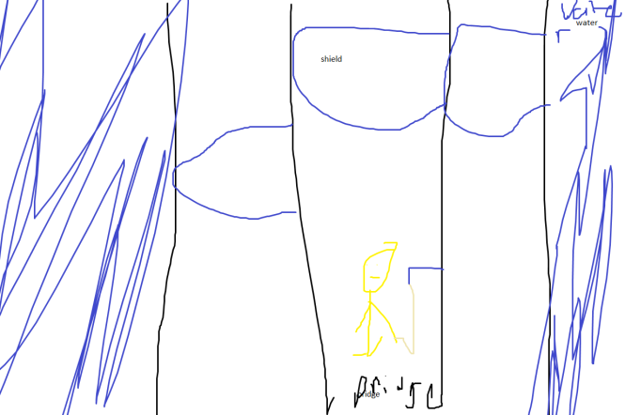

How do you plan to make your game engaging?

Gonna make new levals and different skill set so players can have fun and not the repaet of the same thing