**Source: https://www.cmi.ac.in/~debangshu/lab1/diode.pdf**

**Diode Model**

**DIODE:**

A Diode is a two terminal semiconductor device formed from a junction of n-type and p-type semiconductor material. It is primarily used in rectification. Ideally it is a uni-directional device (i.e. It conducts only when it is forward biased and blocks current when it is reversed biased). However for practical diodes the curve is slightly different as compared to ideal curve.

**Response of DIODE to varying Voltages:**

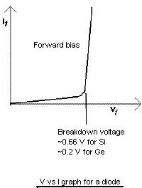

**In the forward-bias region the V-I relationship is described as follows:**

*V*

*I* = *Is*(*enVT −* 1)

In the above equation, I is the forward current, V is the forward voltage, It is the saturation current, and *VT* = *kT/q* is the thermal voltage. Initially, the V vs I graph is linear but then after reaching breakdown, it becomes exponential.

**Forward Biased Readings:**

|  |  |  |
| --- | --- | --- |
| **S.No** | **Voltage(*V* )** | **Current(*mA*)** |
| 1 | 0.283 | 0 |
| 2 | 0.347 | 0.001 |
| 3 | 0.370 | 0.001 |
| 4 | 0.395 | 0.005 |
| 5 | 0.425 | 0.009 |
| 6 | 0.435 | 0.012 |
| 7 | 0.445 | 0.018 |
| 8 | 0.467 | 0.047 |
| 9 | 0.485 | 0.060 |
| 10 | 0.496 | 0.082 |
| 11 | 0.503 | 0.101 |
| 12 | 0.517 | 0.145 |
| 13 | 0.525 | 0.175 |
| 14 | 0.527 | 0.181 |
| 15 | 0.538 | 0.246 |
| 16 | 0.544 | 0.306 |
| 17 | 0.555 | 0.412 |
| 18 | 0.563 | 0.509 |
| 19 | 0.573 | 0.646 |
| 20 | 0.575 | 0.693 |
| 21 | 0.585 | 0.822 |
| 22 | 0.592 | 0.979 |
| 23 | 0.598 | 1.112 |
| 24 | 0.605 | 1.335 |
| 25 | 0.618 | 1.805 |
| 26 | 0.623 | 2.007 |
| 27 | 0.630 | 2.392 |
| 28 | 0.646 | 3.4 |
| 29 | 0.653 | 3.9 |
| 30 | 0.658 | 4.3 |
| 31 | 0.665 | 5.3 |
| 32 | 0.672 | 6.7 |
| 33 | 0.677 | 7.6 |
| 34 | 0.680 | 8.0 |

**Reversed Biased Readings:**

|  |  |  |
| --- | --- | --- |
| **S.No** | **Voltage(*V* )** | **Current(*µA*)** |
| 1 | 0.90 | 0 |
| 2 | 1.60 | 0.001 |
| 3 | 2.07 | 0.002 |
| 4 | 3.78 | 0.003 |
| 5 | 4.94 | 0.004 |
| 6 | 5.95 | 0.005 |
| 7 | 7.27 | 0.006 |
| 8 | 8.01 | 0.007 |
| 9 | 9.32 | 0.008 |
| 10 | 9.84 | 0.009 |
| 11 | 10.34 | 0.010 |
| 12 | 11.94 | 0.011 |
| 13 | 12.77 | 0.012 |
| 14 | 13.93 | 0.013 |
| 15 | 15.11 | 0.014 |
| 16 | 16.32 | 0.015 |
| 17 | 17.03 | 0.016 |
| 18 | 17.81 | 0.017 |
| 19 | 18.56 | 0.018 |
| 20 | 19.35 | 0.019 |

**VI curve of the data:**

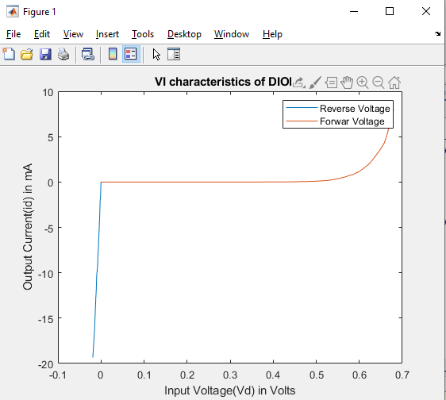

(Plotted in MATLAB from Diode_VI_char.m File)