**Designing High Pass Filter**

**Given:**

Cutoff frequency = 1000 Hz

Stop Band Attenuation = 10 dB at 350 Hz

Sampling Frequency = 5000 Hz

**Derivation:**

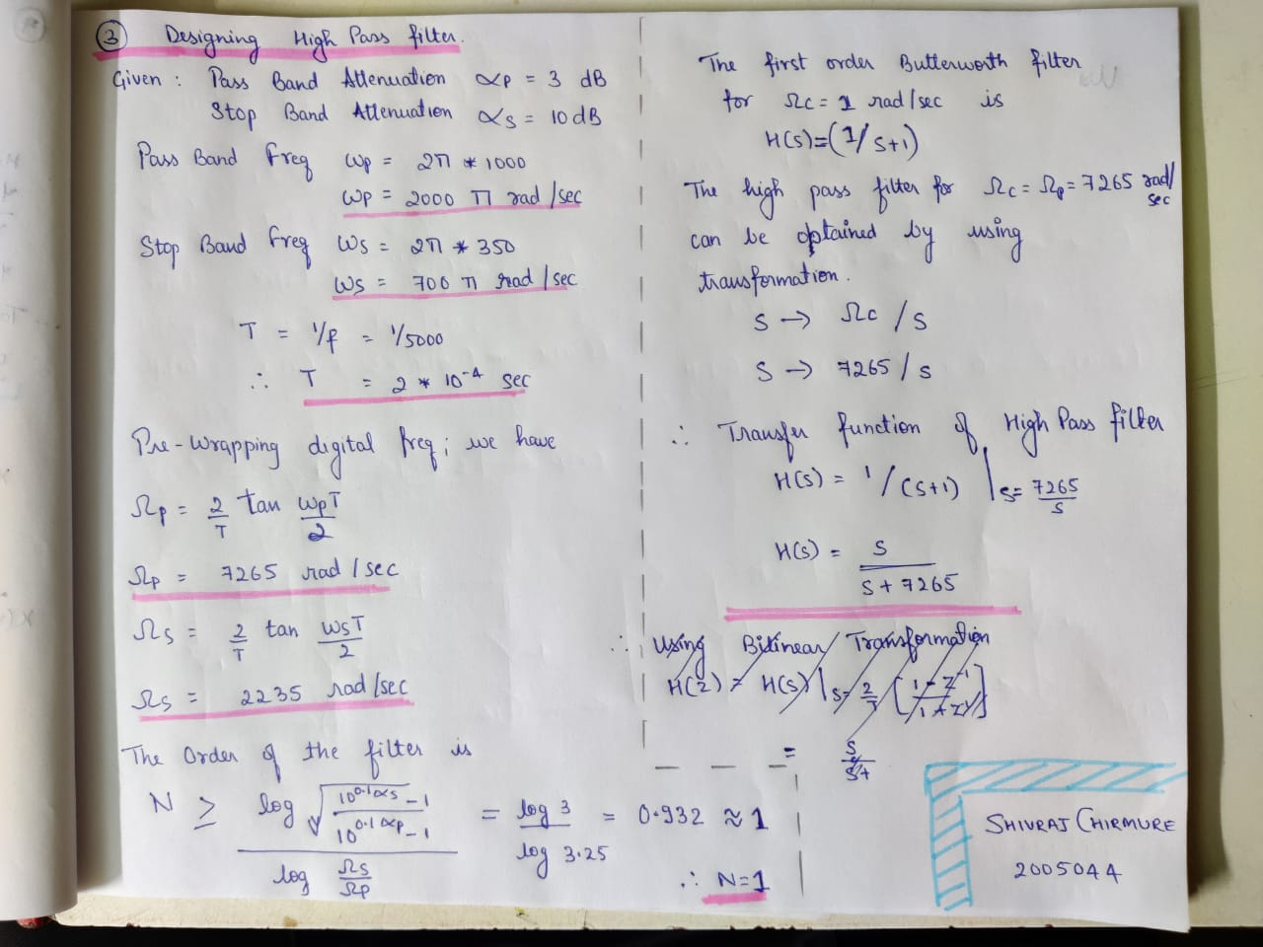

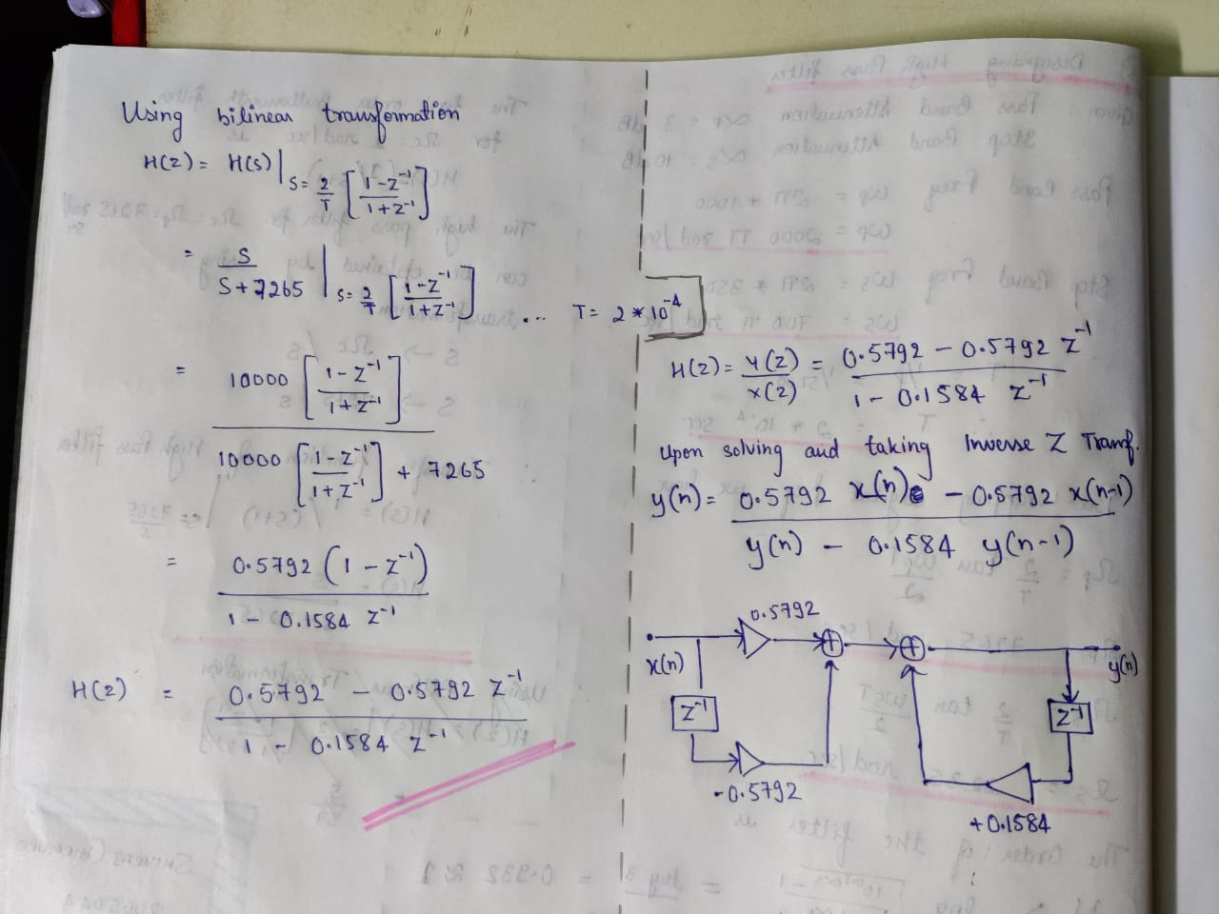

**Therefore, by calculating we find that:**

Pass Band Attenuation = 3dB

Pass Band Frequency = 2000 * pi rad/sec

Stop Band Frequency = 700 * pi rad/sec

T = (1/f) = 2*10^(-4) sec

**H(z) = {0.5792 – 0.5738*z^(-1)} / {1 – 0.1584*z^(-1)}**