**Problem: 5**

Simulate the following equation for 10 seconds

**R (dQ/dt) + (1/C)Q = E(t)**

**Calculation:**

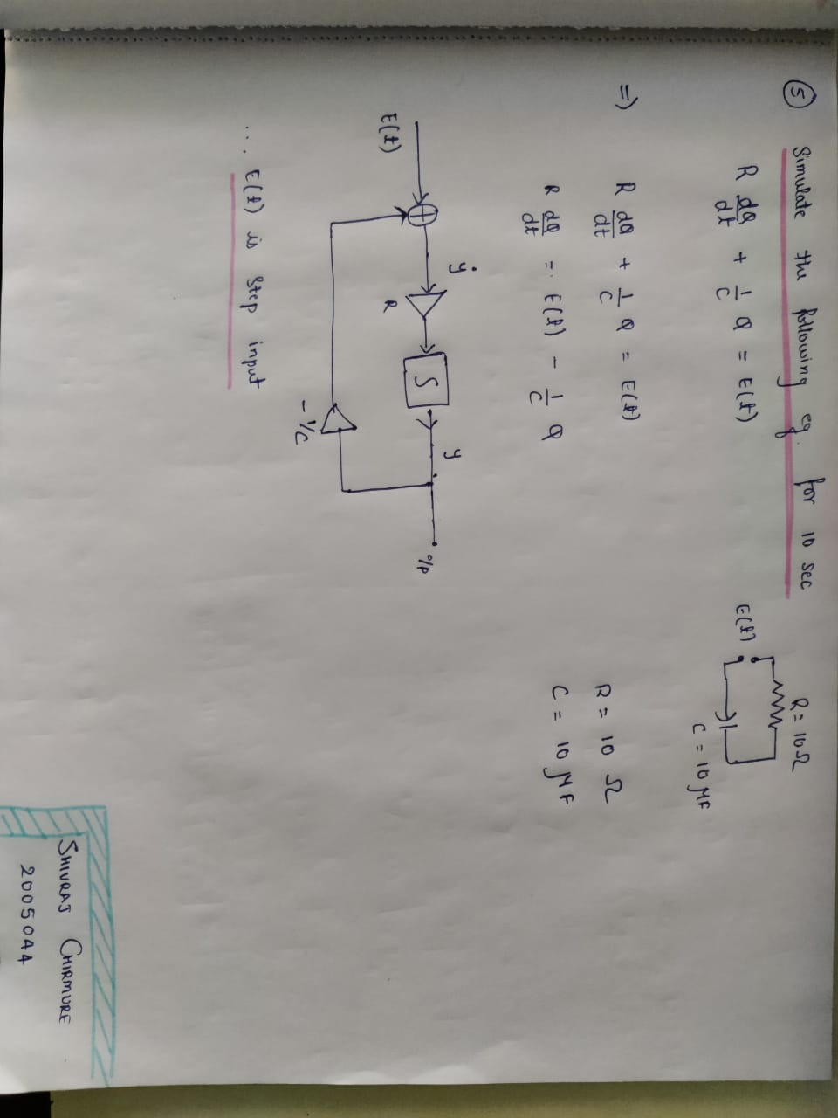

**Run 1:**

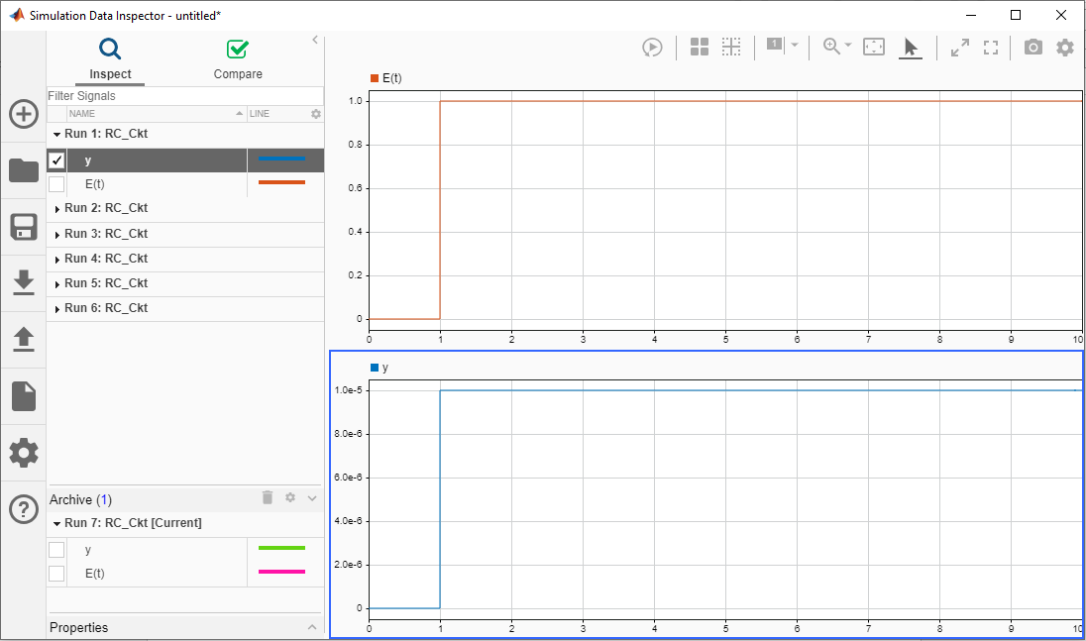

**Run 2:**

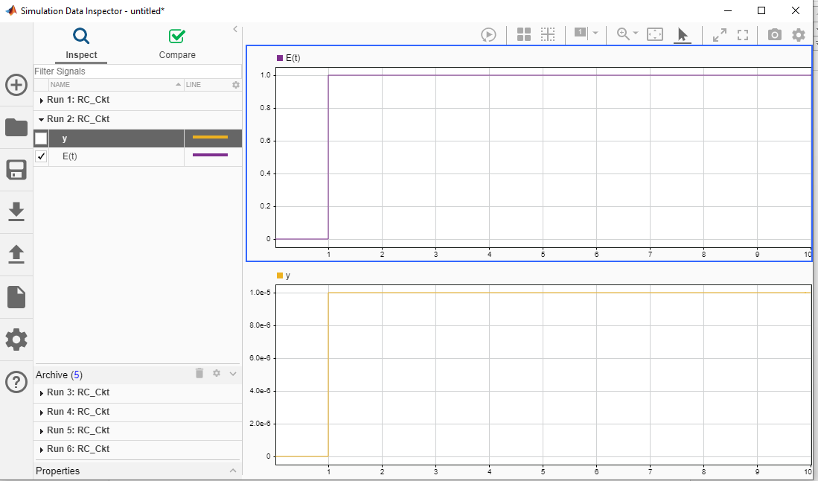

**Run 3:**

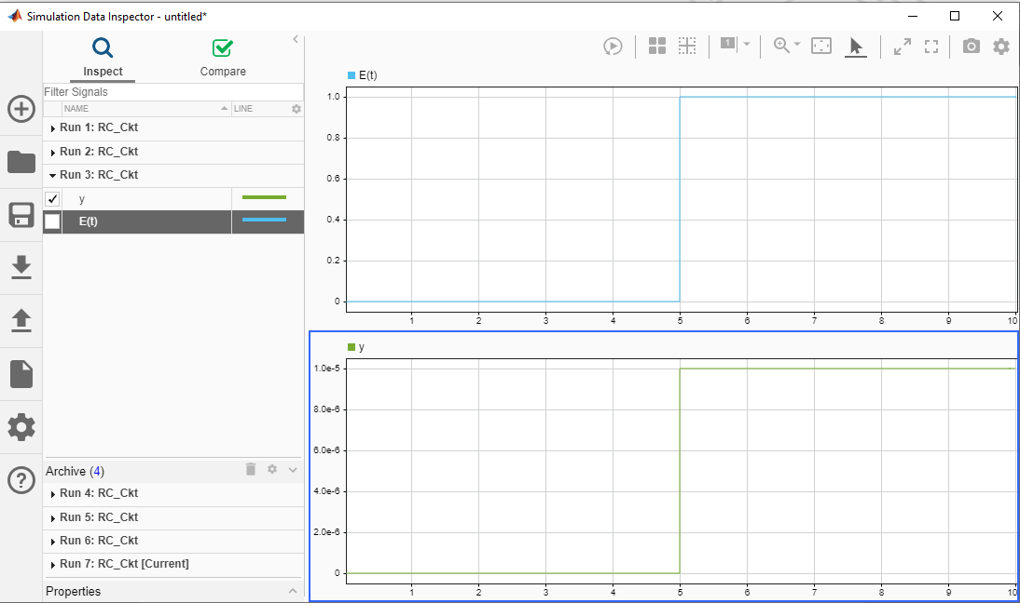

**Run 4:**

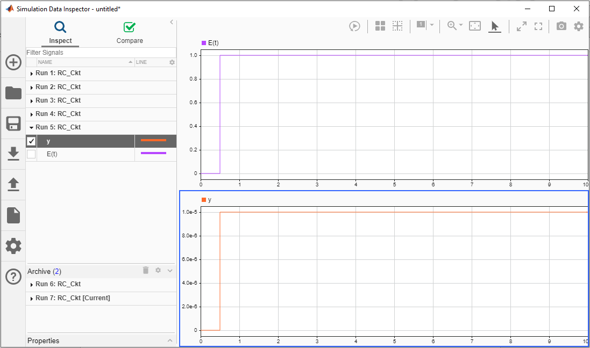

**Run 5:**

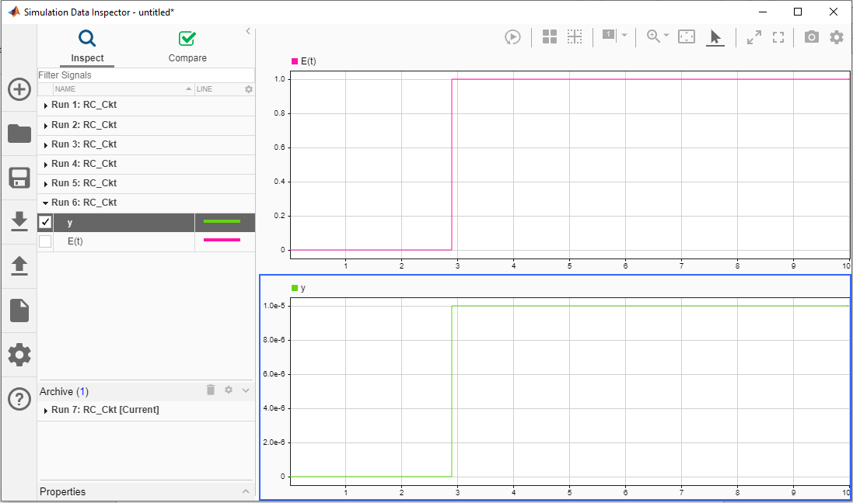

**Run 6:**

