**Problem 9**

**Source:**

[**https://www.youtube.com/watch?v=KurVsueM4fg&feature=youtu.be&ab_channel=ToanNguyen**](https://www.youtube.com/watch?v=KurVsueM4fg&feature=youtu.be&ab_channel=ToanNguyen)

**Designing a BLDC motor**

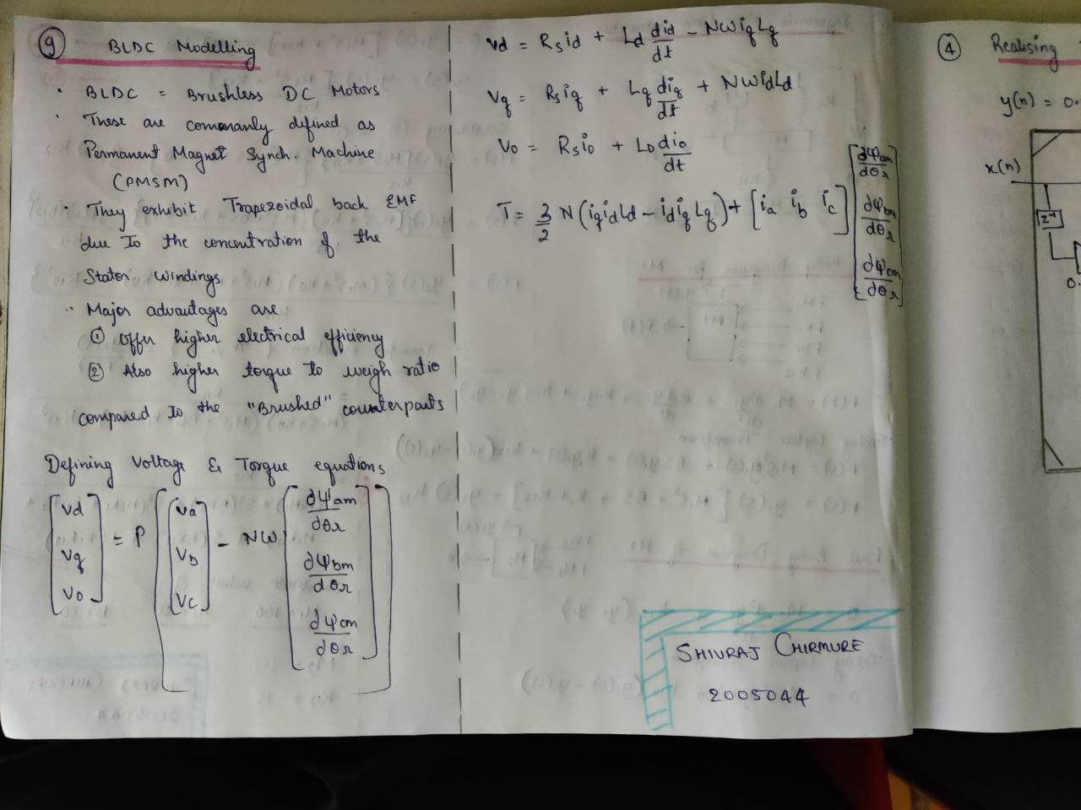

**Gate Block Logic**

|  |  |  |  |  |  |  |  |  |
| --- | --- | --- | --- | --- | --- | --- | --- | --- |
| **emf_a** | **emf_b** | **Emf_c** | **Q1** | **Q2** | **Q3** | **Q4** | **Q5** | **Q6** |
| 0 | 0 | 0 | 0 | 0 | 0 | 0 | 0 | 0 |
| 0 | -1 | 1 | 0 | 0 | 0 | 1 | 1 | 0 |
| -1 | 1 | 0 | 0 | 1 | 1 | 0 | 0 | 0 |
| -1 | 0 | 1 | 0 | 1 | 0 | 0 | 1 | 0 |
| 1 | 0 | -1 | 1 | 0 | 0 | 0 | 0 | 1 |
| 1 | -1 | 0 | 1 | 0 | 0 | 1 | 0 | 0 |
| 0 | 1 | -1 | 0 | 0 | 1 | 0 | 0 | 1 |
| 0 | 0 | 0 | 0 | 0 | 0 | 0 | 0 | 0 |

**Decoder Block Logic**

|  |  |  |  |  |  |
| --- | --- | --- | --- | --- | --- |
| **ha** | **hb** | **hc** | **emf_a** | **emf_b** | **emf_c** |
| 0 | 0 | 0 | 0 | 0 | 0 |
| 0 | 0 | 1 | 0 | -1 | 1 |
| 0 | 1 | 0 | -1 | 1 | 0 |
| 0 | 1 | 1 | -1 | 0 | 1 |
| 1 | 0 | 0 | 1 | 0 | -1 |
| 1 | 0 | 1 | 1 | -1 | 0 |
| 1 | 1 | 0 | 0 | 1 | -1 |
| 1 | 1 | 1 | 0 | 0 | 0 |