**Vending Machine Model using Mealy**

**Semantics**

**Main Model**

1 Coin => Candy

2 Coins => Soda

No Coins => Nill

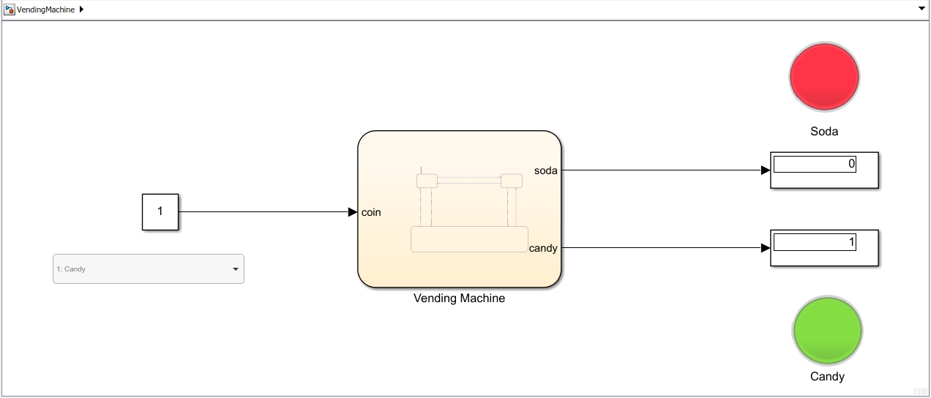

**Stateflow Chart**

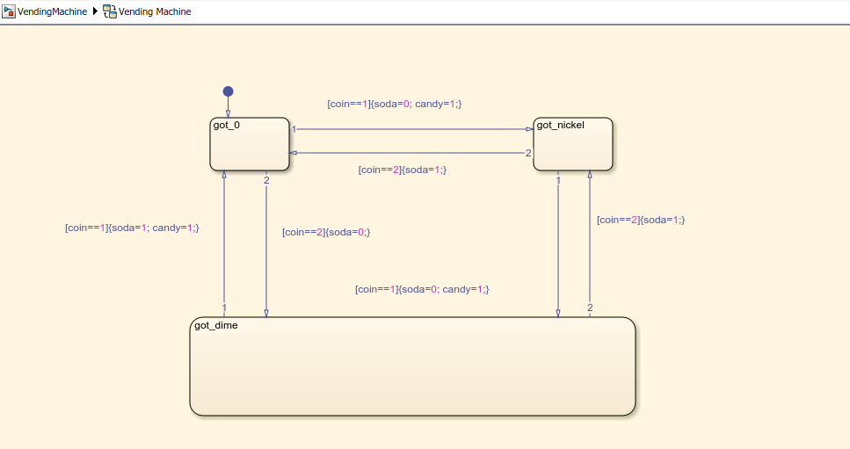

**Output**

**(NOTE: Green Lamp indicates ON and Red Lamp Indicates OFF)**

* **Candy ( 1 Coin)**

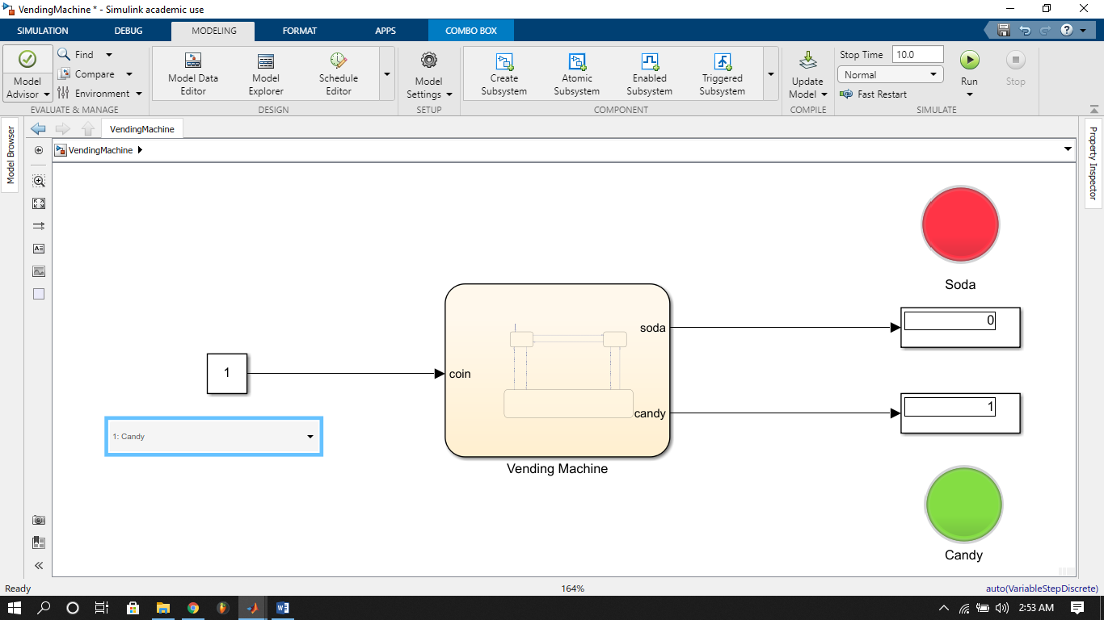

(1 Coin = CANDY)

* **Soda (2 Coins)**

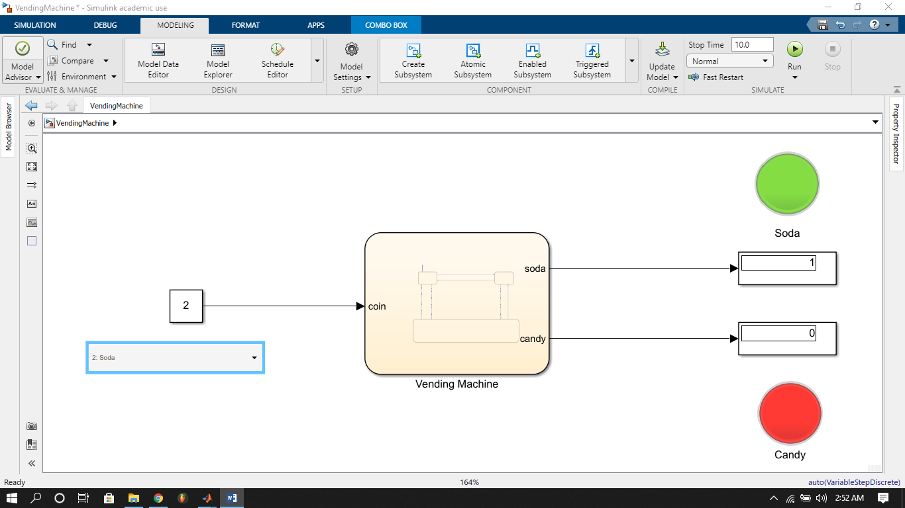

(2 Coins = SODA)

* **No coins**

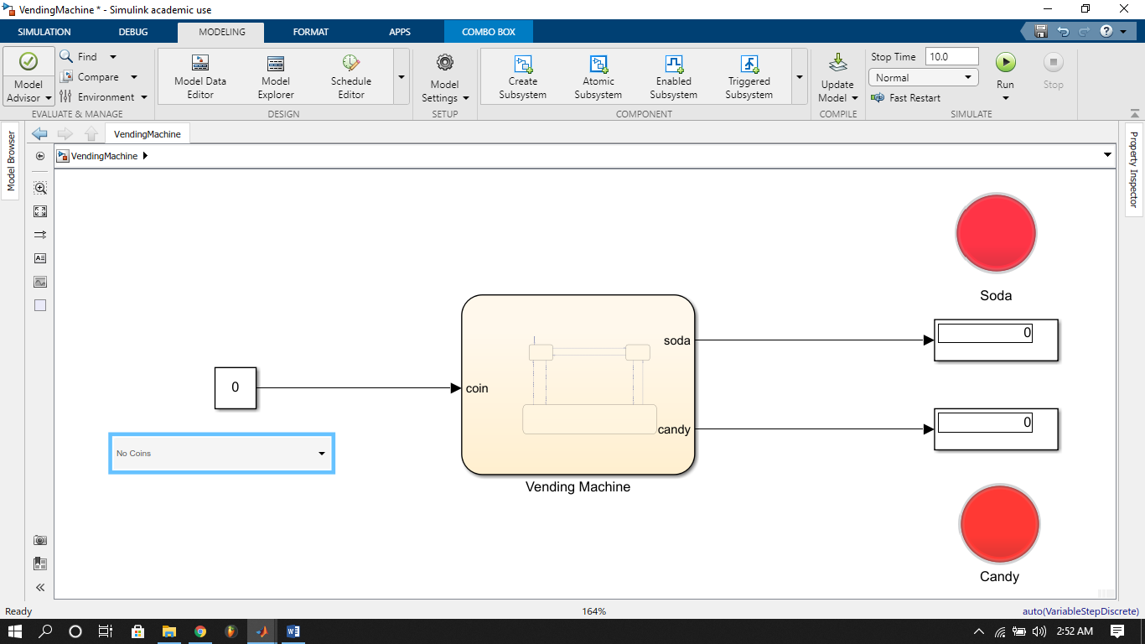

(No Coins = Nill)