**TRAFFIC LIGHT SYSTEM USING MOORE SEMANTICS**

**Main Model**

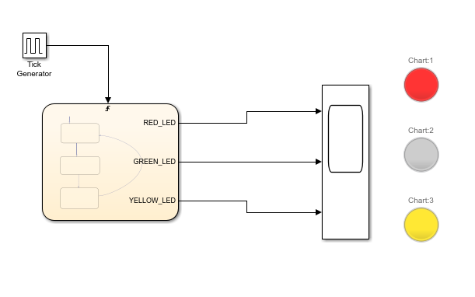

**Indications**

RED_LED : Stop

GREEN_LED: Go

YELLOW_LED: Prepare To Stop

**Stateflow Chart**

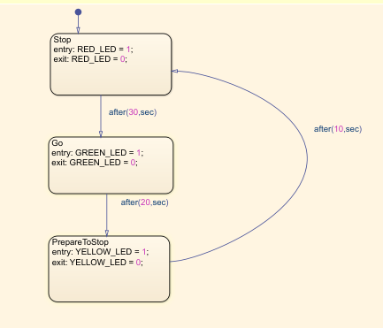

Time taken to change the lights:

RED Light to GREEN Light: 30 seconds

RED Light to YELLOW Light: 50 seconds

RED Light to RED Light: 60 seconds

**Output**

* **The initial state is RED (Stop)**
* Firstly **(at t=0)** the RED Signal is turned ON for 30 sec (Meanwhile Green and Yellow signals are turned OFF)
* After 30 seconds **(at t=30)**, RED signal turns OFF and GREEN signal turns ON for 20 sec (Yellow is still OFF and so is Red)
* After 20 more seconds **(at t=50)**, GREEN signal turns OFF and YELLOW signal turns ON for 10 sec (Meanwhile Red and Green are OFF)
* After 10 more seconds **(at t=60)**, YELLOW signal turns OFF and RED signal turns ON (Green and Yellow are turned OFF)

**(. . . This cycle continues after every 60 sec)**

