**Simulating a Quarter Car Model with**

**Matlab – Simulink**

**AIM:** Design and simulate Quarter Car Model using Matlab – Simulink and implement

* Data Logging
* Data Inspector
* Data Dictionary
* Create a SubSystem (Equation)
* Solver Selection

**INTRODUCTION:**

**Quarter Car Model:** It is a model used to investigate the vibration response of cars with uncertainty under random road input excitations. The sprung mass, unsprung mass, suspension damping, suspension stiffness, and tyre stiffness are considered as random variables.

**PROCEDURE:**

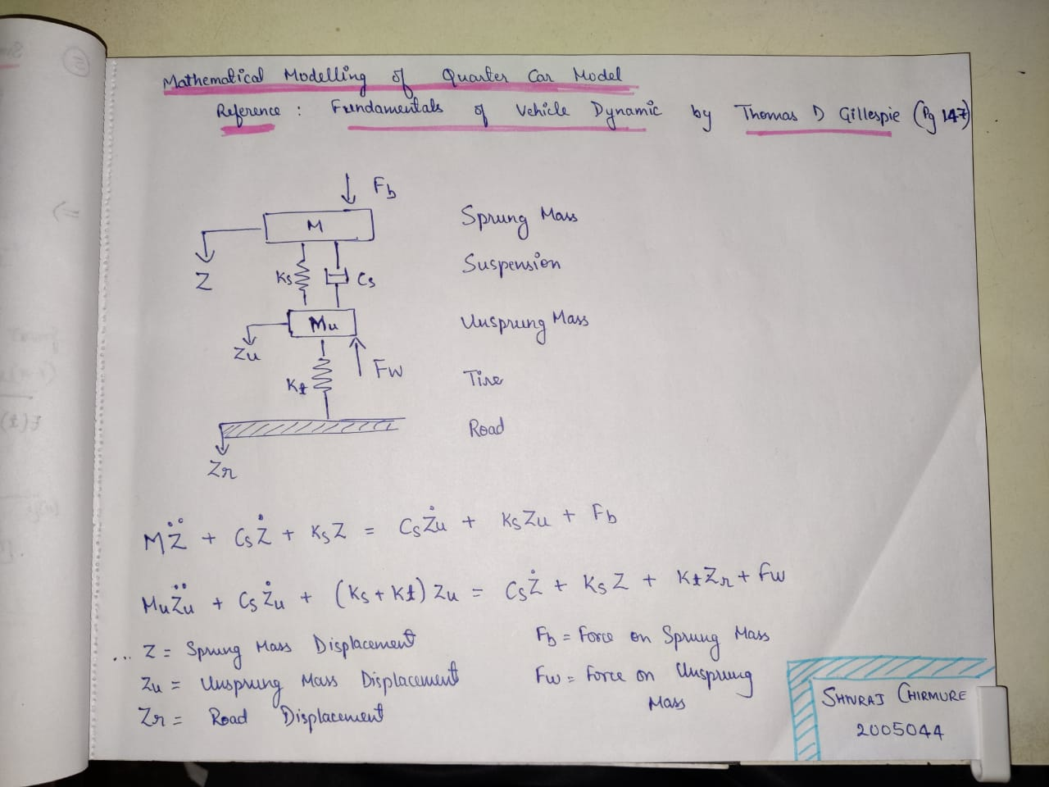

**SIMULINK MODEL:**

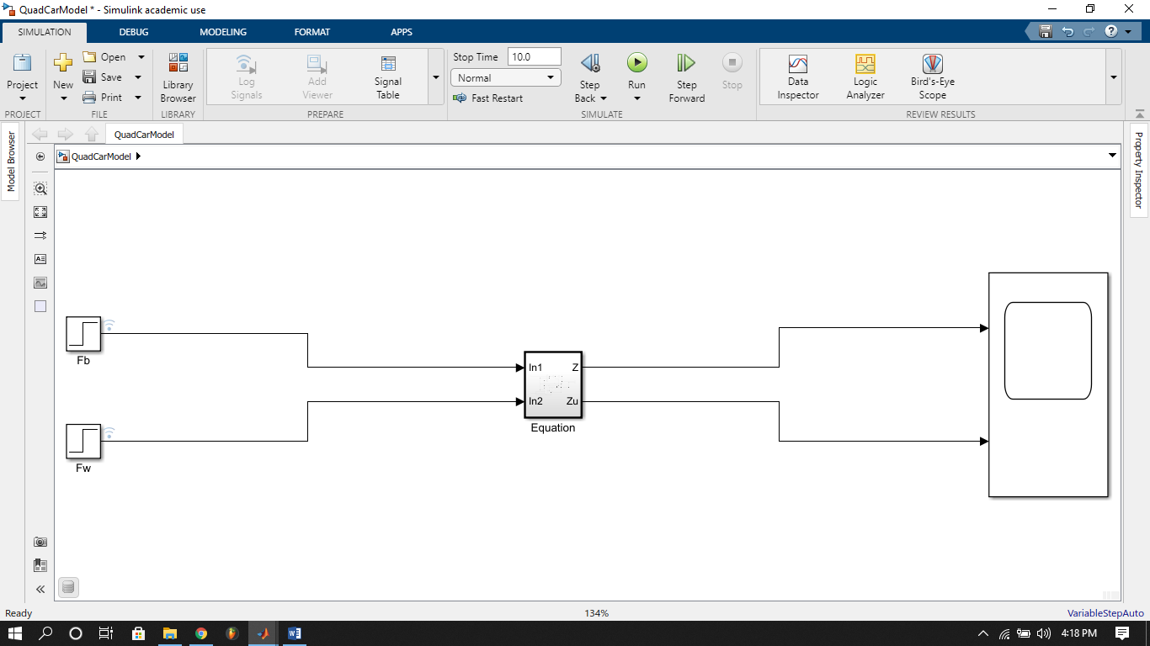

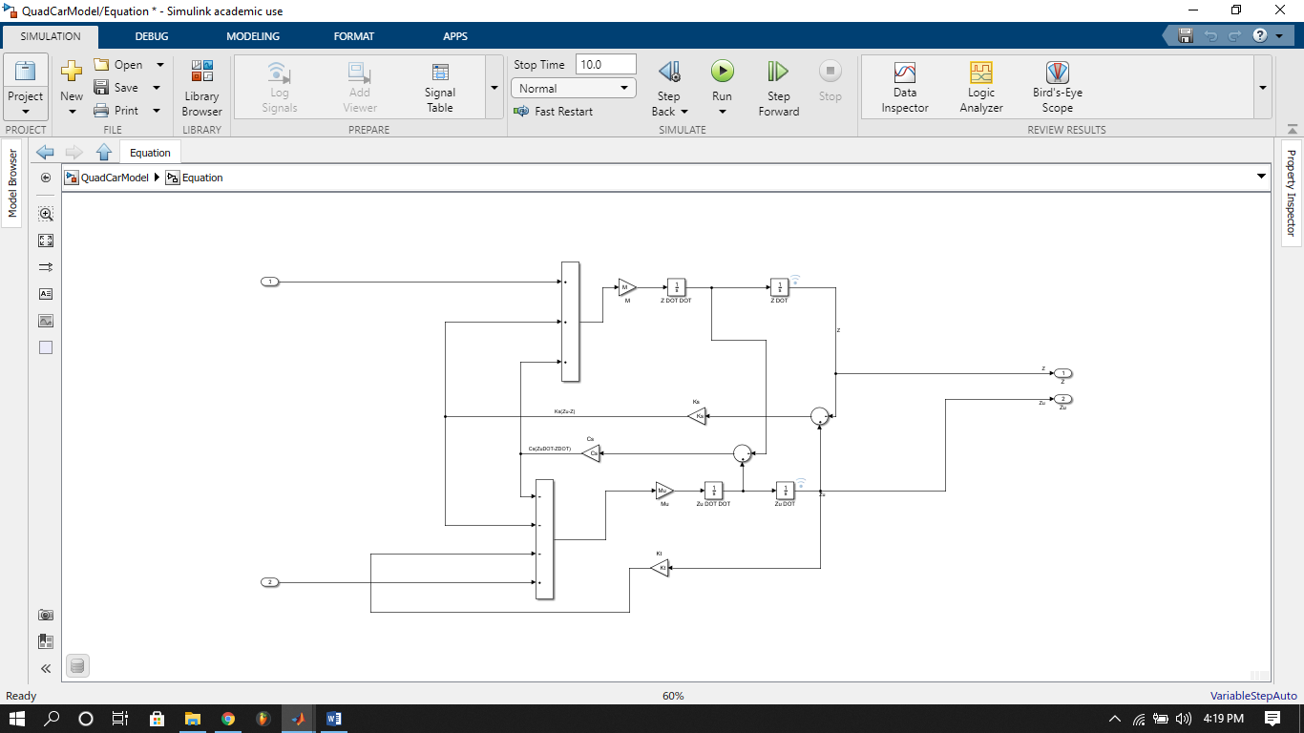

**DATA DICTIONARY (QuadVariables.sldd)**

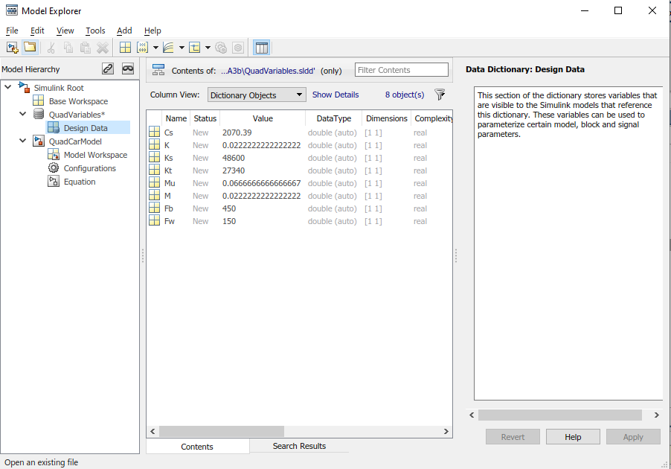\

**REFERNCE VALUES:**

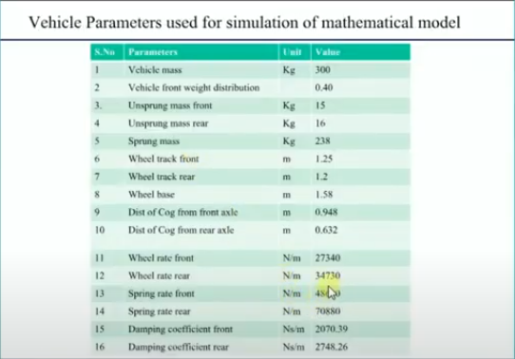

**OUTPUT:**

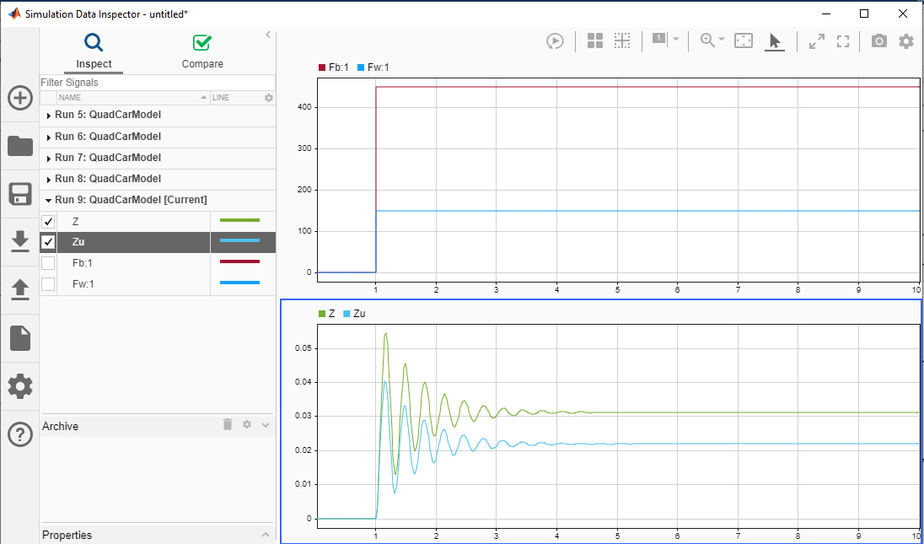

**CONCLUSION:**

The System output gets damped within 3 seconds