Digital Literacy Portfolio – Task 2

1. Overview
In today’s digital world, having a professional online presence is very important for students. As part of this task, I created profiles on GitHub, LinkedIn, and Kaggle to start building my digital identity and prepare for future academic and career opportunities.

2. Platforms Selected

GitHub
- Purpose: Code hosting and project portfolio
- Use: Uploading projects and showcasing my work

Kaggle
- Purpose: Data science and machine learning practice
- Use: Exploring datasets and improving analytical skills

LinkedIn
- Purpose: Professional networking
- Use: Connecting with students and professionals

3. Profile Highlights

GitHub Profile Snapshot
- Profile overview
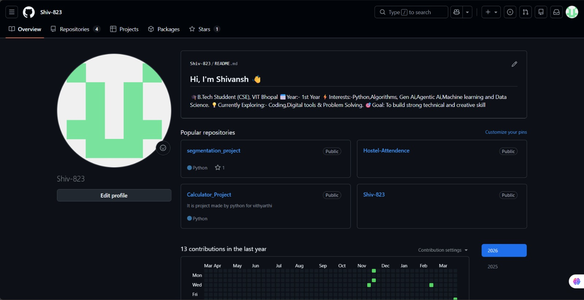

- Repository section
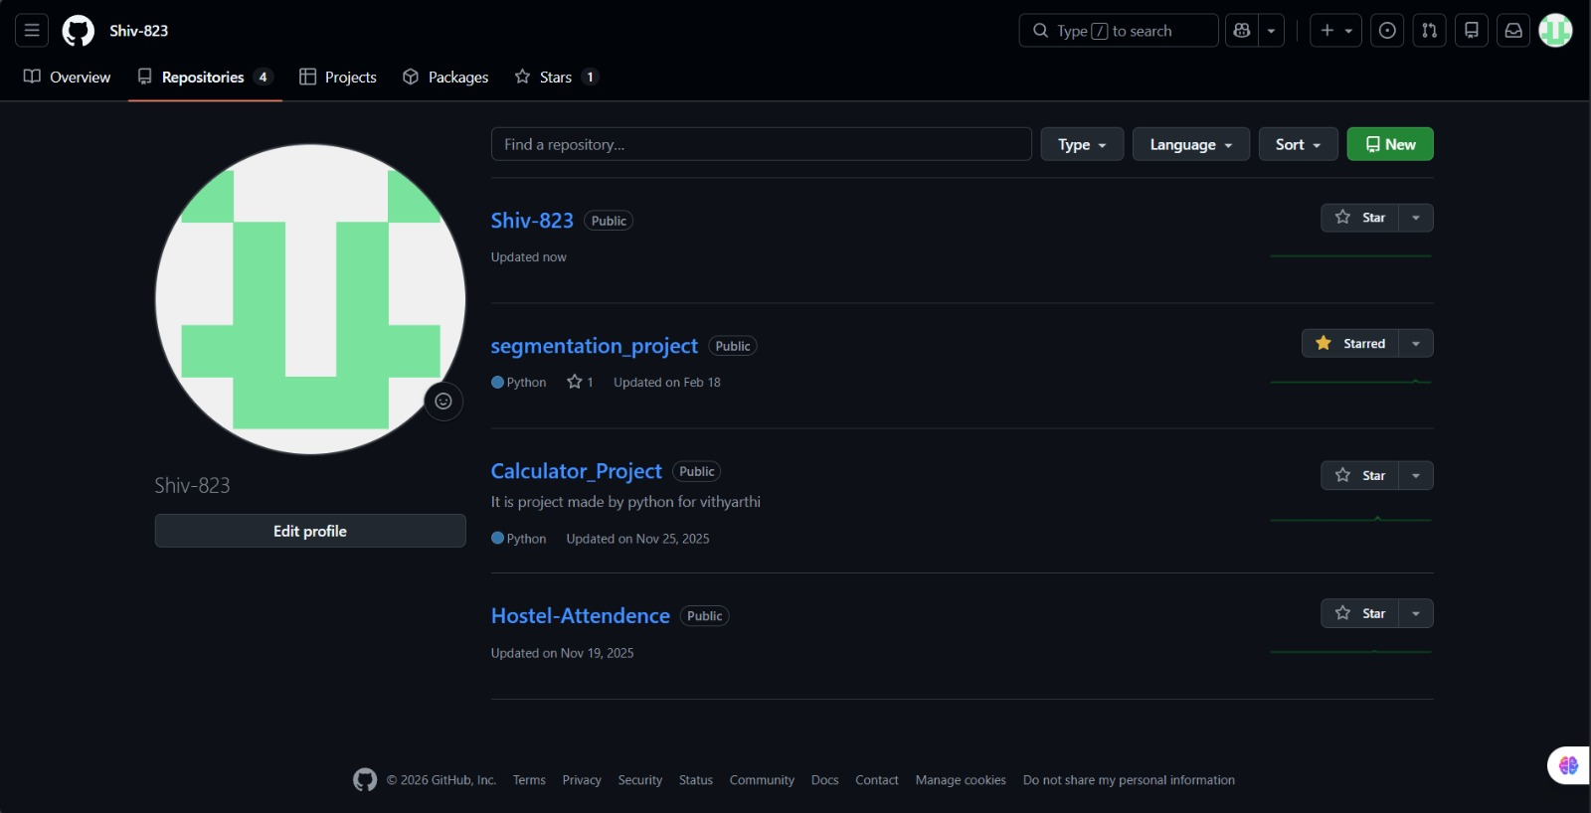
- Profile README
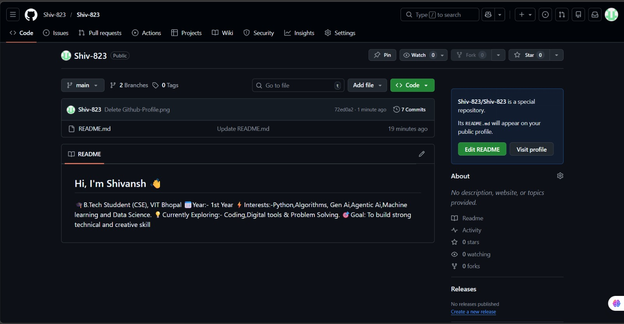

Kaggle Snapshot
- Basic profile setup
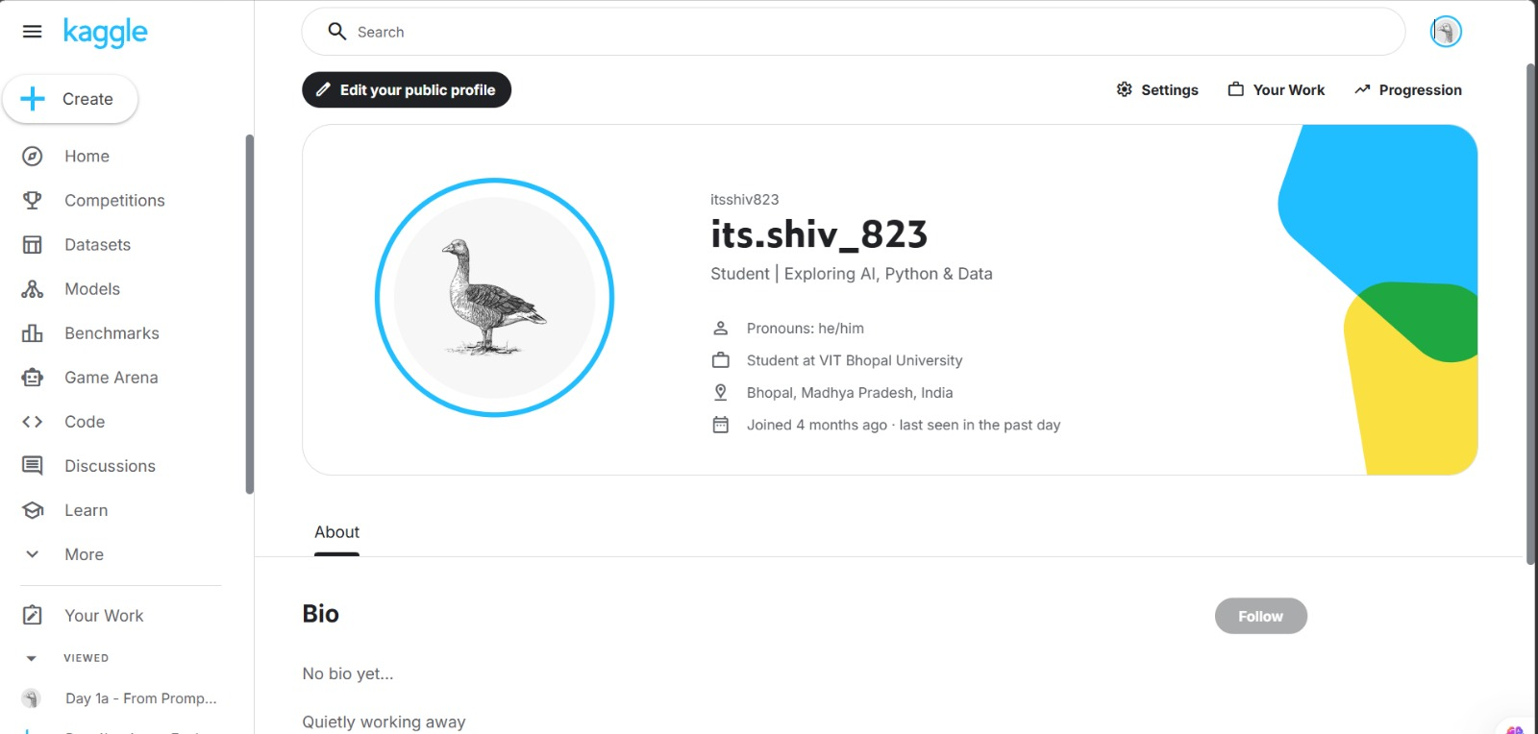

LinkedIn Snapshot
- Profile overview and education section
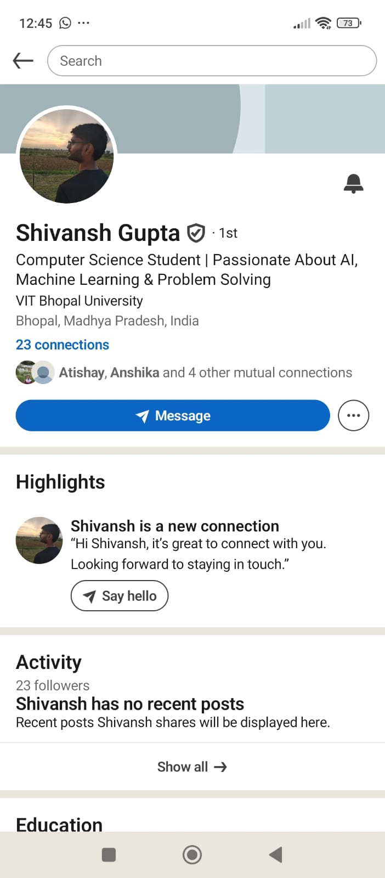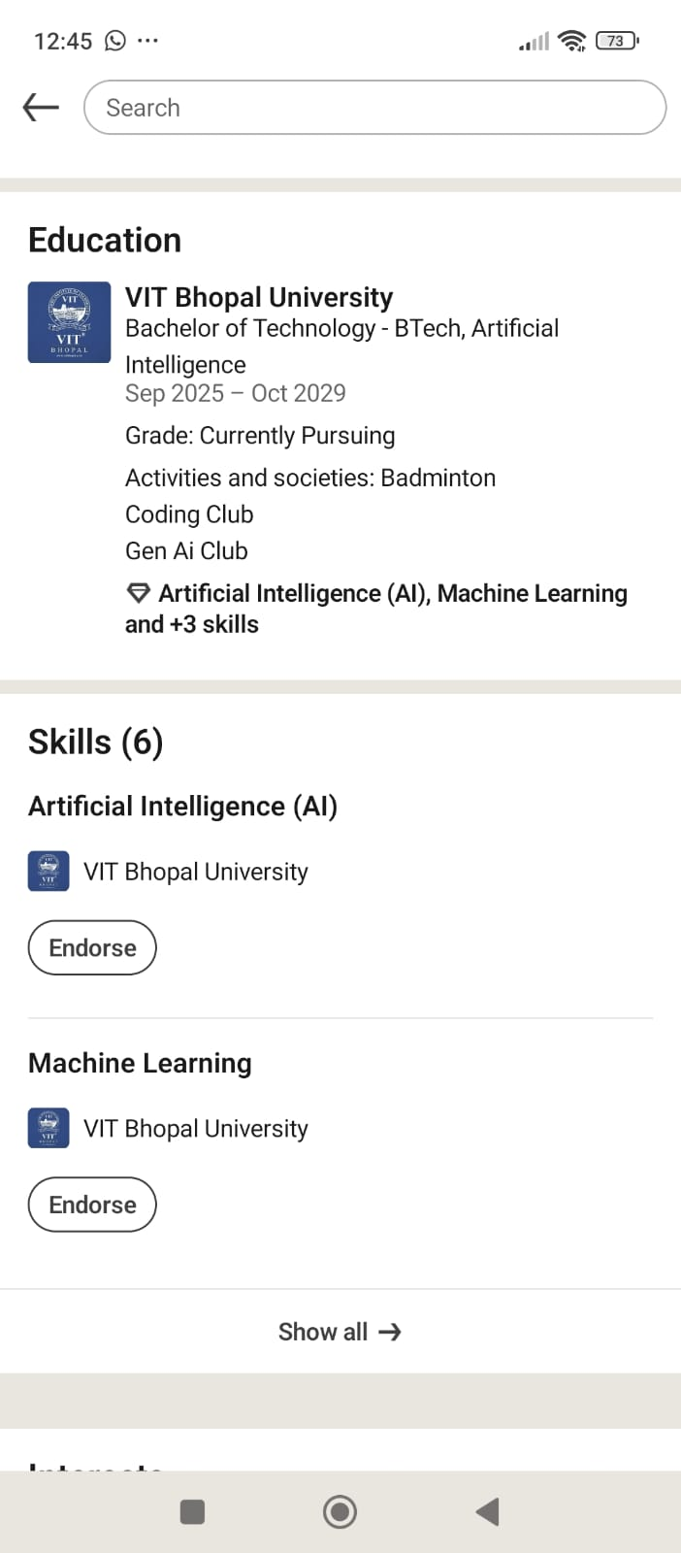

4. Reflection & Learning
For my digital portfolio, I chose GitHub, LinkedIn, and Kaggle because they are widely used platforms for students in the tech field. GitHub helps me store my code and build a project portfolio, while LinkedIn allows me to create a professional identity and connect with others. Kaggle is useful for learning data science and practising real-world problems.
While creating these profiles, I understood how important it is to maintain a professional presence online. It is not just about creating accounts, but also about keeping them updated and meaningful.
Over the next four years, I plan to regularly upload projects on GitHub, grow my network on LinkedIn, and explore Kaggle to improve my skills. These platforms will help me prepare for internships and future career opportunities.

5. Future Roadmap
Year | Focus Area | Platform Use
1st Year | Basics (Python, Git) | GitHub uploads
2nd Year | Projects | Kaggle practice
3rd Year | Internships | LinkedIn networking
4th Year | Placement Preparation | All platforms

