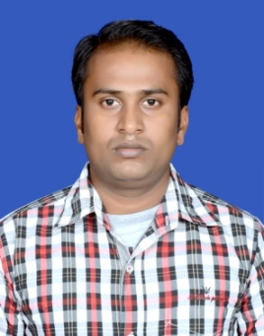**Resume**

**Shiv Kumar**

+91 90311 27789

[E-mail -Kumarshiv9031127789@gmail.com](mailto:E-mail-Kumarshiv9031127789@gmail.com)

**GitHub profile:** [**https://github.com/Shiv-9031**](https://github.com/Shiv-9031)

**OBJECTIVE**

* **To work with an organization where can learn new skills and increase my abilities**

**for the organizational goals as well as myself.**

**EDUCATION QUALIFICATION**

* **M.Sc (Physics) from Nalanda Open University.**
* **B.Sc (Physics Hons.) from Vinoba Bhave University.**

**OTHER ACADEMICS DETAILS**

* **Completed Project on Machine-Learning.**
* **Complete Project on Web-Development.**

**TECHNICAL SKILLS**

* **JAVASCRIPT, REACT-JS, Node-JS,**
* **PYTHON,SQL**

**WORK EXPERIENCE**

**Fresher**

**STENGTH & HOBBIES**

* **Hard Working and Punctual.**
* **Eager to Learn New Skill.**
* **Good Communication Skill.**
* **Reading Books, Exercise and Programming.**

**PERSONAL DETAILS**

**Father’s Name : Dinesh Pandit**

**D.O.B : 22-12-1992**

**Address : Yaduvansh Nagar, Landmark-Laxminarayan complex,**

**Chas, Bokaro - 827013**

**Marital status : Single**