**Title Of Your Project – ERD Model**

**Your Name – Shiva Chembeti**

**Your Github URL - https://github.com/Shiv-Lewis/Project_3**

**Current Date – 11/09/2022**

**ERD using UML – Physical model**

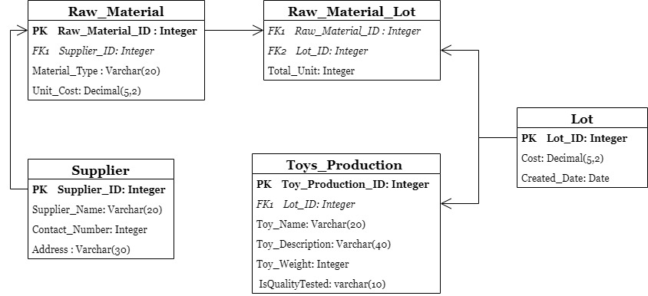

The above diagram is for retail toy industry in UML ERD by using the physical model. Basically, the physical model converts the entities into tables and relationships into foreign keys. The attributes of the entities are converted into the columns of the table.

**ERD using Crow’s Foot notation – Logical model**

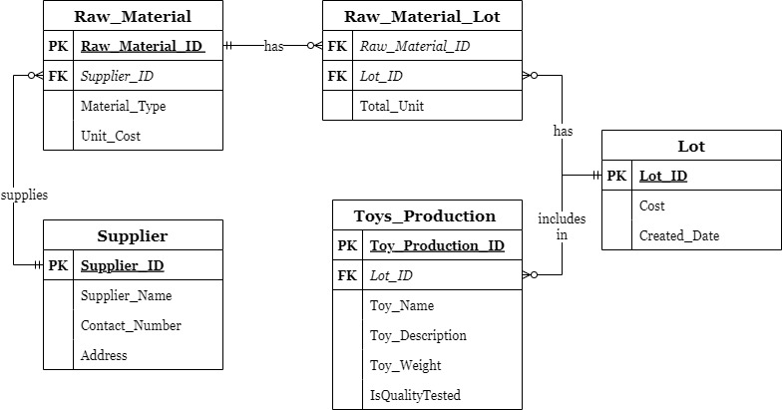

The above diagram is for retail toy industry in UML Crow’s foot notation by using the logical model. The logical model is about specifying the entities primary key and, in this model, only we can find the relationships between the entities. In this model, the many-to-many relationship is resolved.

**Relationship**

The relationship between the entities Supplier and Raw_Material is one to many. The Raw_Material depends on 1 to many Suppliers. i.e., the toy production requires raw materials and thus, it can be collected from same supplier or it can be obtained from different suppliers.

The relationship between the Lot and Raw_Material_Lot is one to many and same for Raw_Material and Raw_Material_Lot. The Raw_Material_Lot depends on 1 or more Lot. The Raw_Material_Lot depends on 1 or many Raw_Material.

The relationship between the Lot and Toys_Production is one to many which means the Toys_Production depends on 1 to many Lots. By using the foreign key Lot_ID, the Toys_Production and Lot entities can be linked.