**Title Of Your Project – Data Manipulation Language Scripts**

**Name – Shiva Chembeti**

**Git Hub Link-https:** **https://github.com/Shiv-Lewis/Week3-Project4-b.git**

**Current Data- 11/17/2022**

1. **Insert one**

Select * from Lot;

Insert into Lot values(6,187.50,'2021-05-17');

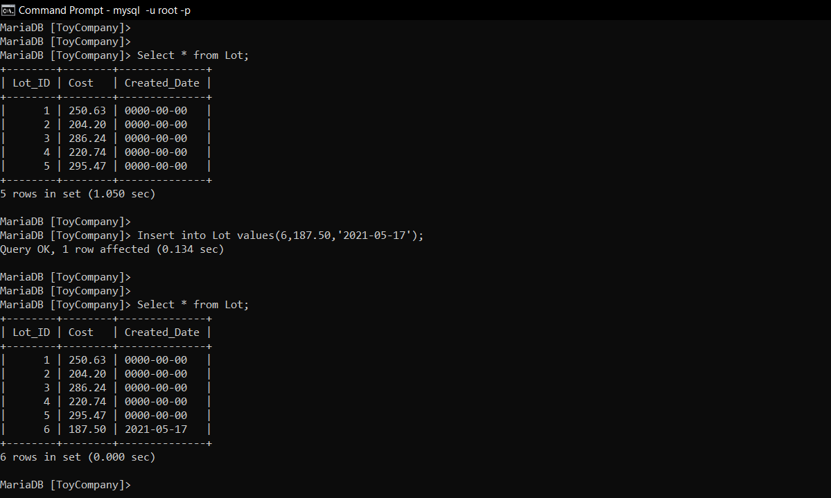

**Insert two**

Select * from Supplier;

Insert into Supplier values(4785,'BBCW distributors',7030455528,'75 Ilchester Road');

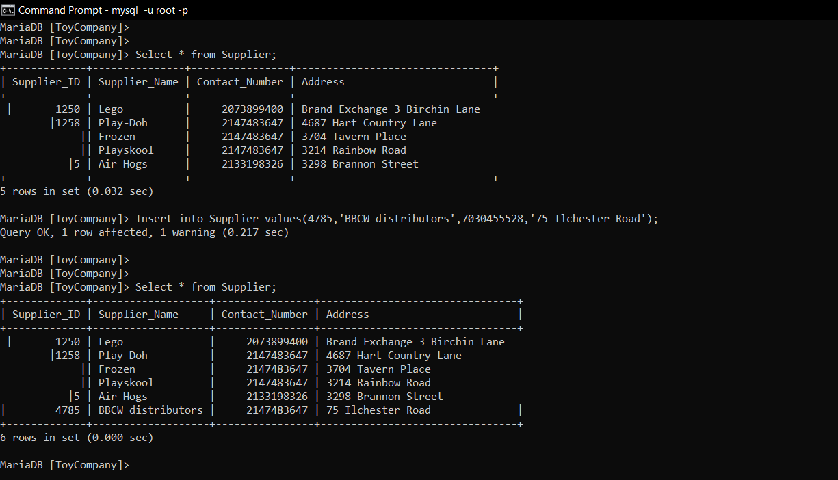

1. **Update one**

Select * from Raw_Material;

update Raw_Material

set Unit_Cost = 140

where Raw_Material_ID = 103;

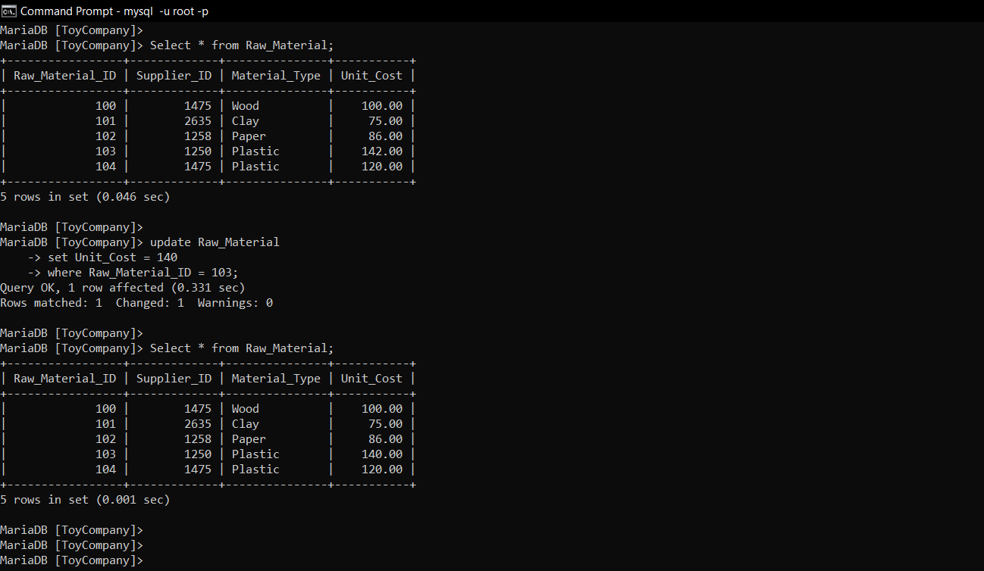

**Update two**

Select * from Supplier;

update Supplier

set Contact_Number = 793692942

where Supplier_ID = 1250;

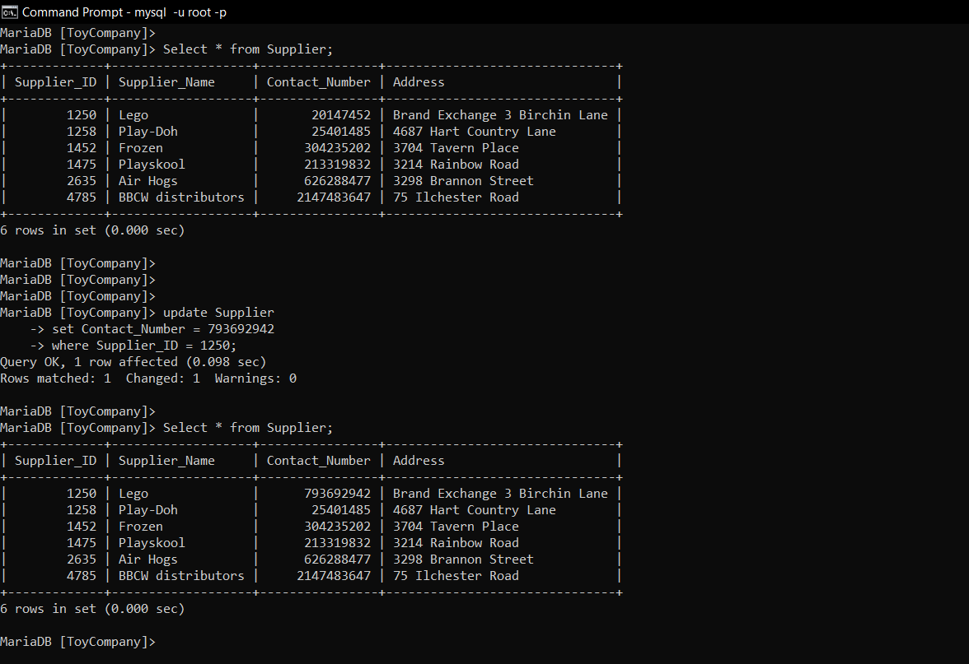

1. **Delete**

Select * from Raw_Material_Lot;

Delete from Raw_Material_Lot

where Lot_ID = 4;

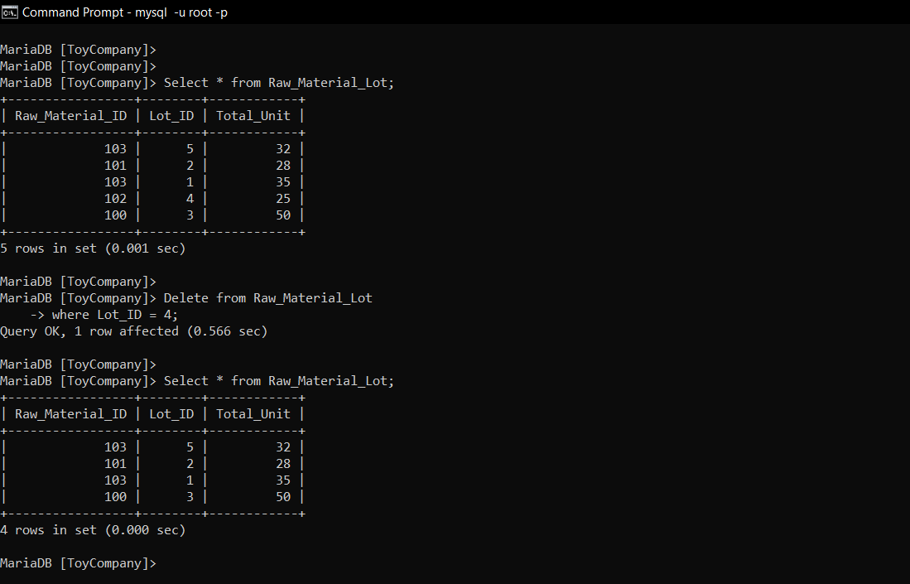

1. **Select**

Select Supplier_ID, Supplier_Name, Contact_Number, Address

from Supplier;

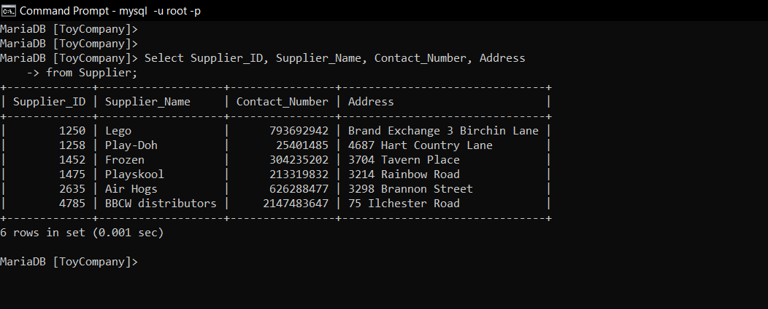

1. **Select one**

Select l.Lot_ID, l.Cost, tp.Toy_Name, tp.Toy_description

from Lot l inner join Toys_Production tp

on l.Lot_ID = tp.Lot_ID;

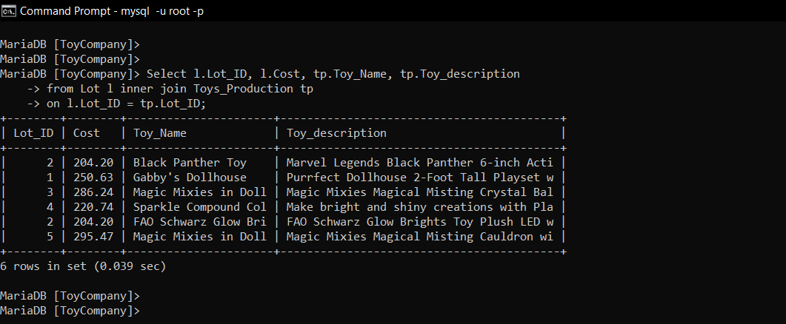

**Select two**

Select rm.Material_Type, rml.Total_Unit

from Raw_Material rm inner join Raw_Material_Lot rml

on rm.Raw_Material_ID = rml.Raw_Material_ID;

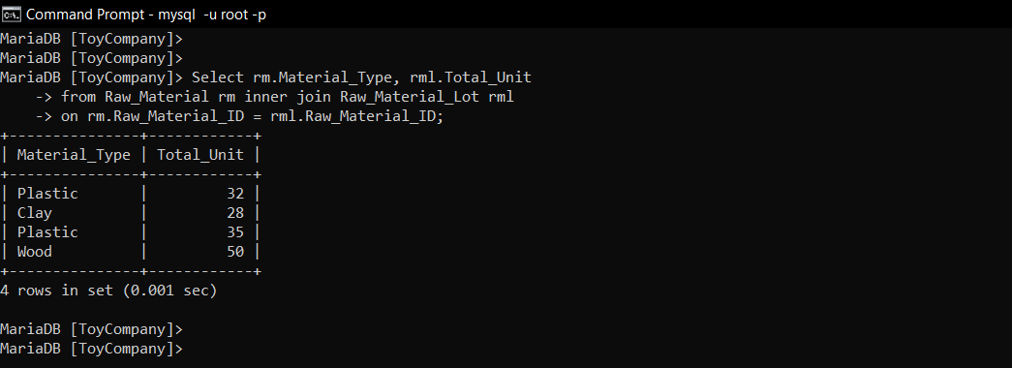

1. **Summary functions**

* **Count**

Select count(*) 'Count of raw material lot'

from Raw_Material_Lot;

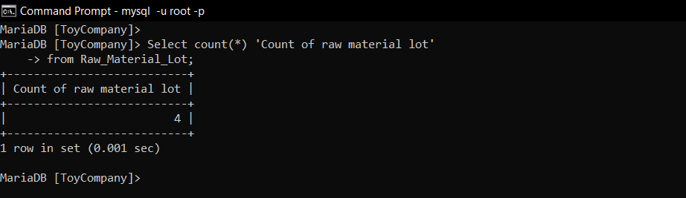

* **Min**

Select min(Unit_Cost) 'Minimum material unit cost'

from Raw_material;

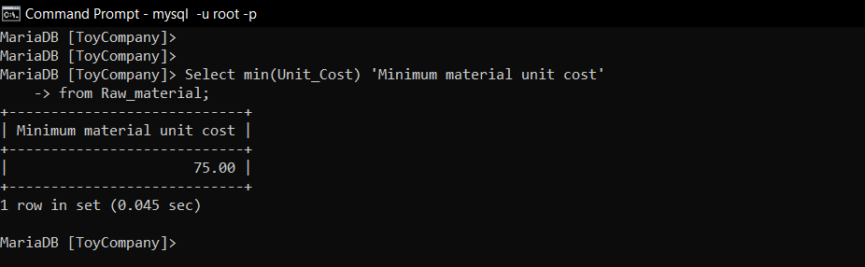

* **Sum**

Select sum(Cost) 'Sum of lot cost'

from Lot;

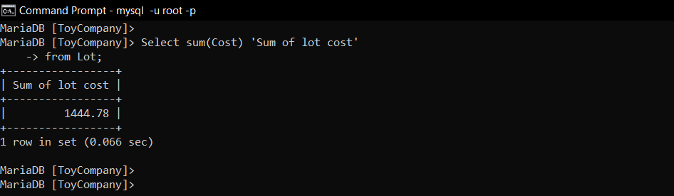

1. **Multi - tab query**

Select s.Supplier_Name, s.Contact_Number, rm.Material_Type, rm.Unit_Cost,

rml.Total_Unit

from Supplier s, Raw_Material rm, Raw_Material_Lot rml

where s.Supplier_ID = rm.Supplier_ID

and rm.Raw_Material_ID = rml.Raw_Material_ID

and rml.Total_Unit > 30;

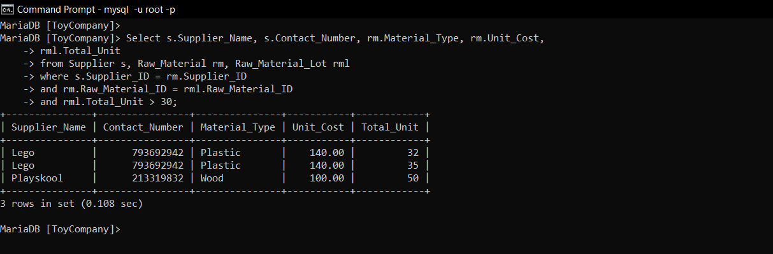

1. **Add ENUM**

desc Toys_Production;

alter table Toys_Production modify IsQualityTested ENUM('Yes','No') not null after Toy_Weight;

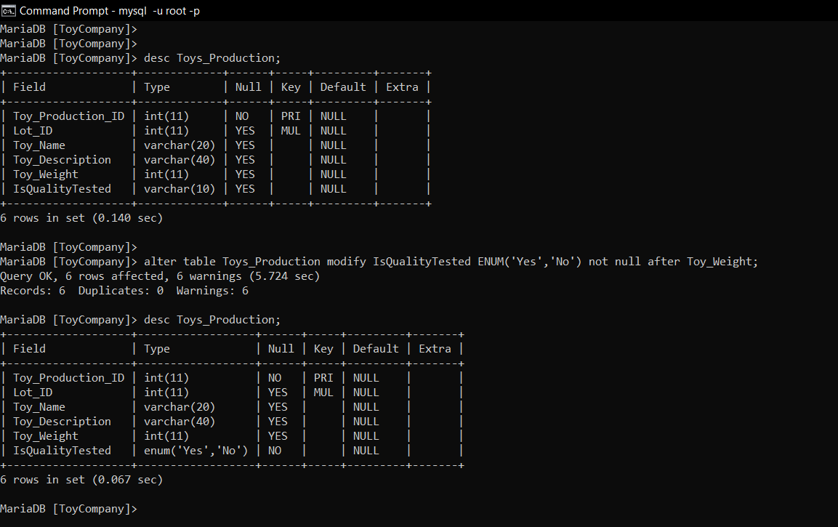

1. **Insert value in ENUM**

* **Null value**

Select * from Toys_Production;

Insert into Toys_Production values(7,2,'Green Toys','Colorful, durable, and earth-friendly toys','10 inches',);

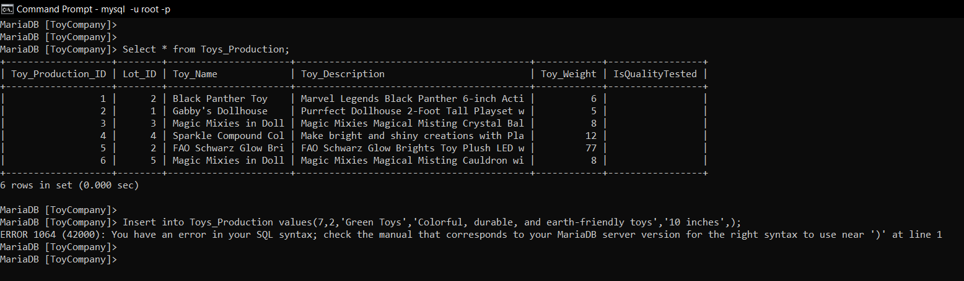

Select * from Toys_Production;

Insert into Toys_Production values(7,2,'Green Toys','Colorful, durable, and earth-friendly toys','10 inches','Yes');

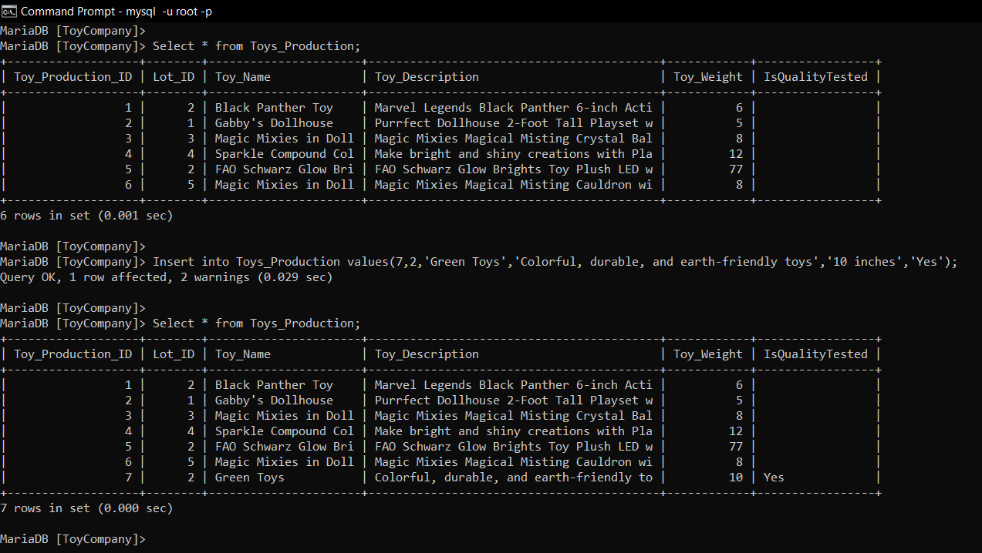

1. **Delete a value**

Select * from Toys_Production;

Delete from Toys_Production

where Toy_Production_ID = 7;

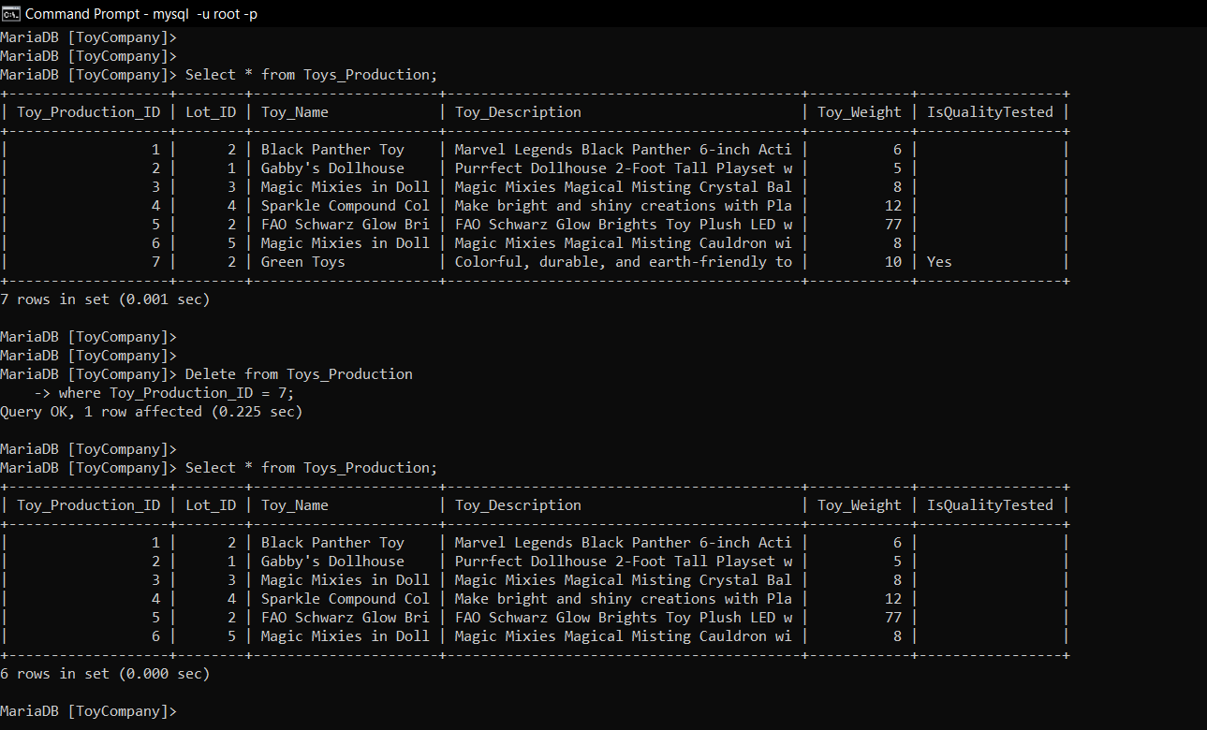

1. **AUTO_INCREMENT**

Select * from Toys_Production;

alter table Toys_Production modify Toy_Production_ID INT not null AUTO_INCREMENT;

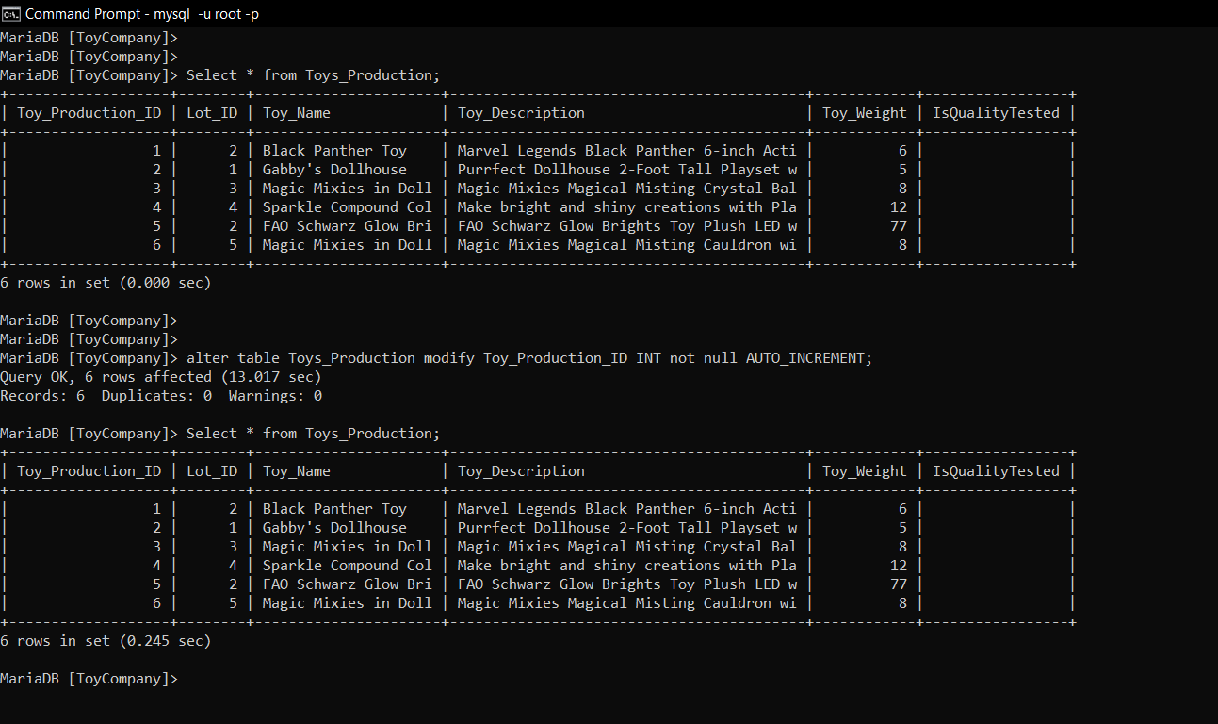

1. **Default**

Select * from Raw_Material;

alter table Raw_Material alter column Material_Type set default 0;

