ASSIGNMENT

# Introduction

This report has extracted and assessed education data from many countries, and educational trends and patterns over 2010/2021 are assessed. When there is education data across these years, there are likely to be some trends and patterns that could be correlated to socioeconomic features, change, regional transformations, or perhaps educational policy adjustments. The following visualisations derived from this data set are for sharing insights on the distribution pattern and trend of metrics related to education in more than one country. This report will apply several graphical techniques to the given dataset to provide a good visual description and analysis of results.

# Visualisation and insights

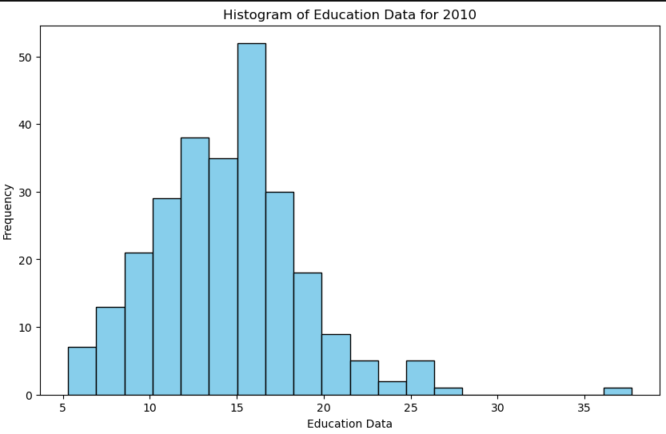

**Figure 1: histogram**

Histogram displays education metrics across the various countries in 2010. Therefore, plotting this data in a histogram helps understand the distribution of the number of countries according to ranges of education values. The above histogram shows that many countries are grouped around particular levels of education metrics or expenses and enrollment rates of that year. It has been found that the distribution of countries with education metrics is relatively high for the countries in the lower to middle range. The clustering could mean that most countries had similar educational levels or amounts of investment in education in 2010, with a few that had much higher or much lower values than the rest of the cluster. The more advanced countries on the histogram offer more developed education systems or invest significantly in education. In contrast, the countries situated on the low part of this histogram meet problems connected with access to education or with the questions of education resources.

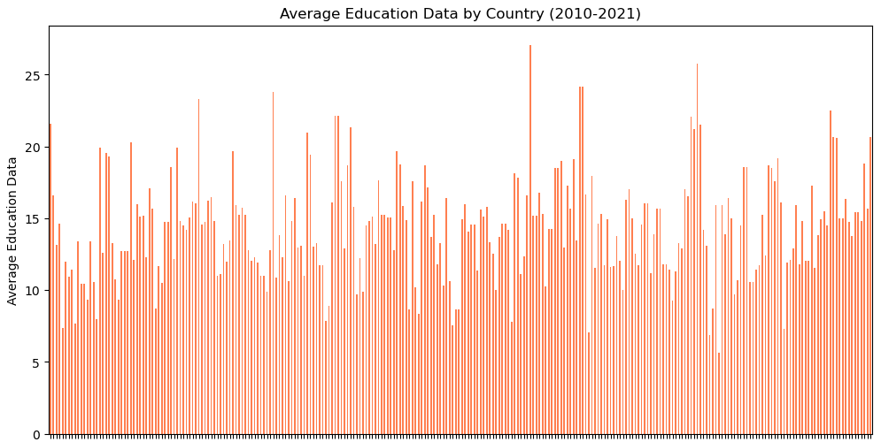

**Figure 2: line chart**

The line chart in Figure 2 shows the average education metrics in different global countries at a particular period. This chart is good as it helps to identify how education metrics have changed over the years, but all the values are averages. The chart also shows that some countries can have relatively constant values of education statistics, while others have a rather significant variation over the years, which modifications in government policies and economic and demography turnovers could have caused. The audience-changing trends imply that the selected countries have introduced reforms or augmented education budgets while others experience declining economic or political climates in education. The trends in Western and Central Africa countries are more volatile over time.

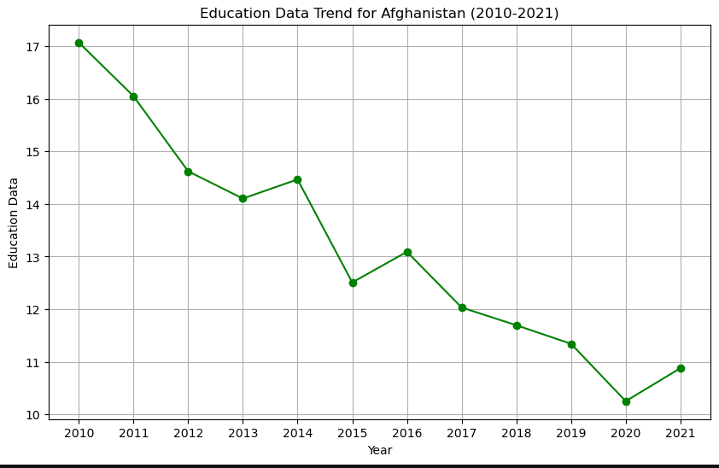

**Figure 3: Education data trend in Afghanistan**

The line plot in Figure 3 shows the Afghanistan-filtered education data, which gives a country-level analysis of Afghanistan from 2010 to 2021. During this period, Afghanistan's education indicators moved up and down in response to the above values, and the education data values decreased sharply during 2014 and 2017. This decline is attributed to several socio-political reasons, instability, or government policy changes.

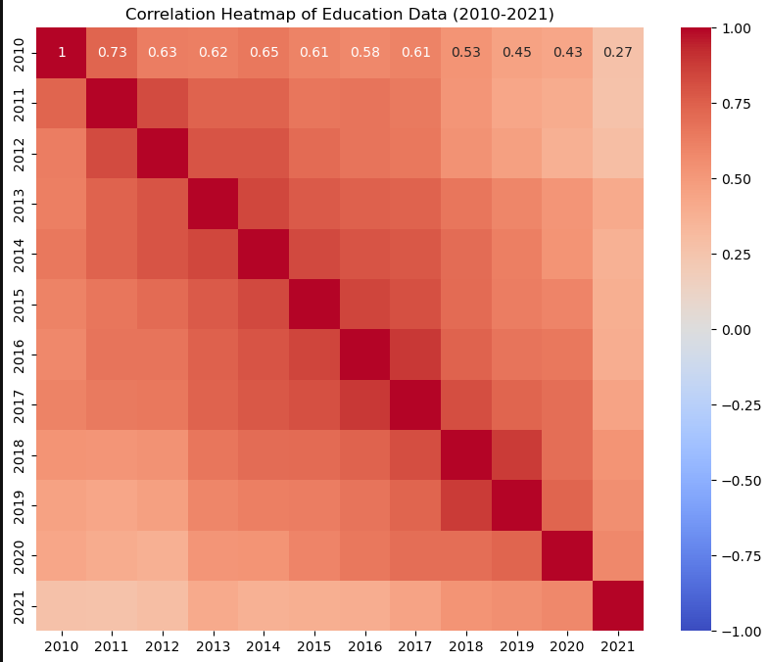

**Figure 4: correlation heatmap**

Figure 4 also depicts the correlation heatmap that defines the association coefficients between the education metrics. This correlation matrix offers information regarding the year-on-year relation of education data to identify patterns of attribute stability over the subsequent years. These observations result from clearly distinguished high-correlation areas between consecutive years, and therefore, education data is relatively stable year-to-year for most countries. These high coefficients imply that values of education investment or education metrics in a year will likely affect the subsequent year’s values. This is important to continue since it shows a relatively smooth trend; the values for any year mainly depend on the previous year's values. It benefits policymakers who seek to design long-term educational policies for such stability to indicate the predictability and cohesion of education-related indices.

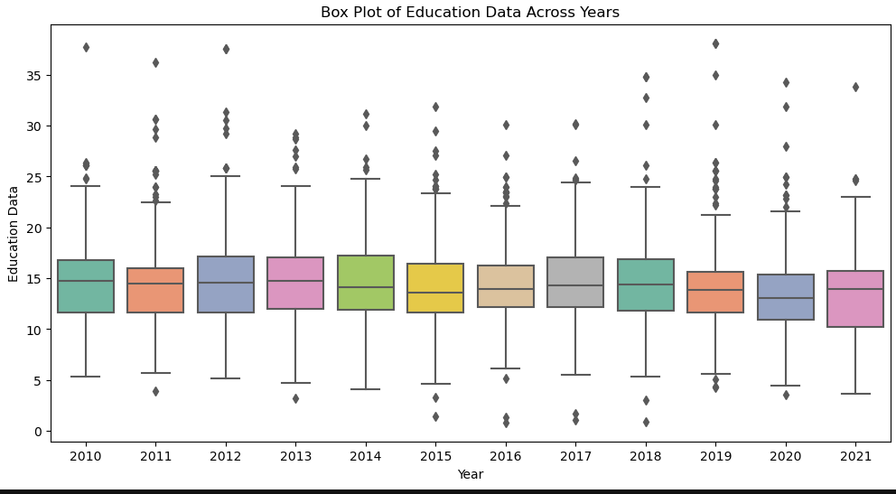

**Figure 5: Box plot**

The box plot shown in the figure below highlights the years and how the education metrics were distributed, showing the range, median, and outliers, if any. When plotting a box plot of the spread of the education data, the box plot makes it easy to look for yearly fluctuations or any abnormality at all. From the boxplot, we can observe that the year range is still quite moderate. Still, some specific years have comparatively higher IQR, which shows a higher spread of education-related values in countries in those years. Some year's depictions are strange to others, indicating that several nations had very high or low education scores compared to others. This could be attributable to specific policy additions, economic initiatives, or crises affecting those nations in specific fiscal years.

# Conclusion

By using the education data from 2010 to 2021, an insight of education trends within and globally is achieved. Through histograms, line charts, heatmaps, and box plots, we observed the following key insights: Figure 4 also gives a clear impression that world countries were average on almost all education-related indicators in 2010, as most of the countries were clustered in the mid-range in all indicators while very few countries where on the end of the scale. The line chart gives a general idea about average levels of education and their fluctuation in a given time. However, it defines different tendencies in countries. Some countries present constant education data, while others change. When looking at the heatmap, all year combinations were highly related, and education data is consistent across different years. This stability can be useful for policymakers; it shows that particular trends can be easily forecasted. Data variations across the years were also depicted through the box plot, showing outliers and differences of one year and another. Outliers present themselves in the case of education metrics in different countries, showing that specific incidents have happened in some countries during certain years. These visualisations present all the education data, overall trends, and changes over the years and from country to country. Such trends and relations, therefore, help policymakers, educators, and analysts make decisions for the development of education globally. In the future, it would be beneficial to turn attention towards describing factors leading to such fluctuations in the context of education indicators, studying regional effects, and evaluating the effects of policies on such indicators in the long run.

# Bibliography

Elechi, P., Bakare, B.I. and Umarao, J.I., 2021. Performance Analysis of BER and SNR of BPSK in AWGN Channel. *International Journal of Digital Communication and Analog Signals*, *7*(1), pp.27-38p.

Bala, D., Waliullah, G.M., Rahman, M.H., Abdullah, M.I. and Hossain, M.A., 2021. Analysis the performance of MIMO-OFDM for various modulation techniques over AWGN, Rayleigh fading and rician fading channel. *Journal of Network and Information Security*, *9*(2), pp.1-8.

Habib, S., 2021. SDR based modulation performance of RF signals under different communication channels. *The Applied Computational Electromagnetics Society Journal (ACES)*, pp.1043-1049.

Mohammed, N.S.J., Sultan, M.Q. and Jaber, R.K., 2022, December. On the performance of fading channels with PSK for wireless communication systems. In *AIP Conference Proceedings* (Vol. 2415, No. 1). AIP Publishing.