PENETRATION TESTING REPORT
Footprinting, OSINT and Network Discovery — Week 2

Field | Details
Student | Shiv Kumar Das
Program / Batch | Networkwalks Internship — BO83
Date | 18 September 2026
Modules | PM1, PM2, PM3, PM4 and PM5
Authorized targets | networkwalks.com (written permission stated); own virtual LAN 192.168.122.0/24

Testing was limited to explicitly authorized systems and passive public-source research. No exploitation was performed.

1. Liability, Authorization and Ethics
All activities documented in this report were performed for education and research. Active reconnaissance was limited to networkwalks.com under the permission stated by the student and to the student’s own virtual LAN. No exploitation, password testing, authentication bypass, persistence, or destructive activity was performed.
For the camera-related GHDB exercise, public indexing was not treated as authorization. One potentially accessible WebcamXP listing was observed; interaction stopped immediately. The camera was not controlled, authenticated to, recorded, or included as a live target. Ten third-party cameras were not validated because written authorization from their owners was unavailable. This limitation follows professional ethical-testing practice.

2. Executive Summary
This Week 2 project covered reconnaissance, open-source intelligence and local network discovery. PM1 used WHOIS, WhatWeb, Nslookup, Curl, Wafw00f and DNSRecon against the authorized Networkwalks domain. PM2 demonstrated Google search operators for educational PDFs and reviewed camera-exposure methodology with strict ethical limits. PM3 used Maltego to identify a public organizational email address. PM4 used theHarvester against microsoft.com as specified by the assignment. PM5 replaced Zenmap with its command-line engine, Nmap, to discover hosts on the student’s own virtual LAN.
The work identified publicly visible infrastructure and technology information, but these observations are not proof of exploitable vulnerabilities. The most important learning outcome was that accessible or indexed information does not remove the need for authorization, careful evidence handling and responsible disclosure.

3. Scope and Limitations
Area | In scope | Limitations
PM1 | Authorized public-facing networkwalks.com reconnaissance | No exploitation or intrusive vulnerability testing
PM2 | Google/GHDB methodology and educational PDF discovery | No continued access or validation of third-party cameras; identifying device data excluded
PM3 | Public email transforms for networkwalks.com | Community Edition and search-engine data limitations
PM4 | Passive theHarvester queries for microsoft.com | Many sources required API keys; source behavior changes over time
PM5 | Host discovery on 192.168.122.0/24 | Virtual LAN only; -sn host discovery, no port scan

4. Tools Used
Tool | Purpose
Kali Linux | Testing workstation
WHOIS | Domain registration and nameserver information
WhatWeb | Web-technology fingerprinting
Nslookup | DNS name resolution
Curl -I | HTTP response headers
Wafw00f | WAF identification
DNSRecon | DNS record enumeration
Google/GHDB | Search-operator-based OSINT
Maltego Graph 4.13.0 | Entity and public email relationship mapping
theHarvester 4.11.1 | Passive host, IP and email collection
Nmap 7.99 | Local host discovery using -sn

5. PM1 — Footprinting with Multiple Kali Tools

5.1 WHOIS
Command: whois networkwalks.com
Observation: GoDaddy.com, LLC was identified as registrar. The record showed creation on 6 November 2019, expiry on 6 November 2027, privacy-protected registration, and HostGator nameservers.
Security relevance: This public information can support infrastructure profiling and defensive exposure review; it is not by itself a confirmed vulnerability.

5.2 WhatWeb
Command: whatweb networkwalks.com
Observation: The site redirected to HTTPS and exposed Apache, WordPress 7.1.1, WP Download Manager 3.3.58, Bootstrap, jQuery, HTML5, Google Tag Manager, Open Graph and IP 192.232.216.135.
Security relevance: This public information can support infrastructure profiling and defensive exposure review; it is not by itself a confirmed vulnerability.

5.3 Nslookup
Command: nslookup networkwalks.com
Observation: The domain resolved to 192.232.216.135 through the local resolver 192.168.122.1.
Security relevance: This public information can support infrastructure profiling and defensive exposure review; it is not by itself a confirmed vulnerability.

5.4 Curl
Command: curl -I https://networkwalks.com
Observation: The server returned HTTP/2 200. Headers identified Apache, a WordPress REST API link under /wp-json/, secure HttpOnly cookie attributes and cache-related headers.
Security relevance: This public information can support infrastructure profiling and defensive exposure review; it is not by itself a confirmed vulnerability.

5.5 Wafw00f
Command: wafw00f networkwalks.com
Observation: Wafw00f 2.4.2 identified ModSecurity (SpiderLabs) after two requests.
Security relevance: This public information can support infrastructure profiling and defensive exposure review; it is not by itself a confirmed vulnerability.

5.6 DNSRecon
Command: dnsrecon -d networkwalks.com
Observation: Enumeration found eight records, including SOA/NS, mail, A, TXT/SPF and autoconfiguration SRV information. A DNSSEC query returned no answer.
Security relevance: This public information can support infrastructure profiling and defensive exposure review; it is not by itself a confirmed vulnerability.
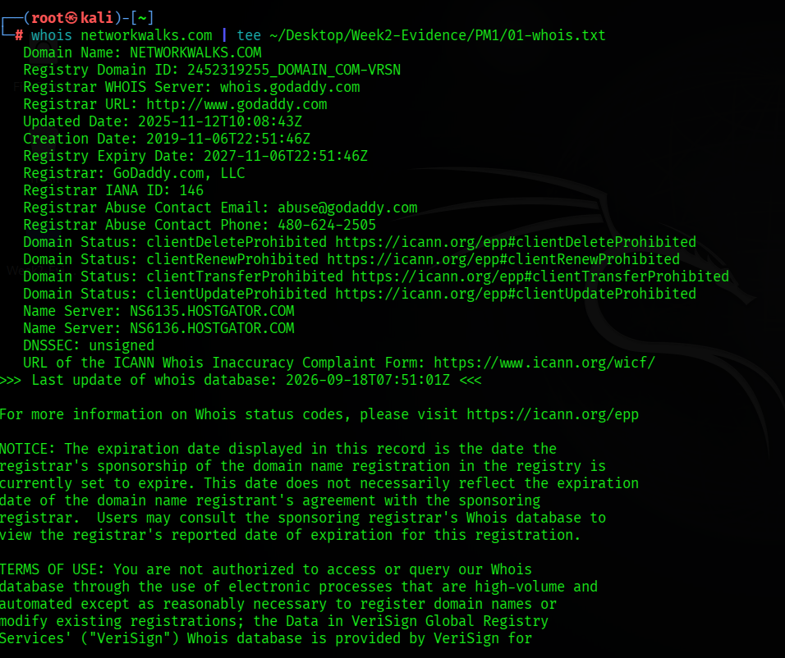
Figure 1 — WHOIS command and key registration data.
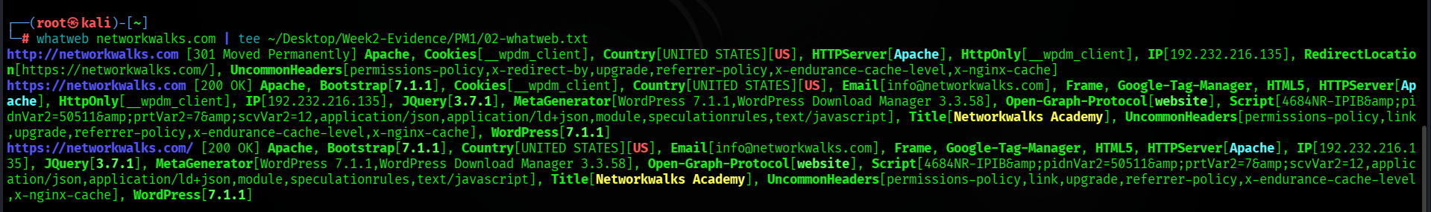
Figure 2 — WhatWeb technology fingerprint.
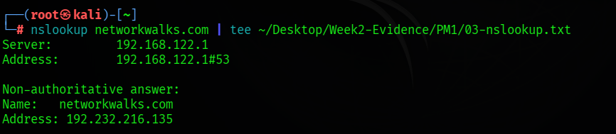
Figure 3 — DNS resolution result.
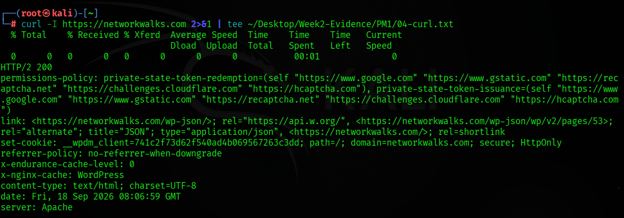
Figure 4 — HTTP response headers.
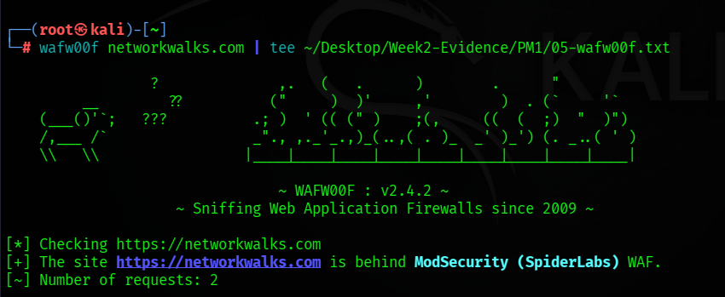
Figure 5 — ModSecurity WAF identification.
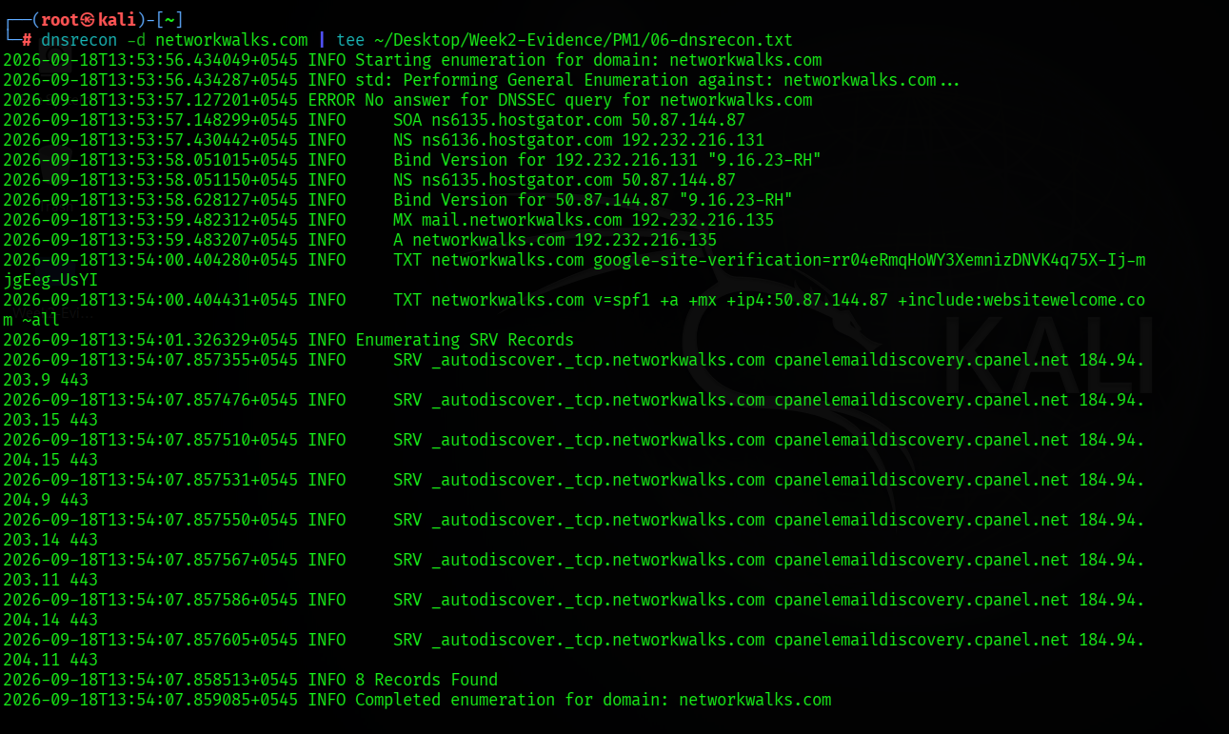
Figure 6 — DNSRecon record enumeration.

6. PM2 — GHDB and Search-Based OSINT

6.1 Mathematics PDF listings
Google query used: filetype:pdf mathematics site:edu
No. | Listing title | Institution/domain
1 | Everything You Always Wanted To Know About Mathematics | Carnegie Mellon University — math.cmu.edu
2 | The History of Mathematics: An Introduction | University of Illinois — illinois.edu
3 | Mathematics Is Not Science | Stanford University — stanford.edu
4 | Mathematics 1 | Phillips Exeter Academy — exeter.edu
5 | Introduction to Computational Mathematics | UC Davis — ucdavis.edu
6 | Mathematics | Wichita State University — wichita.edu
7 | Exploring Practical Applications and Real-World Impact | UNM Digital Repository — unm.edu
8 | Mathematics | Karunya University — karunya.edu
9 | Conceptual and Procedural Knowledge of Mathematics | University of Wisconsin–Madison — wisc.edu
10 | Mathematics for Computer Science | MIT OpenCourseWare — mit.edu
The table records search listings only. Files were not redistributed in the repository, and availability or licensing should be checked with each host before reuse.

Figure 7 — Educational mathematics PDF search results.

Figure 8 — Additional institutional PDF listings.

6.2 Camera-related GHDB methodology and ethical limitation
Assignment-provided example dork: intitle:"webcamXP" inurl:8080
Google returned a potentially exposed WebcamXP listing. Shodan aggregate results also demonstrated that device-search engines can index internet-facing services. Public indexing, however, does not authorize viewing or controlling a camera. Further validation stopped, identifying details were excluded, and the requirement for ten live third-party camera links was not executed without owner authorization.
Requested item | Documented outcome
Ten live camera links | Not collected or published without individual owner authorization
Dork methodology | Demonstrated using the assignment-provided WebcamXP query
Credentials | None tested, collected or reported
Recommended safe substitute | Instructor-controlled cameras, honeypots, or written authorization for ten lab targets

7. PM3 — Footprinting with Maltego
Maltego Graph Desktop 4.13.0 Community Edition was configured. A Domain entity was created and changed from the default maltego.com to networkwalks.com. The Utilities “To Email Addresses [Search Engine]” and “To Emails @domain [Search Engine]” transforms were run.
Result: one unique public organizational address, info@networkwalks.com, was returned. The second transform did not add a new unique address. Search-engine transforms can contain stale or incomplete results and should be verified through authorized channels.
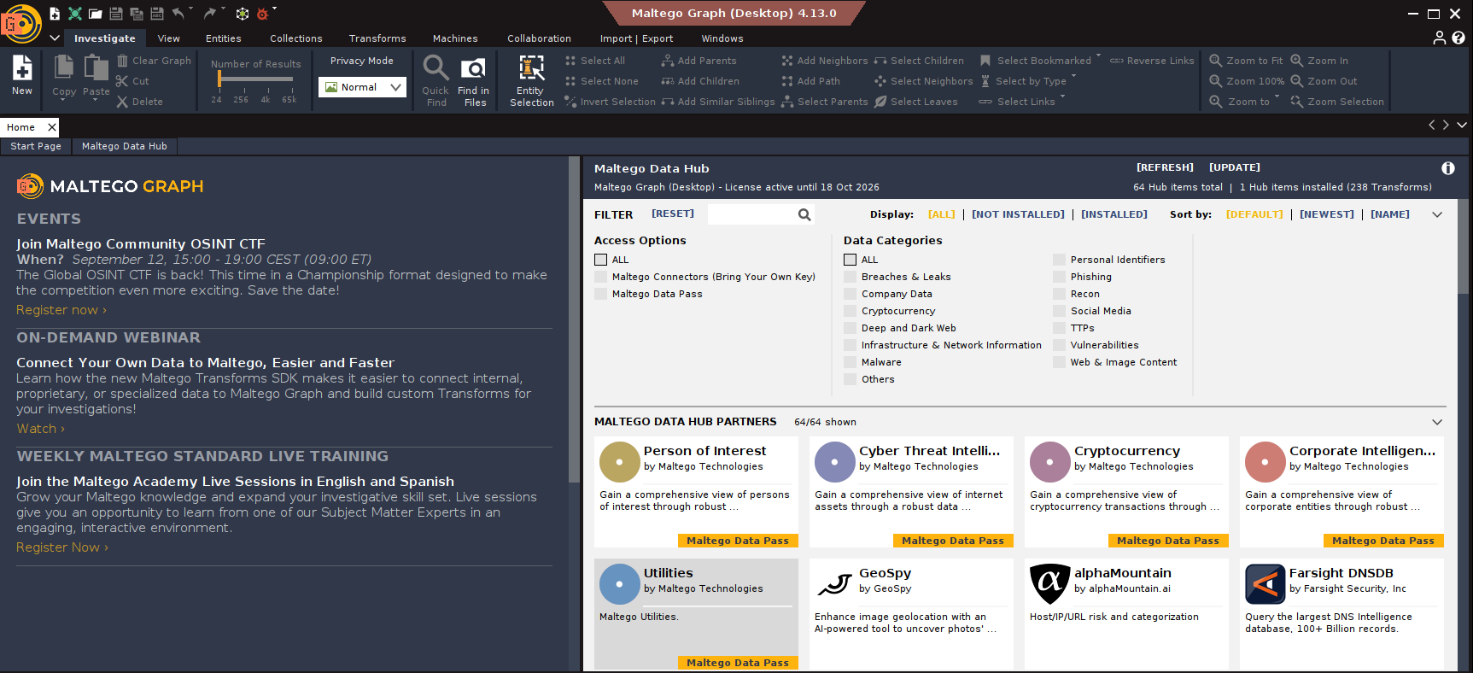
Figure 9 — Maltego installation and active workspace.
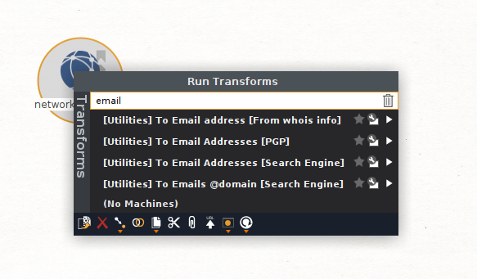
Figure 10 — Email-related transforms selected for the domain entity.
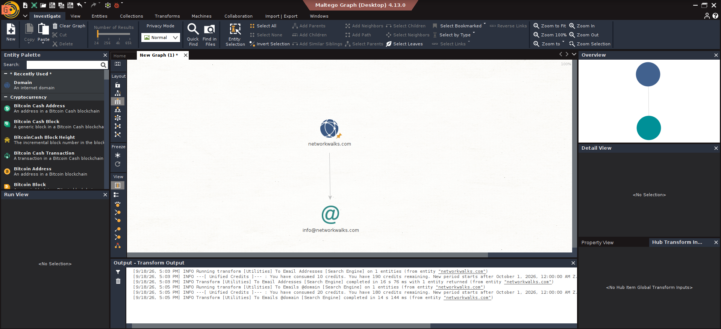
Figure 11 — Final Maltego graph and transform output.

8. PM4 — Footprinting with theHarvester

8.1 Baidu source, limit 1000
Command: theHarvester -d microsoft.com -l 1000 -b baidu
Result: theHarvester 4.11.1 completed the Baidu query but returned no IPs, emails, people or hosts. This was retained as an honest current result because third-party source behavior and parsers change over time.
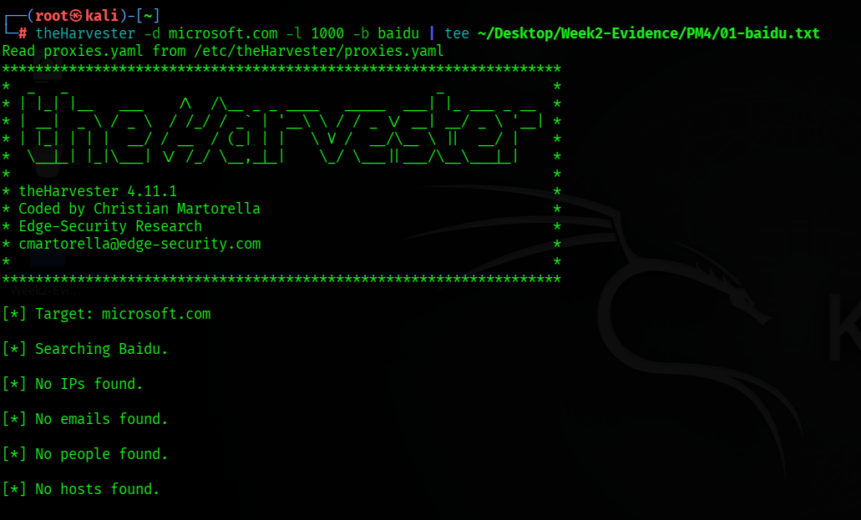
Figure 12 — Baidu-source query and zero-result outcome.

8.2 All sources, limit 50
Command: theHarvester -d microsoft.com -l 50 -b all
Result: the all-sources run attempted many providers. Several required API keys or returned provider-specific errors. Sources that did respond collectively reported 9 ASNs, 134 IP addresses, 3 email addresses, 9,964 hosts and one interesting URL. The limit applies to source searches and does not necessarily cap the final merged host list at fifty lines.
Because the raw host list is very large and may change, only representative screenshots are included; the full output is retained as private evidence. Public repositories should avoid publishing unnecessarily large target inventories.
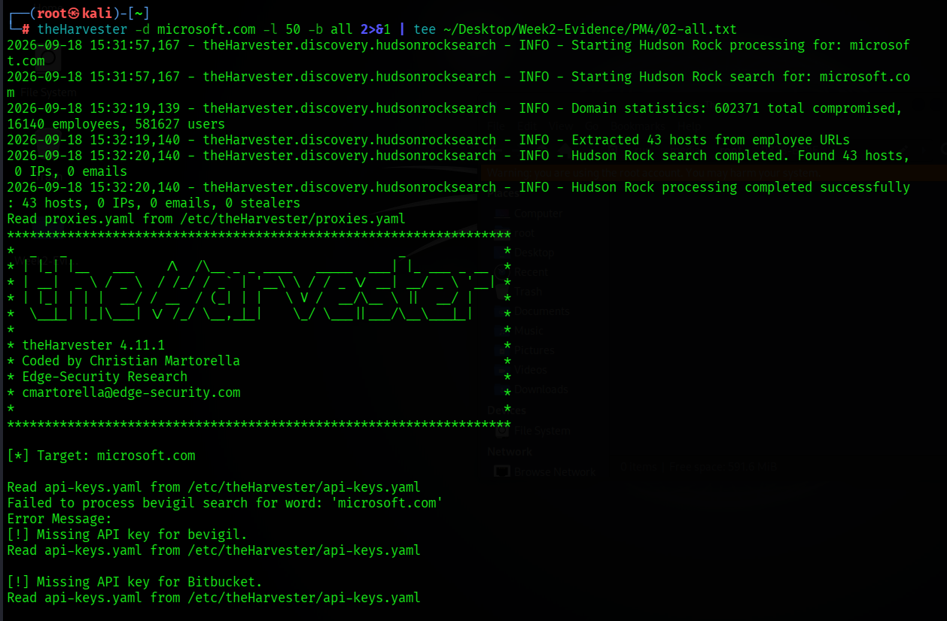
Figure 13 — Start of the all-sources query and source processing.
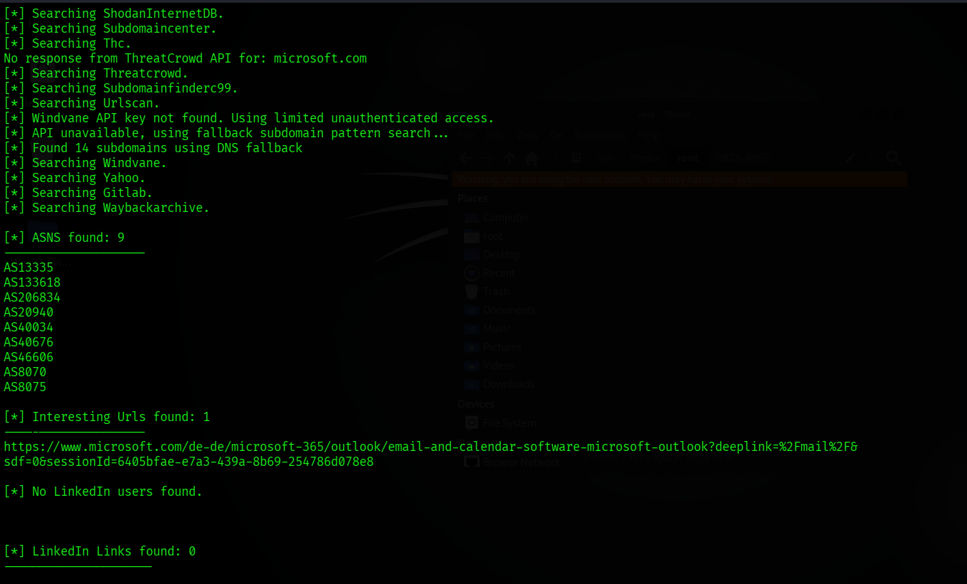
Figure 14 — Aggregate ASN and URL results.
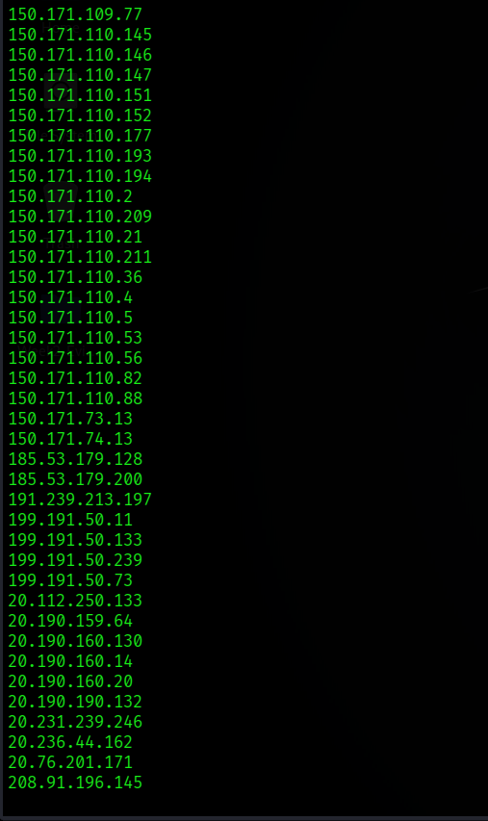
Figure 15 — Summary showing IP, email and host totals.

9. PM5 — Network Discovery with Nmap CLI
Zenmap is the graphical interface for Nmap. The CLI was used as an equivalent for Ping Scan and provides reproducible commands and machine-readable output.
Item | Result
Interface | eth0
Local IP | 192.168.122.235/24
Subnet | 192.168.122.0/24
Gateway | 192.168.122.1
Command | sudo nmap -sn 192.168.122.0/24
Hosts up | 2
Gateway MAC | 52:54:00:4E:56:E3 — QEMU Virtual NIC
Kali MAC | 52:54:00:B8:33:0A
The -sn option performed host discovery only. No port scan, service-version scan or vulnerability script was run.
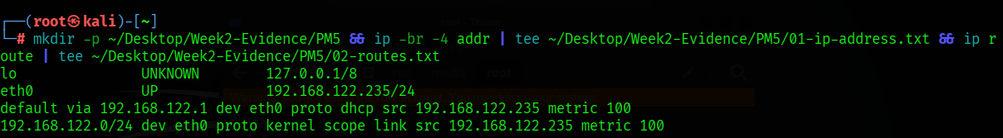
Figure 16 — Local IPv4 address and routing table.
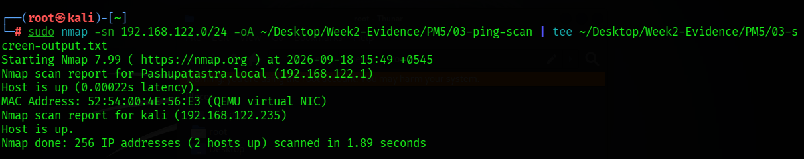
Figure 17 — Nmap host-discovery result.
Figure 18 — Kali interface MAC address.
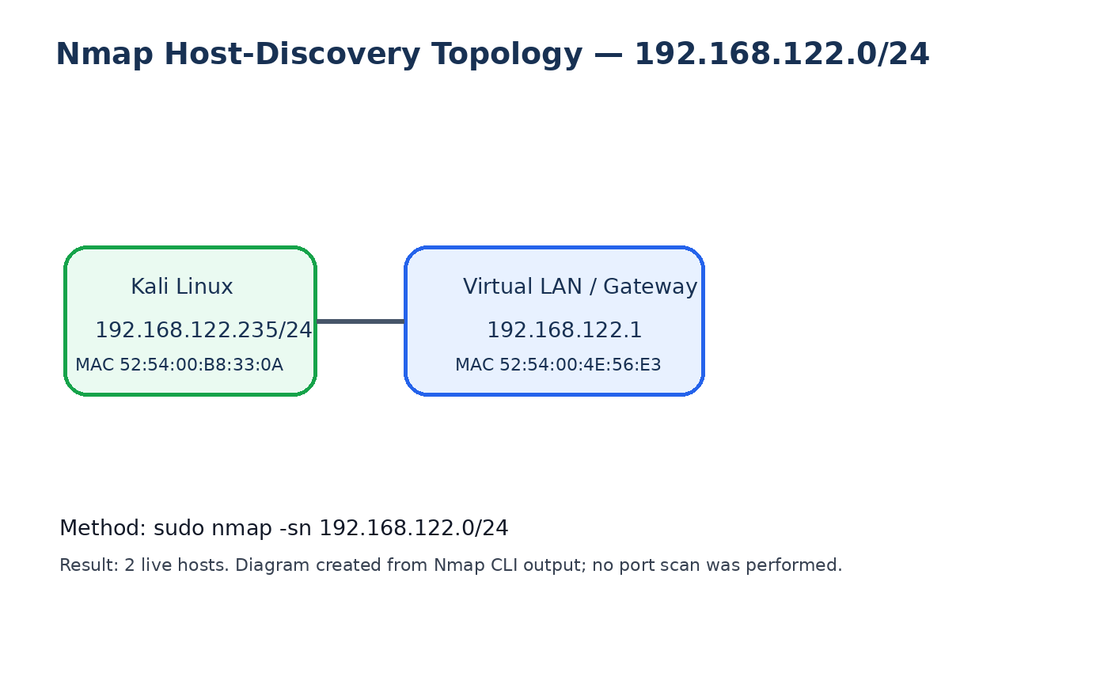
Figure 19 — Topology generated from Nmap CLI discovery output.

10. Risk Analysis
Finding | Potential impact | Level
Public CMS/plugin fingerprints | Can help prioritize targeted security research; requires separate vulnerability validation | Medium
Resolvable server IP and DNS infrastructure | Supports infrastructure mapping | Low
HTTP headers and REST API links visible | Supports application fingerprinting and endpoint discovery | Low
WAF technology identifiable | Reveals a defensive technology but not its rules or bypassability | Low
Large public host inventory for major organizations | May expand the visible attack surface and complicate asset management | Medium
Internet-indexed camera interfaces | May create severe privacy and physical-security exposure if misconfigured | High
Two hosts visible on local virtual LAN | Expected here, but unknown devices should be investigated on managed networks | Low
Risk levels are educational assessments. No finding was exploited or independently confirmed as a vulnerability.

11. Recommendations
- Maintain current CMS and plugin versions and review exposure of version banners.
- Review HTTP headers and remove unnecessary technical disclosures while retaining useful security headers.
- Audit DNS records and decommission obsolete host and service records.
- Keep ModSecurity enabled, updated, tuned and monitored rather than relying on identification resistance.
- Maintain an accurate external asset inventory and review certificate-transparency-derived subdomains.
- Require authentication, network segmentation and VPN access for camera systems; never expose management interfaces directly to the internet.
- Perform authorized internal host discovery periodically and investigate unknown devices.
- Redact personal data, credentials, IP addresses and MAC addresses from public repositories when disclosure is unnecessary.
- Document written authorization, target scope, time window and permitted techniques before every assessment.

12. Conclusion
The project demonstrated how several tools contribute different pieces to a reconnaissance picture. PM1 identified domain, DNS, web technology, HTTP and WAF information. PM2 demonstrated targeted search operators and highlighted the legal difference between discoverability and authorization. PM3 mapped a public domain-to-email relationship. PM4 showed both the value and limitations of multi-source passive OSINT. PM5 used Nmap CLI to identify two live hosts on the student’s own virtual LAN and document their addresses in a simple topology.
The project did not include exploitation. Findings were treated as observations requiring authorization and further validation. The strongest practical lesson was that ethical scope, accurate reporting and safe handling of evidence are as important as running the tools.

Appendix A — Evidence Inventory
Module | Evidence
PM1 | Six command outputs and screenshots
PM2 | Two mathematics search screenshots; camera methodology retained privately and excluded from public release
PM3 | Setup, entity, transform-menu and result screenshots
PM4 | Help, Baidu and all-sources outputs/screenshots
PM5 | IP/routing, Nmap XML/text, scan screenshot, MAC output and generated topology
End of report.

