Week 3 Project Report
Password Auditing with John the Ripper and Networkwalks Tools
Student: Shiv Das
Batch: BO83
Program: Networkwalks Internship
Date: 25 September 2026
Scope: Instructor-provided sample PDF only

1. Objective
The objective was to recover the password of the instructor-provided My Locked PDF1.pdf file using two approved lab methods:
- John the Ripper on Kali Linux.
- Networkwalks Hash Calculator and Password Cracker in a web browser.
The exercise demonstrates how weak passwords can be recovered through dictionary attacks and why stronger passwords are important.

2. Tools and files
- Kali Linux
- John the Ripper: /usr/sbin/john
- PDF hash converter: /usr/share/john/pdf2john.pl
- Kali wordlist: /usr/share/wordlists/rockyou.txt
- Networkwalks Password Cracker
- Instructor-provided My Locked PDF1.pdf
No real user accounts or third-party systems were targeted.

3. Module 1 — John the Ripper

3.1 Prepare the lab directory
mkdir -p ~/week3-lab/{evidence,hashes}
cp "$(find ~/Desktop ~/Downloads -iname 'My Locked PDF1.pdf' -print -quit)" ~/week3-lab/
cd ~/week3-lab

3.2 Confirm the PDF converter
find /usr/share/john -name "pdf2john*" 2>/dev/null
The converter was found at /usr/share/john/pdf2john.pl.

3.3 Extract the PDF hash
/usr/share/john/pdf2john.pl "My Locked PDF1.pdf" > hashes/pdf1.hash
cat hashes/pdf1.hash
The output contained a PDF hash beginning with $pdf$.

3.4 Prepare the wordlist
gunzip /usr/share/wordlists/rockyou.txt.gz

3.5 Run the dictionary attack
john --format=pdf --wordlist=/usr/share/wordlists/rockyou.txt hashes/pdf1.hash
John reported that one password hash was cracked. The public evidence below redacts the recovered password.
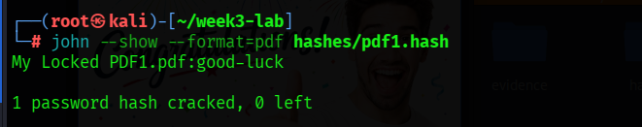
Figure 1. Redacted John the Ripper --show result.

3.6 Verify the recovered password
john --show --format=pdf hashes/pdf1.hash
The recovered password opened the PDF successfully in the document viewer. The course-lab flag is redacted in the public evidence.
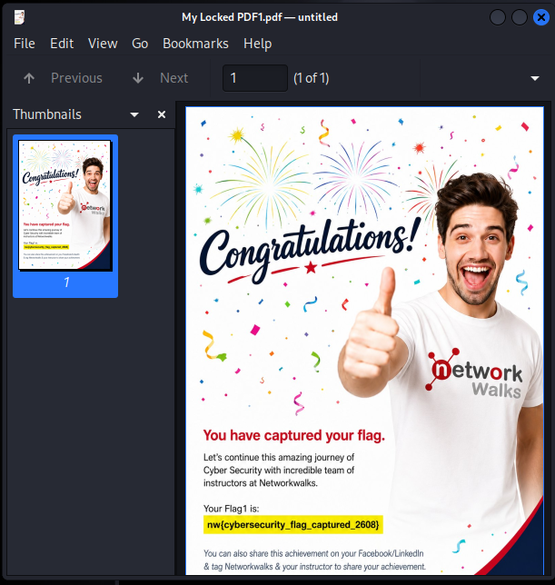
Figure 2. Redacted PDF opened successfully.

4. Module 2 — Networkwalks Tools
The Networkwalks Hash Calculator page available during testing displayed general MD5 and SHA hashes rather than the $pdf$ extractor described in the older handout. Therefore, the PDF hash already extracted with pdf2john.pl was used in the Networkwalks Password Cracker.

4.1 Open the password cracker
firefox https://networkwalks.com/password-cracker/

4.2 Test the built-in list
The built-in 100-password list was tested first. It completed without finding a match.

4.3 Use a small lab wordlist
The full rockyou.txt file caused the browser-based tool to become unresponsive because of its size. For a controlled demonstration of the web tool, a small lab wordlist was created.
printf "123456\npassword\ngood-luck\n" > ~/week3-lab/small-wordlist.txt
The file was uploaded through Upload wordlist (.txt), and the attack was started. The tool reported a successful match and displayed the same password that had been recovered with John the Ripper.
Transparency note: The small wordlist was used only to complete the browser-tool demonstration after the large upload became impractical. The independent password recovery was performed with John the Ripper and rockyou.txt.

4.4 Public evidence
The public screenshot below has the recovered password and full PDF hash redacted.
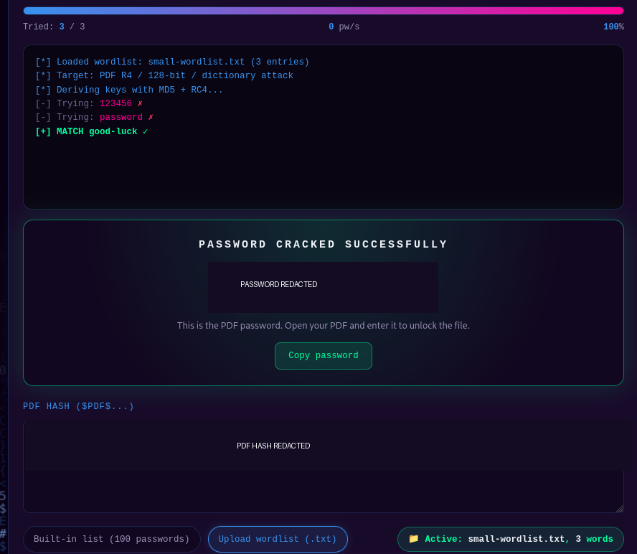
Figure 3. Redacted Networkwalks successful result.

5. Results summary
Module | Method | Result
PM1 | John the Ripper + rockyou.txt | Password recovered; PDF opened successfully
PM2 | Networkwalks Password Cracker | Password matched using the small lab wordlist

6. Security lessons learned
- Short or common passwords are vulnerable to dictionary attacks.
- Password hashes should not be treated as secret substitutes for strong passwords.
- Large wordlists can cause performance problems in browser-based tools.
- Strong passwords should be long, unique, and resistant to common-word guessing.
- Password auditing must only be performed with authorization.

7. Limitations
- The experiment targeted one instructor-provided PDF.
- Results depend on the contents and order of the wordlist.
- A failed dictionary attack does not prove that a password is secure.
- The Networkwalks web tool was tested only with the available browser interface and a small wordlist because the full wordlist caused browser lag.

8. Conclusion
Both required Week 3 lab modules were completed against the authorized sample PDF. John the Ripper recovered the password using a dictionary attack, and the Networkwalks tool independently demonstrated the matching-password workflow. The results show why weak, predictable passwords should not be used to protect sensitive files.

