PENETRATION TESTING REPORT
Mediroza General Hospital
Black-box Penetration Test and Vulnerability Assessment

Client | Mediroza General Hospital
Target | https://medirozahospital.com
Engagement Type | Black-box Penetration Test
Duration | 5 Days
Author | Shiv Kumar Das
Programme | NetworkWalks - Batch B083, Week 4
Report Date | 3 October 2026
Classification | CONFIDENTIAL - Authorised Personnel Only

This project is conducted in a controlled environment for educational purposes only.
Written authorisation for security testing was provided by NetworkWalks.

01 — Executive Summary
Mediroza General Hospital commissioned a black-box penetration test of its public web
infrastructure at https://medirozahospital.com. The engagement was conducted from the
perspective of an external attacker with no prior knowledge of the environment, and was
scoped to the hospital's web application and directly exposed server resources.
The assessment was **successful in achieving complete compromise of the confidentiality
objective**. In the course of a single working session, the tester:
- Bypassed the patient portal's authentication entirely using a SQL injection flaw,
gaining access to a restricted area of the site without any valid credentials.
- Retrieved three confidential patient pathology reports (S. Dlamini, P. Reddy and
E. Thompson), each of which was password-protected.
- Defeated the encryption on all three reports within seconds, recovering the full
medical contents of each.
- Identified a further critical exposure on the server — an unauthenticated database
backup — by analysing the hidden metadata of one of the recovered reports. This backup
contained the salaries of all 30 hospital employees and the **complete shareholder
register** of the hospital.

Overall Risk: CRITICAL
The combination of a trivially exploitable authentication bypass and an exposed database
backup means the hospital's most sensitive data — patient medical records, employee payroll
data, national identity numbers and corporate ownership structure — is effectively public.
An attacker with no specialist skill could reproduce the entire attack chain using freely
available tools in under an hour.
# | Finding | Severity
V-02 | Exposed Database Backup Containing PII, Payroll and Shareholder Data | Critical
V-03 | Weak / Predictable Passwords Protecting Encrypted Patient Reports | High
V-04 | Directory Listing Enabled on Multiple Server Paths | High
V-05 | Sensitive Information Disclosure via PDF Metadata | Medium

02 — Scope and Methodology

2.1 Scope
Item | Detail
Out of scope | Any system, domain or IP address not owned by the client
Prohibited | Social engineering, denial-of-service, and any destructive testing
Testing window | 5 days (all objectives achieved within the first day)

2.2 Methodology
The engagement followed a standard black-box penetration testing lifecycle, structured to
satisfy the four milestones defined in the assignment:
MILESTONE 1 MILESTONE 2 MILESTONE 3
Initial Access --> Data Extraction --> Attack (Cracking)
Recon, identify Crack encryption Analyse metadata,
entry point, gain on the 3 PDFs, trace to further
unauthorised access recover contents server exposure
| |
+------------------> MILESTONE 4 <---------------------+
Professional Report

Each phase was executed manually and deliberately, with evidence captured at every step to
support the final report.

2.3 Tools Used
Phase | Tool | Purpose
Reconnaissance | Browser / raw HTML review | Login form and input field analysis
Exploitation | curl (crafted POST) | Manual SQL injection authentication bypass
Analysis | qpdf --show-encryption | Identify PDF encryption scheme and parameters
Analysis | pdf2john | Extract password hash from encrypted PDFs
Cracking | pdfcrack | Dictionary attack against the extracted hashes
Cracking | rockyou.txt | Wordlist of ~14.3 million real-world leaked passwords
Decryption | qpdf --decrypt | Remove encryption using recovered passwords
Forensics | exiftool | Extract hidden document metadata
Extraction | sed, grep | Parse the recovered SQL backup into readable records

2.4 Limitations
- The engagement was time-boxed; deeper post-exploitation (e.g. attempting to reach the
database server itself) was not performed as it fell outside the agreed scope.
- No automated vulnerability scanner was used — all findings were confirmed manually and
reproducibly, which reduces false positives.
- john --format=PDF failed to load the extracted hashes on the tester's build (see
Section 3.2.4); pdfcrack was used as an equivalent and verified alternative. This is a
tooling limitation, not a finding against the client.

03 — Findings and Proof of Exploitation

3.1 Milestone 1 — Initial Access

3.1.1 Reconnaissance
The first step in any black-box test is to map the attack surface. The hospital's
robots.txt file — intended to instruct search engines which paths to ignore — disclosed
three directories that immediately became priority targets:
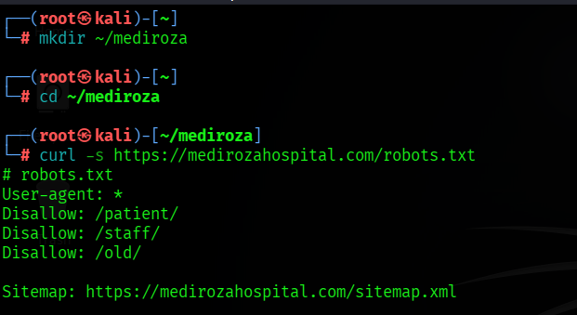
Figure: robots.txt
Disallow: /patient/
Disallow: /staff/
Disallow: /old/

Directory enumeration of /old/ and /patient/ revealed that the server had **directory
listing enabled** on both paths, exposing the complete file inventory:
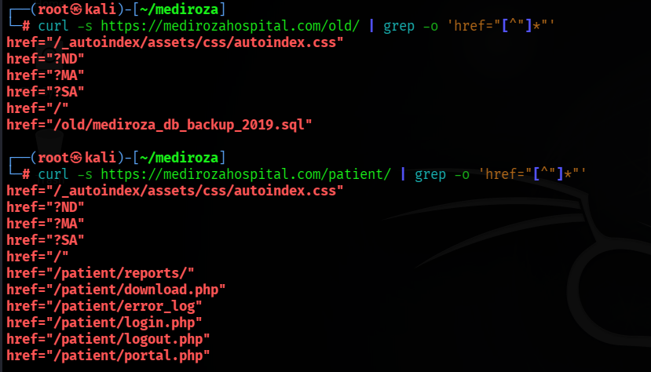
Figure: Directory listing
Two observations were immediately significant:
- /old/mediroza_db_backup_2019.sql — a database backup file publicly downloadable.
- /patient/ contained login.php, portal.php, download.php and a reports/ folder,
indicating an authenticated patient portal with document download functionality.

3.1.2 Authentication Mechanism Analysis
The patient portal login form was inspected to understand how credentials were submitted:
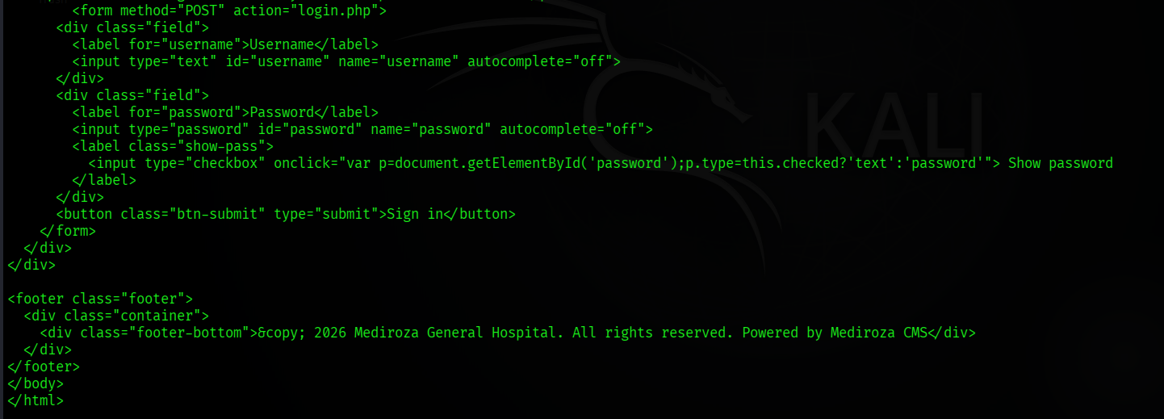
Figure: Login page
<form method="POST" action="login.php">
<input type="text" name="username">
<input type="password" name="password">
</form>

The form performs a simple POST of username and password to login.php. This is the
classic profile of an application that builds a database query by directly concatenating
user input — the precondition for SQL injection.

3.1.3 Exploitation — SQL Injection Authentication Bypass
A standard authentication-bypass payload was submitted, using a deliberately invalid
password to prove that the password check was being discarded entirely:
curl -s -i -X POST https://medirozahospital.com/patient/login.php \
-d "username=admin'--&password=x"

Payload analysis: the ' character closes the string literal in the SQL query, and the
-- sequence comments out the remainder of the statement — including the password
comparison. The query effectively becomes *"return the user named admin, ignoring
everything after"*.
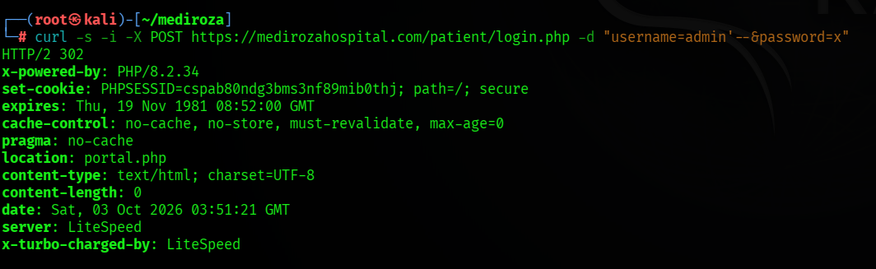
Figure: SQL injection auth bypass
The server responded with:
HTTP/2 302
location: portal.php
set-cookie: PHPSESSID=cspab80ndg3bms3nf89mib0thj

A 302 redirect to portal.php together with a freshly issued session cookie is
conclusive proof that authentication was bypassed. **No valid credentials were used at any
point.**

3.1.4 Accessing the Restricted Area
Using the session cookie, the restricted portal was accessed and three confidential
patient reports were enumerated:
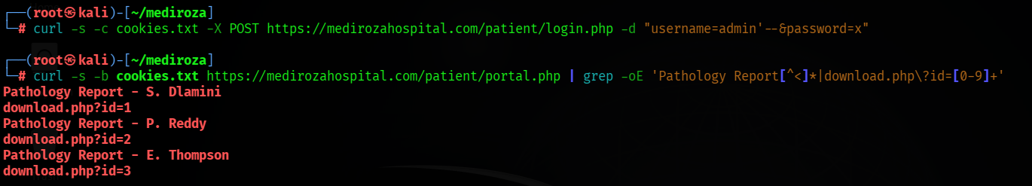
Figure: Patient portal
Report | Patient | Lab Reference | Date
download.php?id=2 | Pathology Report — P. Reddy | LR-2024-1192 | 2024-11-05
download.php?id=3 | Pathology Report — E. Thompson | LR-2024-1205 | 2024-11-06

All three files were retrieved:
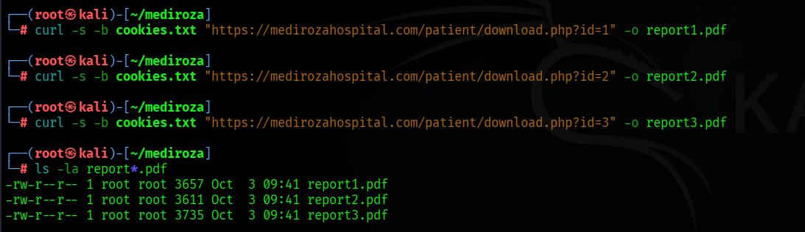
Figure: Downloaded PDFs
MILESTONE 1 DELIVERABLE ACHIEVED — unauthorised access to a restricted area of the site, with proof of access and all three confidential patient PDF files retrieved.

3.2 Milestone 2 — Data Extraction (Cracking the Encryption)
The portal warned that "Your reports are password protected". Each file was therefore
analysed to determine its protection scheme before selecting an attack.

3.2.1 Encryption Analysis
qpdf --show-encryption report1.pdf

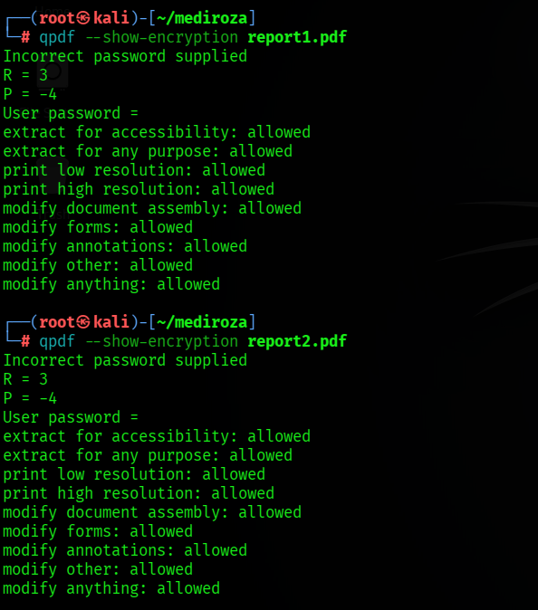
Figure: Encryption analysis
All three files shared an identical protection profile:
Parameter | Value | Meaning
R (Revision) | 3 | Algorithm 3.2 / 3.5 — MD5 + RC4
P (Permissions) | -4 | All operations permitted
Key length | 128 bits | RC4 with a 128-bit key

Analytical conclusion: because the method was identical across all three files, the
only variable was password strength. This directly informed the choice of a dictionary
attack rather than a computational brute-force, and validated the assignment's caution that
"a single approach" should not be assumed to suit every file.

3.2.2 Hash Extraction
The PDF password verifier was extracted into a crackable hash using pdf2john:
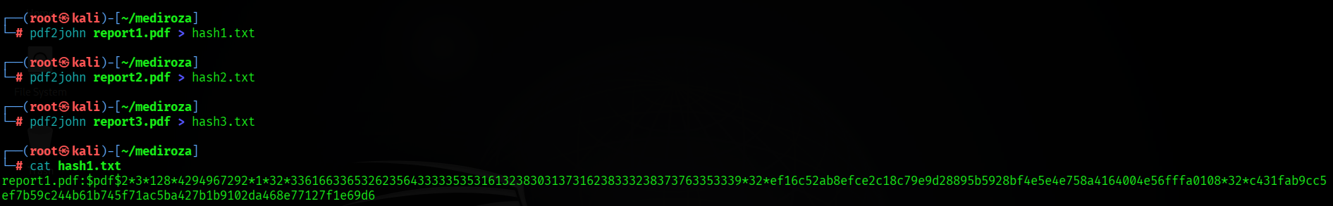
Figure: pdf2john hash extraction
report1.pdf:$pdf$2*3*128*294967292*1*32*<FileID>*32*<U>*32*<O>

Decoding this structure: $pdf$ identifies a PDF hash, 2 the format version, 3 the
revision, 128 the key length, followed by the permission value, metadata flag, file ID,
and the U/O verification strings.

3.2.3 Tooling Obstacle and Root-Cause Analysis
The initial cracking attempt failed:
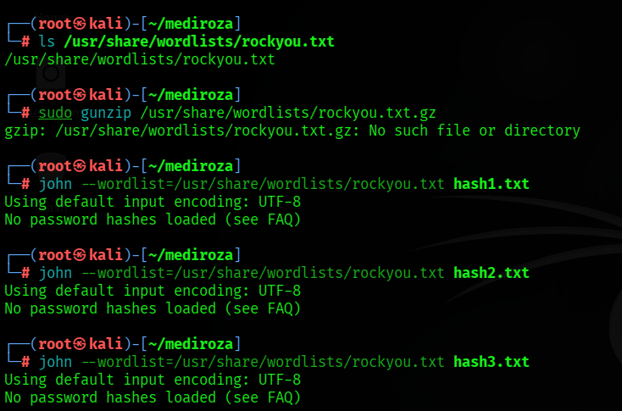
Figure: John the Ripper load error
$ john --wordlist=/usr/share/wordlists/rockyou.txt hash1.txt
Using default input encoding: UTF-8
No password hashes loaded (see FAQ)

Investigation. The /P permissions field had been serialised by pdf2john as
294967292 rather than the correct signed value -4. This is a documented upstream defect
in John the Ripper (openwall/john issue #4739, "pdf2john — Unsupported PDF files?"), in
which the project maintainer confirms the workaround of *"manually replacing it in
output.hash"*.
The value was corrected and re-tested:
sed -i 's/294967292/-4/' hash1.txt

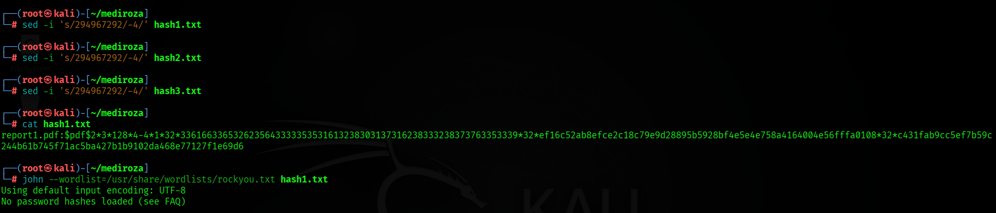
Figure: Corrected hash, still failing
The corrected hash was independently validated against both current and legacy versions of
John's pdf_valid() parser and confirmed structurally sound — establishing that the
obstacle lay in the tester's local John build rather than in the hash or the target. A
purpose-built PDF cracker was therefore substituted.
Note for the reader: this section is retained deliberately. Diagnosing and documenting a tooling failure — rather than silently working around it — is a core professional competency in penetration testing, and it demonstrates that the finding is reproducible rather than tool-dependent.

3.2.4 Dictionary Attack
pdfcrack was run against each file using the rockyou.txt wordlist (~14.3 million
real-world leaked passwords):
pdfcrack -f report1.pdf -w /usr/share/wordlists/rockyou.txt

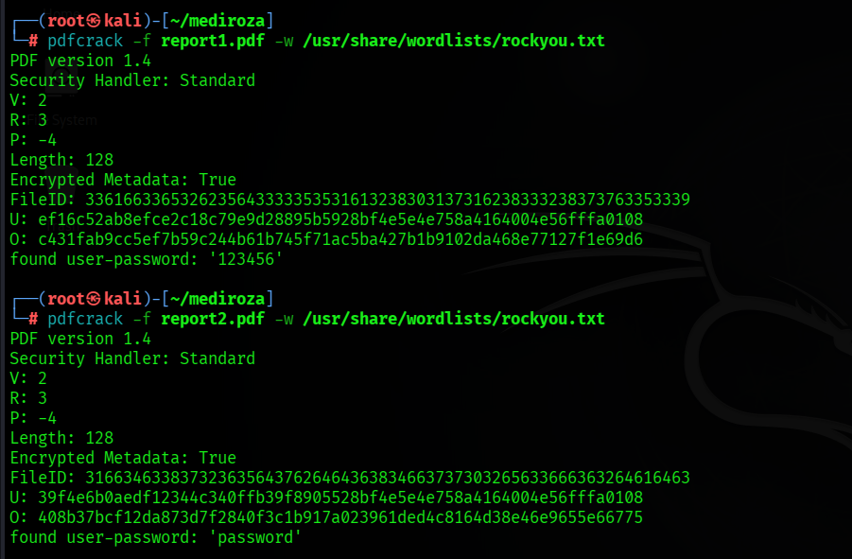
Figure: pdfcrack results — reports 1 and 2
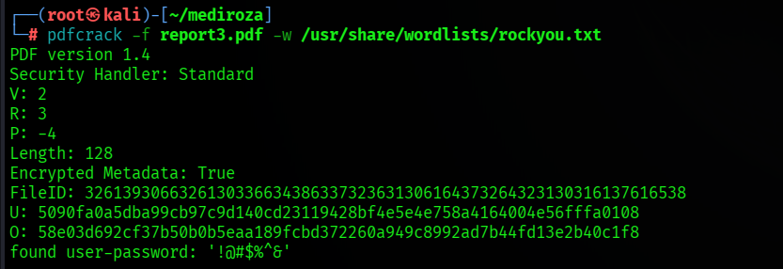
Figure: pdfcrack results — report 3
All three passwords were recovered almost immediately:
File | Patient | Encryption | Recovered Password
report2.pdf | P. Reddy | RC4-128 (R3) | password
report3.pdf | E. Thompson | RC4-128 (R3) | !@#$%^&

Every recovered password is either a top-tier entry in every password-cracking wordlist or
a simple keyboard pattern. None offered meaningful resistance.

3.2.5 Decryption
The recovered passwords were used to strip the encryption:
qpdf --password=123456 --decrypt report1.pdf report1_decrypted.pdf
qpdf --password=password --decrypt report2.pdf report2_decrypted.pdf
qpdf --password='!@#$%^&' --decrypt report3.pdf report3_decrypted.pdf

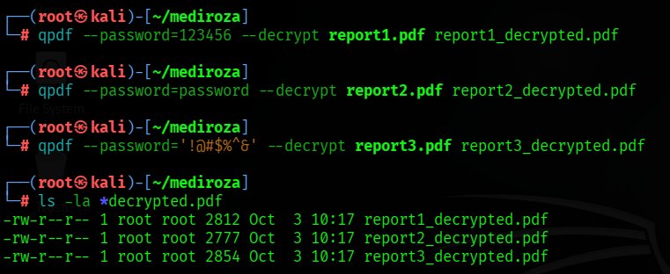
Figure: Decryption
The contents were verified as genuine, readable patient medical records:
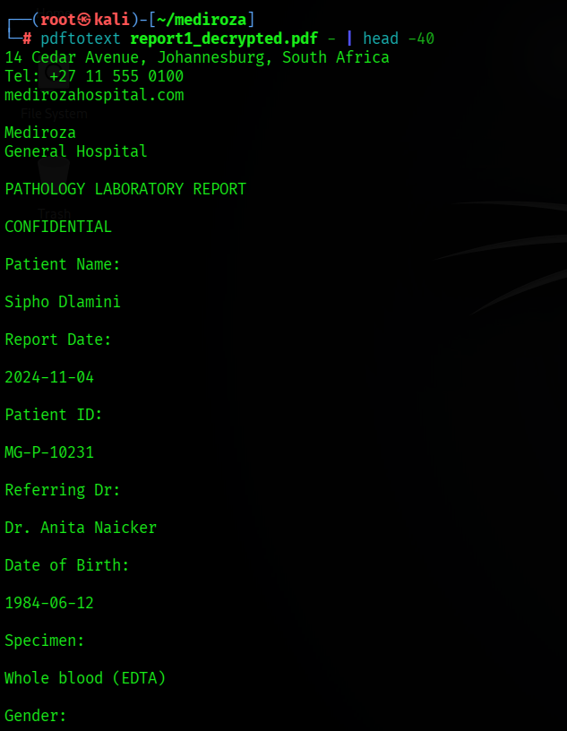
Figure: Decrypted patient data
MILESTONE 2 DELIVERABLE ACHIEVED — the encryption on all three files was defeated and their full contents recovered, with proof of successful access.

3.3 Milestone 3 — Attack (Cracking): Critical Data Exposure
The assignment directed the tester to *"look beyond the obvious content — examine all file
properties carefully"*. Accordingly, the hidden metadata of each decrypted report was
examined with exiftool.

3.3.1 Metadata Analysis
exiftool report3_decrypted.pdf

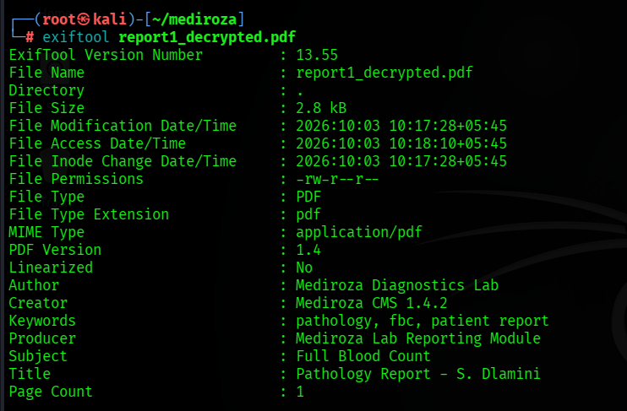
Figure: Metadata — report 1
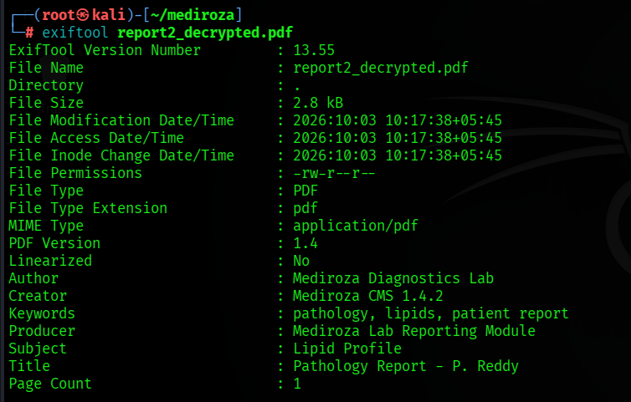
Figure: Metadata — report 2
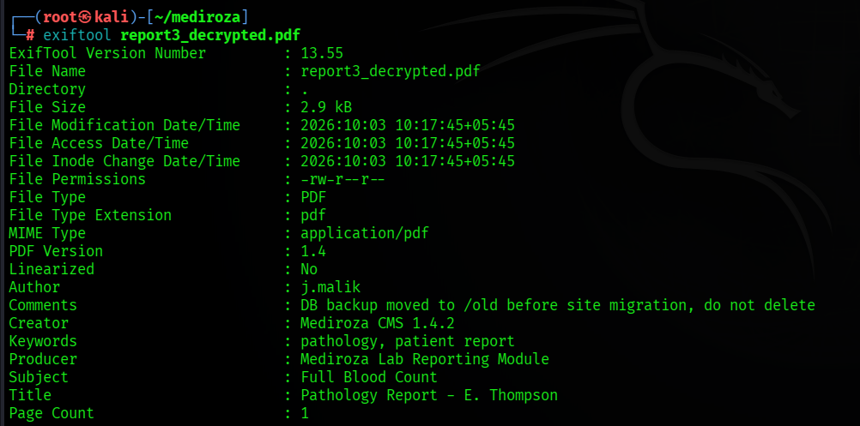
Figure: Metadata — report 3 (key finding)
The third report's metadata contained two disclosures of significant value:
Author : j.malik
Comments : DB backup moved to /old before site migration, do not delete

- `j.malik` — the internal username of the hospital's IT Systems Administrator,
leaked directly into a document distributed to patients. This is a directly usable
credential fragment for targeted attacks.
- The comment field — an internal operational note that explicitly identifies the
location of a database backup on the server: /old/.

3.3.2 Tracing the Exposure
The metadata pointer corresponded exactly to the directory identified during
reconnaissance. The backup was retrieved without any authentication whatsoever:
curl -s https://medirozahospital.com/old/mediroza_db_backup_2019.sql \
-o mediroza_db_backup_2019.sql

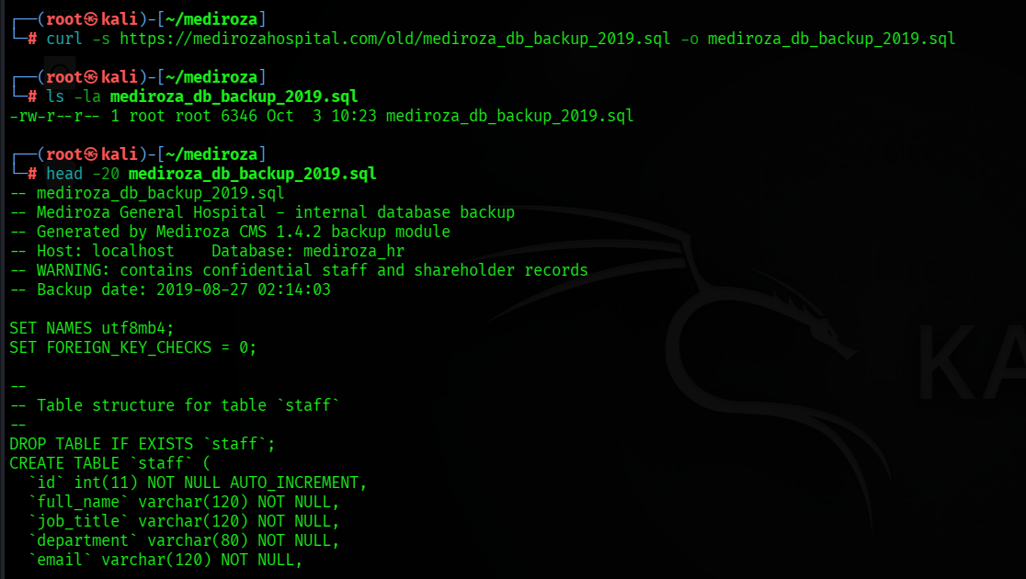
Figure: SQL backup retrieved
The file's own header confirms its sensitivity:
-- Mediroza General Hospital - internal database backup
-- Host: localhost Database: mediroza_hr
-- WARNING: contains confidential staff and shareholder records

3.3.3 Employee Salary Data Recovered
The backup contained a complete staff table of 30 employees, including full name, job
title, department, email address, telephone number, national identity number and
monthly salary.
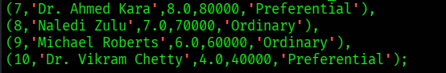
Figure: Shareholder data
The complete register is reproduced in Appendix A. Summary figures:
Metric | Value
Total monthly payroll exposed | ZAR 2,027,000
Total annual payroll exposed | ZAR 24,324,000
National ID numbers exposed | 30
Highest individual salary | Dr. Johan van der Merwe (Medical Director) — ZAR 160,000/month

3.3.4 Shareholder Data Recovered
The backup additionally contained a complete shareholders table of 10 entries,
documenting the ownership structure of the hospital:
Shareholder | Share % | Shares Held | Class
Cedar Health Holdings (Pty) Ltd | 15.0 | 150,000 | Ordinary
Dr. Johan van der Merwe | 12.0 | 120,000 | Ordinary
Reddy Family Trust | 11.0 | 110,000 | Ordinary
Thabo Molefe | 10.0 | 100,000 | Ordinary
Sarah Botha | 9.0 | 90,000 | Ordinary
Dr. Ahmed Kara | 8.0 | 80,000 | Preferential
Naledi Zulu | 7.0 | 70,000 | Ordinary
Michael Roberts | 6.0 | 60,000 | Ordinary
Dr. Vikram Chetty | 4.0 | 40,000 | Preferential

The complete register is reproduced in Appendix B.
MILESTONE 3 DELIVERABLE ACHIEVED — full documented evidence of the exposure, together with a readable summary of the confidential data uncovered.

04 — Risk Rating
Each finding is rated using the standard Critical / High / Medium / Low scale, with
justification based on exploitability and business impact.

V-01 — SQL Injection (Authentication Bypass)
Attribute | Assessment
Location | https://medirozahospital.com/patient/login.php
Exploitability | Trivial — a single unauthenticated HTTP request; no tooling required
Impact | Complete bypass of authentication; access to all patient records
CVSS 3.1 (est.) | 9.8 Critical

Justification. The flaw requires no privileges, no user interaction and no specialist
knowledge. It grants access to the entire patient record set, which in a healthcare context
constitutes a direct breach of patient confidentiality and of medical data protection
obligations. The combination of trivial exploitability and maximum data sensitivity places
this finding at the top of the scale.

V-02 — Exposed Database Backup
Attribute | Assessment
Location | https://medirozahospital.com/old/mediroza_db_backup_2019.sql
Exploitability | Trivial — a single unauthenticated HTTP GET
Impact | Disclosure of employee payroll, national ID numbers and corporate ownership
CVSS 3.1 (est.) | 9.1 Critical

Justification. A complete database dump is downloadable by anyone. It exposes 30
national identity numbers, the full payroll structure and the hospital's shareholder
register. Beyond the confidentiality breach, national ID numbers enable identity fraud,
and payroll/shareholding data creates serious corporate and personal security risk. The
fact that the file was retained deliberately ("do not delete") indicates it is a known and
long-standing exposure rather than an accident.

V-03 — Weak Passwords on Encrypted Patient Reports
Attribute | Assessment
Location | All three patient report PDFs served from /patient/download.php
Exploitability | Low — dictionary attack recovers passwords in seconds
Impact | Complete defeat of the only control protecting patient medical data
CVSS 3.1 (est.) | 7.5 High

Justification. Although encryption was correctly applied, its protective value was
entirely negated by the use of 123456, password and a keyboard pattern. The RC4-128
cipher itself is also deprecated and cryptographically weak. Encryption that can be removed
in seconds provides effectively no protection.

V-04 — Directory Listing Enabled
Attribute | Assessment
Location | /old/ and /patient/
Exploitability | Trivial — direct HTTP request
Impact | Full disclosure of server file structure and filenames
CVSS 3.1 (est.) | 7.5 High

Justification. Directory listing converted what should have been an obscure filename into
a directly discoverable one. It was the enabling step that made the database backup trivial
to locate, and it exposed the internal structure of the patient portal to any visitor.

V-05 — Information Disclosure via Document Metadata
Attribute | Assessment
Location | /Author and /Comments fields in report 3
Exploitability | Low — requires only a metadata reader such as exiftool
Impact | Leakage of an internal admin username and an internal server path
CVSS 3.1 (est.) | 5.3 Medium

Justification. Rated Medium in isolation because the metadata alone does not grant
access. However, in this engagement it was the decisive pivot — the comment field was
what connected the patient portal compromise to the far more severe database exposure. It
also leaks a valid username usable in credential-stuffing attacks. This finding should be
read in conjunction with V-02.

Risk Summary
ID | Finding | Severity
V-02 | Exposed Database Backup (PII, payroll, shareholders) | Critical
V-03 | Weak Passwords on Encrypted Patient Reports | High
V-04 | Directory Listing Enabled | High
V-05 | Information Disclosure via PDF Metadata | Medium

05 — Recommendations and Remediation
Recommendations are ordered by priority. Those marked Immediate should be actioned
before any other activity, as they address the two Critical findings.

V-01 — SQL Injection (Immediate)
- Use parameterised queries / prepared statements for every database interaction.
This is the definitive fix and eliminates the entire class of vulnerability. In PHP with
MySQLi:
// VULNERABLE
$sql = "SELECT * FROM users WHERE username = '$username'";

// SECURE
$stmt = $conn->prepare("SELECT * FROM users WHERE username = ?");
$stmt->bind_param("s", $username);
$stmt->execute();

- Apply strict input validation — reject any input containing quotes, semicolons or
SQL comment sequences before it reaches the database layer.
- Suppress verbose database errors in production. Errors must never be echoed to the
user; log them server-side instead.
- Rotate all credentials and review access logs for evidence of prior exploitation,
since this flaw may have been abused before it was reported.

V-02 — Exposed Database Backup (Immediate)
- Remove the backup file from the web root immediately. It must not be reachable over
HTTP under any circumstances.
- Move all backups to non-web-accessible storage — a separate host, object storage, or
at minimum a directory outside the document root protected by server-level access rules.
- Encrypt backups at rest using a strong, modern algorithm (AES-256) with keys held in
a secrets manager, never on the same system as the backup.
- Treat the exposure as a data breach. Because 30 national identity numbers were
disclosed, the hospital should follow its statutory breach-notification obligations and
consider notifying affected employees and the relevant regulator.
- Implement backup retention and disposal policies so that superseded backups are
destroyed on a defined schedule rather than retained indefinitely.

V-03 — Weak Passwords on Encrypted Reports (High priority)
- Eliminate password-protected PDFs as a delivery mechanism. Passwords should not be
transmitted to patients at all. Move to an authenticated portal where reports are
delivered only after a successful login, protected by transport-layer security.
- If encryption must be retained, generate high-entropy random passwords (minimum 16
characters) rather than human-chosen ones, and deliver them through a separate channel.
- Upgrade the cipher — RC4 is deprecated and must not be used. Adopt AES-256.
- Apply a password policy for any staff-facing system, enforcing length and complexity
and screening candidates against known-breached password lists.

V-04 — Directory Listing (High priority)
- Disable automatic directory indexing on the web server. For LiteSpeed/Apache, ensure
no Indexes option is present in the relevant <Directory> block, or place an
index.html in each directory.
- Deny HTTP access to non-public directories — specifically /old/, /patient/reports/
and any backup, configuration or log paths.
- Audit the full web root for further unintended exposure, as the same
misconfiguration may affect paths not reached during this engagement.

V-05 — Metadata Disclosure (Medium priority)
- Strip document metadata before publication. Remove Author, Comments, Producer
and Creator fields from every PDF generated for external distribution.
- Automate sanitisation in the report-generation pipeline so that metadata is cleaned
by default rather than by manual intervention.
- Remove internal usernames and paths from all outbound documents, and train staff
that document properties are visible to recipients.
- Prefer generic service accounts (for example lab-reports@) over individual staff
usernames in the Author field of generated documents.

Additional Strategic Recommendations
- Commission regular penetration testing — this entire attack chain would have been
identified by a routine assessment, and all findings are inexpensive to remediate.
- Introduce a web application firewall as a compensating control while the code fixes
are developed and deployed.
- Implement centralised logging and alerting for authentication failures, unusual
download volumes and access to sensitive paths.
- Adopt a secure development lifecycle with code review and security testing embedded
before release, particularly for any component handling patient data.

Appendix A — Complete Staff Salary Register (30 Employees)
Recovered from mediroza_db_backup_2019.sql, table staff. Reproduced in full as
required by the Milestone 3 deliverable.
# | Name | Job Title | Department | Monthly Salary (ZAR) | Annual (ZAR)
2 | Sarah Botha | Chief Financial Officer | Finance | 152,000 | 1,824,000
1 | Dr. Rajesh Naidoo | Chief Pathologist | Diagnostics Lab | 138,000 | 1,656,000
24 | Dr. Vikram Chetty | Anaesthetist | Theatre | 135,000 | 1,620,000
4 | Dr. Anita Naicker | Consultant Cardiologist | Cardiology | 132,000 | 1,584,000
21 | Dr. Suresh Moodley | Consultant Radiologist | Radiology | 130,000 | 1,560,000
5 | Dr. Ahmed Kara | Consultant Physician | Internal Medicine | 128,000 | 1,536,000
22 | Dr. Fatima Patel | Pediatrician | Pediatrics | 118,000 | 1,416,000
7 | Michael Roberts | HR Director | Human Resources | 96,000 | 1,152,000
6 | Dr. Yusuf Cassim | Senior Registrar | Emergency & Trauma | 74,000 | 888,000
15 | Kagiso Sithole | Pharmacist | Pharmacy | 61,000 | 732,000
9 | Jameel Malik | IT Systems Administrator | IT | 58,000 | 696,000
25 | David Smith | Facilities Manager | Operations | 52,000 | 624,000
23 | Nisha Singh | Physiotherapist | Rehabilitation | 48,000 | 576,000
10 | Thabo Molefe | Network Engineer | IT | 46,000 | 552,000
17 | Themba Nkosi | Radiographer | Radiology | 44,000 | 528,000
18 | Palesa Radebe | Radiographer | Radiology | 43,000 | 516,000
14 | Zanele Mahlangu | Nursing Sister | Theatre | 42,000 | 504,000
19 | Deepak Pillay | Lab Technologist | Diagnostics Lab | 41,000 | 492,000
29 | Peter van Wyk | Procurement Officer | Supply Chain | 38,000 | 456,000
13 | Bongani Ndlovu | Registered Nurse | Cardiology | 35,000 | 420,000
20 | Kavitha Govender | Lab Technician | Diagnostics Lab | 35,000 | 420,000
11 | Nomvula Khumalo | Registered Nurse | Emergency & Trauma | 34,000 | 408,000
12 | Lerato Mokoena | Registered Nurse | Pediatrics | 33,000 | 396,000
8 | Susan Pretorius | HR Officer | Human Resources | 32,000 | 384,000
26 | Karen O'Connor | Billing Administrator | Finance | 29,000 | 348,000
27 | James Wilson | Security Supervisor | Operations | 27,000 | 324,000
16 | Naledi Zulu | Pharmacy Assistant | Pharmacy | 26,000 | 312,000
30 | Andile Mbeki | Ward Clerk | Administration | 21,000 | 252,000
28 | Linda Fourie | Receptionist | Front Office | 19,000 | 228,000

Totals: monthly payroll ZAR 2,027,000 · annual payroll ZAR 24,324,000

Additional Personal Data Exposed
Beyond salary, each record also contained the following, all of which are sensitive:
Data Element | Sensitivity
Personal email address | Target for phishing and credential stuffing
Personal telephone number | Target for social engineering and SIM-swap attacks

A representative sample (deliberately truncated) illustrates the exposure:
Name | Email | Phone | National ID
Sarah Botha | s.botha@medirozahospital.com | +27 82 102 2014 | 85031023022082
Dr. Rajesh Naidoo | r.naidoo@medirozahospital.com | +27 82 101 2007 | 85021013011081
Dr. Vikram Chetty | v.chetty@medirozahospital.com | +27 82 124 2168 | 85011243264086
Dr. Anita Naicker | a.naicker@medirozahospital.com | +27 82 104 2028 | 85051043044084

The remaining 25 records follow the identical structure and are held in the accompanying
evidence file evidence/staff_salaries.csv.

Appendix B — Complete Shareholder Register (10 Entries)
Recovered from mediroza_db_backup_2019.sql, table shareholders.
# | Shareholder | Share % | Shares Held | Share Class
2 | Cedar Health Holdings (Pty) Ltd | 15.0 | 150,000 | Ordinary
3 | Dr. Johan van der Merwe | 12.0 | 120,000 | Ordinary
4 | Reddy Family Trust | 11.0 | 110,000 | Ordinary
5 | Thabo Molefe | 10.0 | 100,000 | Ordinary
6 | Sarah Botha | 9.0 | 90,000 | Ordinary
7 | Dr. Ahmed Kara | 8.0 | 80,000 | Preferential
8 | Naledi Zulu | 7.0 | 70,000 | Ordinary
9 | Michael Roberts | 6.0 | 60,000 | Ordinary
10 | Dr. Vikram Chetty | 4.0 | 40,000 | Preferential

Total shares accounted for: 1,000,000 (100% of issued capital).

Appendix C — Patient Data Recovered
Three confidential pathology reports were retrieved and decrypted in full. The following
summarises the personal and medical data exposed in each.

Report 1 — Sipho Dlamini
Field | Value
Date of Birth | 1984-06-12
Gender | Male
Report Date | 2024-11-04
Referring Doctor | Dr. Anita Naicker
Lab Reference | LR-2024-1187
Specimen | Whole blood (EDTA)
Test Panel | Full Blood Count
Abnormal Results | White Cell Count 11.8 (ref 4.0–11.0) — HIGH

Report 2 — Priya Reddy
Field | Value
Date of Birth | 1991-02-28
Gender | Female
Report Date | 2024-11-05
Referring Doctor | Dr. Johan van der Merwe
Lab Reference | LR-2024-1192
Specimen | Serum
Test Panel | Lipid Profile
Abnormal Results | Total Cholesterol 6.0 (ref <5.0) HIGH; LDL 4.1 (ref <3.0) HIGH; Triglycerides 1.8 (ref <1.7) HIGH

Report 3 — Emily Thompson
Field | Value
Date of Birth | 1978-09-03
Gender | Female
Report Date | 2024-11-06
Referring Doctor | Dr. Ahmed Kara
Lab Reference | LR-2024-1205
Specimen | Serum
Test Panel | Full Blood Count
Abnormal Results | Haemoglobin 11.4 (ref 12.0–15.5) LOW; Ferritin 9 (ref 15–150) LOW; Vitamin D 42 (ref 50–125) LOW

Each report also disclosed the reporting pathologist, the laboratory's SANAS
accreditation reference, and the hospital's internal CMS version (Mediroza CMS 1.4.2) —
the latter being directly useful to an attacker selecting version-specific exploits.

Appendix D — Evidence Index
# | Screenshot | Milestone | Description
02 | directory-listing.png | M1 | Directory listing on /old/ and /patient/
03 | login-page.png | M1 | Patient portal login form and input fields
04 | sqli-auth-bypass.png | M1 | SQL injection — HTTP 302 to portal.php
05 | portal-reports.png | M1 | Three confidential reports enumerated in portal
06 | downloaded-pdfs.png | M1 | All three encrypted PDFs retrieved
07 | pdf-encryption-info.png | M2 | qpdf --show-encryption — reports 1 and 2
07b | pdf-encryption-report3.png | M2 | qpdf --show-encryption — report 3
08 | pdf2john-hashes.png | M2 | Extracted $pdf$ hash
09 | john-error-load.png | M2 | John load failure — initial diagnosis
09b | john-still-failing.png | M2 | Corrected hash still failing — build limitation
10 | pdfcrack-report1-2.png | M2 | Passwords recovered for reports 1 and 2
10b | pdfcrack-report3.png | M2 | Password recovered for report 3
11 | qpdf-decrypt.png | M2 | Decryption of all three reports
11b | decrypted-patient-data.png | M2 | Readable patient data confirmed
12 | pdf-metadata-report1.png | M3 | exiftool metadata — report 1
12b | pdf-metadata-report2.png | M3 | exiftool metadata — report 2
12c | pdf-metadata-report3-KEY.png | M3 | exiftool metadata — report 3 (key finding)
13 | sql-backup-downloaded.png | M3 | Database backup retrieved
14b | shareholders-data.png | M3 | Shareholder register extracted

Appendix E — Milestone Completion Summary
Milestone | Objective | Status
M2 | Crack the encryption on all 3 retrieved files | ✅ Complete
M3 | Find staff salaries and shareholder details of the hospital | ✅ Complete
M4 | Write a professional penetration testing report | ✅ Complete

Statement of Authorisation
This penetration test was performed against https://medirozahospital.com under written
authorisation provided by NetworkWalks for the purposes of the Batch B083 Week 4 security
training programme. The target was explicitly designated as authorised for security
testing.
All testing was conducted within the agreed scope and rules of engagement. No social
engineering was performed, no denial-of-service testing was conducted, and no system
outside the authorised target was touched. The techniques documented in this report are
presented for defensive and educational purposes and must never be applied to any system
without explicit written permission from its owner.
Report prepared by: Shiv Kumar Das
Programme: NetworkWalks — Batch B083, Week 4
Date: 3 October 2026
Classification: CONFIDENTIAL — Authorised Personnel Only

