* Bazaar

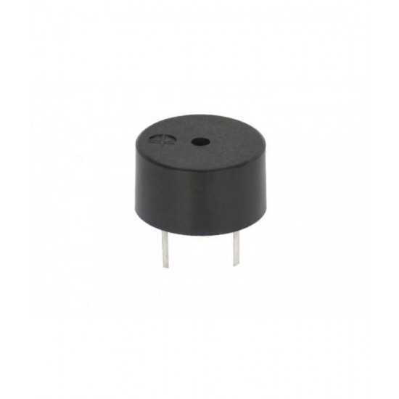

A "bazaar" can refer to different things depending on the context. Without more specific information, I can provide a general explanation.

Marketplace: A bazaar can be a marketplace or street market where vendors sell a variety of goods, often in an open-air setting. These goods can include food, clothing, crafts, and more.

Software Development: In the context of software development, a "bazaar" often refers to the "Bazaar" model of development, which contrasts with the "Cathedral" model. It was popularized by Eric S. Raymond in his essay "The Cathedral and the Bazaar." The Bazaar model emphasizes decentralized, open-source development, where many individuals contribute to a project, as opposed to a closed, centralized approach.

Cultural Event: Some bazaars are cultural events featuring music, dance, and various cultural activities, often organized to showcase and celebrate a particular culture or tradition.

If you have a specific context or type of bazaar in mind, please provide more details for a more precise explanation or specification.

* IR sensor

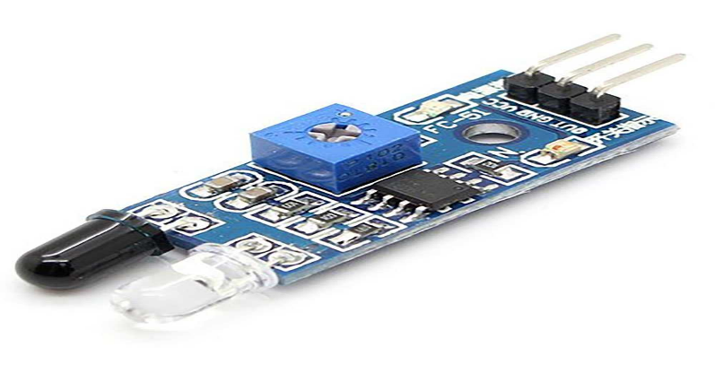

Infrared (IR) sensors are available in various specifications depending on their intended use. Common specifications include

Detection Range: The distance over which the sensor can detect IR radiation.

Sensing Method: Whether it's a passive sensor (detects emitted or reflected IR radiation) or an active sensor (emits IR and detects reflections).

Sensing Spectrum: The range of infrared wavelengths the sensor can detect, typically categorized as near-infrared, mid-infrared, or far-infrared.

Field of View (FOV): The angular range within which the sensor can detect IR radiation.

Response Time: The time it takes for the sensor to detect changes in IR radiation.

Accuracy and Resolution: How precisely the sensor can measure IR radiation levels.

Output Type: Analog (voltage or current), digital (binary output), or communication protocols like I2C or SPI.

Power Requirements: Voltage and current specifications for proper operation.

Environmental Conditions: Operating temperature and humidity range.

Size and Form Factor: Physical dimensions and package type.

Cost: The price of the sensor, which can vary based on features and capabilities.

Specific sensor models may have additional specifications or features tailored to their intended applications, such as proximity sensing, temperature measurement, or motion detection. When selecting an IR sensor, consider these specifications to ensure it meets your requirements.

stepper motor driver

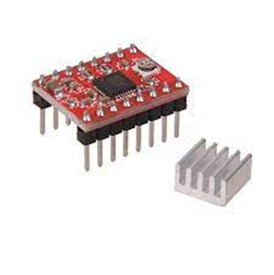

Stepper motor drivers are essential components for controlling the movement of stepper motors. Here are common specifications to consider when selecting a stepper motor driver

Motor Type: Check if the driver is compatible with the type of stepper motor you plan to use, whether it's a bipolar or unipolar motor.

Current Rating: The maximum current the driver can supply to the motor coils. Make sure it matches the motor's rated current or can be adjusted to match it.

Voltage Rating: The supply voltage required for the driver to operate correctly.

Microstepping: The driver's microstepping capability, which determines the level of smoothness and precision in motion control. Common microstepping options include full-step, half-step, 1/4-step, 1/8-step, etc.

Step Resolution: The smallest angle or distance the motor can move per step, often expressed in degrees per step or steps per revolution.

Step/Direction or SPI Control: The communication interface used to send commands to the driver for controlling the motor's movement.

Current Adjustment: Whether the driver allows you to adjust the motor current to match your specific application requirements.

Overcurrent and Thermal Protection: Safety features that protect the driver and motor from overheating or excessive current.

Input Voltage Range: The acceptable range of input voltages for the driver's power supply.

Heat Dissipation: The driver's ability to dissipate heat, which can affect its performance and reliability.

Signal Compatibility: Ensure compatibility with the control signals generated by your microcontroller or controller board (e.g., 5V logic or 3.3V logic).

orm Factor: Physical dimensions and package type (e.g., through-hole or surface-mount)

Price: Consider the cost of the driver, as it can vary depending on features and capabilities.

Additional Features: Some drivers may include advanced features like stall detection, encoder feedback support, or current control algorithms.

Selecting the right stepper motor driver is crucial for the smooth and precise operation of your stepper motor-based system, so be sure to carefully evaluate these specifications based on your specific application requirements.

* RTC module specification

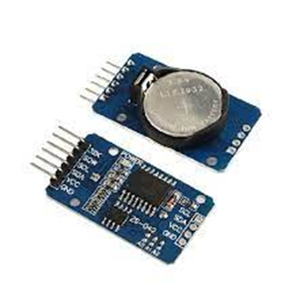

A Real-Time Clock (RTC) module is an electronic component used to keep accurate time in various devices. Here are common specifications for RTC modules

Clock Accuracy: The deviation from real-time over a specified period (e.g., ppm - parts per million).

Timekeeping Format: Whether it provides time in 12-hour or 24-hour format.

Clock Source: Quartz crystal or other timing element used for timekeeping.

Supply Voltage: The voltage required for proper operation.

Operating Temperature Range: The range of temperatures within which the module can operate reliably.

Timekeeping Battery: The type and capacity of the backup battery (e.g., coin cell) used to maintain time when the main power source is disconnected.

Interface: Communication protocols such as I2C, SPI, or UART for setting and reading time.

Alarm Functionality: Whether it supports alarms or interrupts based on specific time settings.

Programmability: The ability to set and adjust time and date settings.

Frequency Output: Some RTC modules can provide square wave or pulse outputs at specific frequencies for applications like periodic interrupts.

Sleep or Low-Power Modes: Capability to reduce power consumption during idle periods.

Form Factor: Physical dimensions and package type (e.g., DIP, SMD, or modules with pins or connectors).

Integration: Whether it includes additional features like temperature sensors or non-volatile memory.

Cost: The price of the RTC module, which can vary based on features and accuracy.

When selecting an RTC module, consider these specifications to ensure it meets the requirements of your application, whether it's for a simple clock, data logging, or precise timing in a microcontroller-based project.

* LCD

LCD (Liquid Crystal Display) specifications can vary depending on the specific model and manufacturer, but here are some common specifications you might find:

Screen Size: This is typically measured diagonally in inches (e.g., 32 inches, 55 inches).

Resolution: It refers to the number of pixels on the screen, usually denoted as width x height (e.g., 1920 x 1080, commonly known as Full HD or 1080p).

Refresh Rate: Measured in Hertz (Hz), it indicates how many times per second the screen refreshes the image (e.g., 60Hz, 120Hz, 240Hz). Higher refresh rates are better for fast-moving content like gaming.

Panel Type: LCD panels come in various types, including IPS (In-Plane Switching), TN (Twisted Nematic), and VA (Vertical Alignment). Each has its own characteristics in terms of viewing angles, color accuracy, and response time.

rightness: Measured in nits, it indicates how bright the screen can get. Higher brightness is better for well-lit rooms.

Contrast Ratio: This measures the difference between the darkest and brightest parts of the screen. A higher contrast ratio typically results in more vibrant images.

Response Time: It's the time it takes for a pixel to change from one color to another. Lower response times are better for gaming and reducing motion blur.

Color Gamut: This describes the range of colors the display can reproduce, often expressed as a percentage of sRGB or Adobe RGB color space.

Viewing Angle: Indicates how well the display maintains color and contrast when viewed from different angles.

Backlighting: LCD displays can use various backlighting technologies, such as LED (Light Emitting Diode) or OLED (Organic Light Emitting Diode).

Connectivity: The types and number of ports available, such as HDMI, DisplayPort, USB, and audio jacks.

Energy Efficiency: Information about the display's power consumption and compliance with energy-saving standards.

These specifications help you understand the capabilities and performance of an LCD display. When choosing an LCD display, consider your specific needs, whether it's for gaming, professional work, or general use, to find the right balance of features for your requirements.

* Bluetooth module

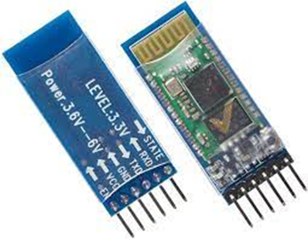

Bluetooth modules come in various types and specifications, but here are some common specifications and features you might find in a typical Bluetooth module:

Bluetooth Version: Bluetooth technology has evolved over the years, with different versions. Common versions include Bluetooth 2.1, Bluetooth 4.0 (Bluetooth Low Energy or BLE), Bluetooth 4.2, Bluetooth 5.0, and Bluetooth 5.1, each offering improvements in range, data transfer speed, and power efficiency.

Range: Bluetooth modules have a maximum communication range, typically measured in meters (e.g., 10 meters for Class 2 devices, 100 meters for Class 1 devices). Range can vary based on environmental factors.

Data Transfer Rate: This indicates how fast data can be transmitted over Bluetooth. It's measured in Mbps (megabits per second) and varies depending on the Bluetooth version.

Power Consumption: Bluetooth Low Energy (BLE) modules are known for their low power consumption, making them suitable for battery-operated devices like wearables and IoT sensors.

Profiles: Bluetooth modules support various profiles (e.g., A2DP for audio streaming, HID for human interface devices, GATT for BLE) that define the types of tasks they can perform.

Operating Voltage: The voltage range that the module requires to operate.

Antenna Type: Some modules come with an integrated antenna, while others allow you to connect an external antenna for improved range.

I/O Pins: The number and type of input and output pins available on the module, which can be used for interfacing with sensors, displays, or other devices.

Security Features: Bluetooth modules often include encryption and authentication features to secure data transmission.

Form Factor: The physical size and shape of the module, which can affect its suitability for different applications.

Certifications: Ensure that the Bluetooth module complies with industry standards and regulations, such as Bluetooth SIG certification.

Software Compatibility: Check if the module is compatible with the programming languages and development tools you plan to use.

Price: The cost of the module can vary significantly depending on its features and capabilities.

When choosing a Bluetooth module, consider your specific project requirements, such as range, power consumption, and data transfer rate, to select the module that best suits your needs. Additionally, ensure that it is compatible with your microcontroller or development platform of choice.s come in various types and specifications, but here are some common specifications and features you might find in a typical Bluetooth module:

* Atmega 32A controller