Tyson Interface Document

ENAB – Source to Procure
Users – ARS, OKTA, GCP to Coupa
Version 1.0

Document Control

Version | Revision Date | Author | Author’s email | Summary of Changes | Reviewer
1.0 | Mar-28-2021 | Nikhil Vardya | nvardya@kpmg.com | Initial document created
1.0. Sprint 1 | Mar-29-2021 | Lindsay Williams | Lindsaywilliams@kpmg.com | Updates to technology sections format (add SnapLogic ARS and Okta sections). Added Comment regarding placement of logic to determine user status (active/inactive) in ARS.
1.0 Sprint 1 | Mar-31-2021 | Ryan Michael | ramichael@kpmg.com | Wrote SnapLogic sections for ARS/Okta
1.0 Sprint 6 | May-26-2021 | Alex Rohlfing | arohlfing@kpmg.com | Updated functional spec to reflect GCP job family field integration

 | Date | Name | Comments
Business Lead(s) | mmm-dd-yyyy |  | <TYSON Name(s)>
ARS Techincal | mmm-dd-yyyy |  | Initial document/ specify the changes
OKTA Techincal | mmm-dd-yyyy |  | Initial document/ specify the changes
Coupa Functional | mmm-dd-yyyy |  | Initial document/ specify the changes
ABAP Design | mmm-dd-yyyy |  | Initial document/ specify the changes
SnapLogic Design | mmm-dd-yyyy |  | Initial document/ specify the changes
SnapLogic Code Review Signoff | mmm-dd-yyyy |  | <TYSON Business, Technical >

Interface ID | Complexity Level | Interface Name
 | Medium | Users

RICEF ID | Complexity Level | RICEF Name/Description
 | High/ Medium/Low

Contacts
Process Owner
Functional Contact
Legacy/Third Party Contact

Parking Lot Item: List any issues still in progress related to this document that require attention.

Reference Documents
 | Location Path and Version
Tyson Coding Standards
SIT Scripts | [provide HP QC URL]
Other Ref Documents

Table of Contents
Functional Overview 6
1 Functional Requirements 6
1.1 Business Overview 6
1.2 Detailed Requirement(s) 6
1.2.1 Coupa Functional Requirements 6
1.2.2 Coupa Process Flow Diagram 8
1.2.3 Coupa Business Process Description 10
1.3 Dependencies & Assumptions 10
SnapLogic 11
2 SnapLogic – ARS Interface Technology Overview 11
2.1 Requirement Details 11
2.1.1 Source 11
2.1.2 Target 11
2.1.3 Snap Process Flowchart for Pipeline : 12
2.2 Infrastructure Details: 12
2.3 Snaps 13
2.3.1 Task & Pipelines 14
2.4 Snap End Point Settings 15
2.4.1 End Point Security 15
2.4.2 Source Snap Connector Settings 15
2.4.3 Target Snap Connector Settings 15
2.5 Error Handling 16
2.5.1 Cronacle Failures 16
2.5.2 Pipeline Failures 16
2.5.3 Rerun Scenarios 18
2.6 Cross Reference 18
2.7 Scheduling 19
2.8 Assumptions & Issues 19
2.9 Performance Considerations 19
2.10 SnapLogic Test Cases 19
3 SnapLogic – Okta Interface Technology Overview 19
3.1 Requirement Details 19
3.1.1 Source 19
3.1.2 Target 20
3.1.3 Snap Process Flowchart for Pipeline : 21
3.2 Infrastructure Details: 21
3.3 Snaps 21
3.3.1 Task & Pipelines 23
3.4 Snap End Point Settings 24
3.4.1 End Point Security 24
3.4.2 Source Snap Connector Settings 24
3.4.3 Target Snap Connector Settings 27
3.5 Error Handling 27
3.5.1 Cronacle Failures 27
3.5.2 Pipeline Failures 28
3.5.3 Rerun Scenarios 29
3.6 Cross Reference 29
3.7 Scheduling 29
3.8 Assumptions & Issues 30
3.9 Performance Considerations 30
3.10 SnapLogic Test Cases 30
4 SnapLogic – GCP Interface Technology Overview 30
4.1 Requirement Details 30
4.1.1 Source 31
4.1.2 Target 31
4.1.3 Snap Process Flowchart for Pipeline : 31
4.2 Infrastructure Details: 31
4.3 Key Snaps Used 32
4.3.1 Task & Pipelines 33
4.4 Snap End Point Settings 34
4.4.1 End Point Security 34
4.4.2 Source Snap Connector Settings 34
4.4.3 Target Snap Connector Settings 34
4.5 Error Handling 35
4.5.1 Cronacle Failures 35
4.5.2 Pipeline Failures 35
4.5.3 Rerun Scenarios 35
4.6 Cross Reference 36
4.7 Scheduling 36
4.8 Assumptions & Issues 36
4.9 Performance Considerations 36
4.10 SnapLogic Test Cases 36
Appendix 36
5 Glossary of Terms 36

Functional Overview

Functional Requirements

Business Overview
Complexity: | Simple | Medium | Complex
Process Area | Procure-to-Pay
Target Audience: | ARS Technical, OKTA Techincal, GCP Technical, Coupa Functional, SnapLogic Technical
General Description: | User integration from ars, okta, GCP into coupa
Business Rationale: | To create user records in Coupa via integration from ARS, OKTA, GCP
Initiating Process: | TBD
Sub Processes: | N/A
Volume per Transaction | Initial Load:  ARS – 1 user  Okta – 1-10 users  GCP – 1-10 users
Frequency of Interface | ARS – Near Real-Time upon user role update  Okta – Nightly  GCP - Nightly

Detailed Requirement(s)

Coupa Functional Requirements
- Users will be imported into Coupa via API calls from SnapLogic. More info on this API can be found here:
https://success.coupa.com/Integrate/Technical_Documentation/API/Resources/Reference/users
- New User creation will be integrated from ARS. ARS has all the necessary fields to create a shell profile and update a User’s permissions in Coupa.
- Okta contains all user attributes necessary to populate Coupa, except for roles and ‘Job Family’, with the ability to identify users assigned to Coupa and to determine attribute changes for all fields required in Coupa.
- Any changes to a user profile outside of Coupa roles, activation, and deactivation will be sourced from OKTA and GCP in nightly delta runs (i.e. name changes, email, job family etc.)
  - Changes may be sourced from ARS instead of OKTA and GCP when there is a role change. This will happen when the user requests a Coupa role update in ARS that is then approved (triggering a push to SnapLogic) and the integration into Coupa runs before the nightly OKTA/GCP integration.
- For the fields ‘First Name’, ‘Last Name’, and ‘Job Family’, GCP is the source of truth and as such the integration is required to overwrite values provided by the ARS and OKTA integrations.
  - In future if new employee attributes are added to Coupa (not listed above) that are not required to be tracked by ARS audits (roles) or for OKTA SSO to function (email) are required to be pulled from GCP.
- Each time the OKTA interface runs, GCP will be called to pull the ‘First Name’, ‘Last Name’, and ‘Job Family’ details for the users in order to overwrite the values pulled from OKTA and ARS.
  - This delta process is achievable because in Workday when the ‘Job Family’ value changes, the department value will change as well. The department field will pass into OKTA and the ‘Job Family’ field will pass into GCP.
  - If a Job Family pulled from GCP is not setup as a department in Coupa, a functional error box office ticket will be generated – this would notify the functional admin team that the department needs to be added to Coupa
  - This allows filtering for only Coupa users for the GCP integration, which does not contain its own way to identify Coupa users.
- During the initial load process the fields designated to come from GCP are required to overwrite the same fields coming from ARS and OKTA.
- Coupa role updates that are requested in ARS will be sent to Coupa. As part of that request, the User’s roles, licenses, content groups, approval groups, and/or account security groups may be updated in Coupa; this information must exist in Coupa prior to the user update. Per the previous requirement, if user attributes (e.g. name, email) are pushed to Coupa from ARS before OKTA, those will be updated in Coupa as well.
- A user’s content groups, approval groups, and account security groups will be determined by the plant they belong to (this provisioning will happen in ARS)
- If all Coupa roles are removed in ARS, the User record in Coupa will be set to “Inactive”
- The 12-character alphanumerical employee ID will be the unique identifier for users in Coupa. The Tyson User ID will also be stored on the user record in Coupa
- ARS will be the source of Coupa roles for Coupa core. Coupa roles for CSO and CLMA will be assigned within their respective modules. However, ARS will store a general CSO and CLMA role in order to assign the CSO or CLMA license on the user record in Coupa core.

Coupa Process Flow Diagram
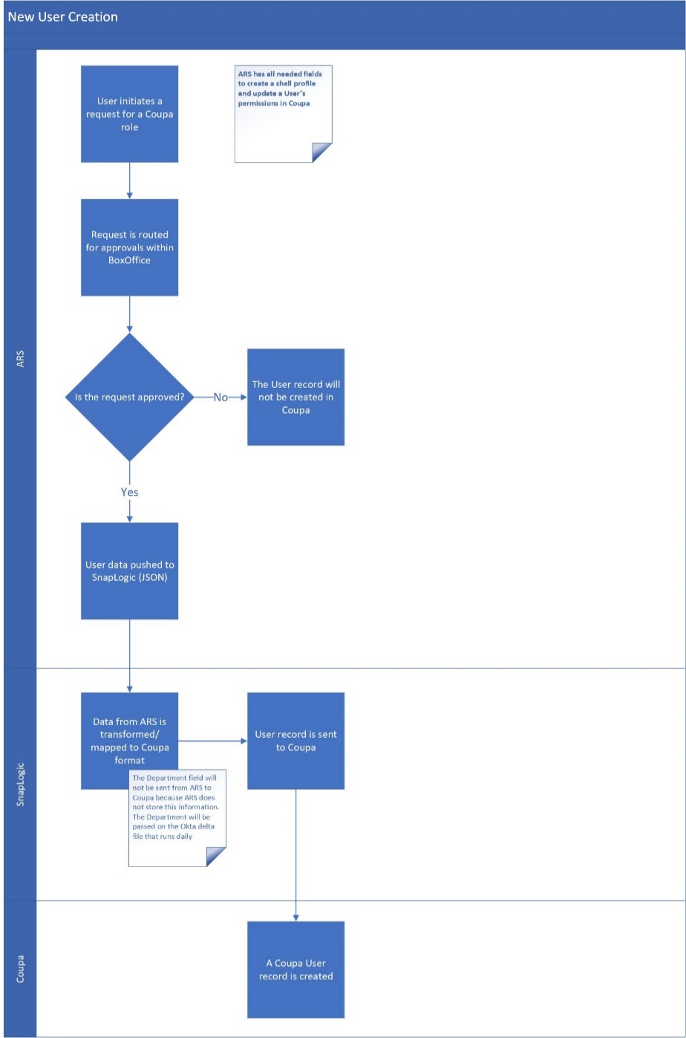
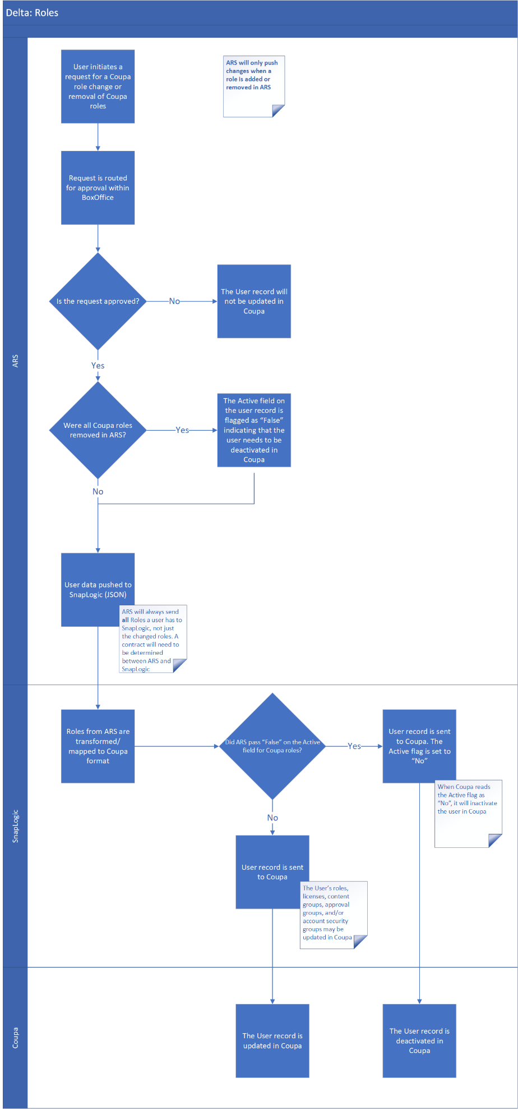

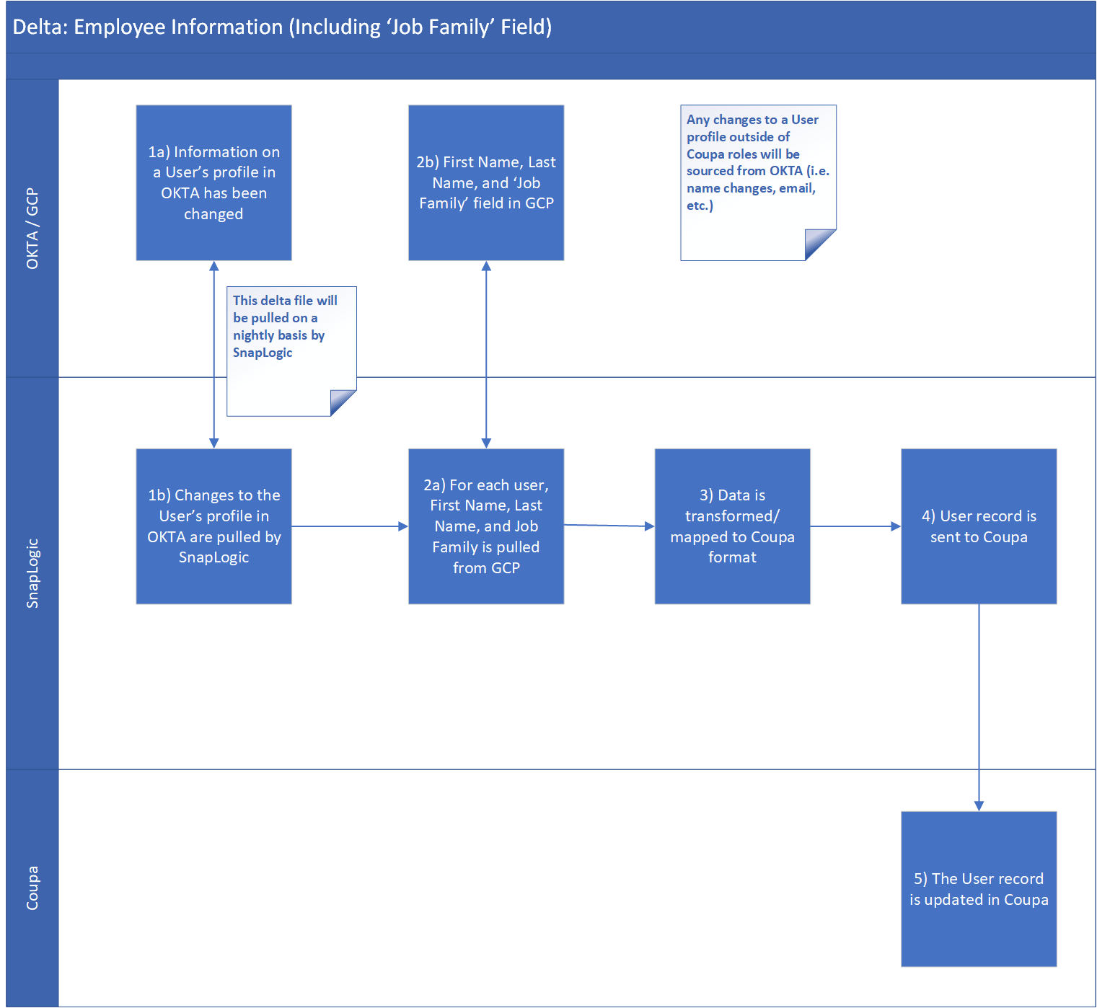

Coupa Business Process Description
An integration will run when a new user is added or altered in ARS. The integration will run daily for delta changes in OKTA and GCP. More info on this integration can be found at: https://success.coupa.com/Integrate/Technical_Documentation/CSV/Import/Users

Dependencies & Assumptions
Assumption 1 | Coupa will adhere to SOC 2 Compliance managed by ARS

SnapLogic

SnapLogic – ARS Interface Technology Overview

Requirement Details

Snap Pipeline Name | pl_ars_to_coupa_users
Brief Description | This Pipeline is called by ARS upon user role changes.  The Pipeline checks if the user exists in Coupa, converts User data from ARS to the format needed by Coupa, and then creates or updates the User in Coupa.  At any given time, the interface gets called with just one user details.
Business Processes Supported | Source to Procurement Processes in Coupa
Interface Frequency and Transaction Volume | Refer to the Functional Section above: Business Overview

Source
- This pipeline is called by ARS using the triggered task URL. Upon being called by ARS, the data received by the API call is received in a Router Snap and copied to an S3 bucket for traceability purposes if the debug parameter is set to ‘Y’ in the config file.

Target
- The target for this Pipeline is Coupa. The Pipeline reads from Coupa to check whether a user exists in Coupa or not. If the user does not exist, the Pipeline uses a REST Post Snap which sends the user data to Coupa to create the user. If the user exists, the Pipeline uses a REST Put Snap which sends the user data to update the existing user in Coupa.
- The Pipeline ends with a Union Snap that returns the status (Y or N) and a status message to ARS.
- The only difference for the output sent to Coupa is that a user update will include the Coupa ID, but a new user will not.

Sample File Structure sent to Coupa:
The file structure is determined by below attached ARS Role Mapping:

Snap Process Flowchart for Pipeline :

An error pipeline will be used to handle errors.

Infrastructure Details:
System Development & Support Tools/Software
Tool/Software | Version | Vendor
SnapLogic | 4.22 | SnapLogic

Snaps
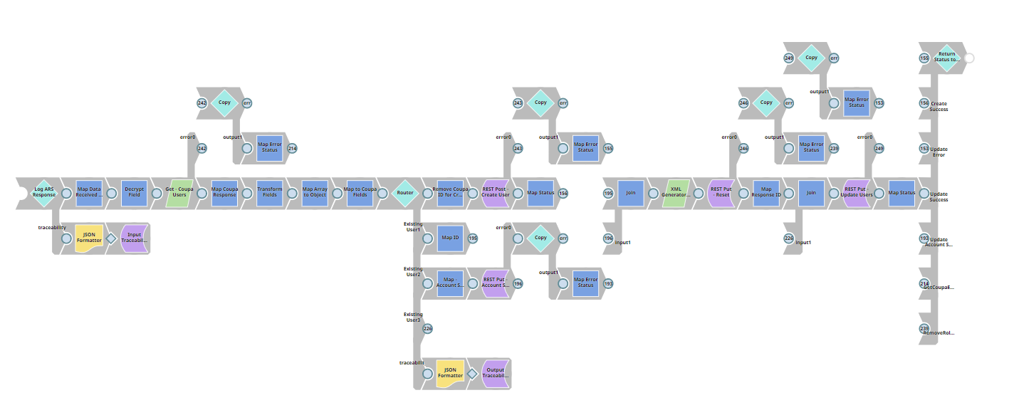

Below is the list of Snaps used in the ARS Pipeline:

S.no | Label | Snap Type Used | Functionality
1 | Log ARS Response | Router | Receives data from ARS and routes to traceability Snaps if the debug parameter is set to ‘Y’
2 | Map Data Received from ARS | Mapper | This Snap will be used to map the data returned from ARS when it calls the Pipeline.
3 | REST Get - Coupa Users | REST Get | This Snap will send the User ID to Coupa and the response will be used to determine if the user is a new or existing user.
4 | Map Coupa Response | Mapper | This Snap maps the response returned from Coupa
5 | Transform Fields | Mapper | This Snap maps and transforms the data returned from ARS to the format needed by Coupa.
6 | Map Array to Object | Mapper | Convert roles, approval groups, and content groups to the format needed by Coupa
7 | Map to Coupa Fields | Mapper | Map to the final fields required by Coupa
8 | Router | Router | This Snap will route the documents to the New User output view if the user does not exist in Coupa or to the Existing User output view if the user does exist in Coupa, and routes to the traceability output Snaps if the debug parameter is set to ‘Y’.
9 | Remove Coupa ID for Create | Mapper | Removes ID for new users since that field does not exist and isn’t sent to Coupa
10 | Rest POST – Create User | REST Post | Creates the new user in Coupa
11 | Map Status | Mapper | Maps status of ‘Y’ and success message to return to ARS
12 | Map Error Status | Mapper | Maps status of ‘N’ and error message to return to ARS
13 | REST Put - Account Security Type | REST Put | Resets account security type in Coupa for an existing user so that it can be updated
14 | REST Put – Reset | REST Put | Resets roles, content groups, account groups, and approval groups in Coupa for an existing user so they can be updated
15 | REST Put – Update Users | REST Put | Updates the existing user in Coupa with the transformed data from ARS
16 | Return Status to ARS | Union | Returns the status and message to ARS
17 | Decrypt Field | Decrypt Field | Decrypt the api key before api call

Task & Pipelines
SnapLogic Asset Name | Type of Artifact | Description
pl_ars_to_coupa_users | Pipeline | ARS Users Pipeline
tk_ars_to_coupa_users | Task | ARS Users Task
s2p_properties.expr | Config File | The config file will be used to set environment properties and expressions that will be used across all S2P SnapLogic integrations.
s2p_error_properties.expr | Config File | This config file will be used to handle error logic (errors, reasons, and resolutions) and will be used across all S2P SnapLogic integrations.
pl_s2p_error_handler | Pipeline | Handles any unexpected errors like SFTP or SAP not accessible or wrong format data received from SAP etc.
pl_ars_to_coupa_users_ut | Pipeline | Unit test pipeline that covers various test cases
pl_ars_to_coupa_users_ut | Pipeline | Unit test pipeline per Tyson standards for CI/CD process validation
TBD – AWS S3 | Accounts | AWS S3 bucket for retriggerable SFTP failures that will hold all files to retrigger in the event of an SFTP failure. This will be used across all S2P integrations.
ac_encrypt_passphrase | Account | Used to encrypt/decrypt message

Snap End Point Settings

End Point Security
Communication between the SnapLogic Integration Cloud, the control plane, and the on-premises processing components is established via SSL encryption on port 443. Communication between the control plane and cloud-based processing components is over HTTPS. The SnapLogic platform communicates with the data plane over HTTPS.

Source Snap Connector Settings
The Pipeline is triggered via ARS. The first Router Snap has an open input view to receive data from ARS.

Target Snap Connector Settings
The Pipeline Target is either a REST Post or a REST Put Snap based on whether or not the user exists already in Coupa.

The Pipeline ends with a Union Snap that merges the status from the New User and Existing User document streams and returns the status to ARS.

Snap Connector Type: REST Post

Property | Description | Value
Label | The Name for the Snap. | REST Post – Create User
Service URL | The service endpoint URL of the REST API call that you want to make. | lib.conf.getAppConf('coupa').baseurl + lib.conf.getAppConf('coupa').users.apipath
HTTP Header | Use this fieldset to create the HTTP header key-value pairs required for defining the headers for different types of input | Key: X-COUPA-API-KEY  Value: lib.conf.getAppConf('coupa').coupaapikey  Key: content-type  Value: application/json  Key: accept  Value: application/json

Snap Connector Type: REST Put

Property | Description | Value
Label | The Name for the Snap. | REST Put – Update Users
Service URL | The service endpoint URL of the REST API call that you want to make. | lib.conf.getAppConf('coupa').baseurl + lib.conf.getAppConf('coupa').users.apipath+"/"+$id
HTTP Header | Use this fieldset to create the HTTP header key-value pairs required for defining the headers for different types of input | Key: X-COUPA-API-KEY  Value: lib.conf.getAppConf('coupa').coupaapikey  Key: content-type  Value: application/json  Key: accept  Value: application/json

Error Handling

Cronacle Failures
The errors below will be handled by Cronacle:
- Pipeline Execution Failures
- Node Failures

Pipeline Failures
- We have augmented the standard Tyson SnapLogic error handling pipeline which has been renamed for this project to include the project name: pl_s2p_errorhandler
- This error pipeline logs errors and sends an email notification including links to SnapLogic and Splunk. Here is a sample of a logged error in Splunk:
Sample UID: 5b90546266ef27321c1e718f_cf422e63-c834-42a2-b88a-928cfb4e3955
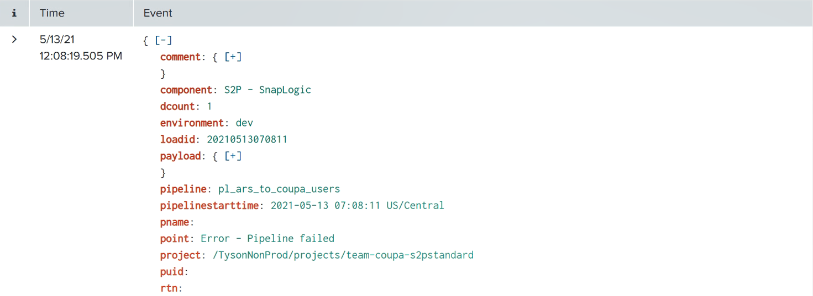
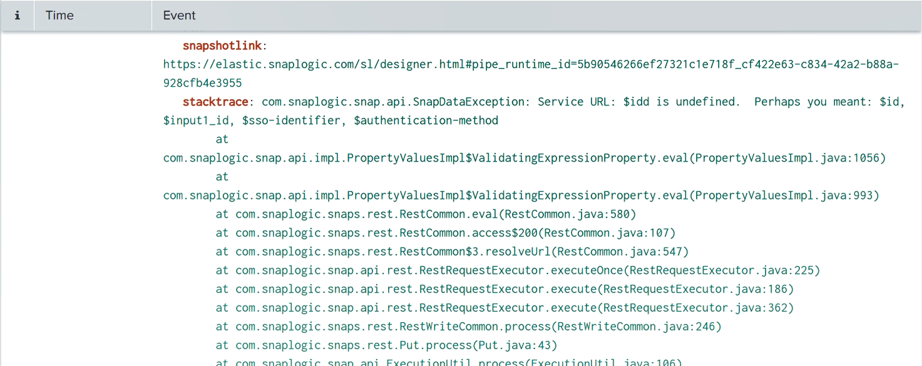

- Email notifications can be turned on and off and email address for error notifications can be configured in the config file: s2p_properties.expr
- Parameters for the error pipeline are listed below:
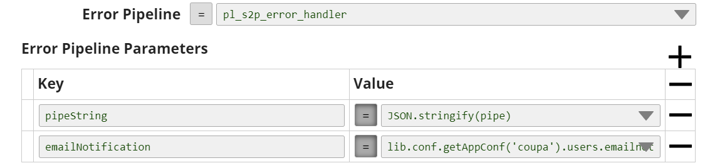
- An example error notification email is below:
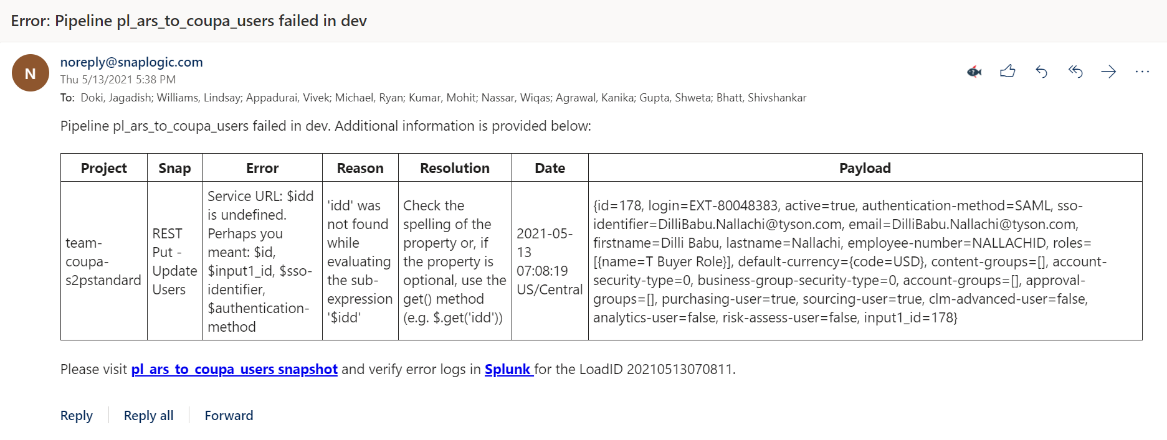

The below errors will be captured by the standard error pipeline:
- Mapping Failures

Rerun Scenarios
In case of failures, the Pipeline returns a status of ‘N’ and an error message to ARS. ARS will need to retrigger.

Cross Reference
Type | Data Information Subject

Scheduling
This Pipeline will run in near real-time with ARS pushing updates to SnapLogic by calling the triggered task for this Pipeline. ARS will call SnapLogic upon a change to a user role (creation, deletion, update).

Assumptions & Issues
- TBD

Performance Considerations
- TBD

SnapLogic Test Cases

Unit Test cases are attached in Teams:
- File name: Tyson_Users_OKTA_GCP_Users_to_Coupa_Unit Testing
- Link

SnapLogic – Okta Interface Technology Overview

Requirement Details
Snap Pipeline Name | pl_okta_to_coupa_users
Brief Description | The Pipeline calls Okta via REST API to get User data available in Coupa group, including Department, then reads User data from Coupa to get the Coupa User ID, converts Okta data to the format needed by Coupa, and updates the Coupa User with the data from Okta.  This pipeline invokes pl_gcp_to_coupa_users and if user exists in GCP then it overrides the value for First Name, Last Name and Department received from Okta
Business Processes Supported | Source to Procurement Processes in Coupa
Interface Frequency and Transaction Volume | Refer to the Functional Section above: Business Overview

Source
- The source of this Pipeline is Okta. This Pipeline uses a REST Get Snap to connect to Okta via an API.

Target
- The target for this Pipeline is Coupa. This Pipeline uses a REST Put Snap to update user data in Coupa.
- The lastsuccesstimestamp is stored in SLDB after a successful Coupa Update and is used in the next run to update only those users modified after this lastsuccesstimestamp (especially for Delta loads).

Sample File Structure sent to Coupa:
[
{
"login": "EXT-80050021",
"authentication-method": "SAML",
"sso-identifier": "Jagadish.Doki@tyson.com",
"email": "Jagadish.Doki@tyson.com",
"firstname": "Jagadish",
"lastname": "Doki",
"employee-number": "",
"default-currency": {
"code": "USD"
},
"department": {
"name": "KPMG"
},
"input1_employee-number": "EXT-80050021",
"id": 174
},
{
"login": "EXT-80050018",
"authentication-method": "SAML",
"sso-identifier": "Lindsay.Williams@tyson.com",
"email": "Lindsay.Williams@tyson.com",
"firstname": "Lindsay",
"lastname": "Williams",
"employee-number": "",
"default-currency": {
"code": "USD"
},
"department": {
"name": "KPMG"
},
"input1_employee-number": "EXT-80050018",
"id": 171
}
]

Snap Process Flowchart for Pipeline :
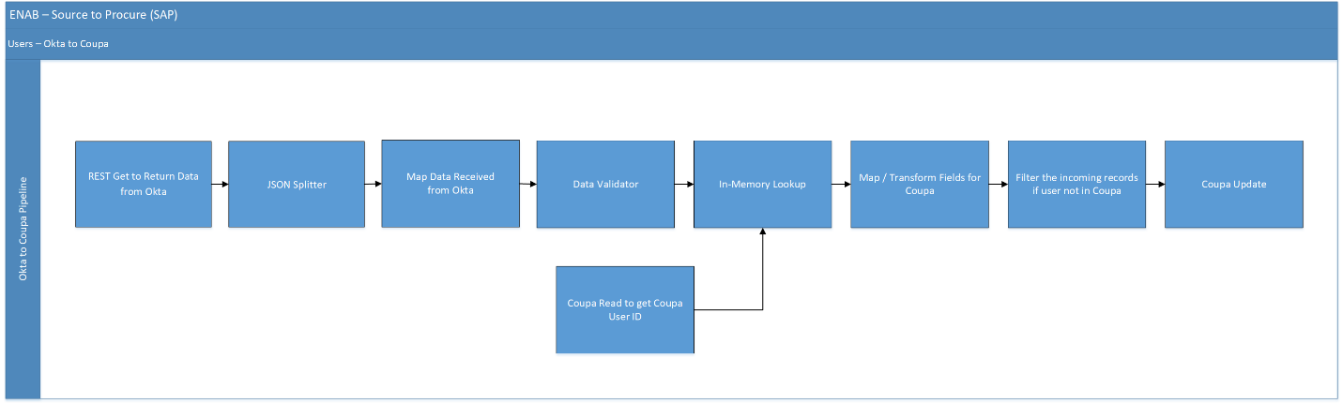

An error pipeline will be used to handle errors.

Infrastructure Details:
System Development & Support Tools/Software
Tool/Software | Version | Vendor
SnapLogic | 4.22 | SnapLogic

Snaps
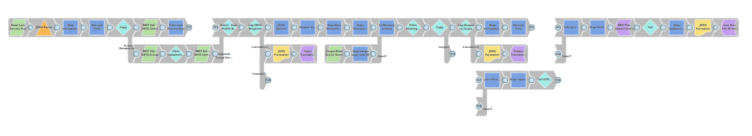

Below is the list of Snaps used in the Okta Pipeline:

S.no | Label | Snap Type Used | Functionality
1 | Read Last Success Run | File Reader | This Snap will Read Last Success Run timestamp from previous run
2 | JSON Parser | JSON Parser | This snap is used to parse the Last Success Run timestamp value which is in JSON format
3 | Copy | Copy | To copy the input flow to different flow
4 | REST Get - OKTA Users | REST Get | This Snap will call Okta via a REST API to return user data from Okta.
5 | REST Get - OKTA Group | REST Get | This Snap will call Okta via a REST API to return user data from Okta.
6 | Filter lastSuccessRunTimestamp | Filter | This snap will filter out the records which are having last updated date > the Last Success Run timestamp
7 | FilterUpdatedLastMembership | Filter | This snap will filter out the records which are having last Membership date > the Last Success Run timestamp
8 | REST Get - OKTA Users-UpdatedGroupMember | REST Get | This Snap will call Okta via a REST API to return user data from Okta.
9 | FilterLastSuccessRun | Mapper | To Map only Last Updated User Profile records
10 | Union-UserProfile-UpdatedMembership | Union | To combine User Profile flow and updated Group Membership flow
11 | Log OKTA Response | Router | This snap will route the execution to main (updating users in coupa) and debug routes; i.e when the debug flag is set to ‘Y’ (for logging the REST Get response in SLDB)
12 | Unique-UserProfiles | Unique | Get Unique records from input
13 | JSON Formatter | JSON Formatter | This snap is used to format the OKTA REST Get response into a json file to store in SLDB
14 | File Writer | File Writer | This snap is used to write the json file in SLDB appended with timestamp for debugging logs
15 | JSON Splitter | JSON Splitter | This Snap will split the response from Okta into each user record.
16 | Map Data Received from Okta | Mapper | This Snap will be used to map the data returned from Okta as expected in Coupa.
17 | Data Validator : Checks Required Fields | Data Validator | This Snap will validate the required fields have been returned from ARS.
18 | Coupa Read Users | Coupa Read | This Snap will get users from Coupa
19 | Map Coupa Login and ID | Mapper | This snap is used to capture user id and login details received from Coupa Read snap
20 | In-Memory Lookup | In-Memory Lookup | This Snap will join the user data returned from Okta with the User IDs from Coupa
21 | Filter Existing Users in Coupa | Filter | This Snap will filter out the incoming records if the user does not exist in Coupa
22 | Coupa Update Users | Coupa Update | This Snap will update the User Record in Coupa
23 | Tail | Tail | This snaps is used to read the last record
24 | Map lastSuccessRunTimestamp | Mapper | This snap is used to capture the pipe.startTime for lastSuccessRunTimestamp
25 | JSON Formatter | JSON Formatter | This snap is used to format the lastSuccessRunTimestamp into a json file to store in SLDB
26 | Last Run File Writer | File Writer | This snap is used to write the json file in SLDB to be used in the next run to filter records with lastupdate timestamp value > than lastSuccessRunTimestamp
27 | Map encrypted Key | Mapper | Map encrypted api key
28 | Decrypt Field | Decrypt Field | Decrypt the api key before api call
29 | Call-GCP_To_Coupa_Users | Pipeline Execute | To Call GCP User Pipeline
30 | Join-OktaUser-Traceability | Join | This snap will join the Traceability flow and User Exist flow
31 | Left-Join-GCPUser-OktaUser | Join | This snap will do left outer join b/w Okta user flow and GCP user flow.

Task & Pipelines
SnapLogic Asset Name | Type of Artifact | Description
pl_okta_to_coupa_users | Pipeline | Okta Users Pipeline
tk_okta_to_coupa_users | Task | Okta Users Task
s2p_properties.expr | Config File | The config file will be used to set environment properties and expressions that will be used across all S2P SnapLogic integrations.
s2p_error_properties.expr | Config File | This config file will be used to handle error logic (errors, reasons, and resolutions) and will be used across all S2P SnapLogic integrations.
pl_s2p_error_handler | Pipeline | Handles any unexpected errors like SFTP or SAP not accessible or wrong format data received from SAP etc.
pl_s2p_abac_handler | Pipeline | Standard pipeline per Tyson’s standards to be included to handle splunk writes and general error handling
pl_okta_to_coupa_users_ut | Pipeline | Unit test pipeline per Tyson standards for CI/CD process validation
pl_gcp_to_coupa_users | Pipeline | Pipeline to get Job Family Details
DAAS_s2p_okta_to_coupa_users | External Job | The job that calls our task to execute pipeline process
TBD | Accounts | AWS S3 bucket for retriggerable SFTP failures that will hold all files to retrigger in the event of an SFTP failure. This will be used across all S2P integrations.
ac_encrypt_passphrase | Accounts | Used to encrypt/decrypt message

Snap End Point Settings

End Point Security
Communication between the SnapLogic Integration Cloud, the control plane, and the on-premises processing components is established via SSL encryption on port 443. Communication between the control plane and cloud-based processing components is over HTTPS. The SnapLogic platform communicates with the data plane over HTTPS.

Source Snap Connector Settings
The Pipeline makes a REST Get Snap to call Okta for user data.

Snap Connector Type: REST Get

Property | Description | Value
Label | The name for the Snap. | REST Get - OKTA Users
Service URL | The service endpoint URL of the REST API call that you want to make. | lib.conf.getAppConf('okta').baseurl + lib.conf.getAppConf('okta').apipath + "users"
Process array | Select to produce a stream of documents with one record in each document | Unchecked
Trust all certificates | Trust all certificates, such as self-signed certificates. | Unchecked
Follow redirects | Select this check box to instruct the Snap to follow redirects. | Checked
Query parameters | Use to add query parameters to your request. | Limit = 1000000
HTTP Header | Use this fieldset to create the HTTP header key-value pairs required for defining the headers for different types of input (e.g. JSON, PDF, DOCX) | Authorization : lib.conf.getAppConf('okta').oktaapikey  Accept : application/json
Response entity type | This field allows you to select the response entity type in the output document | DEFAULT
Read timeout | The number of seconds for which the Snap waits before aborting the request due to a failure to read from the target service. | 900
Connection timeout | The number of seconds for which the Snap waits before aborting the request due to a failure to establish a connection to the target endpoint or service. | 30
Maxinum request attempts | The maximum number of attempts that the Snap must make to receive a response. If the attempts do not result in a response, the Snap terminates the request. | 5
Retry request interval | The number of seconds for which the Snap waits between two successive requests. A retry happens only when the previous attempt resulted in an exception. | 3
Retry policy | Select how you want to handle connection and error responses | Connection Errors
Normalize URL | Select this check box to normalize the Service URL. This enables the Snap to convert double slashes (//) in the URL path to single slash (/). | Checked
Has next | The property in the API response that indicates whether there are more records to be fetched. This property is used for the REST Get pagination feature, which retrieves 20 records at a time (referred to as a page), by default. | N/A
Next URL | Enter the expression that is evaluated on the output document to a URL that the Snap must use to get the next page. This property is used for the REST Get pagination feature. | N/A
Pagination interval(s) | The number of seconds for the Snap to wait before attempting to get the next page. | 0
Show all headers | The REST endpoint may return a response with multiple headers with the same header name. | Unchecked

Target Snap Connector Settings
The Pipeline uses Coupa Update Snap to update user data in Coupa with data from Okta.

Snap Connector Type: Coupa Update

Property | Description | Value
Label | The Name for the Snap. | Coupa Update Users
Response Type | Specifies the level of detail required in the Snap’s output. | all
API Path | The API Name associated with the target resource. | users/:id

Error Handling

Cronacle Failures
The errors below will be handled by Cronacle:
- Pipeline Execution Failures
- Node Failures

Pipeline Failures
- We have augmented the standard Tyson SnapLogic error handling pipeline which has been renamed for this project to include the project name: pl_s2p_errorhandler
- This error pipeline logs errors and sends an email notification including links to SnapLogic and Splunk. Here is a sample of a logged error in Splunk:

https://awslspkidx01.tyson.com:8000/en-US/app/search/search?q=search%20index%3Dtys_snaplogic%20eventtype%3D%22*error*%22%20uid%3D%225b90546266ef27321c1e718f_328c8b5e-0ee5-4092-b25f-07e4b8330b91%22&earliest=1618236443.897&latest=now

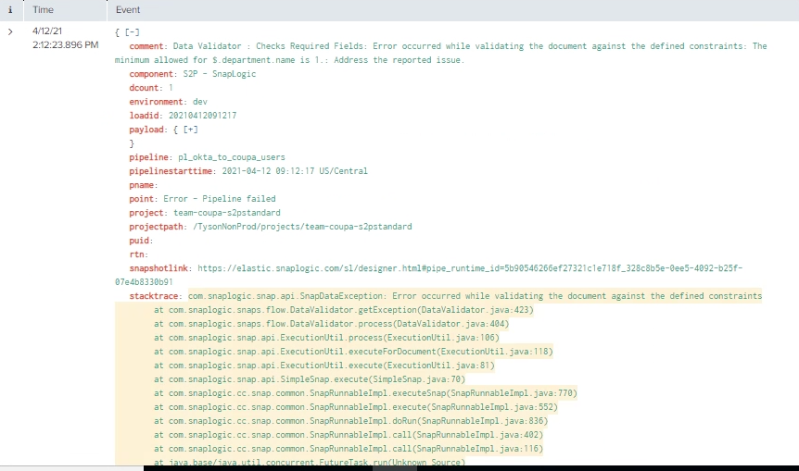

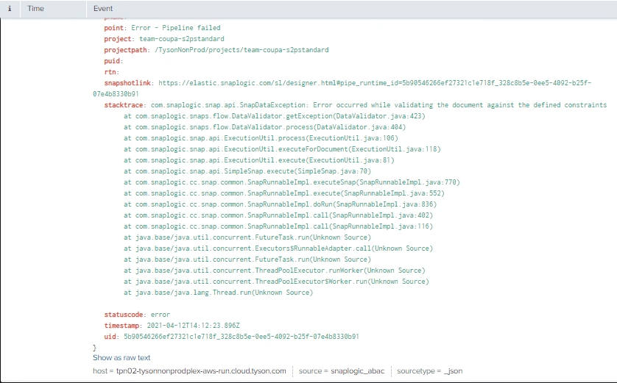

- Email notifications can be turned on and off and email address for error notifications can be configured in the config file: s2p_properties.expr
- Parameters for the error pipeline are listed below:
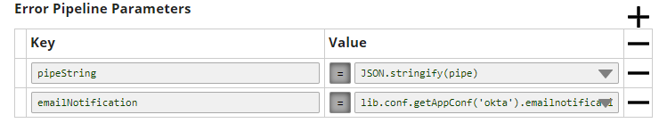
- An example error notification email is below:

The below errors will be captured by the standard error pipeline:
- Connectivity Failures
- Mapping Failures

Rerun Scenarios
- If the interface fails to update an okta user in coupa, an email would be triggered to support staff. Once the issue is fixed in okta, the user information will be processed in next scheduled run.
- In the event of failure of snaplogic pipeline to update the error logs in splunk for a given execution, the last refresh date can be updated in SLDB manually and the user records will be processed from that date onwards.

Cross Reference
Type | Data Information Subject

Scheduling

Initial Load :
The last run timestamp file is to be updated to an older date (Eg. - 1990-01-01T00:00:00.001Z ) to process all the users present in Okta that present in Coupa Group

Delta Load:
This pipeline will be scheduled in Cronacle to run once nightly 8 PM CST.

Assumptions & Issues
- The user is provisioned in ARS and interfaced to coupa through a different Snaplogic pipeline that creates and updates users in coupa core
- The Okta interface design to perform user profile updates in coupa based on the mapping details

Performance Considerations
- TBD

SnapLogic Test Cases

Unit Test cases are attached in Teams:
- File name: SnapLogic_Tyson_Users_OKTA to Coupa_Unit Testing.xlsx
https://teams.microsoft.com/_#/xlsx/viewer/teams/https:~2F~2Ftysononline.sharepoint.com~2Fsites~2FProcurementSourcetoProcure~2FShared%20Documents~2FInterfaces~2F3%20Users~2FSnapLogic_Tyson_Users_OKTA%20to%20Coupa_Unit%20Testing.xlsx?threadId=19:4d6bc54903d24eae84f43f085390064c@thread.tacv2&baseUrl=https:~2F~2Ftysononline.sharepoint.com~2Fsites~2FProcurementSourcetoProcure&fileId=c791f383-1c7e-4942-80de-6b2fb3019e9c&ctx=files&rootContext=items_view&viewerAction=view

SnapLogic – GCP Interface Technology Overview

Requirement Details
Snap Pipeline Name | pl_gcp_to_coupa_users
Brief Description | The Pipeline queries GCP via BigQuery Execute snap to get existing User data, including Job Family, then sends it to Okta User Interface. User details from GCP override the details received from Okta for First Name, Last Name and Department.
Business Processes Supported | Source to Procurement Processes in Coupa
Interface Frequency and Transaction Volume | Refer to the Functional Section above: Business Overview

Source
- The source of this Pipeline is GCP BigQuery. This Pipeline uses a BigQuery Execute Snap to read user data from Data hub.

Target
- This pipeline is executed by Okta User Pipeline, and it returns First Name, Last Name and Job Family to pl_okta_to_coupa_users.

Snap Process Flowchart for Pipeline :

An error pipeline will be used to handle errors.

Infrastructure Details:
System Development & Support Tools/Software
Tool/Software | Version | Vendor
SnapLogic | 4.22 | SnapLogic

Key Snaps Used
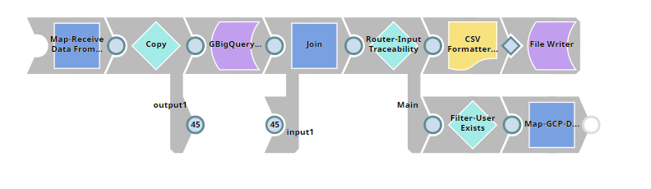

Below is the list of Snaps used in the GCP Users Pipeline:

S.no | Label | Snap Type Used | Functionality
1 | Map-Receive Data From Okta | Mapper | This Mapper has open ended view to receive input from Okta pipeline.
2 | Map-Receive Data From Okta | Google Big Query | This Snap will check existing user in GCP and get Job Family records
3 | Join-BQueryAndMapInput | Join | This Snap will join the Mapper input and GCP output
4 | Router-Input Traceability | Router | This Snap will route data to Main or Debug Traceability flow.
5 | Filter-User Exists | Filter | This snaps is used to check If user exists in GCP or not
6 | Map-GCP-DeptEmpToOkta | Mapper | This snaps is used to map field from GCP to Okta user update
7 | CSV Formatter | CSVFormatter | This snap is used to format the lastSuccessRunTimestamp into a json file to store in SLDB
8 | File Writer | File Writer | This snap is used to write the json file in SLDB for debugging

Task & Pipelines
SnapLogic Asset Name | Type of Artifact | Description
pl_gcp_to_coupa_users | Pipeline | GCP Users Pipeline
tk_gcp_to_coupa_users | Task | GCP Users Task
s2p_properties.expr | Config File | The config file will be used to set environment properties and expressions that will be used across all S2P SnapLogic integrations.
s2p_error_properties.expr | Config File | This config file will be used to handle error logic (errors, reasons, and resolutions) and will be used across all S2P SnapLogic integrations.
pl_s2p_error_handler | Pipeline | Handles any unexpected errors like GCP or Coupa not accessible or wrong format data received from GCP etc.
pl_s2p_abac_handler | Pipeline | Standard pipeline per Tyson’s standards to be included to handle splunk writes and general error handling
pl_gcp_to_coupa_users_ut | Pipeline | Unit test pipeline per Tyson standards for CI/CD process validation
DAAS_s2p_gcp_to_coupa_users | External Job | The job that calls our task to execute pipeline process
TBD | Accounts | AWS S3 bucket for retriggerable SFTP failures that will hold all files to retrigger in the event of an SFTP failure. This will be used across all S2P integrations.

Snap End Point Settings

End Point Security
Communication between the SnapLogic Integration Cloud, the control plane, and the on-premises processing components is established via SSL encryption on port 443. Communication between the control plane and cloud-based processing components is over HTTPS. The SnapLogic platform communicates with the data plane over HTTPS.

Source Snap Connector Settings
The Pipeline makes a BigQuery Execute Snap to read user data from Data hub.

Snap Connector Type: BigQuery Execute

Property | Description | Value
Project ID | The project on which the query should be executed | dev-2135-entdatahub-3e44fa
Query | The query that you want to execute on BigQuery for the selected project | "SELECT  employee_id,employee_first_name,employee_last_name,hr_job_family_descr  FROM api.employee WHERE employee_id ='" + $id + "'"
Standard SQL | This checkbox is selected if you want to use the Standard SQL dialect in teh Query field | Checked
Destination dataset ID | Dataset ID of the dataset where the desination table has to be created in case of the query returning large query results | api

Error Handling

Cronacle Failures
The errors below will be handled by Cronacle:
- Pipeline Execution Failures
- Node Failures

Pipeline Failures
- We have augmented the standard Tyson SnapLogic error handling pipeline which has been renamed for this project to include the project name: pl_s2p_errorhandler
- This error pipeline logs errors and sends an email notification including links to SnapLogic and Splunk. Here is a sample of a logged error in Splunk:
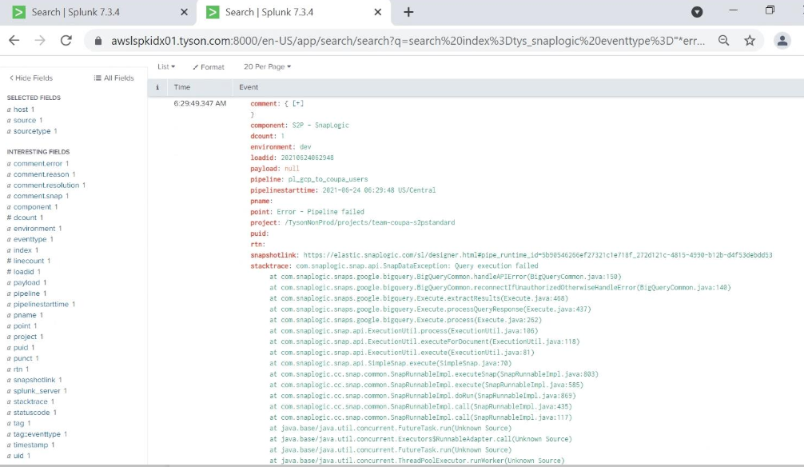
- Email notifications can be turned on and off and email address for error notifications can be configured in the config file: s2p_properties.expr
- Parameters for the error pipeline are listed below:
- An example error notification email is below:
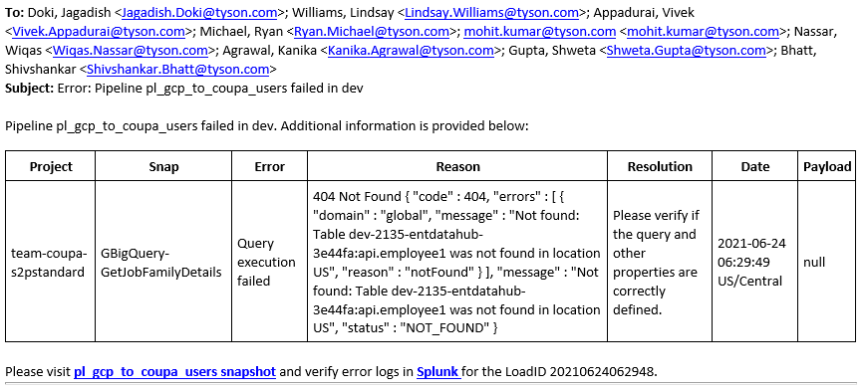

The below errors will be captured by the standard error pipeline:
- Connectivity Failures
- Mapping Failures
- Google BigQuery Execute errors

Rerun Scenarios
- If the interface fails to update an user in coupa using details from GCP, an email would be triggered to support staff. Once the issue identified and fixed, the user information will be processed in next scheduled run.
- In the event of failure of snaplogic pipeline to update the error logs in splunk for a given execution, the last refresh date can be updated in SLDB manually and the user records will be processed from that date onwards.

Cross Reference
Type | Data Information Subject

Scheduling

Initial Load :
The last run timestamp file is to be updated to an older date (Eg. - 1990-01-01T00:00:00.001Z ) to process all the users present in GCP that present in Coupa Group.

Delta Load:
This pipeline will be scheduled in Cronacle to run once nightly 8 PM CST.

Assumptions & Issues
- The user is provisioned in ARS and interfaced to coupa through a different Snaplogic pipeline that creates and updates users in coupa core
- The GCP interface design to perform Job Family updates in coupa based on the mapping details

Performance Considerations
- TBD

SnapLogic Test Cases

Unit Test cases are attached in Teams:
- File name: SnapLogic_Tyson_Users_GCP to Coupa_Unit Testing.xlsx

Appendix

Glossary of Terms

Term | Definition

