Aim
To simulate cross-correlation and autocorrelation on discrete-time signals using Python and observe the similarity between signals.

Theory

Correlation
Correlation is the measure of similarity between two signals or waveforms. It is widely used in signal processing, image processing, and pattern recognition.
There are two types of correlation:
- Cross Correlation
- Auto Correlation

Cross Correlation
Cross-correlation measures the similarity between two different discrete-time signals as one signal is shifted in time with respect to the other.
Formula
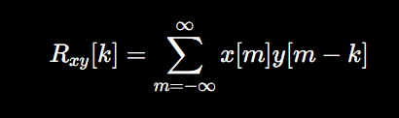
Applications:
- Signal detection
- Noise reduction
- Pattern matching
- Radar and communication systems

Autocorrelation
Autocorrelation measures the similarity of a signal with its own delayed version.
Formula
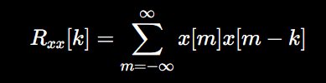
Applications:
- Power estimation
- Radar
- Sonar
- Wireless communication systems
Code:
import numpy as np
import matplotlib.pyplot as plt

def cross_correlation(signal1, signal2):
# Compute cross-correlation
cross_corr = np.correlate(signal1, signal2, mode='full')
return cross_corr

def autocorrelation(signal):
# Compute autocorrelation
auto_corr = np.correlate(signal, signal, mode='full')
return auto_corr

# Define discrete-time signals
signal1 = np.array([1, 2, 3, 4, 5])
signal2 = np.array([2, 4, 6, 8, 10])

# Compute correlations
cross_corr = cross_correlation(signal1, signal2)
auto_corr = autocorrelation(signal1)

# Plot results
plt.figure(figsize=(10,6))

plt.subplot(2,1,1)
plt.stem(cross_corr)
plt.title("Cross-correlation")
plt.xlabel("Time Lag")
plt.ylabel("Magnitude")

plt.subplot(2,1,2)
plt.stem(auto_corr)
plt.title("Autocorrelation")
plt.xlabel("Time Lag")
plt.ylabel("Magnitude")

plt.tight_layout()
plt.show()
Output:
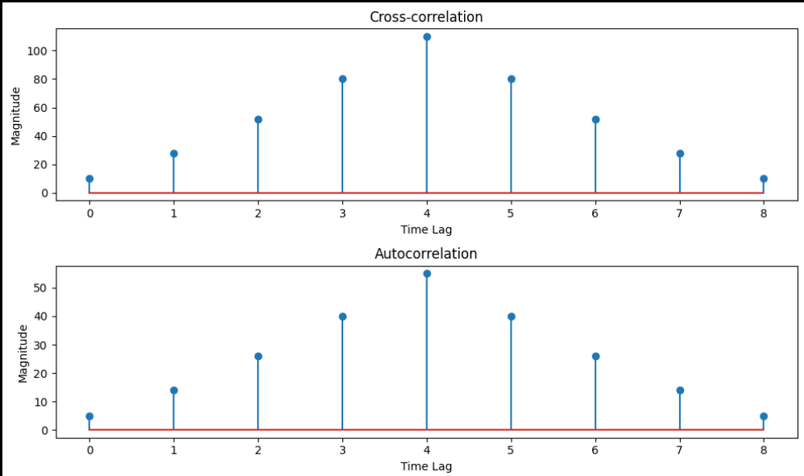

Output
- Cross-correlation graph
- Autocorrelation graph

Result
The cross-correlation and autocorrelation of the given discrete-time signals were successfully simulated using Python. The corresponding correlation sequences were obtained and displayed using stem plots, verifying the similarity between the signals and the self-similarity of the signal.

Conclusion
The experiment was performed successfully to simulate cross-correlation and autocorrelation on discrete-time signals. It was observed that cross-correlation measures the similarity between two different signals, while autocorrelation measures the similarity of a signal with itself. The generated plots clearly demonstrated these properties, confirming the correct implementation of the correlation functions in Python.

