**Title: Gym Management System**

1. **Introduction**

The Gym Management System (GMS) is an all-in-one software solution crafted to address the complex needs of modern fitness centers and gyms. By automating and simplifying various aspects of gym management, this system aims to improve operational efficiency, enhance member experience, and provide valuable insights for decision-making.

1. **Core Features:**
2. **Person:**

* **NAME:** In the context of databases and software systems, name usually refers to a field or attribute that stores the name of a person, entity, or object.
* **EMAIL:** In databases and software systems, email typically refers to a field or attribute that stores a person's email address.
* **PHONE_NO:** In databases and software systems, phone_no (or phone_number) refers to a field or attribute that stores an individual's or entity's telephone number.

1. **Member:**
   * **MEMBER_ID:** Allows gym staff to easily register new members, capturing essential information such as personal details, contact information, and membership type.
   * **PREFERENCE:** Type of training registered by a member such as cardio, yoga, aesthetic, heavy lifter, or strength training.
2. **Specification:**
   * **SPECIFICATION:** Allows members to view available classes and book their spots, with options for managing bookings, cancellations, and waitlists.
   * **DESCRIPTION:** Enables gym staff to modify or cancel classes, update class details, and handle last-minute changes.
   * **SCHEDULE:** typically refers to a plan or timetable for events, activities, or tasks.
3. **Trainer:** 
   * **TRINER_ID:** In a gym management system or similar context, trainer_id refers to a unique identifier assigned to a personal trainer.
   * **SPECIALIZATION:** It refers to the specific area of expertise or focus that a trainer has within their field.
4. **Payment History:**
   * **PAYMENT_ID:** It refers to a unique identifier assigned to a specific payment transaction.
   * **SUBSCRIPTION:** It refers to the quantity of money involved in a transaction or record.
   * **PAYMENT DATE:** It refers to the specific date on which a payment transaction is recorded or processed.
5. **Equipment:**

* **EQUIPMENT_ID:** A unique identifier assigned to each piece of equipment. It serves as a primary key in the database to ensure that each equipment item can be uniquely identified and referenced.
* **EQUIPMENT_NAME:** The name or description of the equipment. It typically includes details that help identify the equipment, such as "Treadmill," "Dumbbell Set," or "Elliptical Machine."
* **CONDITION:** Describes the state or quality of the equipment. Common values might include "New," "Good," "Fair," "Poor," or "Needs Repair."
* **QUANTITY:** The number of units of the equipment available. This indicates how many pieces of a particular type of equipment are in stock or currently available.

1. **Implementation Considerations:**
2. Cardinalities:

1:N: One member can make multiple payments.

N:M: Multiple members can attend the same class, and one member can attend multiple classes.

M:M: One trainer can conduct multiple classes, and multiple trainers can conduct the same class.

N:M: A class can utilize multiple pieces of equipment, and one piece of equipment can be used in multiple classes.

1. Relationships:

MEMBER MAKES PAYMENT: A member can make one or more payments.

MEMBER ATTEND CLASS: A member can attend one or more classes.

MEMBER USES EQUIPMENT: A member can use one or more equipment.

CLASS CONDUCTS TRAINER: A class is conducted by one or more trainers.

CLASS USES EQUIPMENT: A class can utilize one or more equipment.

1. **ER Diagram:**

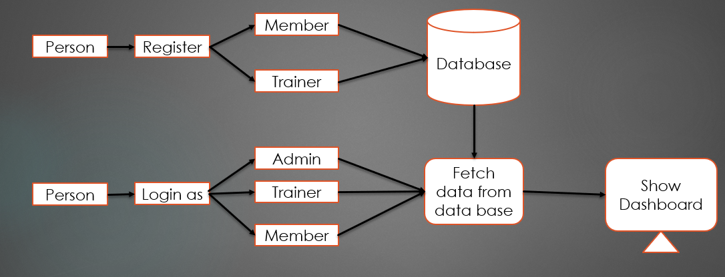

1. **Benefits:**

* **Operational Efficiency:** Reduces administrative workload and operational complexities by automating routine tasks and providing a centralized management platform.
* **Enhanced Member Experience:** Offers a user-friendly interface for members to manage their accounts, book classes, and make payments, leading to higher satisfaction and retention.
* **Informed Decision-Making:** Provides valuable data and insights through reporting and analytics, helping gym managers make informed decisions to drive growth and improve services.
* **Improved Communication:** Facilitates better interaction between gym staff and members through automated notifications, reminders, and updates, fostering a more connected community.