1.What are the two values of the Boolean data type? How do you write them?

🡪 True and False are two Boolean values.

2. What are the three different types of Boolean operators?

🡪 and ,or ,not are three types of Boolean operators.

3. Make a list of each Boolean operator's truth tables (i.e. every possible combination of Boolean values for the operator and what it evaluate ).

🡪 AND operator truth table: OR operator truth table: NOT truth table

|  |  |
| --- | --- |
|  | |
| input | | output | |
| 0 | 0 | 0 | FALSE |
| 0 | 1 | 0 | FALSE |
| 1 | 0 | 0 | FALSE |
| 1 | 1 | 1 | TRUE |

|  |  |  |  |
| --- | --- | --- | --- |
| 0 | 0 | 0 | FALSE |
| 0 | 1 | 1 | TRUE |
| 1 | 0 | 1 | TRUE |
| 1 | 1 | 1 | TRUE |

|  |  |
| --- | --- |
| input | output |

|  |  |
| --- | --- |
| input | output |

|  |  |  |
| --- | --- | --- |
| 0 | 1 | TRUE |
| 1 | 0 | FALSE |

4. What are the values of the following expressions?

(5 > 4) and (3 == 5) -🡪 FALSE

not (5 > 4) 🡪 FALSE

(5 > 4) or (3 == 5) 🡪 TRUE

not ((5 > 4) or (3 == 5)) 🡪 FALSE

(True and True) and (True == False) 🡪 FALSE

(not False) or (not True) 🡪 TRUE

5. What are the six comparison operators?

🡪a) equal to (==) b) greater than (>) c) less than(<)

d) greater than or equal to(>=) e) less than or equal to (<=) f) not equal to (!=)

6. How do you tell the difference between the equal to and assignment operators?Describe a condition and when you would use one.

🡪equal to operator is comparison operator to compare two values whether they are equal or not

and assignment operator is used to assign values to a variable .

7. Identify the three blocks in this code:

spam = 0 🡪 Initialize the variable spam

if spam == 10: 🡪 check whether spam value equal to 10 if yes then go to inside block

print('eggs') 🡪if yes print eggs

if spam > 5: 🡪 if spam value greater than 5 then go to inside block

print('bacon') 🡪 print bacon

else: 🡪 else if spam not greater than 5 nor equal to 10 then go to inside block

print('ham') and print ‘ham ‘ , ‘spam’ and ‘spam’

print('spam')

print('spam')

8. Write code that prints Hello if 1 is stored in spam, prints Howdy if 2 is stored in spam, and prints Greetings! if anything else is stored in spam.

🡪 spam =1

if spam==1:

print ‘Hello’

if spam=2:

print ‘Howdy’

else:

print ‘Greetings!’

9.If your programme is stuck in an endless loop, what keys you’ll press?

🡪 CTRL +C

10. How can you tell the difference between break and continue?

🡪 Break keyword will exit the current loop when condition is met and other statements after break statement will not be executed .Continue statement will skip that single iteration of loop when condition is met and resume the execution of other statements just after it.

11. In a for loop, what is the difference between range(10), range(0, 10), and range(0, 10, 1)?

🡪 range(10) 🡪 start=0 (by default) ,end= 9, step size= 0(by default)

Range(0,10)🡪 start=0 , end=end-1=9 ,step size =0 (by default)

Range(0,10,1) 🡪 start =0 ,end= 9 ,step size =1

12. Write a short program that prints the numbers 1 to 10 using a for loop. Then write an equivalent program that prints the numbers 1 to 10 using a while loop.

🡪 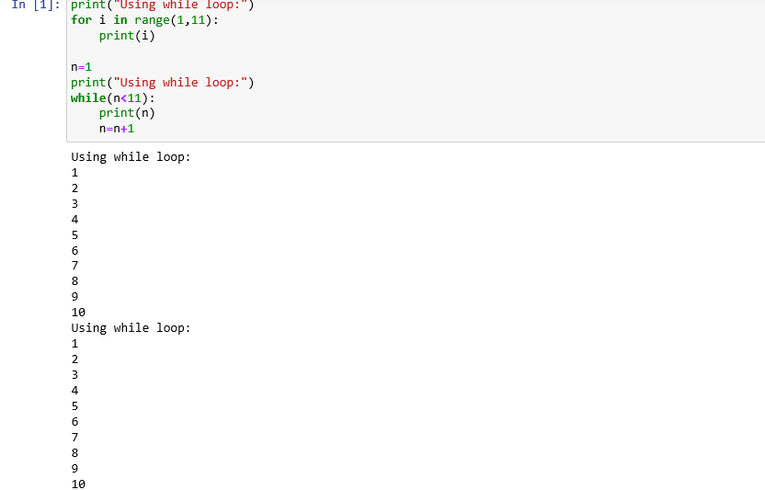

13. If you had a function named bacon() inside a module named spam, how would you call it after importing spam?

🡪import spam as sp

sp.bacon()