Project Work Report On

A Study on Forex, Commodity, and Cryptocurrency Market Analysis through Live Streaming at
THE TRADING FOX
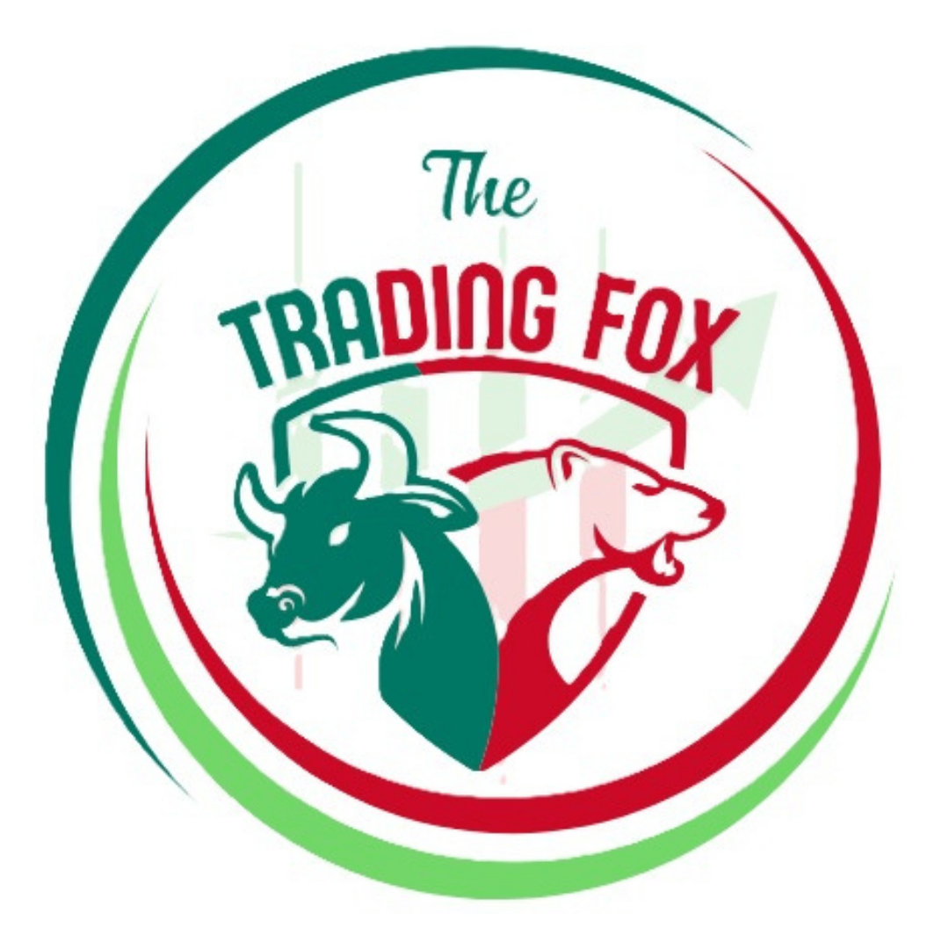

Submitted By – Shivraj singh solanki
Roll No – MBA-RTU-2024-5040
Rajasthan Technical University, Kota
For The Partial Fulfillment for the Requirement of Degree of
Master of Business Administration (MBA)

Under The Guidance of
Dr. Sandeep Vyas

International School of Informatics and Management

“A Study on Forex, Commodity,
and
Cryptocurrency Market Analysis
through Live Streaming”

DECLARATION

I, Shivraj Singh Solanki, hereby declare that the Project Report titled
A Study on Forex, Commodity, and Cryptocurrency Market Analysis through Live Streaming has been prepared by me under the guidance of Dr. Sandeep Vyas, Faculty, Department of MBA, International School of Informatics and Management.
I further declare that this report is submitted in partial fulfillment of the requirements for the award of the degree Master of Business Administration from Rajasthan Technical University, Kota.
I affirm that this project is my original work and has not been submitted, either in full or in part, for a degree or diploma at any other university or institution.

Preface
This project report is prepared as a part of my internship at The Trading Fox, where I worked as a Stock Research Analyst and YouTube Live Streamer. The main purpose of this report is to explain my learning experience, the work I performed during the internship, and the knowledge I gained about financial markets and trading analysis.
During this internship, I got the opportunity to learn about different financial markets such as forex, commodities, and cryptocurrencies. I observed how traders analyze markets using technical and fundamental analysis and how real-time trading insights are shared through YouTube live streaming. This experience helped me understand how market movements work and how traders study price charts to identify possible trading opportunities.
In this report, I have explained the basic concepts of financial markets, trading instruments like gold, silver, and crypto, and the process of analyzing markets during live streaming sessions. I have also shared my learning outcomes, challenges, and practical experiences gained during the internship.
A preface is usually written by the author to explain the purpose and background of the report and to introduce the context in which the work was completed.
I hope this report clearly presents my internship experience and the knowledge I gained during my training at The Trading Fox.

Acknowledgements

I would like to express my sincere gratitude to The Trading Fox for giving me the opportunity to complete my internship as a Stock Research Analyst and YouTube Live Streamer. This internship helped me gain practical knowledge about financial markets, trading analysis, and live streaming. It was a valuable experience that improved my understanding of forex trading, especially in markets such as gold, silver, and cryptocurrencies.
I would also like to thank my mentor and team members at The Trading Fox for their continuous support and guidance during the internship. Their knowledge and advice helped me learn how to analyze market charts, prepare trading ideas, and conduct live streaming sessions confidently.
I am also thankful to my college teachers and academic supervisors for encouraging me to complete this internship and prepare this project report. Finally, I would like to thank my family and friends for their constant motivation and support throughout this journey.
Acknowledgement sections in internship reports are important because they allow students to express gratitude to the people who supported their learning and professional development.

SHIVRAJ SINGH SOLANKI
IIIM (International School of Informatics and Management) ENROLL NO:- MBA -RTU-2024-5040

EXECUTIVE SUMMURY

This internship report presents my experience and learning as a Stock Research Analyst and YouTube Live Streamer at The Trading Fox. The main objective of this internship was to understand financial markets and develop practical skills in market analysis, trading education, and digital communication.
The Trading Fox is an online platform that provides financial market education through live streaming and market analysis. During the internship, I learned how to analyze different financial instruments such as gold, silver, and cryptocurrencies by using both technical and fundamental analysis. I also observed how global economic events, market trends, and trading sessions influence price movements.
One of the most important parts of my internship was participating in YouTube live streaming sessions where market charts were analyzed in real time. In these sessions, I explained market trends, discussed possible trade setups, and answered questions from viewers. This helped me improve my communication skills and confidence while presenting financial information to an online audience.
The internship also helped me understand important concepts such as risk management, trading psychology, and responsible trading practices. It gave me practical exposure to how professional traders observe markets and share knowledge with learners.
An executive summary is a short section that provides a clear overview of the entire report so readers can quickly understand its purpose, key findings, and conclusions.
Overall, this internship was a valuable learning experience that improved my understanding of financial markets and online trading education.

Table of Contents
1. Introduction to Financial Markets
2. About The Trading Fox
3. Internship Overview
4. Role of a Stock Research Analyst
5. Live Streaming in Financial Education
6. Overview of Forex Market
7. Trading Instruments: Gold, Silver, Crypto
8. Technical Analysis Basics
9. Fundamental Analysis
10. Risk Management
11. Live Market Analysis Process
12. YouTube Live Streaming Workflow
13. Audience Engagement Strategies
14. Trading Psychology
15. Trading Tools and Platforms
16. Ethics and Professional Conduct
17. Challenges During Internship
18. Learning Outcomes
19. Case Study: Gold Market Analysis
20. Case Study: Crypto Market Analysis
21. Conclusion
22. References
1. Introduction to Financial Markets
Financial markets are places where people buy and sell financial assets such as stocks, currencies, commodities, bonds, and cryptocurrencies. In simple terms, they act like a marketplace where buyers and sellers meet to trade different financial instruments and decide their prices. These prices are mainly determined by the forces of demand and supply. When more people want to buy an asset, its price usually rises, and when more people want to sell, the price usually falls.
Financial markets play an important role in the economy. They help companies and governments raise money for their projects and development. At the same time, they provide opportunities for investors and traders to grow their money by investing or trading in different assets. By connecting people who have extra money with those who need funds, financial markets support economic growth and business activities.
There are different types of financial markets. The stock market is where shares of companies are bought and sold. When people buy stocks, they own a small part of that company. The forex market (foreign exchange market) is where different currencies are traded, such as the US dollar, euro, or Japanese yen. It is the largest financial market in the world and operates globally.
Another important market is the commodity market, where traders buy and sell physical goods like gold, oil, wheat, and coffee. Commodity prices usually change because of factors such as weather conditions, global demand, and political events. In recent years, the cryptocurrency market has also become popular, where digital currencies like Bitcoin and Ethereum are traded.
Today, most financial markets operate online through electronic trading platforms. This allows traders from different parts of the world to participate in trading at any time. Because of technology, financial markets have become faster, more accessible, and more transparent for individuals and institutions.
In conclusion, financial markets are an essential part of the global economy. They help in the movement of money, support investment opportunities, and allow traders and investors to participate in different financial activities. Understanding financial markets is the first step for anyone who wants to learn trading or investing.

2. About The Trading Fox
The Trading Fox is an online platform that focuses on financial education and trading analysis. Its main goal is to help people learn about different financial markets such as forex (currency trading), commodities like gold and silver, and cryptocurrencies like Bitcoin and Ethereum. The company provides learning resources and market insights so that beginners and experienced traders can understand how the financial market works and make better trading decisions.
The platform mainly teaches trading through live sessions, market explanations, and technical analysis tutorials. These sessions are designed to explain how prices move in the market and how traders can identify possible trading opportunities. Technical analysis is an important part of trading education because it helps traders study price charts, patterns, and indicators to predict future price movements.
One of the key features of The Trading Fox is its YouTube live streaming sessions. In these live sessions, analysts watch the market in real time and explain what is happening with different assets such as gold, silver, currencies, or cryptocurrencies. Viewers can see the charts and price movements while the analyst explains possible trends, support and resistance levels, and trading strategies.
Live streaming makes learning trading easier and more interactive. Instead of only reading about trading, viewers can see how experienced traders analyze the market step by step. During the live stream, the host may also answer questions from viewers and explain difficult trading concepts in simple language. This helps learners understand the market better and build confidence in their trading knowledge.
Another important part of The Trading Fox platform is market breakdowns. A market breakdown means explaining why a market is moving up or down. For example, if the price of gold increases, the analyst might explain how economic news, inflation, or interest rates affected the market. Understanding these reasons helps traders make more informed decisions when buying or selling assets.
The platform also focuses on teaching trading strategies. A trading strategy is a planned method that traders use to enter and exit trades. Strategies may include analyzing chart patterns, identifying trends, and using indicators like moving averages or RSI. Learning these strategies helps traders manage risk and avoid making random decisions in the market.
In addition to strategies, The Trading Fox encourages traders to learn about risk management. Trading can involve financial risk, so it is important to understand how to control losses and protect trading capital. By learning proper risk management techniques, traders can improve their chances of long-term success.Overall, The Trading Fox works as a learning and analysis platform for financial trading. Through live sessions, educational videos, and market explanations, it helps traders understand how financial markets operate. The platform aims to make trading knowledge more accessible so that people can learn how to analyze markets, follow strategies, and develop better trading skills.

3. Internship Overview
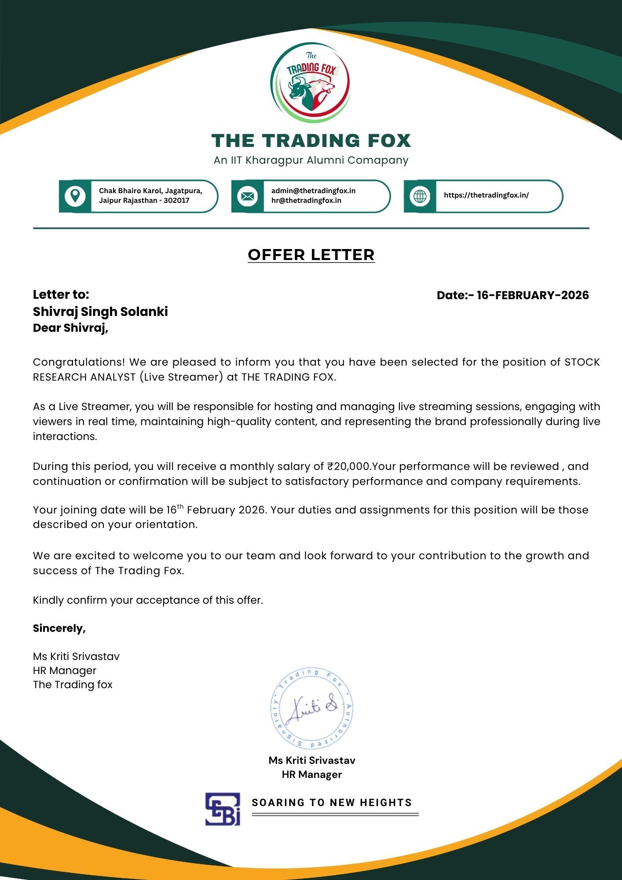
Internship Role and Responsibilities
The internship at The Trading Fox focuses on helping students develop practical skills related to financial markets, communication, and online content creation. During the internship, the intern work as a Stock Research Analyst and YouTube Live Streamer. The main responsibility is to study the financial markets and share useful market insights with viewers in a simple and understandable way.
Financial markets include areas such as stocks, forex, commodities, and cryptocurrencies where traders buy and sell different financial assets. These markets operate based on demand and supply, and their prices change due to economic news, global events, and investor activity.
As part of the internship, the intern regularly monitors market movements and keeps track of important price changes in different assets. This helps in understanding market trends and identifying possible trading opportunities. The intern also prepares charts using technical analysis tools to study price patterns and support or resistance levels.
Another important responsibility is explaining potential trade setups to viewers. This means discussing where a trader might consider buying or selling an asset based on market analysis. The intern presents these ideas during YouTube live streaming sessions, where real-time market discussions take place.
During the live sessions, the intern interacts with viewers by answering their questions and explaining trading concepts in simple language. This helps beginners understand how the markets work and how traders analyze charts before making decisions.
Overall, this internship provides hands-on experience in financial market research, technical analysis, and digital communication. It helps interns improve their analytical thinking, presentation skills, and confidence while discussing live market movements with an online audience.
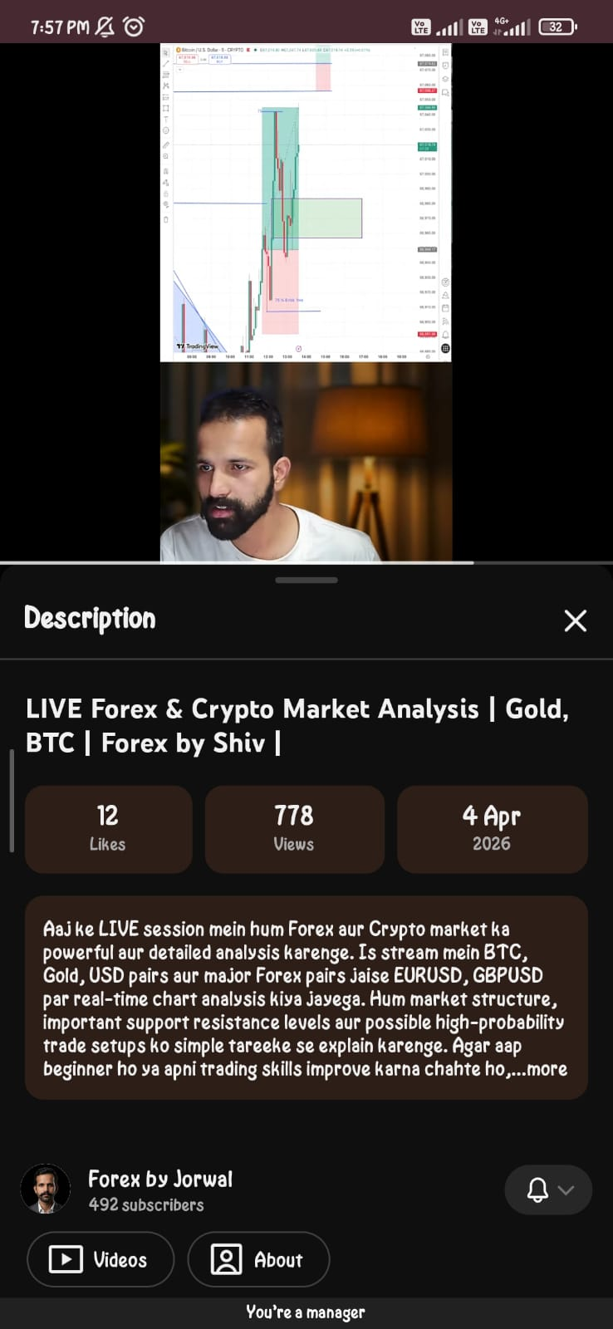

4. Role of a Stock Research Analyst
A Stock Research Analyst is a professional who studies financial markets and different trading instruments to find possible trading opportunities. The main job of the analyst is to collect and study market data, observe price movements, and provide useful insights that help traders make better decisions. Research analysts analyze market trends, economic news, and historical price data to understand how financial assets may move in the future.
To perform this role effectively, a stock research analyst needs a good understanding of market behavior and trading strategies. One of the most important skills is the ability to analyze price charts and patterns. This process is known as technical analysis, where analysts study past price movements and trading volume to identify trends and possible future price changes. By using charts, indicators, and support or resistance levels, analysts try to predict whether the price of an asset may rise or fall.
During the internship, the analyst mainly focuses on short-term trading opportunities. Short-term trading involves analyzing price movements that occur within a short period, such as minutes, hours, or days. The intern studies the forex and commodity markets, with special attention to popular trading instruments like gold and silver. These assets are widely traded because their prices are influenced by global economic conditions, inflation, and geopolitical events.
In addition to commodities, the intern also studies cryptocurrency markets, which include digital assets like Bitcoin and Ethereum. Cryptocurrency markets are known for their high volatility, meaning prices can change quickly within a short time. By studying price charts and market trends, the analyst can identify potential entry and exit points for trades.
Overall, the role of a stock research analyst during the internship is to carefully observe market behavior, analyze charts, and share trading ideas based on data and technical indicators. This process helps traders understand market movements and make more informed trading decisions.

5. Live Streaming in Financial Education
Live streaming has changed the way people learn about trading and financial markets. In the past, most learning happened through books, recorded videos, or classroom lectures. Today, platforms such as YouTube Live allow analysts and educators to share their knowledge with thousands of viewers instantly. This means learners can watch market analysis and educational content as it happens in real time.
One of the biggest advantages of live streaming is real-time interaction. During a live session, the presenter can explain current market conditions while viewers watch charts and price movements happening live. At the same time, viewers can ask questions in the chat section and receive answers immediately. This makes learning more engaging and similar to a real classroom environment.
Live streaming also makes financial education more accessible. Anyone with an internet connection can join a session from anywhere in the world. This removes geographical barriers and allows beginners and experienced traders to learn directly from experts without attending physical classes.
Another important benefit is the interactive learning experience. Unlike recorded videos, live sessions allow the host to explain strategies, show real-time chart analysis, and demonstrate how trading decisions are made. Viewers can observe how analysts study technical indicators, identify support and resistance levels, and react to market news. This practical approach helps learners understand how trading works in real market conditions.
Live streaming also creates a community of traders and learners. Participants can share opinions, discuss market trends, and learn from each other during the session. This collaborative environment helps beginners gain confidence and develop a better understanding of trading strategies.
Overall, live streaming has become a powerful tool for financial education. It combines real-time market analysis, interactive communication, and global accessibility, making it easier for people to learn trading concepts and stay updated with market movements.
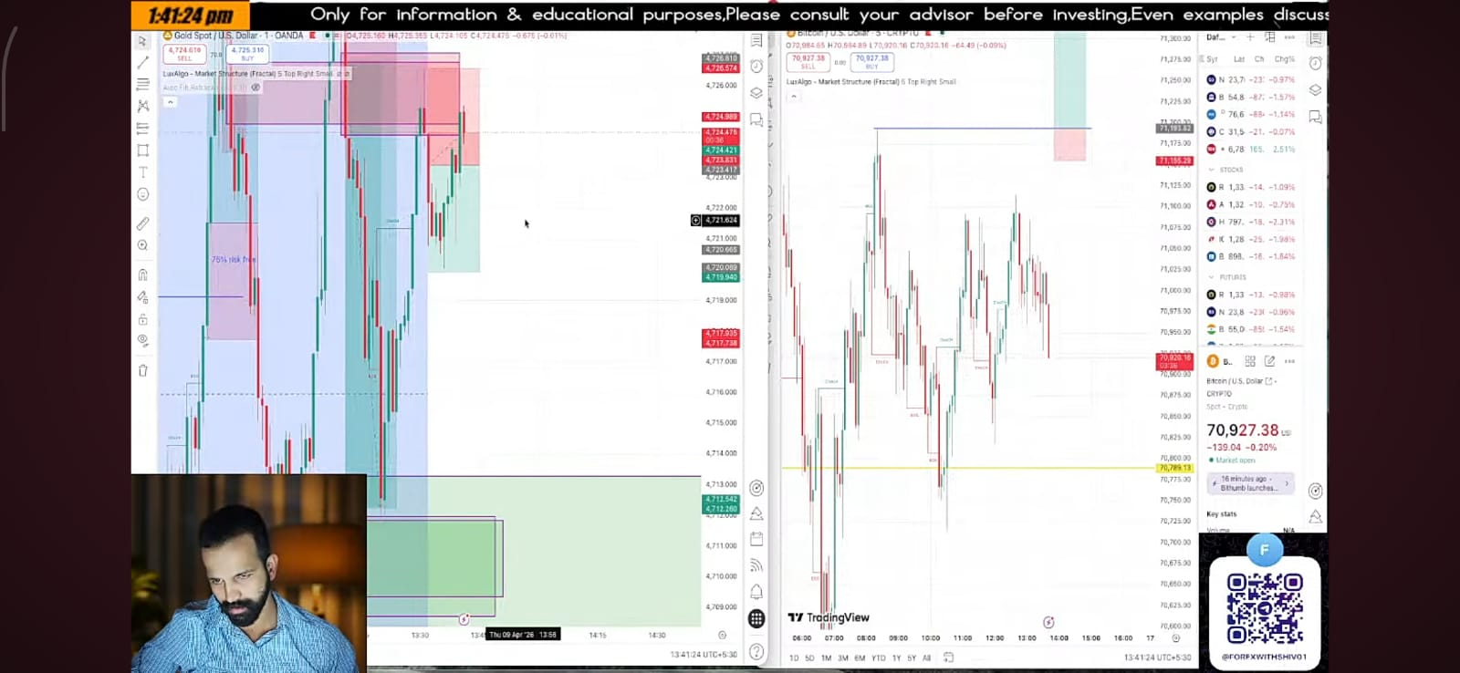

6. Overview of Forex Market
The foreign exchange market, commonly called the forex market, is the largest and most active financial market in the world. In this market, different currencies are bought and sold by traders, banks, financial institutions, and governments. The main purpose of the forex market is to exchange one currency for another, usually for international trade, investment, or speculation. The forex market is extremely large and liquid, with trillions of dollars traded every day.
One unique feature of the forex market is that it operates 24 hours a day, five days a week. Because financial centers around the world—such as London, New York, Tokyo, and Sydney—operate in different time zones, trading continues almost all the time. This allows traders from different countries to participate in the market at any time during the trading week.
In the forex market, currencies are traded in pairs, such as EUR/USD or GBP/USD. When a trader buys a currency pair, they are buying one currency while selling another at the same time. The value of currencies changes constantly based on supply and demand.
Many factors influence the movement of the forex market. Important factors include economic news, interest rates, inflation data, and political events. For example, if a country’s economy is performing well, its currency may become stronger. On the other hand, economic uncertainty or political instability can weaken a currency.
Along with currencies, traders often analyze commodities such as gold and silver while studying the forex market. These precious metals are closely connected to global economic conditions and the strength of major currencies like the US dollar. Gold and silver are commonly known as safe-haven assets, which means investors often buy them during times of economic or political uncertainty to protect their wealth.
For example, when there is a global financial crisis, war, or high inflation, investors may shift their money from risky assets into gold or silver. This increases their demand and can cause their prices to rise. Because of this relationship, traders often include gold (XAU/USD) and silver (XAG/USD) in their forex market analysis.
Overall, the forex market plays a very important role in the global economy. It helps countries trade with each other, supports international investments, and provides many opportunities for traders to profit from changes in currency and commodity prices.

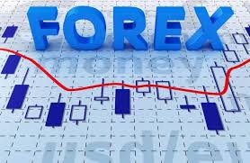

7. Trading Instruments: Gold, Silver, Crypto
In financial markets, traders use different trading instruments to make profits from price movements. Some of the most popular instruments include gold, silver, and cryptocurrencies. These assets are widely traded in global markets and are often analyzed by traders using technical and fundamental analysis.
Gold and silver are precious metals that are traded as commodities in financial markets. They are popular among traders because their prices react strongly to global economic conditions. For example, when inflation increases or when there is economic uncertainty, many investors buy gold to protect their money. Because of this, gold is often considered a safe-haven asset, meaning it tends to hold its value during financial crises or market instability.
Silver also shares some safe-haven characteristics, but it behaves slightly differently from gold. Silver has large industrial demand because it is used in electronics, solar panels, and manufacturing. This makes its price more sensitive to economic growth and industrial activity. As a result, silver prices often move more sharply than gold and can be more volatile in the market.
Another important trading instrument today is cryptocurrency. Cryptocurrencies such as Bitcoin and Ethereum are digital assets that operate on blockchain technology. Unlike traditional assets, cryptocurrencies are decentralized, meaning they are not controlled by any government or central bank. Crypto markets are known for their high volatility, where prices can rise or fall rapidly within a short period of time.
Because of these fast price movements, cryptocurrencies attract many traders who are interested in short-term trading opportunities. However, the high volatility also means that trading crypto involves higher risk compared to traditional assets.
To analyze these markets effectively, traders usually combine technical analysis and macroeconomic understanding. Technical analysis involves studying charts, patterns, and indicators to predict price movements. At the same time, traders must also pay attention to global economic news, inflation data, interest rate decisions, and geopolitical events because these factors can strongly influence the prices of gold, silver, and cryptocurrencies.
Overall, successful trading requires understanding both market data and global economic factors to make informed trading decisions. 
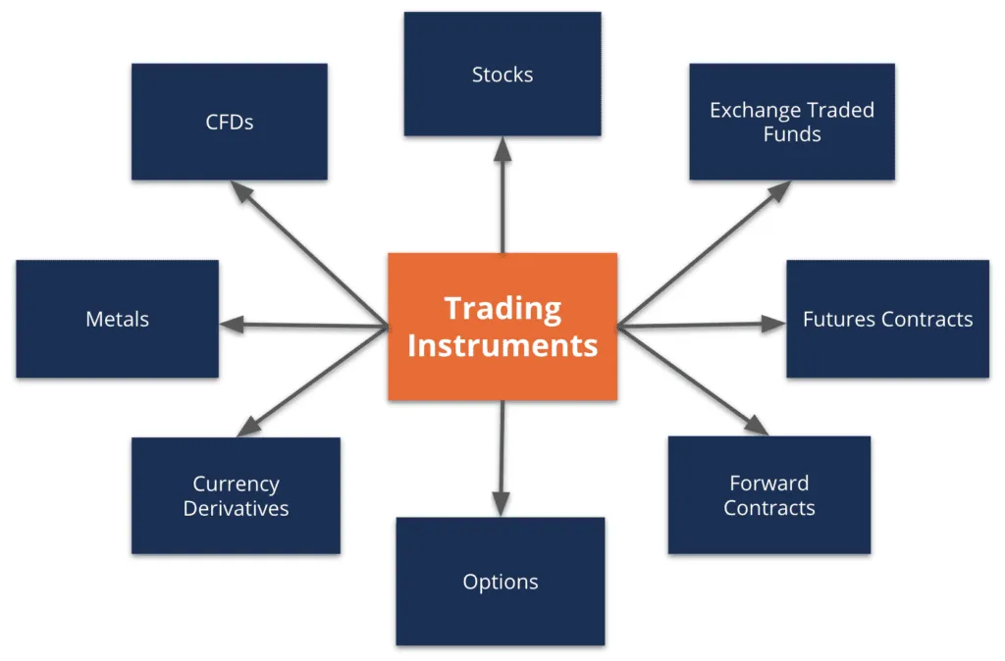

8. Technical Analysis Basics
Technical analysis is a method used by traders to study price charts and market data in order to understand how the price of an asset may move in the future. Instead of focusing only on economic news or company information, technical analysis mainly studies past price movements and patterns on charts. By looking at these patterns, traders try to identify trends and make better trading decisions.
One of the most important concepts in technical analysis is support and resistance. Support is a price level where the market usually stops falling and may start moving upward because buyers enter the market. It acts like a price floor. Resistance, on the other hand, is a level where the price may stop rising because sellers begin to enter the market. It works like a price ceiling. Traders use these levels to decide where they might buy or sell an asset.
Another common tool used in technical analysis is the moving average. A moving average calculates the average price of an asset over a certain period of time, such as 20 days, 50 days, or 200 days. It helps traders understand the overall direction of the market by smoothing out small price fluctuations. When the price stays above a moving average, it often indicates an upward trend, while a price below it may suggest a downward trend.
Traders also use trend lines to identify the direction of the market. A trend line is drawn by connecting important points on a chart, such as higher lows in an uptrend or lower highs in a downtrend. These lines help traders see whether the market is moving upward, downward, or sideways.
In addition to these tools, traders use momentum indicators such as RSI , febonachi or vol to measure the strength of a trend and determine whether the market is overbought or oversold. These indicators help traders confirm their analysis before entering a trade.
During live trading sessions, charts are analyzed in real time while the market is moving. Analysts observe price action, support and resistance levels, and indicators to identify possible entry points (where to buy) and exit points (where to sell). This real-time analysis helps traders understand how professional traders study the market and make decisions based on chart patterns and technical indicators.
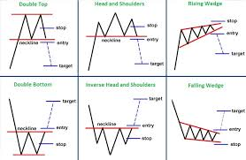

9. Fundamental Analysis
Fundamental Analysis in Financial Markets
Fundamental analysis is a method used by traders and investors to study the economic and financial factors that affect the price of assets in the market. Instead of focusing only on price charts, fundamental analysis looks at the overall health of the economy and important economic data to understand why prices move. The main goal is to identify whether a currency, commodity, or other financial asset may increase or decrease in value in the future.
Several important macroeconomic factors influence financial markets. One of the most important factors is interest rates. Interest rates are set by central banks and represent the cost of borrowing money. When interest rates increase, investors often move their money into that country’s assets because they can earn better returns. This increased demand can strengthen the value of a currency in the forex market.
Another key factor is inflation, which refers to the rise in the general price level of goods and services over time. High inflation reduces the purchasing power of money and can affect the value of a country’s currency. Central banks closely monitor inflation and may adjust interest rates to control it. Because of this connection, inflation data is very important for traders who follow fundamental analysis.
Employment data is also an important economic indicator. Reports about job creation, unemployment rates, and wage growth help traders understand the strength of an economy. A strong job market usually means that people are earning more money and spending more, which can support economic growth and influence market prices.
Another major factor is central bank policy. Central banks such as the Federal Reserve, European Central Bank, or other national banks make decisions about interest rates and money supply. These decisions can strongly affect financial markets because they influence borrowing costs, investment activity, and economic growth.
By studying these macroeconomic variables, traders can better understand the direction of the market. Fundamental analysis helps traders predict long-term trends and identify potential opportunities in forex, commodities, and other financial markets. When combined with technical analysis, it allows traders to make more informed and balanced trading decisions.
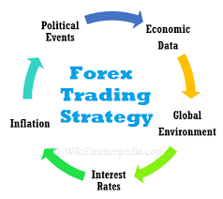

10. Risk Management
Risk Management in Trading
Risk management is a very important part of trading. It helps traders protect their money and control losses when the market moves in the wrong direction. In financial markets, prices can change quickly and sometimes unpredictably. Because of this, traders must follow proper risk management techniques to avoid losing a large amount of money in a single trade. Risk management mainly focuses on protecting trading capital while still allowing traders to participate in market opportunities.
One of the most common tools used in risk management is a stop-loss order. A stop-loss is a predefined price level where a trade automatically closes if the market moves against the trader. This helps prevent further losses and removes emotional decision-making from trading. For example, if a trader buys gold at a certain price, they can set a stop-loss slightly below that price. If the market falls to that level, the trade will close automatically, limiting the loss.
Another important concept in risk management is position sizing. Position sizing means deciding how much money or how many units of an asset a trader should buy or sell in a trade. This decision is based on the trader’s total capital and how much risk they are willing to take. Many professional traders follow a rule of risking only 1% to 2% of their trading capital on a single trade. This helps ensure that even a series of losing trades does not completely damage the trading account.
Discipline is also a key part of risk management. Traders must follow their trading plan and avoid emotional decisions such as revenge trading or increasing trade size after losses. A disciplined trading strategy helps maintain consistency and prevents unnecessary risks.
During the internship, strong emphasis is placed on responsible trading practices. Interns are taught that trading is not a guaranteed way to make profits and that financial markets always involve risk. By learning proper risk management techniques such as stop-loss placement, position sizing, and disciplined trading, traders can reduce potential losses and improve their chances of long-term success in the market.

Sample Market Analysis Charts

Example chart used during live streaming sessions for explaining market trends.
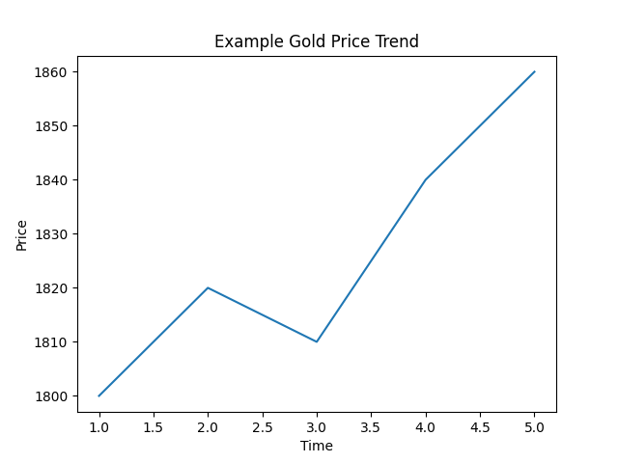

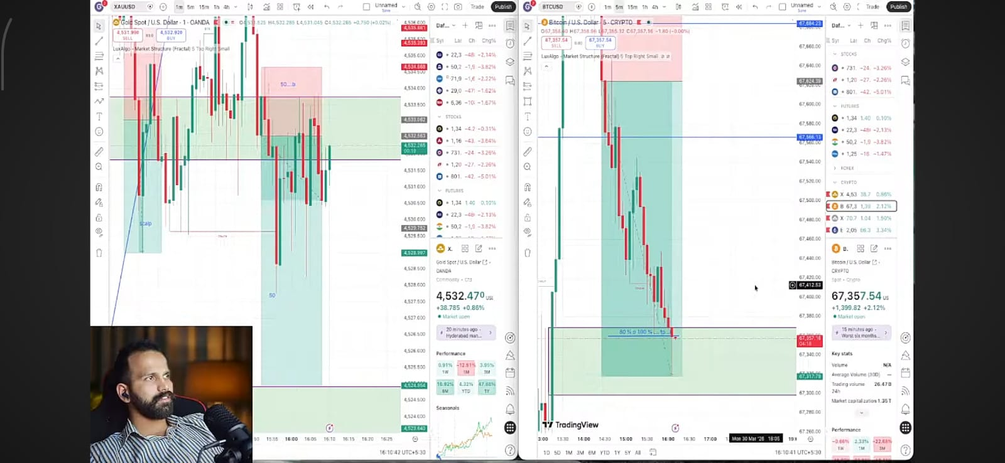

Example cryptocurrency price movement used during analysis.
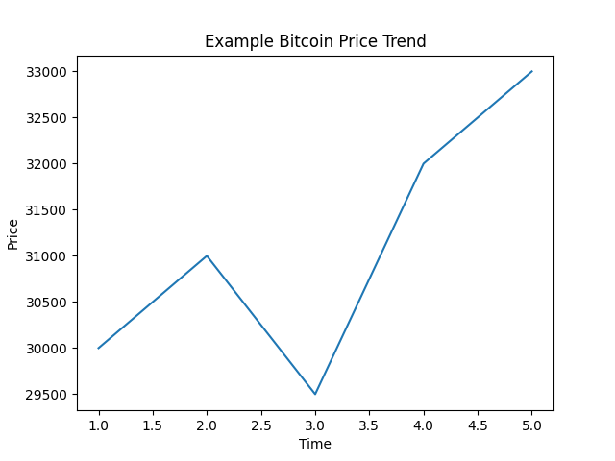

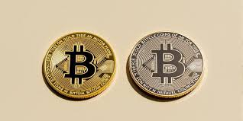

11. Live Market Analysis Process
Market Observation and Live Streaming Experience
During the internship, the intern regularly observed the financial markets to understand how prices move during different times of the day. Financial markets such as forex, gold, silver, and cryptocurrencies operate almost 24 hours a day, but market activity changes depending on which region of the world is trading. The global trading day is mainly divided into three major sessions: the Asian session, the London session, and the New York session. Each of these sessions has different levels of market activity and volatility.
The Asian session is usually the first trading session of the day. During this time, markets in countries such as Japan, Singapore, and Australia are active. This session is generally calmer compared to the others. Price movements are often slower and markets may move within a range because trading volume is relatively lower. Many traders use this session to observe the market and identify key price levels that may become important later in the day.
The London session is considered one of the most active trading periods. London is a major financial center, so a large number of banks, institutions, and traders participate in the market during this time. Because of the high trading volume, price movements usually become stronger and more volatile. Many important trends in the forex and commodity markets often start during this session.
After the London session begins, the New York session starts when financial markets in the United States open. This session is also very active, especially when it overlaps with the London session. During this overlap period, trading volume and volatility often increase, creating many opportunities for traders. Important economic data releases from the United States can also cause sudden price movements in assets such as gold, silver, and cryptocurrencies.
Understanding these sessions helped the intern learn how market behavior changes throughout the day. By watching price charts during each session, it became easier to identify patterns, trends, and possible trading opportunities.
Before starting a live streaming session, proper preparation is required. The analyst first studies price charts to identify important support and resistance levels. Economic news and global events are also reviewed because they can affect market movements. After this preparation, the analyst identifies key trading zones and possible trade setups to discuss during the live session.
During the live broadcast, the analyst explains market observations while showing charts in real time. The audience can watch how price movements are analyzed and how traders interpret market behavior. The analyst also explains possible entry and exit points based on technical analysis.
Audience interaction is an important part of live streaming. Viewers often ask questions about trading strategies, market trends, and risk management. The analyst responds to these questions during the live session, helping viewers understand trading concepts more clearly.
This interaction creates a learning environment where viewers can gain practical knowledge of trading. By combining real-time analysis with audience engagement, live streaming becomes an effective way to educate traders and share market insights.


12. YouTube Live Streaming Workflow
YouTube Live Streaming Workflow of Trading in the Forex Market
YouTube live streaming has become a popular way for trading analysts to share real-time market analysis and trading education with viewers. In a forex trading live stream, the analyst shares their screen, explains chart movements, discusses economic news, and interacts with viewers while the market is actively moving. This allows learners to observe how professional traders analyze the market and make decisions during live conditions.
The workflow of a YouTube live trading session usually follows several important steps.
1. Pre-stream Preparation
Before starting the live stream, the analyst prepares the session by studying the market. This includes checking important economic news, reviewing global financial events, and analyzing charts using trading platforms such as TradingView. Key levels like support and resistance, trend lines, and possible trade setups are identified. Preparing these levels helps the analyst explain the market clearly during the live session.
The analyst also sets up the streaming tools. Software such as OBS (Open Broadcaster Software) is often used to capture the screen, charts, microphone, and sometimes a webcam. The streaming software is connected to YouTube Studio using a stream key so the broadcast can go live smoothly.
2. Starting the Live Broadcast
Once everything is ready, the analyst starts the YouTube live stream. At the beginning of the session, the analyst usually gives a brief introduction about the markets, explains the trading session (Asian, London, or New York), and provides a quick overview of current market conditions.
3. Real-Time Market Analysis
During the live stream, the analyst shares charts and analyzes price movements in real time. Technical analysis tools such as trend lines, indicators, and support or resistance levels are used to explain possible trading opportunities. Sometimes the analyst discusses potential entry points, stop-loss levels, and profit targets based on market conditions.
Live trading streams often include market commentary, where analysts explain how economic news, central bank decisions, or global events may affect currency pairs, gold, silver, or cryptocurrencies.
4. Audience Interaction
One of the most important parts of a live stream is viewer engagement. Viewers can ask questions through the live chat while watching the charts. The analyst answers questions related to trading strategies, risk management, or current market trends. This interactive communication helps viewers understand trading concepts better and makes the learning process more engaging.
5. Session Summary
At the end of the live stream, the analyst usually summarizes the key market insights discussed during the session. Important price levels, trade ideas, and market expectations for the next trading session may also be explained.
Overall, the YouTube live streaming workflow involves preparation, real-time analysis, audience interaction, and session review. This process helps traders learn how markets behave in real time and provides practical trading education through live market observation.
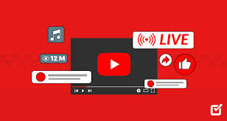

13. Audience Engagement Strategies
Audience Engagement Strategies in YouTube Streaming While Trading in the Forex Market
Audience engagement is very important in YouTube live streaming, especially when streaming trading sessions in the forex market. Engagement means keeping viewers interested, active, and involved during the live broadcast. When viewers interact with the streamer through comments, questions, or discussions, the live session becomes more educational and enjoyable. Strong engagement also helps build a loyal community of traders who regularly join the live sessions.
One of the most effective engagement strategies is interacting with viewers through live chat. During a live trading session, viewers often ask questions about market trends, trade setups, or risk management. The analyst should read these messages and respond to them in real time. This makes viewers feel valued and encourages them to participate more actively in the discussion. Responding to comments and questions creates a strong connection between the streamer and the audience.
Another important strategy is asking questions to the audience. Instead of only explaining charts, the analyst can ask viewers questions such as: “Do you think gold will break this resistance level?” or “Should we wait for confirmation before entering a trade?” These types of questions encourage viewers to share their opinions in the chat, which increases interaction and discussion during the stream.
Planning interactive segments is also helpful for maintaining engagement. For example, the analyst can include short Q&A sessions, quick polls, or discussions about market news during the live stream. These segments give viewers an opportunity to participate and share their thoughts about trading strategies or current market conditions.
Another effective method is explaining live chart movements clearly and simply. When viewers understand what is happening in the market, they are more likely to stay engaged. The analyst should explain support and resistance levels, trend direction, and possible trade setups in an easy-to-understand way. This helps beginners learn while experienced traders follow the analysis.
Consistency is also important for audience engagement. When live sessions are conducted regularly at the same time, viewers develop a habit of joining the stream. Over time, this builds a community where traders return to learn, share ideas, and discuss the market together.
In conclusion, audience engagement is a key factor in successful YouTube trading streams. By interacting with viewers, asking questions, explaining charts clearly, and including interactive segments, analysts can create a more engaging and educational experience. This approach not only improves learning but also helps build a strong community of traders who regularly participate in the live sessions.

14. Trading Psychology
During my internship, I learned that trading is not only about charts, indicators, and strategies. A very important part of trading is trading psychology, which means controlling emotions and maintaining the right mindset while trading. Trading psychology refers to how a trader manages emotions such as fear, greed, confidence, and stress while making trading decisions. If emotions are not controlled, they can lead to wrong decisions and losses in the market.
While doing YouTube live streaming during forex trading, maintaining the right mindset becomes even more important. When I analyze the market live in front of viewers, I need to stay calm and focused. Many viewers watch the analysis to understand market movements, so it is important to explain the charts clearly and avoid making emotional decisions during the session.
One of the biggest psychological challenges in trading is fear. Sometimes when the market moves against a trade, traders feel afraid and may close the trade too early. On the other hand, greed can also affect trading decisions. Greed may cause traders to hold trades for too long or take unnecessary risks in the hope of making more profit. These emotions can negatively affect trading performance if they are not controlled.
During live streaming, I try to follow a disciplined trading approach. This means sticking to the trading plan, respecting stop-loss levels, and not entering trades without proper analysis. Discipline helps traders avoid emotional decisions and maintain consistency in trading.
Another important aspect of trading psychology is patience. The market does not always give trading opportunities immediately. Sometimes traders must wait for the right setup before entering a trade. During live sessions, I explain to viewers why patience is important and how waiting for confirmation can reduce unnecessary risk.
I also learned that traders should accept losses as a normal part of trading. No strategy can win every trade. Professional traders understand that small losses are part of the learning process and focus on long-term consistency instead of short-term results.
Overall, trading psychology plays a very important role in forex trading and live streaming. By staying calm, following a trading plan, controlling emotions, and maintaining discipline, traders can make better decisions and improve their performance in the financial markets.

15. Trading Tools and Platforms
Trading Tools and Platforms in Forex Trading
During my internship, I learned that using the right trading tools and platforms is very important when trading in the forex market. These tools help me analyze price movements, understand market structure, and find possible trading opportunities. Without proper tools, it becomes very difficult to study the market and make good trading decisions. Trading platforms allow me to see live price charts, apply indicators, and monitor different financial instruments such as gold, silver, and cryptocurrencies.
One of the main tools I use for trading analysis is a charting platform. Platforms like TradingView or MetaTrader allow traders to view real-time price charts and study different timeframes such as 5 minutes, 15 minutes, 1 hour, or daily charts. On these charts, I can draw important levels like support and resistance, trend lines, and market structure levels. These visual tools help me understand where the market may move next and where potential trading opportunities might appear.
During my trading analysis, I also look for AA and A+ setups. These setups help me focus on high-quality trades instead of taking random entries. An AA setup usually means a good trading opportunity where the market shows clear signals such as trend direction, strong price levels, and confirmation from price action. An A+ setup is considered an even stronger opportunity where several factors come together at the same time, such as strong support or resistance, trend alignment, and good risk-to-reward ratio. By focusing on A+ setups, traders try to improve the probability of successful trades.
Another important concept that I learned during my trading practice is the order block. An order block is a price zone on the chart where large institutional traders, such as banks or big investors, place significant buy or sell orders. These zones often become strong support or resistance levels in the market. When the price returns to an order block area, the market may react strongly because of the large orders placed there. Order blocks are considered important because they represent the activity of large market participants and can help traders find high-probability entry points.
I also use a concept called Fair Value Gap (FVG) in my trading analysis. A Fair Value Gap happens when the market moves very quickly in one direction, leaving a small imbalance between buyers and sellers. This creates a gap on the chart where very little trading took place. Because of this imbalance, the market often returns to this area later to “fill the gap” before continuing its movement. Traders watch these zones carefully because they can act as temporary support or resistance levels.
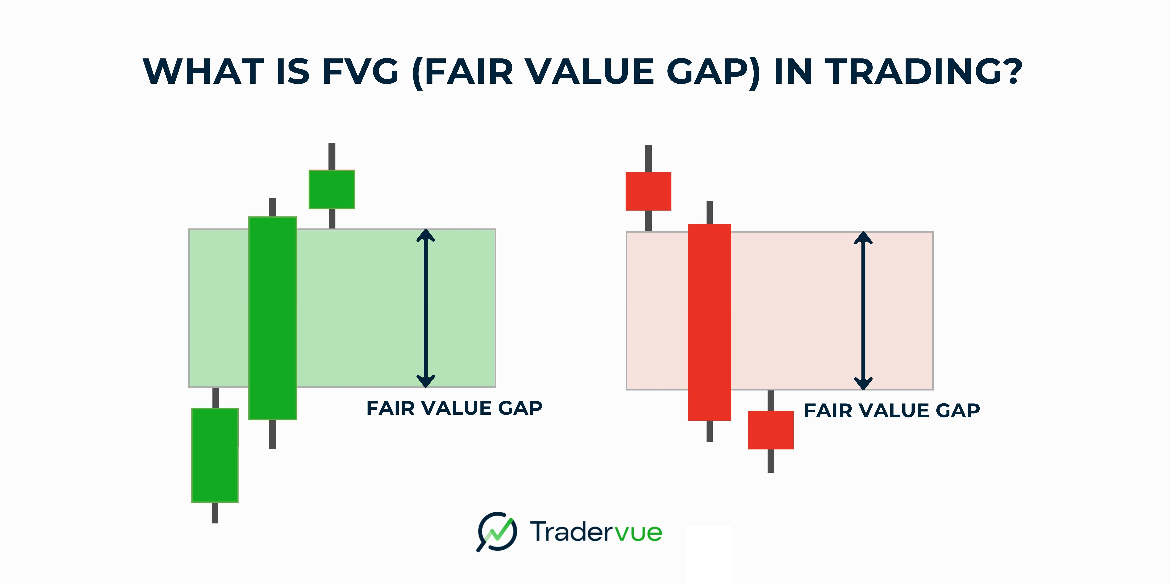
In many trading strategies, traders combine order blocks and FVG to identify strong trading zones. When both appear in the same area on the chart, the probability of a market reaction can increase. These concepts are commonly used in price-action strategies such as Smart Money Concepts (SMC) and ICT trading methods.
Overall, trading tools and platforms play a very important role in forex trading. They allow traders to study charts, analyze market behavior, and explain trading ideas clearly during live streaming sessions. By using charting platforms, identifying A+ setups, and understanding concepts like order blocks and fair value gaps, I can perform better market analysis and share useful insights with viewers during live trading sessions.
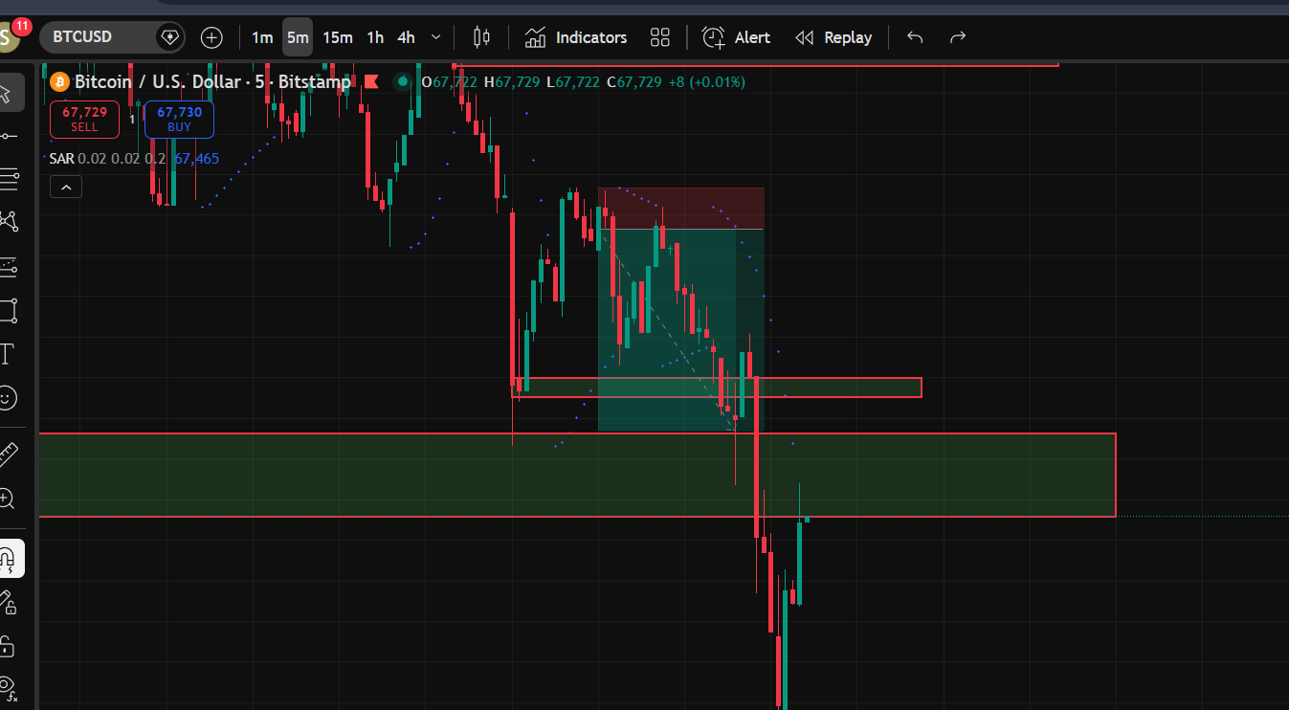

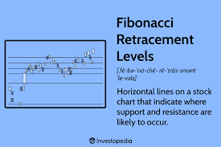

16. Ethics and Professional Conduct
During my internship, I learned that ethics and professional conduct are very important when sharing trading knowledge on YouTube live streams. As a trading analyst and live streamer, I am not only analyzing the market but also guiding viewers who may be learning trading for the first time. Because of this responsibility, it is important to behave honestly, professionally, and responsibly while explaining trading ideas.
One of the most important ethical practices during live streaming is transparency. When I discuss trade setups or market analysis, I clearly explain that these are only educational opinions and not guaranteed profits. Forex trading involves a high level of risk, and traders can lose money as well as make profits. It is important to remind viewers about this risk so they can make their own informed decisions. Providing clear risk information helps maintain trust and prevents misunderstandings.
Another important ethical principle is avoiding misleading information. While analyzing charts or discussing market movements, I must ensure that the information I provide is based on proper analysis and reliable data. Forex markets are influenced by many factors such as economic news, political events, and interest rate changes. Therefore, it is important to present information accurately and avoid exaggerating profit opportunities. Ethical trading education should focus on learning and understanding the market rather than promising quick profits.
During YouTube live sessions, I also try to maintain professional communication with the audience. Viewers often ask questions about trade setups, indicators, and risk management. I answer these questions politely and clearly so that everyone can understand the explanation. Maintaining respectful communication helps create a positive learning environment for viewers.
Another key part of professional conduct is avoiding market manipulation or unfair practices. Ethical trading requires fairness and transparency so that all market participants have equal opportunities. Any attempt to manipulate prices or spread false information can harm the integrity of financial markets. Such practices are considered unethical because they create unfair advantages and damage trust in the market.
As a live streamer, I also understand the importance of responsible influence. Many viewers may follow the analysis shared during the session. Because of this, I try to focus more on teaching trading concepts such as market structure, risk management, and technical analysis instead of encouraging viewers to blindly copy trades.
Overall, ethics and professional conduct play a very important role in YouTube trading streams. By being honest, transparent, respectful, and responsible, I can create a trustworthy learning environment for viewers. This approach helps build credibility, encourages responsible trading practices, and supports the long-term development of traders in the financial markets.

17. Challenges During Internship
During my internship, one of the biggest challenges I faced was doing YouTube live streaming for the first time while analyzing the forex market. At the beginning, everything felt new and slightly difficult because I had to focus on both trading analysis and communicating with viewers at the same time. Live streaming is not just about talking on camera; it requires preparation, technical setup, and confidence.

One of the first challenges I experienced was feeling nervous while speaking live. When I started streaming, I was aware that many people might be watching the session. This made me feel a little uncomfortable in the beginning. Speaking clearly while analyzing charts and explaining market movements required practice. Many new streamers face camera shyness at the start, but with regular streaming and practice, confidence slowly improves.
Another challenge was managing the technical setup. Live streaming requires a stable internet connection, working microphone, camera, and screen-sharing software. Sometimes technical problems such as slow internet or audio issues can affect the quality of the live stream. Before going live, I had to check whether the charts were visible, the microphone was clear, and the streaming software was working properly. Testing equipment and internet connection is important because technical problems can interrupt the session and affect the viewer experience.
I also faced difficulty in managing both trading analysis and audience interaction at the same time. During live trading sessions, I needed to focus on price charts, technical analysis, and possible trade setups. At the same time, viewers were asking questions in the live chat. Answering these questions while continuing the market analysis required concentration and time management. With practice, I gradually learned how to balance chart analysis and viewer interaction.
Another challenge was explaining trading concepts in simple language. Some viewers were beginners who did not fully understand technical terms like support, resistance, or trend structure. I had to explain these concepts clearly so that everyone could follow the analysis. This helped me improve my communication and teaching skills.
Sometimes the market itself also created challenges. The forex market can move very quickly, especially during the London or New York trading sessions. While explaining the market during a live stream, prices may suddenly change. This requires quick thinking and the ability to explain the situation calmly to viewers.
Overall, doing YouTube live streaming for the first time was a learning experience for me. Although I faced challenges such as nervousness, technical setup issues, and managing live interaction, these experiences helped me develop better communication, confidence, and market analysis skills. Over time,


I became more comfortable with live streaming and improved my ability to explain trading concepts to the audience in real time.

18. Learning Outcomes

During my internship at The Trading Fox, I gained many valuable learning experiences while doing YouTube live streaming and forex market analysis. This internship helped me understand both the technical side of trading and the communication skills required to explain market analysis to an audience. By observing and analyzing the market every day, I was able to improve my understanding of how the forex market works in real time.
One of the most important things I learned was how to analyze financial markets effectively. While preparing for live streams, I regularly studied charts of assets such as gold, silver, and cryptocurrencies. I practiced identifying support and resistance levels, trend direction, and possible trade setups. This improved my ability to read price charts and understand market behavior. Learning technical analysis and applying it in live market conditions helped me connect theoretical knowledge with practical experience.
Another important learning outcome was understanding trading strategies and risk management. During the internship, I learned how professional traders manage risk using stop-loss orders and proper position sizing. I also learned that successful trading is not only about making profits but also about protecting capital and maintaining discipline. Risk management is considered a key skill in trading because it helps traders control losses and stay consistent in the long run.

The internship also helped me develop better communication and presentation skills. While doing YouTube live streaming, I had to explain complex trading concepts in a simple way so that viewers could easily understand them. This experience improved my confidence in speaking, explaining charts, and answering questions from the audience. Communicating clearly with viewers is important because many beginners join live streams to learn how trading works.

Another valuable outcome was learning how to work in a real-time market environment. Financial markets move very quickly, and traders must analyze information and make decisions within seconds. Through live streaming sessions, I learned how to stay calm and focused while explaining market movements and interacting with viewers at the same time.

I also gained experience in using trading platforms and digital streaming tools. I learned how to set up charts, analyze different timeframes, and share my screen during live sessions. At the same time, I understood how live streaming creates an interactive learning environment where viewers can ask questions and discuss trading ideas.
Overall, this internship helped me develop several important skills such as market analysis, risk management, communication, and confidence in live presentations. These learning outcomes will be very useful for my future career in financial markets, trading analysis, and digital financial education.

19. Case Study: Gold Market Analysis

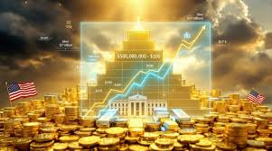
During my internship, I had the opportunity to closely observe and analyze the gold market (XAU/USD). Gold is one of the most popular trading instruments in the forex and commodity markets because it reacts strongly to economic news, global events, and investor sentiment. By studying gold charts regularly and explaining them during live YouTube sessions, I learned how different factors influence its price movement.
Gold is widely known as a safe-haven asset, which means investors often buy gold during times of economic uncertainty, financial crises, or geopolitical tensions. When investors feel that other financial markets such as stocks or currencies are risky, they move their money into gold to protect their wealth. Because of this behavior, gold prices often rise during periods of global instability.
While analyzing the gold market, I noticed that interest rates and inflation play a major role in gold price movements. Gold does not provide interest or dividends like bonds or savings accounts. Therefore, when interest rates increase, investors may prefer assets that generate returns, which can reduce the demand for gold. On the other hand, when interest rates fall or inflation increases, gold becomes more attractive as a store of value.
Another important factor in gold trading is the strength of the US dollar. Gold is traded globally in US dollars, so the relationship between gold and the dollar is very important. When the US dollar becomes stronger, gold often becomes more expensive for international buyers, which can reduce demand and push prices lower. However, when the dollar weakens, gold tends to become cheaper for other countries to buy, which can increase demand and cause prices to rise.
During my analysis, I also observed how economic news and geopolitical events can create sudden movements in the gold market. For example, events such as wars, economic crises, or major political decisions can increase uncertainty in financial markets. In such situations, investors often move their funds into gold, causing the price to rise quickly. However, gold prices can also become volatile because traders react quickly to news and market sentiment.
From a technical analysis perspective, gold charts often show clear trends and important price levels. While studying the charts, I focused on identifying support and resistance levels, trend lines, and price patterns. These technical tools helped me understand where the market might react or reverse. For example, when gold reaches a strong resistance level, the price may slow down or move downward. Similarly, when the price reaches a strong support level, buyers may enter the market and push the price upward.
During YouTube live streaming sessions, I presented these observations to viewers. I explained how technical analysis and fundamental analysis work together when analyzing the gold market. Technical analysis helps identify entry and exit points on the chart, while fundamental factors such as interest rates, inflation, and global news explain why the market moves.
Another important lesson from this case study is that the gold market can be highly volatile. Prices can move quickly within a short period of time, especially during major economic announcements or unexpected global events. Because of this volatility, proper risk management is essential when trading gold.

Overall, this case study helped me gain practical experience in analyzing one of the most actively traded commodities in the financial markets. By observing price movements, studying economic factors, and explaining market analysis during live sessions, I developed a deeper understanding of how the gold market works and how traders interpret market behavior in real time.

20. Case Study: Crypto Market Analysis

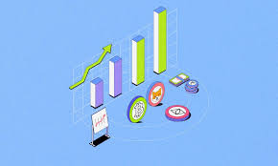
During my internship, I also tried to understand the crypto market because many traders follow both forex and cryptocurrency trading. In this case study, I analyzed the crypto market to learn how price movements work and how traders make decisions. Crypto trading is interesting because the market is very fast and active 24 hours a day.
First, I started by studying the basic behavior of the crypto market. I noticed that cryptocurrencies such as Bitcoin and Ethereum move very quickly compared to many traditional markets. Sometimes the price changes within minutes. This is because the crypto market is highly volatile, meaning prices can rise or fall sharply in a short time. Volatility shows how much the price of an asset moves over time. In crypto trading, large price swings are normal and can create both opportunities and risks for traders.
While analyzing the crypto charts, I mainly focused on price action and market structure. I used candlestick charts to observe trends and identify support and resistance levels. These levels helped me understand where the price might reverse or continue moving. I also looked for patterns like breakouts, pullbacks, and consolidation zones.
Another important factor I studied was market liquidity. Liquidity means how easily a cryptocurrency can be bought or sold without affecting the price too much. Coins with high trading volume usually have better liquidity and more stable price movement. For example, large cryptocurrencies such as Bitcoin usually have higher liquidity because many traders are buying and selling them. Smaller coins with lower trading volume can move very quickly because even a small trade can change the price significantly.
During my analysis, I also learned that market sentiment plays a big role in crypto trading. News, social media, and global events can quickly influence traders’ emotions. If traders become excited or optimistic, prices may rise rapidly. On the other hand, fear or negative news can cause sudden price drops. Because of this, the crypto market is often influenced more by investor psychology than by traditional financial data.
To understand the market better, I followed some important trading indicators and tools. For example, I used trend lines, moving averages, and volume analysis to confirm the strength of a trend. Volume helped me see whether buyers or sellers were stronger in the market. When the volume increased during a breakout, it often showed that the movement was strong and reliable.
One challenge I noticed during my crypto market study was the speed of price changes. Since crypto trading runs 24/7 without closing hours, price movements can happen at any time. This makes it important for traders to manage risk carefully and avoid emotional decisions. Good traders always follow risk management rules and avoid overtrading.
Through this case study, I learned that successful crypto trading requires patience, discipline, and proper market analysis. A trader must understand volatility, liquidity, and market sentiment before entering a trade. These factors help in predicting possible price movements and making better trading decisions.
Overall, this crypto market analysis helped me improve my understanding of digital asset trading. It also showed me how important technical analysis, market psychology, and risk management are in modern financial markets. By studying the crypto market regularly, I was able to gain practical knowledge that can also help in other markets like forex and commodities.

21. Conclusion
In conclusion, this internship experience helped me understand many important aspects of trading and YouTube live streaming. During this period, I learned not only how the forex market works but also how to explain trading concepts to an online audience in a simple and clear way. It was a valuable learning journey where I improved both my trading knowledge and communication skills.
First, I learned the complete workflow of YouTube live streaming while trading. I understood how to set up a live stream, analyze charts, and explain my trading decisions to viewers in real time. Live streaming helped me become more confident and disciplined because I had to explain every step of my analysis clearly. It also taught me how to manage time between trading and interacting with the audience.
Another important learning was audience engagement. While streaming, it is important to keep viewers interested by answering questions, explaining strategies, and sharing market insights. This helped me build better communication skills and understand what beginners want to learn about trading.
I also learned about trading psychology. Trading requires patience, discipline, and emotional control. When the market moves against a trade, it is important to stay calm and follow the trading plan instead of making emotional decisions. Successful traders focus on controlling their emotions and following their strategy.
During the internship, I explored different trading tools and platforms. I used charting tools and price-action concepts such as AA and A+ setups, order blocks, and FVG to analyze the market. These tools helped me understand market structure and identify possible trading opportunities.
Ethics and professional conduct were also important lessons during this internship. While sharing trading content on YouTube, it is necessary to be honest and responsible. A trader should avoid giving false promises or guaranteed profit claims and always explain that trading involves risk. Proper risk management, such as using stop-loss and position sizing, is necessary to protect trading capital. Risk management helps traders limit losses and control how much money they risk in each trade.
I also faced some challenges, especially because it was my first time doing YouTube streaming. Sometimes technical issues, nervousness, and managing live trades at the same time were difficult. However, these challenges helped me gain practical experience and improve my confidence.
Finally, through case studies like gold market analysis and crypto market analysis, I learned how different markets behave and how traders study price movements. Overall, this internship helped me gain practical knowledge about trading, market analysis, and online content creation. It was a very helpful experience that improved my skills and understanding of financial markets.

22. References

During my internship and while preparing this report on forex trading and YouTube live streaming, I used several educational websites and online resources to understand the financial markets. These references helped me learn about forex trading, technical and fundamental analysis, risk management, and the role of assets such as gold and silver in the global market.
One of the most useful sources was Babypips, which is a well-known learning platform for beginner forex traders. It explains trading concepts step by step and helps beginners understand currency pairs, market behavior, and trading strategies in a simple way. Many traders use this platform to build their basic knowledge of the forex market.

Another important reference was Investopedia, which provides detailed articles and tutorials about financial markets. It explains topics such as technical analysis, trading psychology, and risk management. These articles helped me understand how traders read charts, identify trends, and manage trading risk effectively.


I also studied educational materials related to forex trading basics. These sources explain how the foreign exchange market works, how currencies are traded in pairs, and how traders analyze price movements using technical and fundamental methods. Learning these concepts helped me understand the foundation of trading and market analysis.
For understanding commodities like gold and silver, I used research articles and financial blogs. These sources explain that gold is often considered a safe-haven asset, meaning investors tend to buy it during times of economic uncertainty or financial crisis. Because of this, gold is widely traded by forex traders and often moves with global economic events.
In addition, I followed financial news and online trading communities to observe how traders discuss market trends and trading strategies. These discussions helped me understand real-world market behavior and the importance of macroeconomic events in trading decisions.
Overall, these references helped me gain a better understanding of financial markets, trading strategies, and the educational role of YouTube live streaming in explaining trading concepts to beginners.

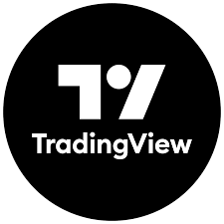
https://www.tradingview.com/markets/
https://www.investopedia.com/
https://currencystrengthmeter.org/
https://www.forexfactory.com/
https://www.babypips.com/

