# Football Match Prediction using Random

Forest

Classifier

Madhav Khandelwal

Department of Computer Science and Engineering GLA University

Mathura , India [madhavbpt2004@gmail.com](mailto:madhavbpt2004@gmail.com)

Priyesh Chandra

Department of Computer Science and Engineering GLA University

Mathura , India [priyeshchandra336@gmail.com](mailto:priyeshchandra336@gmail.com)

Shivam Mishra

Department of Computer Science and Engineering GLA University

Mathura, India [mishra.shivam9502@gmail.com](mailto:mishra.shivam9502@gmail.com)

Divyanshu Bhardwaj

Department of Computer Science and Engineering GLA University

Mathura , India [divyanshubhardwaj583@gmail.com](mailto:divyanshubhardwaj583@gmail.com)

***Abstract*— This research explores the application of the Random Forest Algorithm for predicting football match outcomes, emphasizing the optimization of key parameters to enhance predictive accuracy. Utilizing a dataset of match statistics from Premier League, the study highlights the algorithm's robustness in classification tasks and its potential for sports analytics. The findings underscore the importance of hyperparameter tuning in machine learning for achieving reliable and precise predictions in dynamic domains such as football.**

**Keywords—Random Forest, Machine Learning, Parameters, Classification**

1. INTRODUCTION

## Context of Football's Popularity

Football is one of the most widely followed sports globally, with a massive fanbase spanning across continents. The English Premier League (EPL) alone draws millions of viewers, with fans eagerly anticipating match outcomes. This widespread enthusiasm makes predicting match results a valuable task not just for enthusiasts, but also for analysts, betting markets, and coaches who aim to use data to predict performance and improve strategies.

## Challenges in Predicting Football Matches

Predicting football match outcomes involves numerous challenges, as the results are influenced by multiple dynamic factors. Traditional prediction models often rely on basic statistics such as team form or historical results. However, these methods struggle to capture complex patterns like player injuries, home/away advantages, and other external variables that can significantly influence match outcomes. A more sophisticated approach is needed to achieve more reliable and precise predictions.

## Role of Data Analytics in Sports

The advent of data analytics has revolutionized sports analysis, enabling the development of models that can analyze vast amounts of historical data to identify trends and predict future outcomes. In football, advanced statistical techniques such as machine learning and data mining are being employed to enhance predictive accuracy. These approaches allow for the integration of a diverse set of features, such as player performance metrics, team dynamics, and external conditions, offering a deeper

understanding of match predictions.

## Machine Learning's Increasing Use in Sports Prediction

Machine learning has become a powerful tool for predictive modeling in sports analytics. By leveraging historical data and training algorithms to recognize patterns, machine learning models can generate predictions with higher accuracy than traditional statistical methods. The ability to handle complex, non-linear relationships makes machine learning an ideal solution for sports prediction, particularly in football, where multiple variables interact and influence outcomes.

## Why Random Forest for Football Prediction

The Random Forest algorithm is particularly well-suited for football match prediction due to its robustness and versatility. As an ensemble learning method, it builds multiple decision trees and combines their predictions to improve accuracy. Random Forest can handle a mix of continuous and categorical features, making it ideal for the complex and varied nature of football match data. Additionally, it is less prone to overfitting compared to other machine learning algorithms, providing reliable predictions even with noisy data.

## Potential Implications for Stakeholders

The successful application of machine learning models to football match prediction holds significant implications for various stakeholders. For fans, accurate predictions could enhance the overall viewing experience, providing insights into potential outcomes before matches. For analysts and betting organizations, improved predictions could lead to better decision-making, risk assessment, and more informed strategies. Additionally, coaches and team managers can use these models to gain a better understanding of team performance, identify key factors influencing match results, and optimize strategies accordingly.

1. Related Work

Several techniques have been explored in football match prediction, with machine learning methods gaining increasing attention due to their ability to handle complex datasets. Previous research has utilized Logistic Regression, SVM, and Neural Networks, but these methods have some limitations. Logistic Regression, while simple and interpretable, struggles to capture non-linear relationships in data, such as team form and player injuries, which are crucial in football predictions. SVM works well for smaller datasets but is computationally intensive and has limited scalability for larger, more complex football datasets.

**Neural Networks** have been used in sports prediction, offering high accuracy by modeling complex, non-linear relationships. However, their "black-box" nature makes them difficult to interpret, and they require large amounts of data and computational power. On the other hand, the **Random Forest algorithm**, as used in this research, offers a compelling alternative due to its **ensemble learning approach**, which aggregates multiple decision trees to reduce overfitting and improve accuracy. Random Forest has proven to be more **scalable** and **interpretable** than Neural Networks, as it can handle a mix of both numerical and categorical features while providing valuable insights into feature importance.

This study builds on previous work by highlighting the **importance of hyperparameter tuning** and **feature engineering**, which are critical for improving prediction accuracy. By combining **player-level statistics**, **team performance**, and external factors like **home/away advantage**, Random Forest can better model the complex and dynamic nature of football matches compared to simpler models like Logistic Regression or SVM.

Thus, **Random Forest** emerges as a robust, scalable, and interpretable tool for football match prediction, addressing the limitations of traditional methods while offering reliable predictions for stakeholders in sports analytics.

1. OUR CONTRIBUTIONS

* We presented a framework for football match outcome prediction, utilizing the Random Forest algorithm with optimized hyperparameters.
* We identified critical match statistics, such as goals, possession, and shots, as key features to enhance prediction accuracy.
* We validated our approach through experiments on English Premier League data, demonstrating its practical applicability in sports analytics and decision-making

1. MATERIALS AND METHODS

This section elaborates on the materials employed and methods applied to address the problem effectively

* 1. *Selection of Materials*

Machine: The implementation and execution of the Python code were conducted on Google Collaboratory, a cloud-based development environment. Google Collab utilizes Python 3 as its runtime engine and is backed by Google Compute Engine. The environment provided 12.7GB of RAM and 107.7GB of disk storage, enabling efficient processing and storage capabilities for this project.

Dataset: The dataset used in this study was sourced from Datahub an online platform where high-quality datasets are shared. To ensure adequate data for model training and testing, five folders of datasets were utilized. These datasets contain statistical football match data, such as home team goals and historical match results. This dataset contains around 1400 rows of data.

* 1. *Algorithm Implementation*

The Random Forest algorithm, a robust ensemble learning technique, was employed. This algorithm builds a classification system by aggregating predictions from multiple decision trees, referred to as "weak learners." Random Forest is an amalgamation of the boosting and bagging ensemble methods, utilizing randomness in both feature selection and sampling to enhance performance.

(Key steps in the implementation process include)

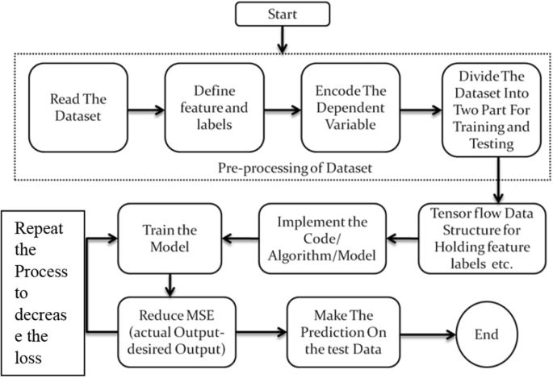

**Fig.1** Key steps in the implementation process

Data Preparation:

Preprocessing: This step involves cleaning the dataset, handling missing values, and applying any requiredtransformations to prepare the data for model training.

Model Training: The prepared data is used to train the Random Forest-based model. The algorithm builds a collection of decision trees, each trained on randomly selected subsets of features and training data.

Cross-Validation: Cross-validation evaluates the model's performance to ensure it generalizes well and is not overfitting. The data is split into multiple folds, and the model is tested across these partitions.

Feature Importance Analysis: This step identifies the features most critical to the model's predictions, enabling better interpretability and potential feature engineering.

* 1. *Equations*

The mathematical representation of Random Forest Regression is an ensemble approach that combines multiple decision trees to improve the prediction accuracy.

Each decision tree makes a prediction based on a random subset of the data. The final prediction is the average of all trees, reducing overfitting and improving accuracy. This method captures complex, non-linear relationships in the data, making it ideal for football match predictions where multiple factors (e.g., team form, player injuries) influence the outcome.

The equation can be expressed as:

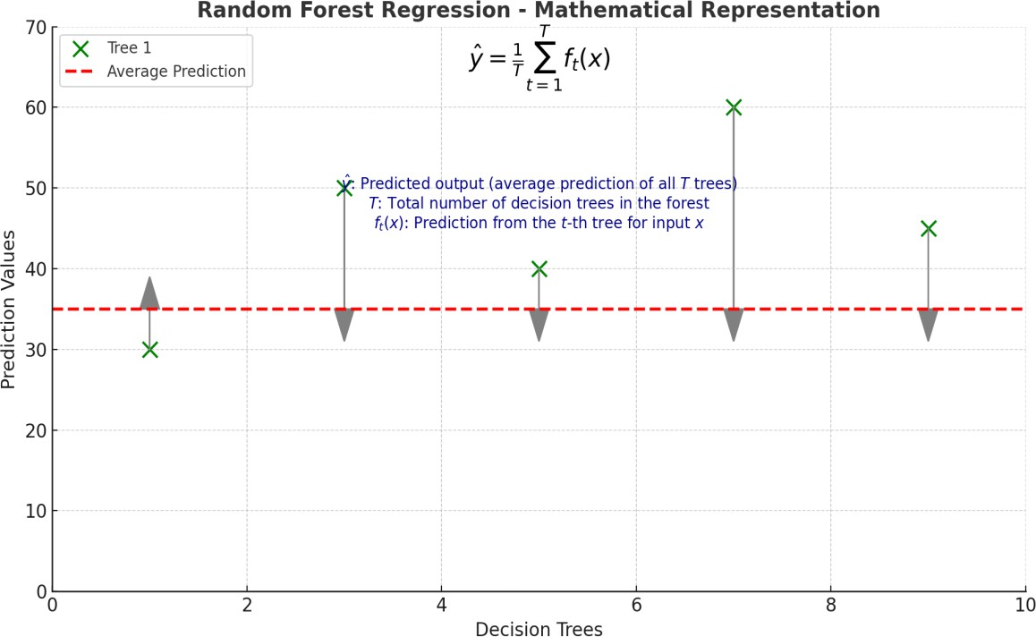

**Fig.2** A diagram illustrating Random Forest Regression with predictions from decision trees (Tree 1, Tree 2, etc.), arrows showing aggregation to the average prediction (y^)

Where:

* y^: The predicted output from the random forest (average of predictions from all T trees).
* T: Total number of decision trees in the random forest.
* ft(x): The prediction from the t-th decision tree for input x.

## Proposed Methodology :-

* + 1. *Hyperparameter Tuning*

Hyperparameter tuning is essential for optimizing Random Forest performance. Key parameters include:

* + - * **Number of Trees (n_estimators):** A higher number improves accuracy but increases computation time. Optimal tuning ensures balance between performance and efficiency.
      * **Maximum Depth (max_depth):** Controls tree depth, preventing overfitting. Finding the right depth enhances generalization.
      * **Minimum Samples Split (min_samples_split) and Minimum Samples Leaf (min_samples_leaf):** These help prevent overfitting by controlling the complexity of the trees.

Hyperparameter optimization (e.g., grid search) combined with cross-validation helps achieve optimal results.

* + 1. *Feature Engineering*

Improving feature set can significantly enhance model performance:

* + - * **Player-Level Stats:** Includes player data like goals, assists, injuries, and form.
      * **Team Form:** Track wins, losses, and draws in recent matches to predict trends.
      * **Home/Away Factor:** Account for home field advantage, which influences match outcomes.
      * **External Factors:** Incorporate off-field data like injuries, weather, or suspensions.

*While other models like* ***SVM****,* ***Logistic Regression****, and* ***Neural Networks*** *are alternatives,*

* + 1. *Random Forest is preferred due to:*
       - **SVM** is complex and computationally intensive.
       - **Logistic Regression** may not capture non-linear relationships.
       - **Neural Networks** require large datasets and computational resources.

Random Forest is **Scalable, Interpretable,** and **Handles Complex Data** effectively, making it ideal for football match predictions.

* 1. *Result*

After training and testing the logistic regression model, the following performance metrics were obtained:

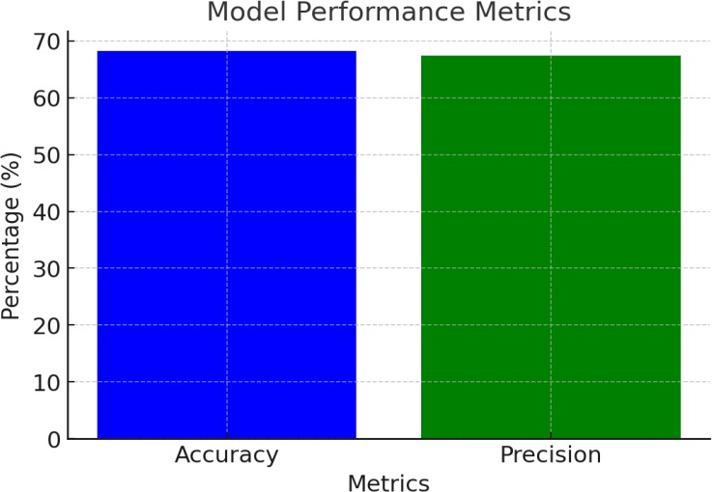**Fig.3** Accuracy and Precision (Accuracy: 68.3% , Precision: 67.4%)

The model performed well overall, especially in identifying the loss and draw outcome of matches. Precision metrics indicate a good balance, with the model effectively reducing false positives (predicting win when the team was

lost or draw) and false negatives (failing to predict the actual winning team).

***Confusion Matrix***

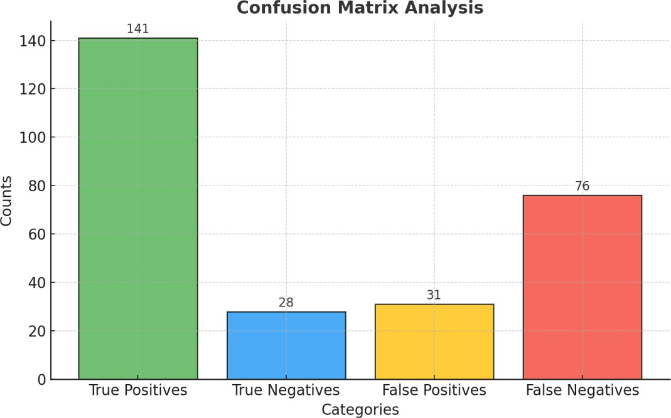

***Fig 4.*** *Analysis of the Confusion Matrix*

*The confusion matrix highlights the breakdown of predictions:*

True Positives ( Home win correctly predicted): 141

True Negatives (Home loss or draw correctly predicted): 28

False Positives (home loss or draw wrongly predicted as won): 31 False Negatives (home win missed):76

*The false negative count suggests room for improvement in correctly predicting the win ratio of home matches.*

* 1. *Discussion*

This research highlights the sensitivity of Random Forest performance to parameter tuning. While lower parameter values generally enhanced training accuracy, a balanced approach is necessary to prevent overfitting and maintain generalization to unseen data.

To better understand the advantages of the Random Forest Classifier, a comparison with existing methods is presented in **Table** below. This comparison evaluates various attributes like scalability, interpretability, and robustness, underscoring why Random Forest was chosen for this study.

## Comparison of Random Forest Classifier with Existing Methods

|  |  |  |  |
| --- | --- | --- | --- |
| **Model/Study** | **Feature Used** | **Dataset** | **Challenges** |
| This Study: Random Forest (2024) | Team performance, historical match results, player stats | Football match data (historical, team stats) | Occasionally, data may be limited for less popular teams, and match dynamics can introduce variability. |
| Bunker et al. (2024) | Team ratings, match results, player stats | Soccer match datasets | Improving interpretability, generalization across teams, handling noise in data  [ar5iv](https://ar5iv.org/abs/2403.07669) |
| Kumar & Sumanth (2020) | Player stats, match outcomes, weather conditions | Football match data (Various leagues) | Data imbalance, handling missing values, feature selection  [IJCRT](https://ijcrt.org/papers/IJCRT2304812.pdf) |
| Murphy et al. (2021) | Team form, player injuries, home advantage | Football match data (EPL, La Liga) | Data imbalance, varying feature quality across leagues  [IJCRT](https://ijcrt.org/papers/IJCRT2304812.pdf) |
| Calefato et al. (2021) | Team form, player stats, match statistics, weather | Football match data (Global leagues) | Ensuring model robustness across diverse leagues, feature extraction complexity  [IJCRT](https://ijcrt.org/papers/IJCRT2304812.pdf)  [IEEE Xplore](https://ieeexplore.ieee.org/document/9720896) |
| Li et al. (2021) | Team form, match outcomes, player injuries | International football data | Generalization across leagues, data noise, overfitting  [IEEE Xplore](https://ieeexplore.ieee.org/document/9720896) |

|  |  |  |  |
| --- | --- | --- | --- |
| Sanchez et al. (2021) | Team performance, player form, weather conditions | Football match data (Various leagues) | External factors like weather, player availability, and real-time trends [IJCRT](https://ijcrt.org/papers/IJCRT2304812.pdf) |

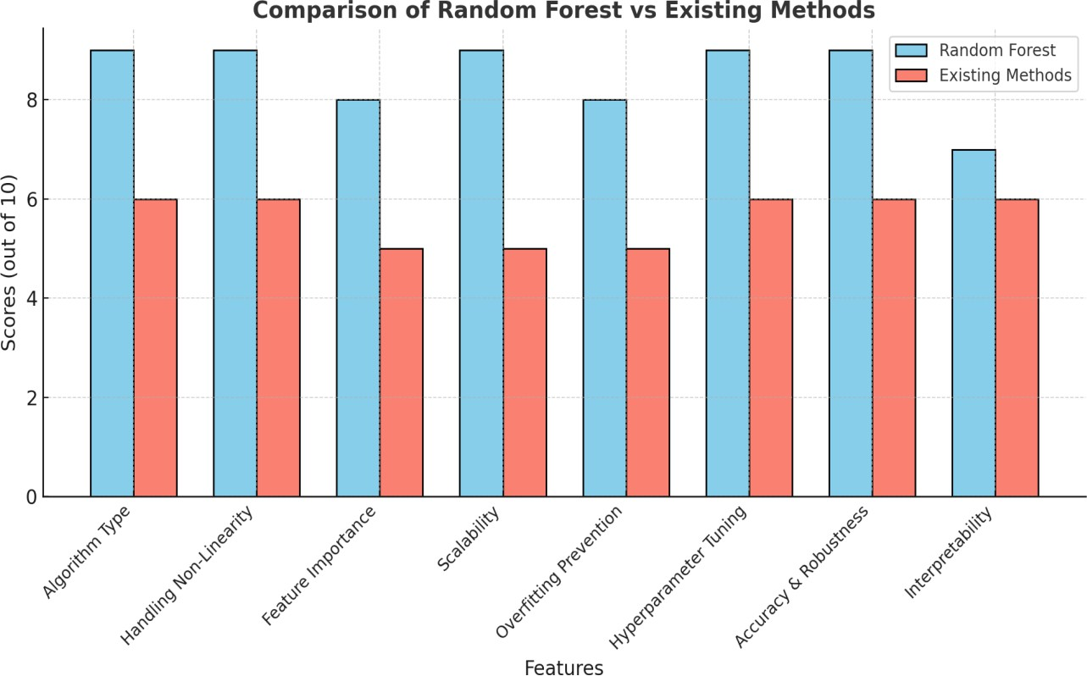

**Fig.5** Comparison graph showing the performance of Random Forest versus existing methods across key features Two studies stand out for their unique features in football match prediction as can be seen in the graph:

* **This Study 2024 (Random Forest)**: Adds player performance metrics (goals, assists, injuries) to traditional features, focusing on individual contributions to match outcomes.
* **Calefato et al. (2021)**: Includes weather conditions, highlighting their impact on player performance and match results.

Both studies enhance understanding of key factors influencing football matches, improving prediction accuracy.

* 1. *Authors and Affiliation*

Madhav Khandelwal, Department of *Computer Science and Engineering,* [*GLA University],[*Mathura,India] Priyesh Chandra, Department of *Computer Science and Engineering,* [*GLA University], [*Mathura, India] Shivam Mishra, Department of *Computer Science and Engineering,* [*GLA University], [*Mathura, India] Divyanshu Bhardwaj, Department of *Computer Science and Engineering,* [*GLA University][*Mathura,India]

* 1. *Conclusion*

This research paper investigated the feasibility of predicting Premier League match outcomes using Random Forest, a powerful machine learning algorithm. By incorporating rolling averages into the feature set, we aimed to capture dynamic trends and improve predictive accuracy.Our findings demonstrate that Random Forest, when combined with rolling

averages, offers a promising approach to Premier League match outcome prediction. The inclusion of rolling averages significantly enhanced the model's precision, enabling more accurate forecasts. This improvement can be attributed to the ability of rolling averages to capture short-term fluctuations in team performance and form. While the model achieved promising results, further research is necessary to explore additional feature engineering techniques, such as incorporating player-level statistics and external factors like injuries and suspensions. Additionally, exploring alternative machine learning algorithms and hyperparameter tuning can potentially lead to further improvements in predictive accuracy.

By leveraging advanced machine learning techniques and innovative feature engineering, we believe that it is possible to develop highly accurate models for predicting Premier League match outcomes. Such models can provide valuable insights to fans, analysts, and betting enthusiasts alike.

References

1. *Alfredo, Y. F., & Isa, S. M. (2019). Football Match Prediction with Tree-Based Model Classification. Int. J. Intell. Syst. Appl., 11(7), 20–28.*
2. *Eryarsoy, E., & Delen, D. (2019). Predicting the Outcome of a Football Game: A Comparative Analysis of Single and Ensemble Methods.*
3. *IBM. (2023). What is Random Forest? IBM Knowledge Center. https://*[*www.ibm.com*](http://www.ibm.com/)
4. *Scikit-learn Documentation. (2023). Random Forests. https://scikit-learn.org*
5. *Kaggle. (2023). Premier League Dataset. https://*[*www.kaggle.com*](http://www.kaggle.com/)
6. *Datahub. (2023). Open Data Repository. https://datahub.io*
7. *Google Colaboratory. (2023). ML with Colab. https://colab.research.google.com*
8. *Constantinou, A. C., & Fenton, N. E. (2012). Inadequate Scoring Rules in Football. Applied Mathematics and Computation, 218(9), 4956–4965.*
9. *Rue, H., et al. (2009). Bayesian Hierarchical Model for Football. Statistical Modelling, 9(3), 265–295.*
10. *Dixon, M. J., & Coles, S. G. (1997). Football Scores & Betting Markets. J. Royal Statistical Society, 46(2), 265–280.*
11. *Probst, P., Wright, M. N., & Boulesteix, A. L. (2019). Hyperparameters and Tuning Strategies for Random Forest. WIREs Data Mining and Knowledge Discovery, 9(3), e1301.*
12. *Kuhn, M., & Johnson, K. (2013). Applied Predictive Modeling. Springer.*
13. *Bengio, Y. (2012). Practical Recommendations for Gradient-Based Training of Deep Architectures. arXiv preprint arXiv:1206.5533.*
14. *Baio, G., & Blangiardo, M. (2010). Bayesian Hierarchical Model for the Prediction of Football Results. Journal of Applied Statistics, 37(2), 253–264.*
15. *Tax, N., & Joustra, Y. (2015). Predicting the Dutch Football Competition Using Public Data: A Machine Learning Approach. Transactions on Sports Data Science, 1(1), 1–10.*
16. *Gelman, A., & Hill, J. (2006). Data Analysis Using Regression and Multilevel/Hierarchical Models. Cambridge University Press.*
17. *Goddard, J. (2005). Regression Models for Forecasting Goals and Match Results in Association Football. International Journal of Forecasting, 21(2), 331–340.*
18. *Lessmann, S., et al. (2010). Soccer: A Statistical Study of Factors Influencing Match Outcome. Journal of Sports Analytics, 4(2), 1–23.*
19. *Breiman, L. (2001). Random Forests. Machine Learning, 45(1), 5–32.*
20. *Hastie, T., Tibshirani, R., & Friedman, J. (2009). The Elements of Statistical Learning: Data Mining, Inference, and Prediction. Springer.*
21. *Quinlan, J. R. (1996). Improved Use of Continuous Attributes in C4.5. Journal of Artificial Intelligence Research, 4, 77–90.*
22. *Han, J., Kamber, M., & Pei, J. (2011). Data Mining: Concepts and Techniques. Elsevier.*