Unit Test

Unit test is a piece of code written by developer to test certain functionality of code.
The class which we want to test is called as System/Class under Test.
The method which we want to test is called as Method Under Test.
Unit test instantiates class under test, executes method under test and verifies that it worked as expected.

A good unit test should be
easy to write and
easy to read
It should be reliable
Fast
Isolated

Let us say we have given a BookService Class
Under this we external dependencies
bookRepository: BookRepository: Data Base
emailService:EmailService: Email Server
authorApiClient: AuthoreApiClient: HTTP

These external dependencies should be removed from unit tests by replacing real objects with their fake replacements called as Test Doubles.

Test Double is a generic term for any case where you replace a production object for testing purpose.

Sometimes it is not possible to unit test a code because of the unavailability of external dependency

If code under test is dependent on database operations, it is not possible to unit test the code unless the data base is available.

If code under test is sending an email, it is not good to send email everytime tests are run.

E.g. Think of a Stunt Double in movies which replaces actors whenever actor is not available or actor needs to perform dangerous actions etc.

Type of Test Doubles:
- Dummy Test Double
- Fake Test Double
- Stub Test Double
- Mock Test Double
- Spy Test Double

Fake
Fake objects are usually light weight objects used only for testing. They have working implementations, but not as actual production object.

We create a fake object of dependency here.

It is not like whole data base but it is in very basic form.

Fake objects have functional implementation, but it is in very basic form.

For example, instead of actual production database we can use an(in-memory database, hashmaps or lists) in test.

So, there was BookService which was accessing BookRepository
but can’t do so always for test.
So, create fake one FakeBookRepository having a list or hashmap and fake implementation.

Dummy Testing
Dummies doesn’t have any business logic
It is an object that is used only for the code to compile.
For example we are passing object as a parameter to a constructor. It is passed just to make code compile.
That has nothing to do with unit testing

Stub
stub object provides predefined answers to method executions made during the test
we usually create Stub test double for the external dependency
and whenever the class under test calls the method on the external dependancy then it is provided with some predefined answers for class under test.

We call external dependancy having some hardcoded response for a perticlualr test.
That is called stub which returns back the coded response.

Spy

Spy objects similar to stub by they record information about how they were executed
They are used with stubbed external dependancy + recording every interaction with external dependancy.

BookRepository(will not be accessed)

BookService

BookRepositorySpy(storing return statement from BookRepository)

Mock test double

It works very similar to spy.
Mock objects record method calls on it, and verifies later that recorded calls match.

The assert and the behaviour varification is usually done at mock object.

BookService depends on BookRepository which is faked by BookRepositoryMock which has certain behaviour and its verification capability.

But from Test again this is verified that BookRepositoryMock and its behaviour was called or not.

MOKITO

Creation of fake, stub, and all was easy up to this point because the application file was not too large.

But if there are many function behaviours to be tested which depend on external dependancies, then making fake repositories become hactic for all of them

Mocking help us in testing functionality of class in isolation.

It does not require database connection, communicating to external servers or going over network to test a functionality.

Mock object simulate real service by taking in actual input and returning back expected output.
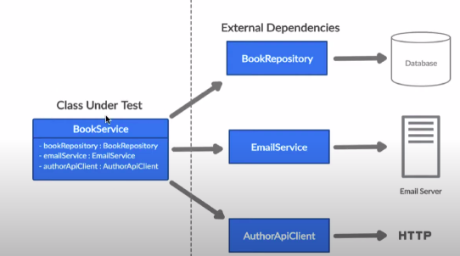
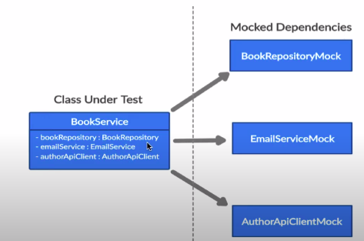

Mockito is an open source testing framework for java.

The framework allows the creation of test doubles objects (mock objects) for unit tests. It uses Java Reflection in order to create mock objects.

It is one of the top 10 Java libraries used by java developers.

Benefits of Mockito

It saves developers from writing test doubles or mock objects on their own

It has support for exception handling

It has support for stubbing methods. It helps us in returning configured response.

It can check order of method calls and number of times method being called.

Annotation support

