Linux assignment 2:-
Create user "nikhil" with home directory set as "/home/nikhil"
(a) nikhil user should have "/bin/sh" shell for his environment

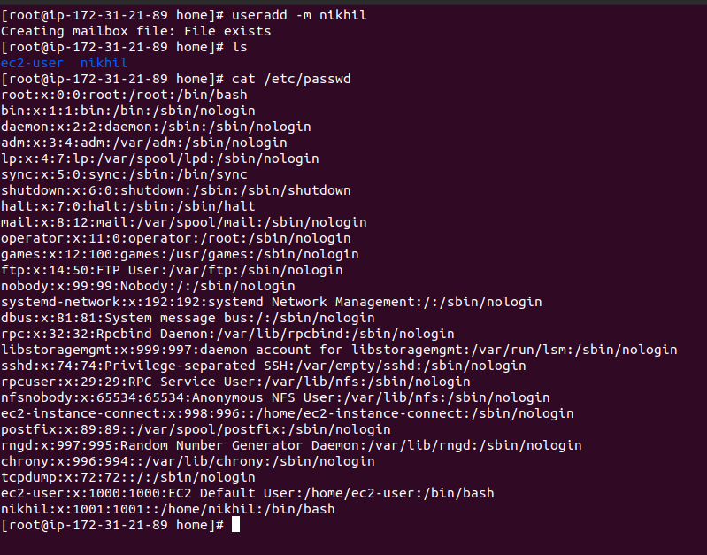
rtere

b) His password should expire in 9 days and 2 days before password expiry, he should get warning. User account must expire in 1 month from creation date

user ac:- chage E 202105-nikhil (ac expire date never to may 11 changed)

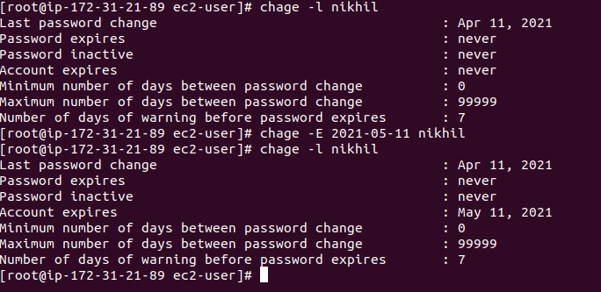
password expire:-
command:-chage -M 9 nikhil

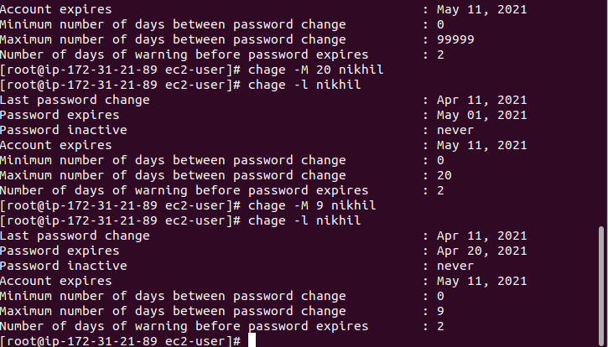
password warrning before expire:-

command-chage -W 2 nikhil

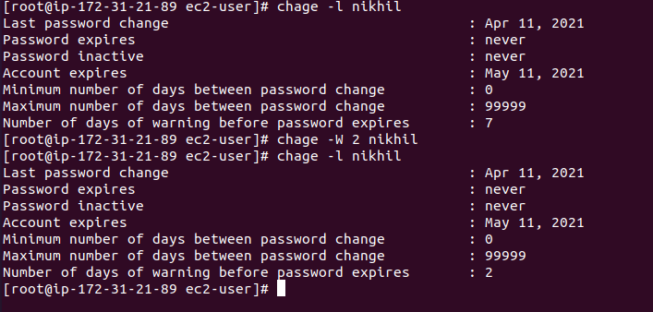

(2) Inside folder "/" , create new home directory as "nikhil" (/nikhil) and setup this folder as a home directory for user "nikhil"
