OpenDhi Group
AI Agents — Architecture, Governance
& Palantir Benchmark
A companion to AI_Agents_Architecture_Model_Plan_v1.docx

WHO THIS DOCUMENT IS FOR
Business / leadership — read Part A. Plain language, diagram-led.
Build / engineering team — read Parts B, C and D. Architecture, governance, and reliability decisions in full.
Everyone — for model selection, cost tables, and scale economics, see the companion document: AI_Agents_Architecture_Model_Plan_v1.docx.

Version | 1.0 — Draft for internal review
Companion document | AI_Agents_Architecture_Model_Plan_v1.docx — model selection, cost tables, scale economics
Date | 27 July 2026
Classification | Internal — Confidential

Contents
1. Executive Summary
2. How This Fits Together
3. The Six-Layer Stack
4. Journey Engine — Orchestration Loop
5. Per-Journey Step Classification
6. Data Freshness & Caching Policy
7. Data Governance & Access Control
8. Reliability & Scaling Decisions
9. How Palantir Runs Agents on SAP, and What We're Adopting
10. What “Enterprise Standard” Requires From Here
11. Open Questions Still Needing a Decision
12. Where to Find Cost & Scale Detail
13. Glossary

1. Executive Summary
WHAT THIS DOCUMENT ADDS
This is the architecture-and-governance companion to AI_Agents_Architecture_Model_Plan_v1.docx. That document covers which agents need a model, what they cost, and how the system scales financially. This one covers how the system actually runs — the Journey Engine, the agent-vs-code test applied step by step with guardrails, data governance and access control, the reliability decisions, and a direct benchmark against how Palantir runs agents on SAP. Read them together for the full picture.

Key points this document establishes
- The Journey Engine is a deterministic state machine, not an LLM, and it lives inside the AI Execution Layer itself rather than a separate orchestration service — a decision that trades third-party reliability tooling for a lighter, more sovereign stack.
- Every step in the catalog has been tested against one rule: does its input need interpretation, or is it already clean and structured? Only the first case needs an agent. Applied consistently across Contract Creation, Payroll Creation, and H2R Lifecycle, most steps turn out to be deterministic code, not AI.
- Data governance follows Palantir's Ontology security pattern in principle — acting-identity propagation, row and field-level access control — but deliberately right-sized for this platform's small, fixed role taxonomy rather than the full generalized policy engine Palantir needs for arbitrary customer org structures.
- Comparing directly against Palantir's production pattern on SAP confirms this architecture already converges on the right shape, and surfaces one real gap: a dedicated agent evaluation/regression pipeline, which Palantir treats as core infrastructure (AIP Evals), not an optional extra.
- Retry policy, multi-tenancy, LLM concurrency, and model fallback are confirmed decisions, documented here with the reasoning behind each — not just the conclusion.

2. How This Fits Together
In plain language, before the technical detail: a Journey is a real business process — a payroll run, a contract, an employee's leave request — made of ordered steps. Each step is owned by exactly one type of actor: an AI Agent, a Human Role, a System Action, or a Client Action.
A fixed piece of code called the Journey Engine walks through those steps in order, like a conductor following a score. When a step needs judgment — interpreting a free-text request, matching a policy, evaluating a rule — it calls an AI agent, which reasons over the relevant context and proposes an action. That proposal is checked by plain code, then passed through a governance check: routine items proceed automatically, anything that crosses a risk threshold is routed to a human for approval. Only after that does the system actually act on a real external system — SAP, ADT, Docuseal, a bank.
The two things that keep this safe at scale: the AI agent never decides its own oversight — code always decides whether a human needs to look at something — and every action, whoever or whatever performed it, is logged against the journey it belongs to.

3. The Six-Layer Stack
The architecture assembles on top of the systems that already exist — nothing in the base is replaced. Context rises up the stack as events happen; approved actions descend back down into the real systems.
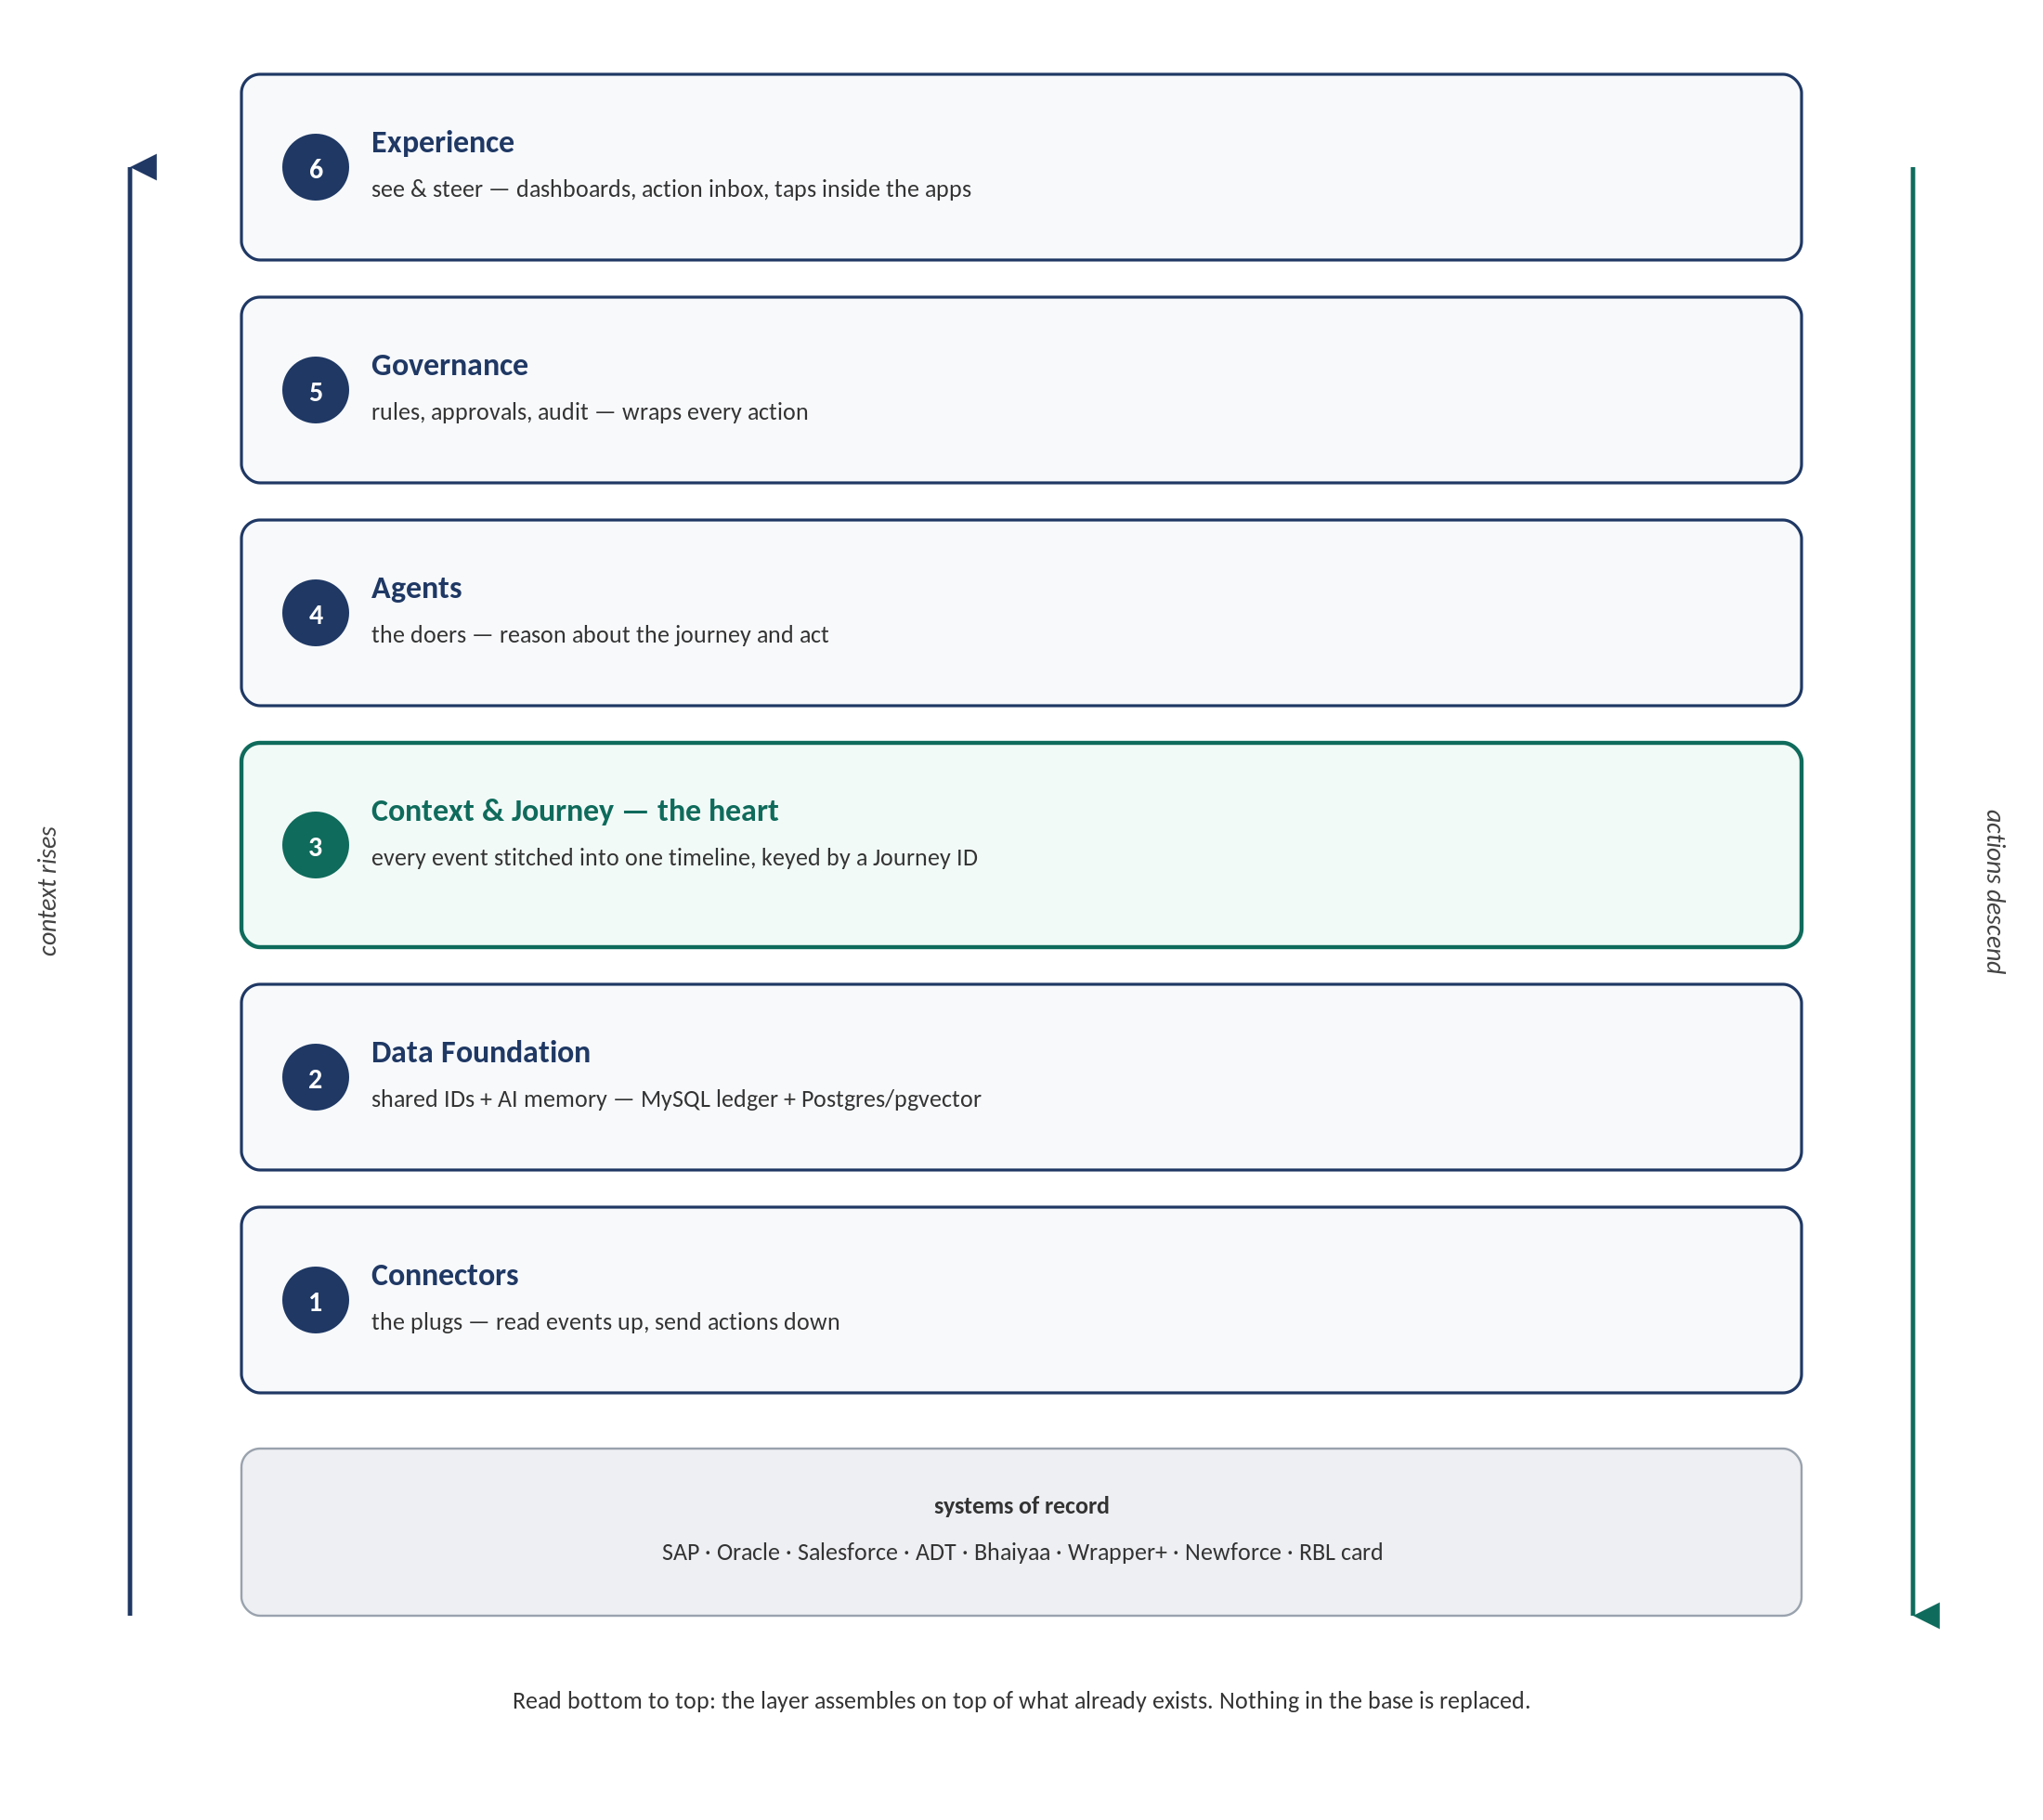
The Context & Journey layer is deliberately called out as “the heart” — it is what stitches events from every system into one timeline keyed by a Journey ID. Per-product AI can answer questions about a single system; this layer is what lets one assistant understand a whole process that spans several.

4. Journey Engine — Orchestration Loop
CONFIRMED DECISION
The Journey Engine is a deterministic state machine — not an LLM — and it lives inside the AI Execution Layer itself, not as a separate orchestration service such as Temporal.

Why not let agents watch the journey and self-trigger. If agents poll shared journey state to decide when to act, the system ends up with many independent processes racing against shared state — a real risk the moment two agents' guardrails touch the same record. Instead, the Journey Engine owns the step sequence and invokes the assigned agent when it is that step's turn. Agents are stateless: called, reasoned, returned a structured tool call, done. They never watch anything and never call an external API directly.
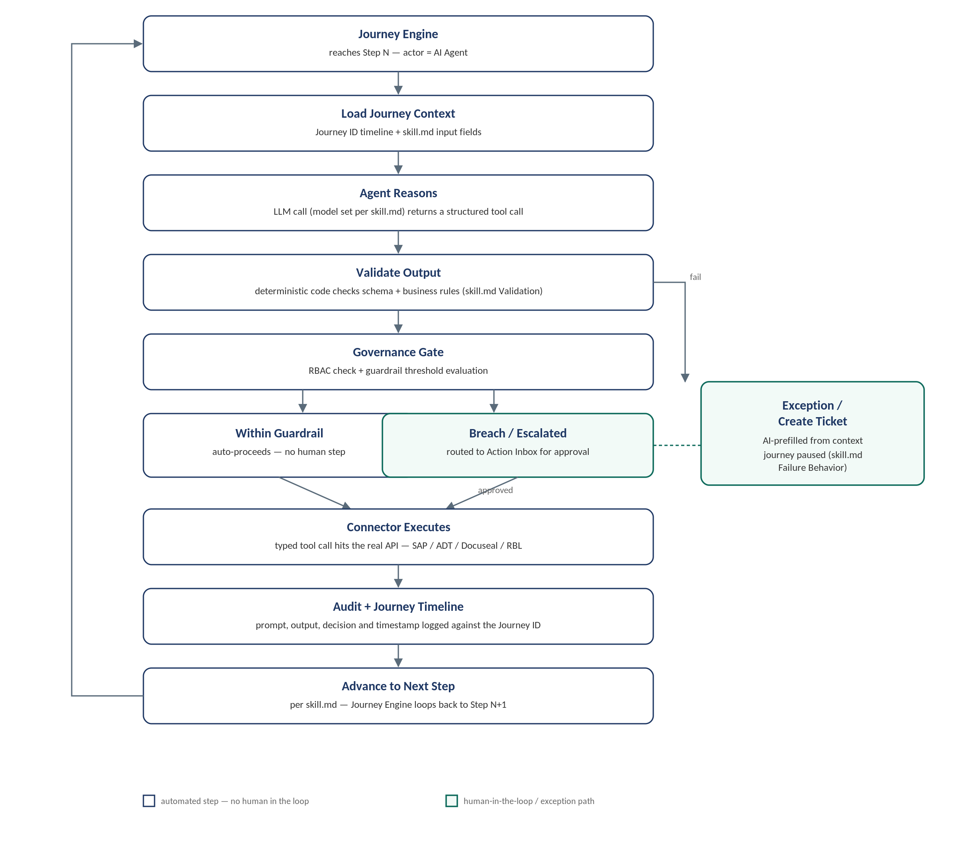
What this decision commits the team to. Keeping the Journey Engine in-layer is consistent with the “lighter, sovereign” positioning already established — no third-party runtime dependency. It also means retries, timeouts, and dead-letter handling are not inherited for free and must be built deliberately (Section 8).

5. Per-Journey Step Classification
The full step-by-step application of the Agent-vs-Code Test to all three active journeys. This is the definitive reference for what to build as an agent versus what to build as plain automation.

5.1 Contract Creation (O2C)
Step | Actor (per journey doc) | Agent or Code? | Guardrail | Note
1 | AI Prompt Parser | Agent — Haiku 4.5 | Fully Automated | Free-text deal/employee prompt into structured fields. Ambiguous-match exception is a code check on extraction confidence.
2 | AI Contract Assistant | Code | Fully Automated | Confirmed: fixed template set, clean structured selection criteria (contract type, country, employment type) → decision table + template-merge.
3 | Human — Journey Initiator | Human step | Human Approves Next Step | Mandatory checkpoint by design — not an automation target.
4 | AI + Docuseal | Code | Fully Automated | Template-merge into contract doc + Docuseal API trigger. Failure → deterministic exception/retry.
5 | Human — Contract Reviewer | Human step | Human Approves Next Step | Deliberate control point, same as Step 3.
6 | Client Action (Docuseal) | Code (mechanics only) | Fully Automated, then waits | System sends request and tracks status via code. The signing act itself belongs to the client.
7 | AI Onboarding Engine | Likely code — confirm | Fully Automated | Checklist/document-presence tracking is deterministic unless document verification classifies unstructured uploads.
8 | AI Payroll Readiness Check | Code | Fully Automated | Completeness check — required fields present, yes/no.

5.2 Payroll Creation (H2R)
Step | Actor (per journey doc) | Agent or Code? | Guardrail | Note
1 | AI Prompt Parser (shared) | Agent — Haiku 4.5 | Fully Automated | Same shared Prompt Parser used across all three active journeys — one model config, reused.
2 | AI Timesheet Sync | Code | Fully Automated | Structured data sync from ADT (your own system) — no interpretation.
3 | AI Payroll Engine | Agent + Code (hybrid) — Haiku 4.5 | Guardrail Evaluated | Model resolves which rate/rule applies and flags anomalies. Arithmetic is a deterministic function. The guardrail threshold check is code comparing the computed value to the configured limit — the model never decides whether it breached the guardrail.
3a | Human — Journey Initiator | Human step | Human Approves Next Step | Routing is code (guardrail passed); the approval act is human.
3b | Human — Department Manager | Human step | Human Approves on Deviation | Routing is code (guardrail breached); the approval act is human.
4 | Human — Finance Approver | Human step | Human Approves Next Step, always | Non-negotiable regardless of guardrail outcome — deliberate final control point, never an automation target.
5 | AI Payslip Generator | Code | Fully Automated | Template-merge.
6 | AI Payroll Archive | Code | Fully Automated | Pure storage write — arguably should not be labelled an “AI” agent at all.

5.3 H2R Lifecycle
Step | Actor (per journey doc) | Agent or Code? | Guardrail | Note
1 | AI Prompt Parser (shared) | Agent — Haiku 4.5 | Fully Automated | Same shared agent again.
2 | AI Compliance Hub Sync | Code | Fully Automated | Structured fetch from Compliance Hub — no interpretation.
3 | AI Leave Policy Engine | Agent — Haiku 4.5 | Human Approves on Deviation | Genuine judgment — matching country to policy with no clean 1:1 mapping. Escalation should be code checking the model's match-confidence score against a threshold, not the model declaring itself uncertain.
4 | Human — Department Manager | Human step | Human Approves on Deviation | Fires only when the confidence check says so; the decision itself stays human.
5 | AI Offboarding Engine | Likely code — confirm | Fully Automated | Same open question as Contract Creation's Onboarding step.

PRINCIPLE
Every Human Step stays a Human Step, regardless of how capable the agents get. Proposal Approved, Contract Approved, the within-guardrail and escalated approvals, Finance Sign-Off, and Deviation Approval are intentional control points, not automation backlog. What shrinks with better engineering is the code layer, not the human layer.

6. Data Freshness & Caching Policy
CORRECTING A COMMON MISREADING
“Linked, not merged” and “reads live, copies the minimum” does not mean every step re-hits the source system's live API for the same fact, every time. Once a fact is fetched for a journey run, it is stitched into that run's timeline as a Journey event, and every later step in the same run reads it from there — never re-fetched live within one run.

Three freshness tiers
- Reference data that rarely changes (rate cards, leave policy documents, org structure) — fetch once, cache with a TTL of hours to a day, refresh in the background.
- Journey-scoped facts (this employee's attendance for this pay period, this deal's terms) — fetch once when first needed in the run, persist as a Journey event, reused by every later step in that same run.
- Point-of-action data where staleness is the actual risk (current card balance right before disbursal, compliance status right before it gates an action) — deliberately re-fetch fresh at the moment of execution, even if a similar fact was fetched earlier in the run.

Connector-level notes
- Deterministic (“System Action” / no-LLM) steps call the Connector function directly from the Journey Engine — no model anywhere in that path.
- For batch operations (e.g. a payroll run across hundreds of employees), use the source system's bulk/batch endpoint (SAP OData $batch, ADT bulk export) instead of firing one live call per record — this is both a rate-limit and a cost consideration (see Section 10).

7. Data Governance & Access Control
Benchmark: modelled on how Palantir's Ontology enforces access for AIP agents — object/property-level security policies, acting-identity propagation, and per-query dynamic enforcement — but deliberately right-sized for this platform's small, fixed role taxonomy rather than ported over wholesale. Palantir's full generalized policy engine is built for arbitrary, unknown org structures across every customer; this platform has five well-defined roles, so the same guarantee can be achieved far more cheaply. See Section 9 for the full Palantir comparison.
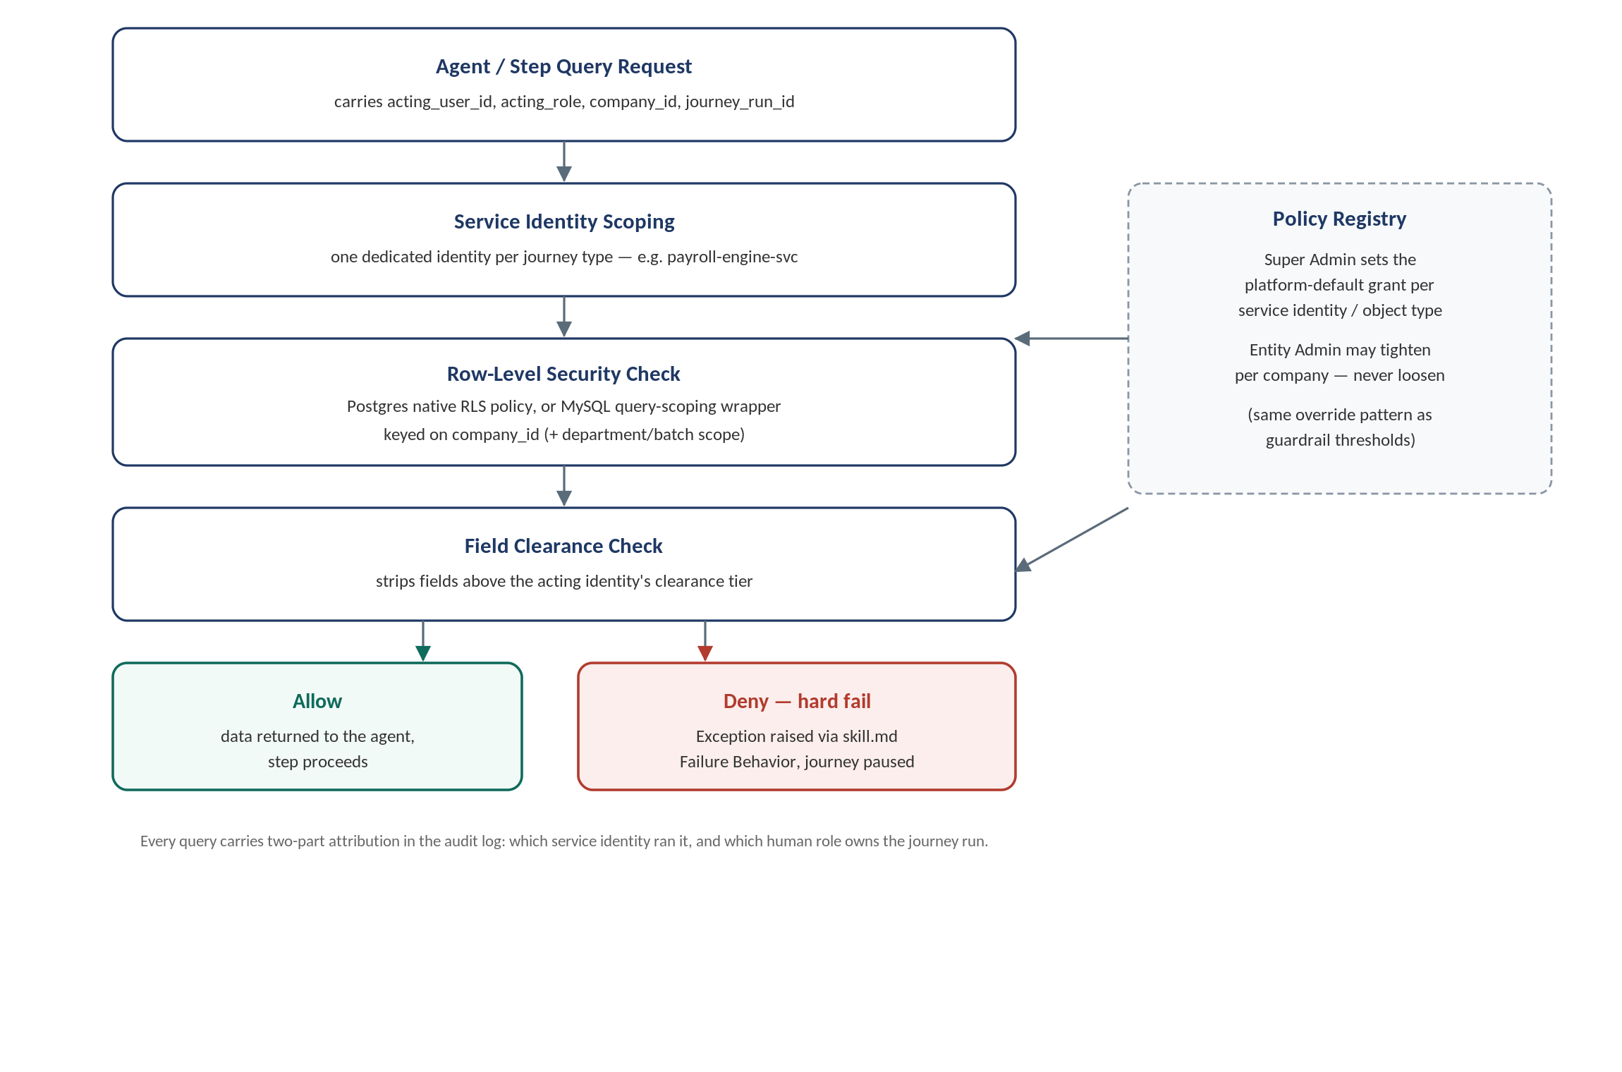

7.1 Acting identity
Confirmed: each journey type gets a dedicated service identity (e.g. payroll-engine-svc, contract-assistant-svc, leave-policy-svc), scoped to exactly the object types, rows, and fields that journey needs. This identity is set in every query's session context. Every audit log entry still records two things: which service identity ran the query, and which human/role owns the journey run it belongs to — service identity is not a substitute for human accountability.

7.2 Clearance tiers
Confirmed: reuse the existing role ladder — Journey Initiator < Department Manager < Finance Approver < Entity Admin. Every sensitive field (bank details, wage amount, compliance/immigration documents) is tagged with the minimum tier required to see it. A service identity's grant is capped at the clearance level of whichever human role normally owns that step.

7.3 Policy ownership
Confirmed: Super Admin sets the platform-default grant list per service identity per object type; Entity Admin can tighten it per company, never loosen it — identical to the existing guardrail-threshold override pattern.

7.4 On denial
Confirmed: any out-of-scope field or row access blocks the query and raises an Exception through the existing skill.md Failure Behavior path — the same Create Ticket / AI-prefill flow as any other validation failure. Practical consequence: there is no soft landing, so every service identity's grant list must be scoped generously and correctly before go-live — start from exactly the fields each skill.md already declares as Input Fields, then tighten later only if an audit shows a field is never used, not the reverse.

7.5 Technical implementation
- PostgreSQL (Data Foundation's AI/RAG side): native Row-Level Security, one policy per object type keyed on service identity + company_id (+ batch/department scope where relevant), session variable set before every query.
- MySQL (ledger): no native RLS — enforced via a single mandatory query-scoping wrapper function; no connector or agent tool queries the ledger directly.
- Field clearance: one shared serialization/masking function, applied when assembling each skill.md's declared Input Fields, strips anything above the acting identity's clearance before it reaches the agent's context.
- Registry: a versioned table of service identities and their grant lists, owned by Super Admin, tightenable by Entity Admin — same storage pattern as guardrail thresholds.

7.6 When to revisit this
This right-sized model holds as long as access is being filtered against this platform's own five generic roles. Once Phase 3 connects directly to a customer's own SAP or Oracle instance, the platform is respecting whatever arbitrary, customer-specific role structure already exists inside their ERP — at that point, something closer to Palantir's full dynamic marking system becomes the appropriate tool. Build it when that connector work starts, not speculatively now.

8. Reliability & Scaling Decisions

8.1 Retry & idempotency
Decision (confirmed): platform-default retry policy (Super Admin-set), with per-step configuration that can only tighten, never loosen — the same override pattern already used for guardrail thresholds. Still open: the actual retry count, backoff curve, and the idempotency-key scheme for write-back, so a retried disbursal call cannot double-load a card. These need input from whoever owns the SAP/RBL connector build.

8.2 Multi-tenancy
Decision (confirmed): a single shared, stateless Journey Engine instance, tenant-isolated by company_id at every context lookup and database query — no per-tenant dedicated deployments for now. This matches the “stateless and horizontally scalable” reliability claim already in the architecture PDF, and is the cheapest option to run and operate.
CORRECTNESS FLAG
The single most common way multi-tenant SaaS platforms fail is not a compromised API key — it is one query somewhere that omitted the company_id filter. Tenant isolation should be enforced at the data-access layer itself (every table has a non-optional company_id, every query goes through a wrapper that cannot omit it), not trusted to application logic scattered across agents and connectors.

8.3 LLM concurrency & batching at scale
Decision (confirmed): use the model vendor's Batch API for bulk, non-urgent steps — the monthly Payroll Engine run across all employees is the clear fit (roughly half the per-token cost, naturally paced). Live, interactive steps (Contract Creation's back-and-forth) stay on synchronous calls — batch results land in minutes to hours, which is wrong for anything a person is waiting on in real time.

8.4 Model fallback
Decision (confirmed): each agent has a primary and an automatic fallback, and the fallback is same-vendor (Claude Haiku 4.5 primary, the same model via AWS Bedrock cross-region inference as fallback on a direct-API outage) rather than cross-vendor. One tool-call schema and one audit format throughout — no reconciliation problem between two providers' output formats.

9. How Palantir Runs Agents on SAP, and What We're Adopting
Mapped onto this platform's own layer names, Palantir's production pattern for running AI agents on top of SAP is structurally very close to what this architecture already specifies — useful validation, and one useful gap to close.
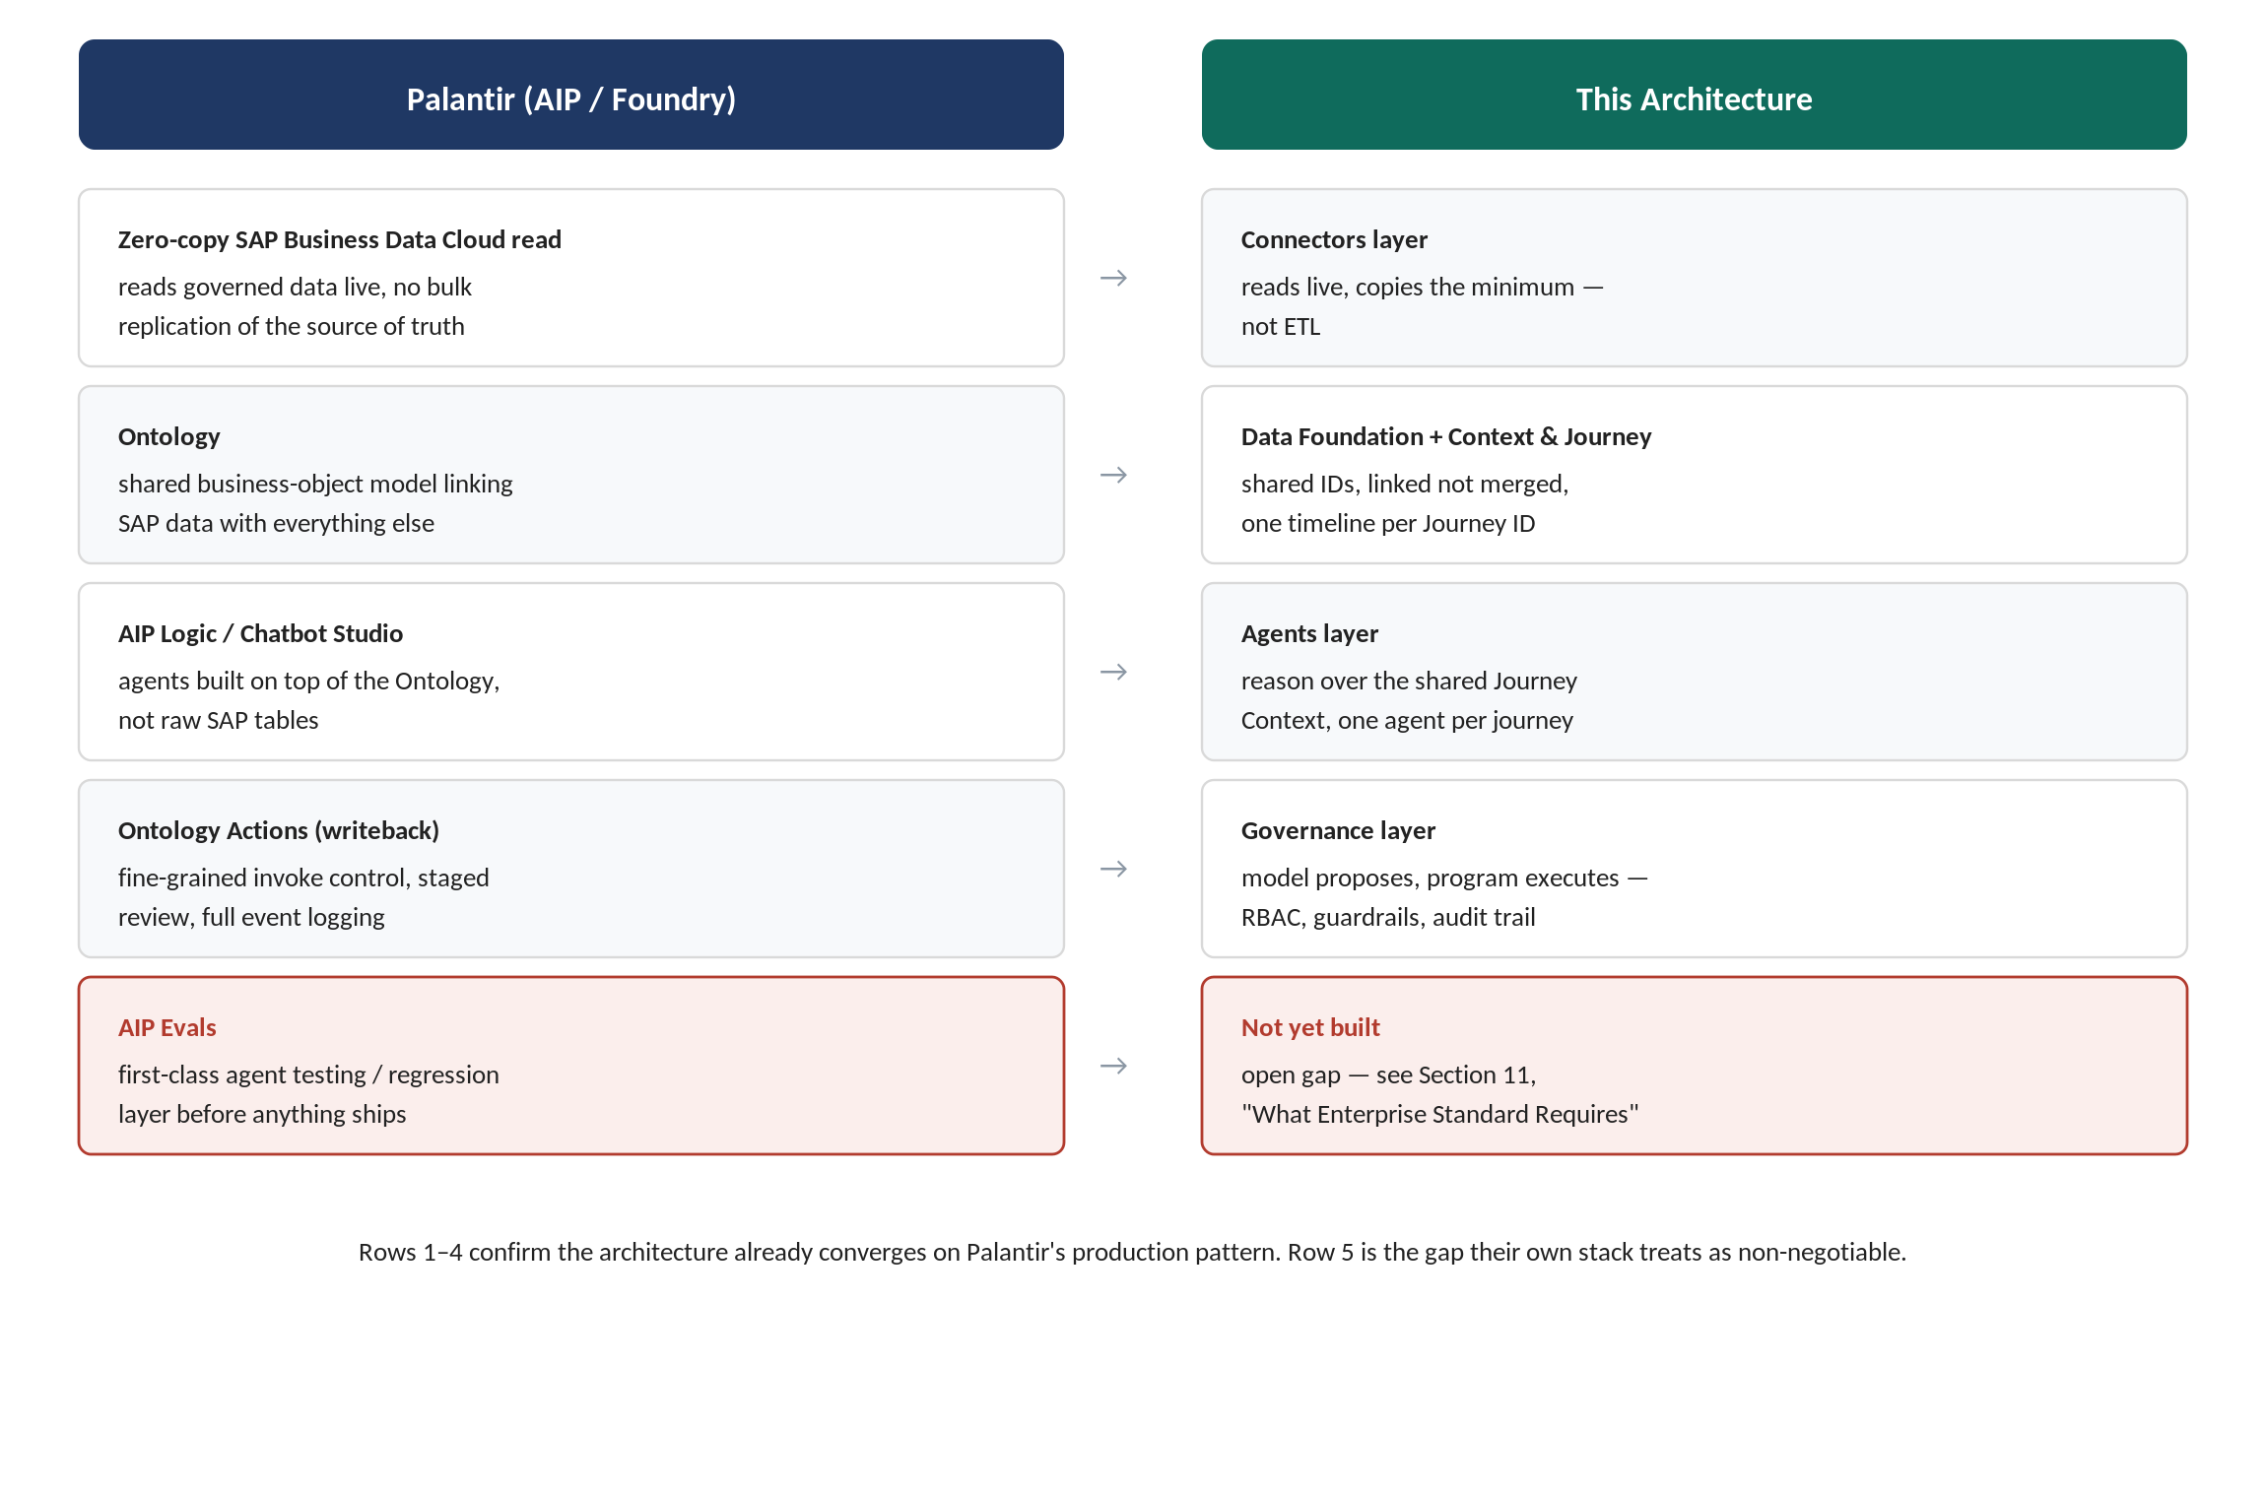

9.1 The mapping, in detail
- Reading SAP — zero-copy, not ETL. Through the SAP Business Data Cloud partnership, Palantir Foundry gets governed, zero-copy access to SAP data — no bulk replication. This is the Connectors layer's “reads live, copies the minimum” principle, with SAP as a formal launch partner.
- The shared semantic layer — Palantir's “Ontology”: a shared business-object model (Employee, Order) linking SAP data with everything else into one operational picture. Functionally, this is the Data Foundation plus Context & Journey layer: shared IDs, linked not merged, one timeline instead of disconnected systems.
- The agents — AIP Logic / Chatbot Studio, built on top of the Ontology, reasoning over shared context rather than raw SAP tables. Same shape as this platform's Agents layer.
- Writeback — Ontology Actions. Fine-grained control over who may invoke a given action, test-driven frameworks before publishing a change, staged/batch review, and full logging of every event. This is close to a one-to-one match with this platform's Governance layer: “model proposes, program executes,” applied to writeback.

9.2 The one gap Palantir treats as core infrastructure
AIP Evals — a dedicated, first-class product layer for testing and evaluating agent behaviour before it ships. This is exactly the agent evaluation/regression pipeline gap flagged in Section 10. Palantir's own production stack confirms it is not optional at scale; it is load-bearing infrastructure, not a nice-to-have added later.

9.3 Not to conflate
Palantir also runs a separate SAP product — AI-assisted ECC-to-S/4HANA data migration (96% validation accuracy within hours, 99.8% within two weeks; now an SAP Endorsed App with a Solution Extension planned for Q3 2026). That is a migration tool, a different problem from the live execution-agent pattern this document is about — worth keeping the two apart in any competitive narrative.

10. What “Enterprise Standard” Requires From Here
What the architecture as currently scoped is missing, ordered by how much it undercuts a claim already being made or a deal already being pursued — not by ease of implementation.

10.1 Data sovereignty vs. third-party LLM APIs
Every agent call ships employee wage data, bank details, or SAP financial records into a prompt sent to a cloud LLM API. This is in tension with the “sovereign, data stays in the customer's control” claim already in the architecture PDF, and it is the standard objection an enterprise security review raises. Three ways out: a regional-hosted endpoint (AWS Bedrock ap-south-1 Mumbai, Azure OpenAI India region, Vertex AI Mumbai) so data does not leave the country; redact/tokenize PII before it hits the prompt and rehydrate after; or self-host an open-source model inside the customer's own cloud for the highest-sensitivity steps. Decide before this goes in front of an SAP customer's security team.

10.2 No agent evaluation / regression pipeline
There is currently no mechanism to test a skill.md change or a model swap before it reaches production. Standard practice: a golden test set per agent, run automatically before any prompt or model version change ships, tracking accuracy, hallucination rate, and guardrail-bypass rate over time. Palantir's own AIP Evals confirms this is core infrastructure at scale, not optional.

10.3 No LLM gateway / provider abstraction
The primary + automatic fallback model decision means every future model swap should be a configuration change, not a redeploy across every agent. A thin routing layer (self-hosted LiteLLM or Portkey, or an equivalent thin wrapper) is what actually delivers that.

10.4 Prompt injection is not yet addressed
Agents read external, sometimes human-authored text — SAP fields, timesheet notes, contract clauses. “Model proposes, program executes” contains the blast radius on the execution side, but a manipulated proposal can still read as reasonable to a human approver and get rubber-stamped. Worth an explicit red-team pass before launch.

10.5 No FinOps layer
Per-tenant token spend needs tracking and alerting so one customer's unusually large batch does not quietly erode margin, and a model-deprecation policy is needed since vendors retire model versions on a schedule.

10.6 Explainability as a product feature, not just an audit log
The guardrail-breach flags shown to Department Manager/Finance are threshold math today (“+18% above guardrail”). An AI-generated plain-language reason alongside that number reinforces the “categorically different” positioning in a sales demo, not just in this document.

10.7 Compliance certification is a sales gate, not an engineering one
Real wage and personal data flowing through this system means SOC 2 and India's DPDP Act compliance will come up in every enterprise SAP/Oracle deal's security review. SOC 2 alone takes months — if this process has not started, an excellent architecture will not prevent the deal stalling on paperwork.

11. Open Questions Still Needing a Decision
- Retry count, backoff curve, and idempotency-key scheme for write-back — needs input from whoever owns the SAP/RBL connector build.
- Whether AI Onboarding Engine and AI Offboarding Engine are genuinely deterministic, or whether document verification within them involves classifying unstructured uploads (which would need a model).
- What AI Benefits Enrollment's agent actually does — rule-based eligibility (deterministic) versus a plan-recommendation feature (Haiku-tier) changes its classification entirely; not specified in the current product design.
- Real transaction volumes for Procure-to-Pay, Finance-to-Accounts, Immigration, and Expense Claims, to replace the illustrative ratios used in Section 10 (e.g. “1 purchase order per 20 employees per month”) — these will vary a great deal by industry vertical.
- RBL/Paycraft's actual API rate limits — not publicly documented, needs direct confirmation from RBL.
- Whether the Journey Engine's per-step loop needs any additional resilience pattern beyond the retry/idempotency policy once real production traffic is observed.
- Each SAP-connected customer's existing Digital Access licensing tier and total document volume across all their other systems — the aggregate cost figures in Section 10 depend entirely on this and cannot be generalised.

12. Where to Find Cost & Scale Detail
This document is deliberately scoped to architecture, governance, and reliability. For anything about which model to use, what it costs, or how it scales financially, see the companion document.
Topic | Where | What it covers
Which agents need a model, journey by journey | AI_Agents_Architecture_Model_Plan_v1.docx, Section 8 | Full nine-journey catalog, agent by agent, with the reasoning for each
Model choice and cost by scale | v1, Section 9 | Pilot / Growth / Enterprise model plan, self-hosting breakeven math
API rate limits, volume, and cost | v1, Section 10 | SAP/Infor/Salesforce published limits, illustrative volume tables, SAP Digital Access exposure

13. Glossary
Term | Meaning in this document
Journey Engine | The deterministic state machine that sequences a journey's steps and invokes the assigned agent or connector at each one. Lives inside the AI Execution Layer.
Agent-vs-Code Test | For every step: does the input need interpretation, or is it already clean and structured? Only the first case needs a model call.
Service identity | A dedicated, scoped identity per journey type (not a human), used to filter every data access down to exactly what that journey legitimately needs.
Clearance tier | The minimum role level (Journey Initiator / Department Manager / Finance Approver / Entity Admin) required to view a given sensitive field.
Row-Level Security (RLS) | A database-native mechanism (used here in PostgreSQL) that filters query results by a session-level identity, automatically, on every query.
Ontology | Palantir's term for a shared business-object model linking data across systems — the closest Palantir equivalent to this platform's Data Foundation + Context & Journey layer.
Ontology Actions | Palantir's governed writeback mechanism — the closest equivalent to this platform's Governance layer.
AIP Evals | Palantir's dedicated agent testing/evaluation layer — currently a gap in this architecture (Section 10).

