TASK 1: Repository Setup
Goal: Initialize Git and create first commit
Steps:
1. Create a folder named git-assignment-yourfullname
2. Navigate into the folder
3. Initialize Git repository
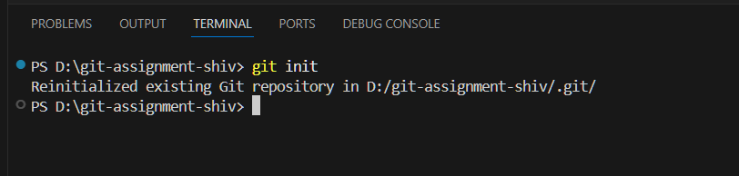
4. Create a file named index.txt
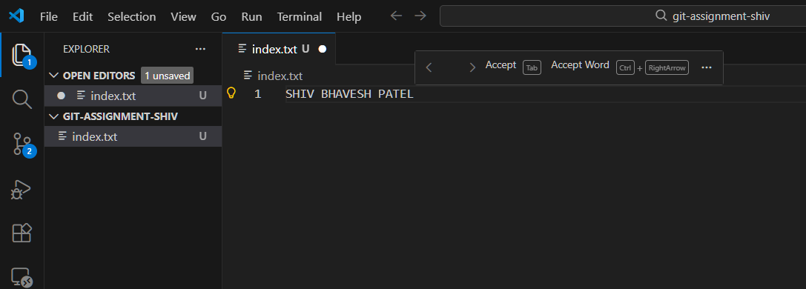
5. Check repository status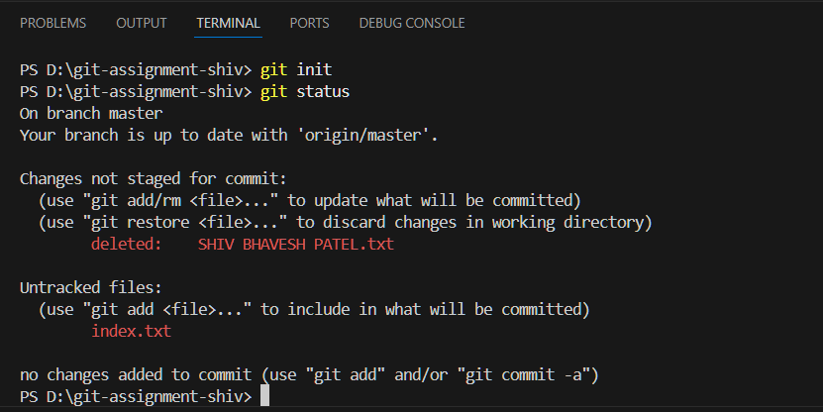

6. Stage the file
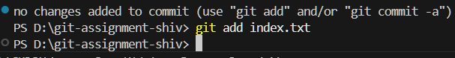
7. Commit with message: Initial project setup
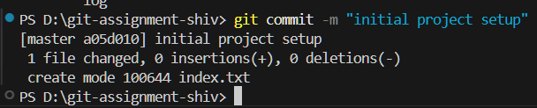

TASK 2: Branch Creation & Work
Goal: Work independently in a branch
Steps:
1. Create a branch named feature-header
2. Switch to feature-header
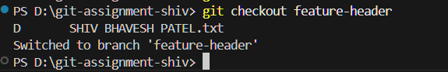
3. Create a file named header.txt
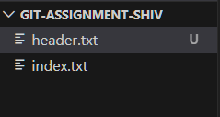
4. Stage the file
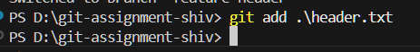

5. Commit with message:
Added header section

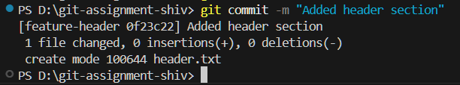

TASK 3: Branch Switching Observation
Goal: Observe branch isolation
Steps:
1. Switch back to master
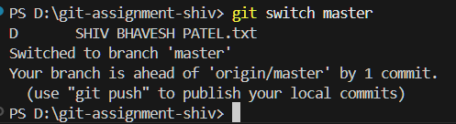
2. List files and observe
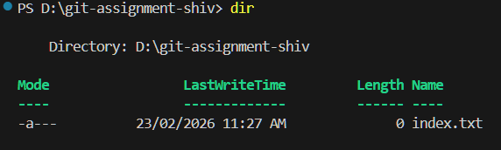
3. Switch again to feature-header
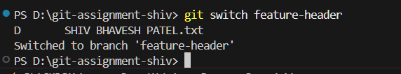
4. List files and observe
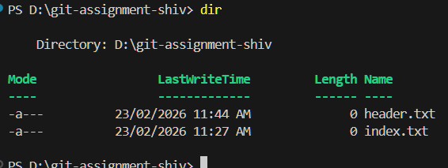
TASK 4: Undo a Mistake
Goal: Safely undo file changes
Steps:
1. In feature-header, modify index.txt
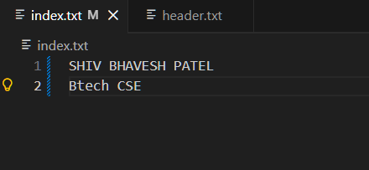
2. Check repository status
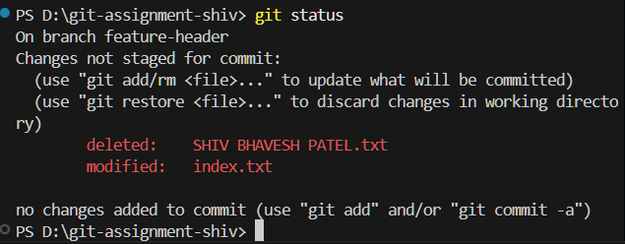
3. Undo the change using Git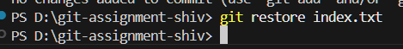

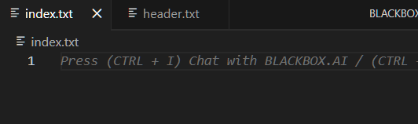
4. Verify status again
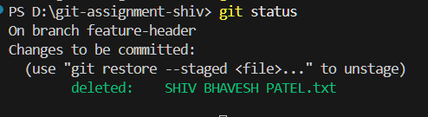

TASK 5: Merge Feature Branch
Goal: Combine work into master
Steps:
1. Switch to master
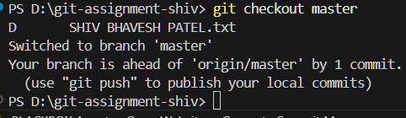
2. Merge feature-header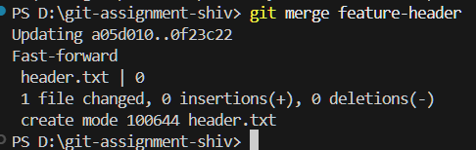

3. Verify merged files
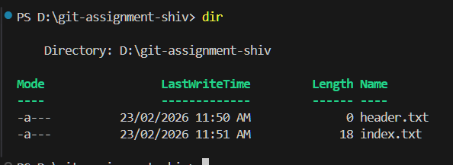
4. Check commit history
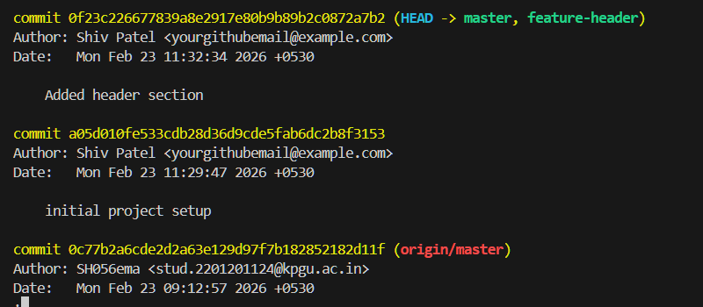

TASK 6: Checkout a Commit (Detached HEAD)
Goal: Understand commit-level navigation
Steps:
1. View commit history
2. Checkout any older commit
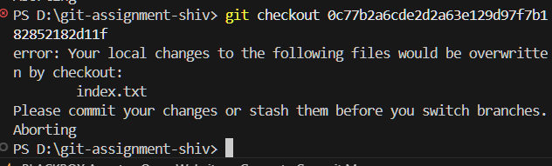
3. Check current branch status
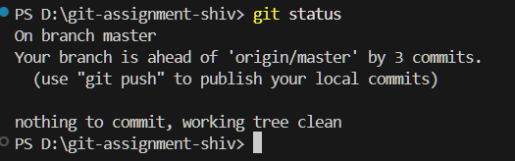
4. Switch back safely to master
