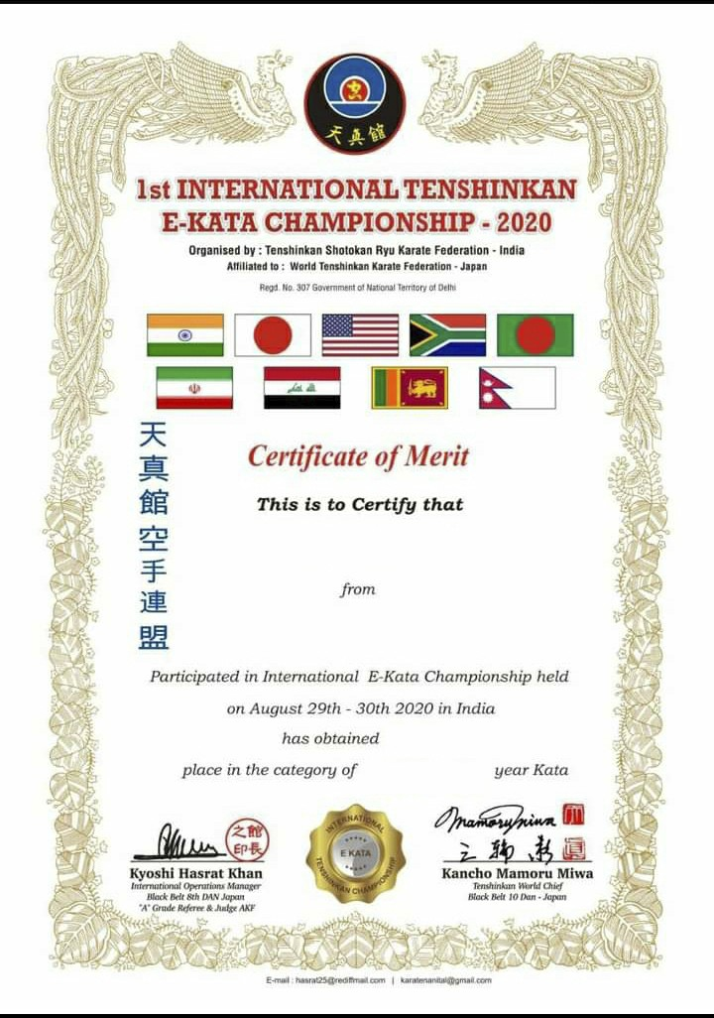

KRISHNA KUMAR

UTTARAKHAND, INDIA

2nd

MALE- 25