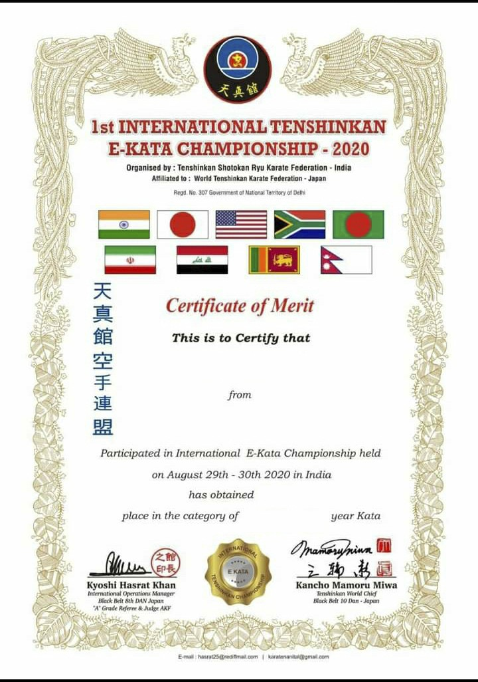

KISHU KUMAR

BIHAR, INDIA

2ND

MALE- U/14