**MINI PROJECT – I**

**(2019-21)**

# GLA ASSISTANT

**PROJECT REPORT**



**Institute of Engineering & Technology**

**Team Members**

MANALI SHARMA

(171500176)

(manali.sharma_cs17@gla.acs.in)

SHIV SHANKAR TRIPATHI

(171500319)

(shiv.tripathi_cs17@gla.ac.in)

## Supervised By

**Mr AMIR KHAN.**

**Technical Trainer**

**Department of Computer Engineering & Applications**

**GLA University, Mathura**

**ACKNOWLEDGEMENT**

It gives us a great sense of pleasure to present the report of B.Tech project undertaken during B.Tech third year. We owe special debt of gratitude to **MR. Amir Khan**, Technical Trainer, GLA University, Mathura for his constant support and guidance throughout the course of our work. His sincerity, thoroughness and perserverance have been a constant source of inspiration for us. It is only his cognizant efforts that our endeavors have seen light of the day. We also do not like to miss the opportunity to acknowledge the contribution of all faculty members of the department of computer science for their kind assistance and cooperation during the development of our project. Last but not the least, we acknowledge our friends for their contribution in the completion of the project. I would also like to thank all those who directly or indirectly supported or helped me in completing my project in time. I would like to express our gratitude towards my parents and members of my college for their kind cooperation and encouragement which helped me in completion of this project. All of them have willingly helped me out with their ability.



**Department of Computer Engineering and Applications**

**GLA University, Mathura**

**17 km. Stone NH#2, Mathura-Delhi Road, P.O. – Chaumuhan,**

**Mathura – 281406**

**CERTIFICATE**

*This is to certify that the project entitled* ***“GLA Assistant”*** *carried out in Mini Project – I Lab is a bona fide work done by* ***Manali Sharma (171500176)*** *and*  ***Shiv Shankar Tripathi(171500319)*** *and is submitted in partial fulfillment of the requirements for the award of the degree Bachelor of Technology (Computer Science & Engineering).*

**Signature of Supervisor:**

**Name of Supervisor: Mr. Amir Khan (Technical Trainer)**

**Date:**

**ABSTRACT**

This project aims to provide a user friendly environment and a simple way to access information about GLA University. This project is broadly divided into two modules. The first module is based upon giving the queries to the assistant. These queries will be given by simply speaking. The second module consists of the answer that will be given by the assistant in the form of voice output. This assistant helps us to get the required information with the help of single tap. You have to give the voice command to the application and then it responds according to the information stored in our dataset. We have used NLTK and python. In case question is not there in our dataset in that case it searches from the Google and gives the respective information. This application helps to provide information without even typing our query and just by giving voice input. It gives output in the form of voice.

CHAPTER 1

**INTRODUCTION**

1.1 Project Plan

1.1.1 About the Project

1.1.2 Purpose and Scope

1.2 About NLTK

1.3 Python 3.6

1.3.1 Improvements in Standard Library

1.3.2 Security Improvements

1.3.3 Windows Improvements

1.3.4 New features

1.4 About Language Used

1.4.1 Python Language

1.5 WolframAlpha

1.6 Regular Expression

1.7 Reflections

CHAPETR 2

**SOFTWARE DEVELOPMENT LIFE CYCLE**

2.1 Data flow diagram

2.2 Use case diagram

CHAPTER3

SCREENSHOTS

CHAPTER4

FUTURE SCOPE

CHAPTER5

CONCLUSION

REFERENCES

**CHAPTER 1**

**INTRODUCTION**

**1.1 PROJECT PLAN**

**1.1.1 ABOUT THE PROJECT**

Users primarily interact with the GLA Assistant through **natural voice**. In the same nature and manner as Google Now, the Assistant is able to search the Internet, give information about GLA University, and show information from the Wolfram|Alpha  account. In this project, we are proposing a tool using Python, Data Analytics and NLTK that will give you information about GLA University. It will work in almost the similar way as the Google Assistant works. It will be effective and reliable and can easily be used. You can easily give command to the assistant by simply speaking your question or query. This tool can be easily accessed by the user by giving a voice command. It will be helpful in many ways. In this project we just simply give voice command as input and get the output as in voice and also in text form.

Google assistant works by listening to our questions and then works on that question by matching that with its dataset. Our project also works in the same way such that the questions asked are first matched with those present in our dataset and if they

are present there then output is displayed on your screen and if it is not present then it makes a Google query and displays the answer according to that question.

**1.1.2 Purpose and Scope**

The purpose of this project is to make things easier the one who wants to know about our college. In our project the main key here is voice. This GLA Assistant uses voice recognition, speech synthesis and natural language processing (NLP) to provide a service through our application which we have implemented.

The implemented project recognizes voice and gives output based on our query. It can cover vast information about GLA and can also answer your query from searching with web with the help of wolframalpha. Apart from our dataset it can give other information also.

**1.2 ABOUT NLTK**

NLTK is a leading platform for building Python programs to work with human language data. It provides easy-to-use interfaces to over 50 corpora and lexical resources such as WordNet, along with a suite of text processing libraries for classification, tokenization, stemming, tagging, parsing, and semantic reasoning, wrappers for industrial-strength NLP libraries, and an active discussion forum.

Thanks to a hands-on guide introducing programming fundamentals alongside topics in computational linguistics, plus comprehensive API documentation, NLTK is suitable for linguists, engineers, students, educators, researchers, and industry users alike.

NLTK is available for Windows, Mac OS X, and Linux. Best of all, NLTK is a free, open source, community-driven project.

NLTK has been called “a wonderful tool for teaching, and working in, computational linguistics using Python,” and “an amazing library to play with natural language.”

Natural Language Processing with Python provides a practical introduction to programming for language processing. Written by the creators of NLTK, it guides the reader through the fundamentals of writing Python programs, working with corpora, categorizing text, analyzing linguistic structure, and more. The online version of the book has been been updated for Python 3 and NLTK 3.

**1.3 Python 3.6**

Python 3.7 is now released and is the latest feature release of Python. They plan to continue to provide bug-fix releases for 3.6.x though the end of 2018 and security fixes through 2021.

Python 3.6.0 is the newest major release of the Python language, and it contains many new features and optimizations. The dict type has been re-implemented to use a more compact representation based on a proposal by Raymond Hettinger and similar to PyPy dict implementation. This resulted in dictionaries using 20% to 25% less memory when compared to Python 3.5.

* Customization of class creation has been simplified with the new protocol.
* The class attribute definition order is now preserved.
* DTrace and System Tap  probing support has been added.

**1.3.1 Significant improvements in the standard library:**

* A new file system path protocol has been implemented to support [path-like objects](https://docs.python.org/3.6/glossary.html#term-path-like-object). All standard library functions operating on paths have been updated to work with the new protocol.
* The [datetime](https://docs.python.org/3.6/library/datetime.html#module-datetime) module has gained support for [Local Time Disambiguation](https://docs.python.org/3.6/whatsnew/3.6.html#whatsnew36-pep495).

**1.3.2 Security improvements**:

* The new [secrets](https://docs.python.org/3.6/library/secrets.html#module-secrets) module has been added to simplify the generation of cryptographically strong pseudo-random numbers suitable for managing secrets such as account authentication, tokens, and similar.
* On Linux, [os.urandom()](https://docs.python.org/3.6/library/os.html#os.urandom) now blocks until the system urandom entropy pool is initialized to increase the security. See the [**PEP 524**](https://www.python.org/dev/peps/pep-0524) for the rationale.

**1.3.3 Windows improvements**:

[PEP 528](https://docs.python.org/3.6/whatsnew/3.6.html#whatsnew36-pep528) and [PEP 529](https://docs.python.org/3.6/whatsnew/3.6.html#whatsnew36-pep529), Windows filesystem and console encoding changed to UTF-8.

* The py.exe launcher, when used interactively, no longer prefers Python 2 over Python 3 when the user doesn’t specify a version (via command line arguments or a config file). Handling of shebang lines remains unchanged - “python” refers to Python 2 in that case.
* python.exe and pythonw.exe have been marked as long-path aware, which means that the 260 character path limit may no longer apply.
* A ._pth file can be added to force isolated mode and fully specify all search paths to avoid registry and environment lookup. See [the documentation](https://docs.python.org/3.6/using/windows.html#finding-modules) for more information.

**1.3.4 New Features**

**PEP 498: Formatted string literals**

[PEP 498](https://www.python.org/dev/peps/pep-0498) introduces a new kind of string literals: f-strings, or [formatted string literals](https://docs.python.org/3.6/reference/lexical_analysis.html#f-strings).

Formatted string literals are prefixed with 'f' and are similar to the format strings accepted by [str.format()](https://docs.python.org/3.6/library/stdtypes.html#str.format). They contain replacement fields surrounded by curly braces. The replacement fields are expressions, which are evaluated at run time, and then formatted using the [format()](https://docs.python.org/3.6/library/functions.html#format) protocol.

**1.4**  **About Language used**

We use python language in our project in which we import some modules such as pyttsx3,wolfarmalpha, speech_recognition etc.

**1.4.1 Python Language**

**Python** is advance an [interpreted](https://en.wikipedia.org/wiki/Interpreted_language), [high-level](https://en.wikipedia.org/wiki/High-level_programming_language), [general-purpose](https://en.wikipedia.org/wiki/General-purpose_programming_language) [programming language](https://en.wikipedia.org/wiki/Programming_language). Created by [Guido van Rossum](https://en.wikipedia.org/wiki/Guido_van_Rossum) and first released in 1991, Python's design philosophy emphasizes [code readability](https://en.wikipedia.org/wiki/Code_readability) with its notable use of [significant whitespace](https://en.wikipedia.org/wiki/Off-side_rule). Its language constructs and [object-oriented](https://en.wikipedia.org/wiki/Object-oriented_programming) approach aim to help programmers write clear, logical code for small and large-scale projects.

**1.5 Wolfram Alpha**

**Wolfram|Αlpha** (also_styled **WolframAlpha** or **Wolfram**|**Alpha**) is a computational knowledge engineor [answer engine](https://en.wikipedia.org/wiki/Answer_engine) developed by Wolfram Alpha LLC, a subsidiary of [Wolfram Research](https://en.wikipedia.org/wiki/Wolfram_Research). It is an online service that answers factual queries directly by computing the answer from externally sourced "curated data", rather than providing a list of documents or web pages that might contain the answer as a [search engine](https://en.wikipedia.org/wiki/Search_engine) might.

Wolfram Αlpha, which was released on May 18, 2009, is based on Wolfram's earlier flagship product [Wolfram Mathematica](https://en.wikipedia.org/wiki/Wolfram_Mathematica), a computational platform or toolkit that encompasses computer algebra, symbolic and numerical computation, visualization, and statistics capabilities. Additional data is gathered from both academic and commercial websites such as the CIA's [The World Factbook](https://en.wikipedia.org/wiki/The_World_Factbook), the [United States Geological Survey](https://en.wikipedia.org/wiki/United_States_Geological_Survey), a Cornell University Library publication called All About Birds, [Chambers Biographical Dictionary](https://en.wikipedia.org/wiki/Chambers_Biographical_Dictionary), [Dow Jones](https://en.wikipedia.org/wiki/Dow_Jones_%26_Company), the [Catalogue of Life](https://en.wikipedia.org/wiki/Catalogue_of_Life), [CrunchBase](https://en.wikipedia.org/wiki/CrunchBase),  [Best Buy](https://en.wikipedia.org/wiki/Best_Buy),[[8]](https://en.wikipedia.org/wiki/Wolfram_Alpha#cite_note-8) the [FAA](https://en.wikipedia.org/wiki/Federal_Aviation_Administration)[[9]](https://en.wikipedia.org/wiki/Wolfram_Alpha#cite_note-9) and optionally a user's Facebook account.

**1.6 Regular Expression**

A RegEx, or Regular Expression, is a sequence of characters that forms a search pattern.

RegEx can be used to check if a string contains the specified search pattern.

Python has a built-in package called re, which can be used to work with Regular Expressions.

Import the  re  module. When you have imported the re module, you can start using regular expressions

A regular expression, often called a **pattern**, is an expression used to specify a [set](https://en.wikipedia.org/wiki/Set_(computer_science)) of strings required for a particular purpose. A simple way to specify a finite set of strings is to list its [elements](https://en.wikipedia.org/wiki/Data_element) or members. However, there are often more concise ways to specify the desired set of strings. For example, the set containing the three strings "Handel", "Händel", and "Haendel" can be specified by the **pattern** H(ä|ae?)ndel; we say that this pattern **matches** each of the three strings. In most [formalisms](https://en.wikipedia.org/wiki/Formalism_(mathematics)), if there exists at least one regular expression that matches a particular set then there exists an infinite number of other regular expressions that also match it—the specification is not unique. Most formalisms provide the following operations to construct regular expressions.

**1.7 Reflections**

Reflection refers to the ability for code to be able to examine attributes about objects that might be passed as parameters to a function. For example, if we write type(obj) then Python will return an object which represents the type of obj.

Using reflection, we can write one recursive reverse function that will work for strings, lists, and any other sequence that supports slicing and concatenation. If an obj is a reference to a string, then Python will return the str type object. Further, if we write str() we get a string which is the empty string. In other words, writing str() is the same thing as writing “”. Likewise, writing list() is the same thing as writing [].

**CHAPETR 2**

**SOFTWARE DEVELOPMENT LIFE CYCLE**

**2.1 DFD**

**DATA FLOW DIAGRAM**

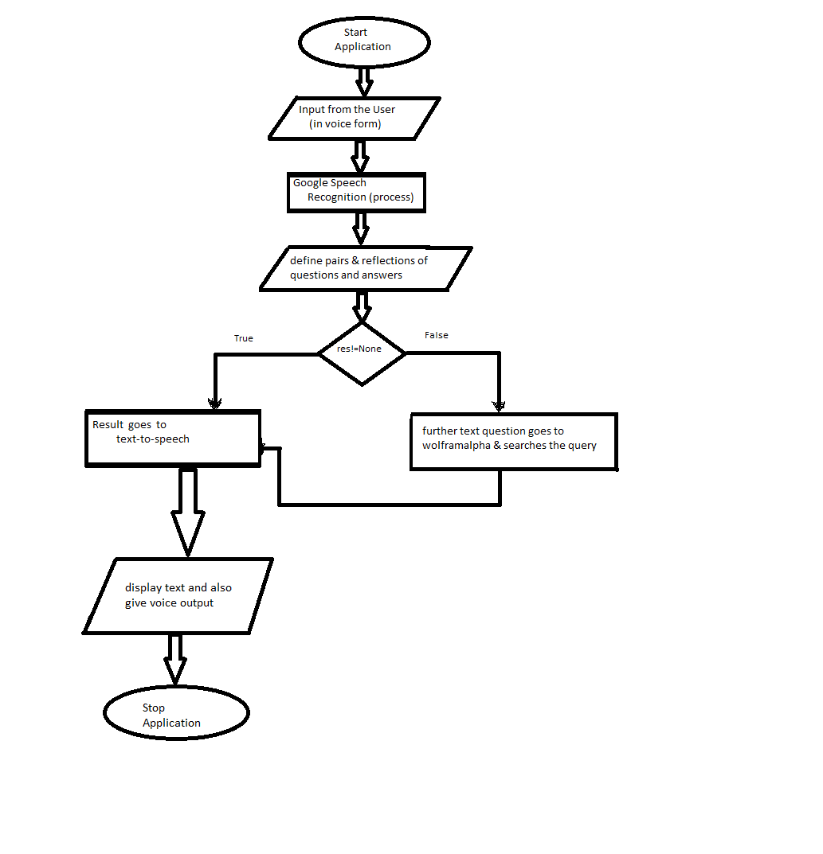

**USE CASE DIAGRAM**

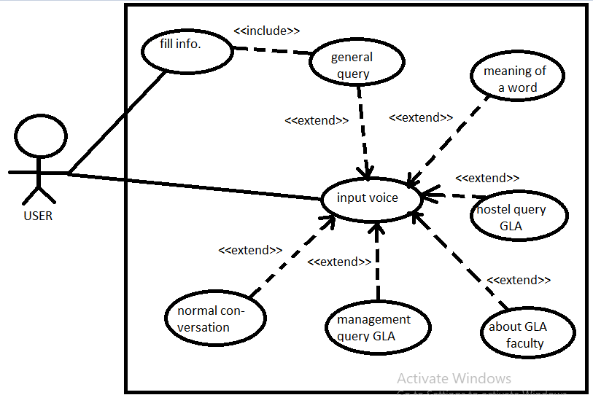

**CHAPTER3**

SCREENSHOTS

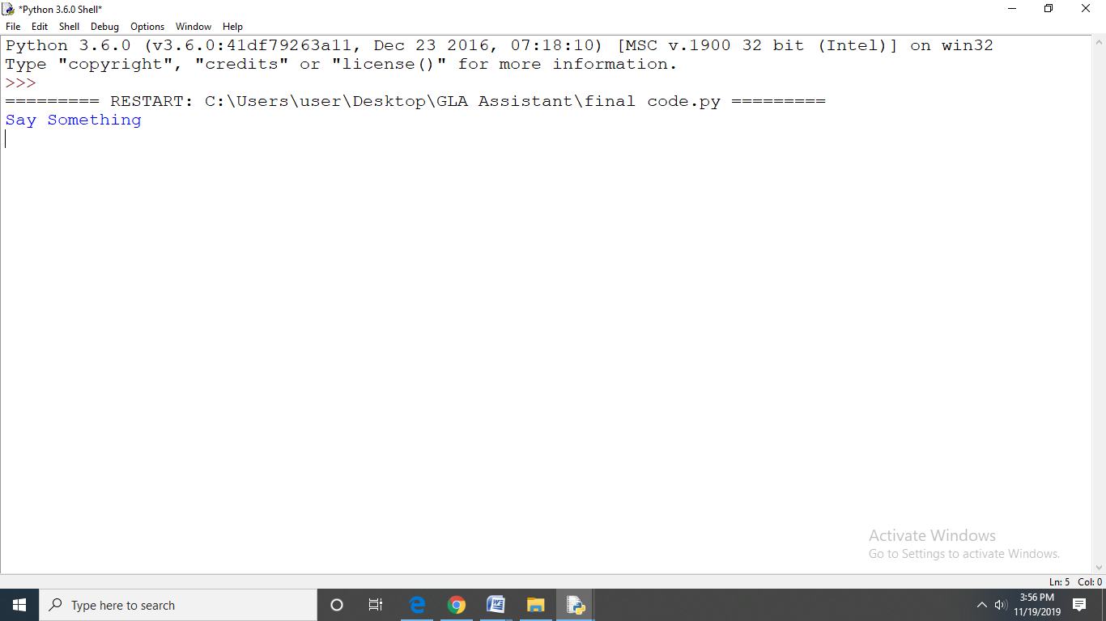

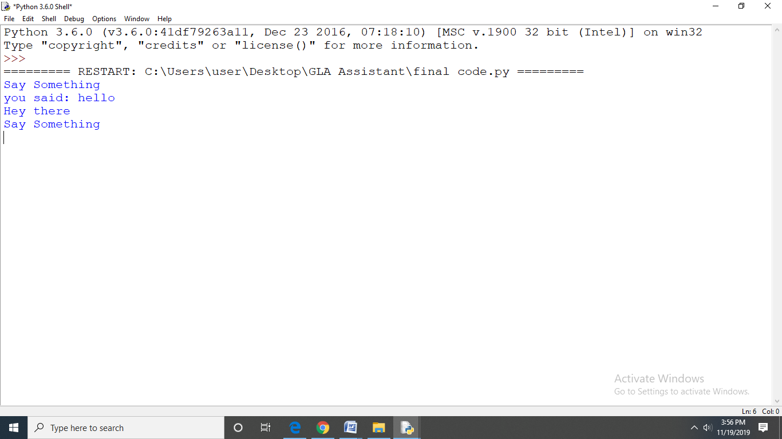

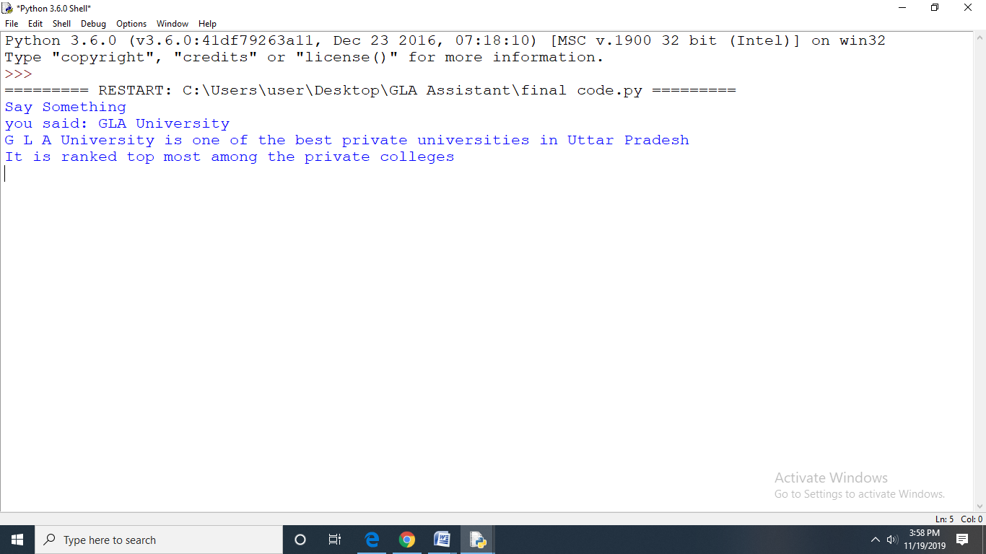

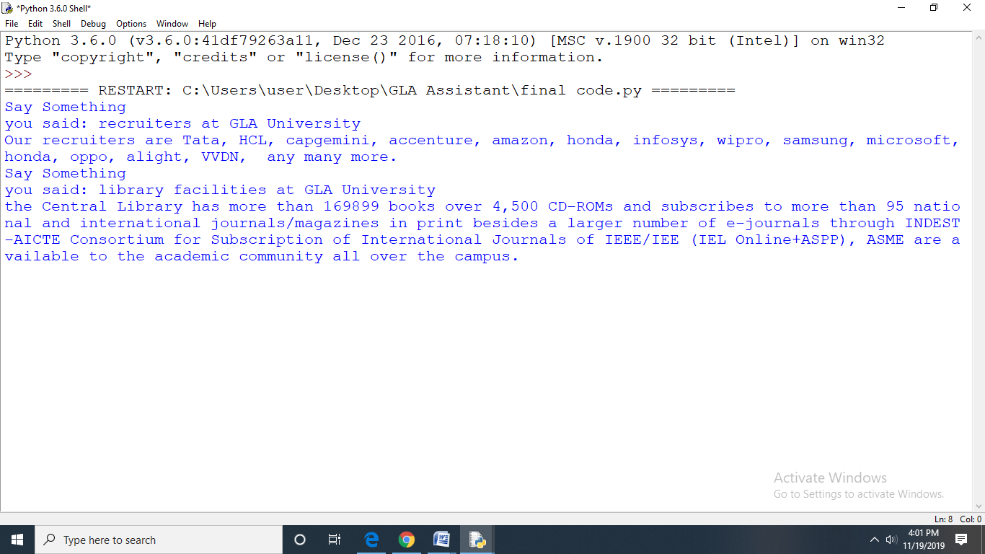

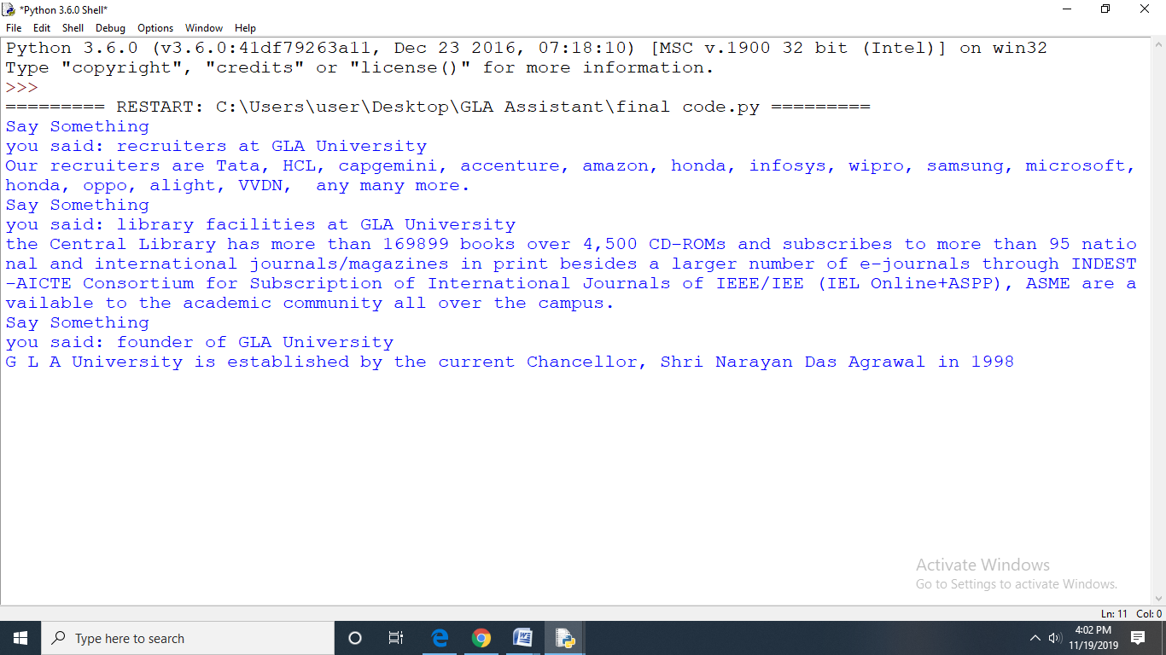

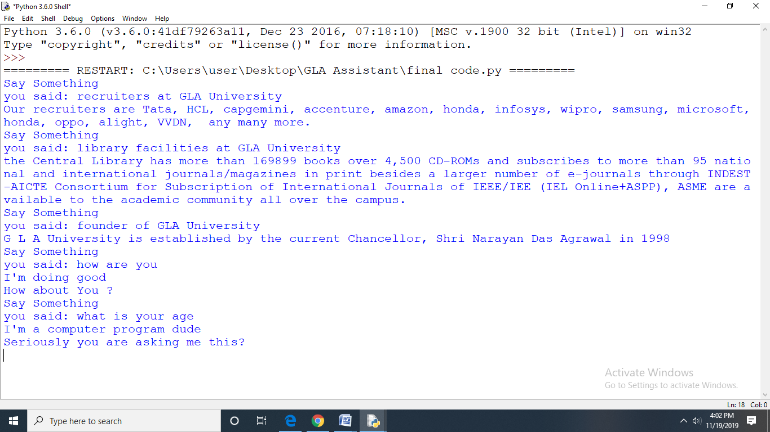

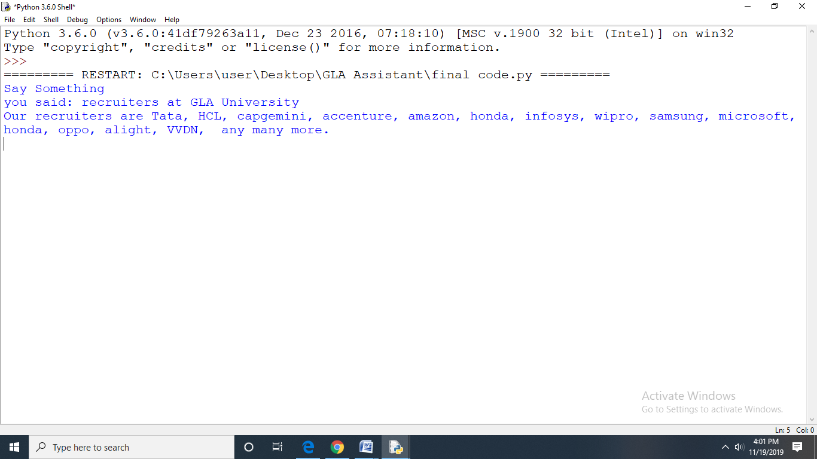

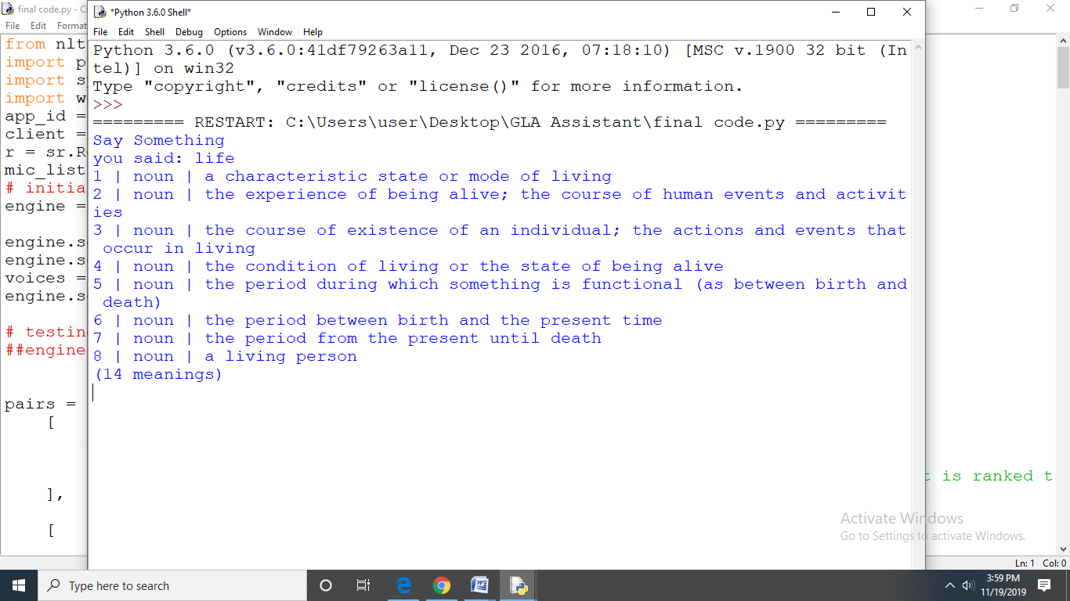

**CODE FOR THE PROJECT**

from nltk.chat.util import Chat, reflections

import pyttsx3

import speech_recognition as sr

import wolframalpha

app_id = "HPEGVV-T8WLEEJ734"

client = wolframalpha.Client(app_id)

r = sr.Recognizer()

mic_list = sr.Microphone.list_microphone_names()

# initialisation

engine = pyttsx3.init()

engine.setProperty('rate', 150)

engine.setProperty('volume', 10.0)

voices = engine.getProperty('voices')

engine.setProperty('voice', voices[1].id)

# testing

##engine.say("My first code on text-to-speech")

pairs = [

[

r"GLA University(.*)",

[

"G L A University is one of the best private universities in Uttar Pradesh \nIt is ranked top most among the private colleges"]

],

[

r"(.*)courses offered by GLA(.*)",

["G L A University,Mathura, Uttar Pradesh has 83 Courses with Average Fees 1,57500 per year"]

],

[

r"(.*)founder of GLA(.*)",

["G L A University is established by the current Chancellor, Shri Narayan Das Agrawal in 1998 "]

],

[

r"(.*)deparments in GLA(.*)",

[

"Computer Engineering & Applications Electrical Engineering Electronics & Communications Mechanical Engineering Civil Engineering"]

],

[

r"(.*)project mentor(.*)",

["Mr. Amir khan is our project mentor. He is faculty of Training and Development Department"]

],

[

r"(.*)total number of students(.*)",

["The university is home to more than 12,000 students enrolled in a variety of professional courses"]

],

[

r"(.*)number of companies visiting(.*)",

["150+ companies visited GLA University in the session 2019-2020. This also contains many MNC's."]

],

[

r"(.*)highest package(.*)",

["22 lakhs per annum is the Highest Package Offfered"]

],

[

r"(.*)facilities provided to students(.*)",

[

"A Well designed and maintained buildings, contemporary laboratories, spacious residential complexes and recreational fascilities makes the campus one of the best in the regions and gives its students an edge over their counterparts coming from other universities"]

],

[

r"(.*)facilities provided to hostel inmates(.*)",

[

"GLA Hostels offers many facilities such as gym, Common room, Canteen, Departmental store, Ground, internet facility, 24 x 7 Water and electricity,Stationary, Library, auditorium, Dispensary"]

],

[

r"(.*)cse department(.*)",

[

"Department of Computer Engineering and Applications at GLA University offers various programs at both under graduate and post graduate level. All the programs feature a combination of theoretical and practical elements in order to provide the students a platform to correlate the learning. In addition, guest lectures and talks by eminent persons from industry and academia are frequently arranged to keep the students abreast with the latest technologies"]

],

[

r"(.*)electrical Department(.*)",

[

"Electrical Engineering is one of the fastest growing fields that involves the study and application of electricity and electronics. It is the most interesting branch of engineering because it involves the study of computer, electrical and electronics and communication. Electrical engineering deals with generation, transmission and distribution of electricity"]

],

[

r"(.*)mechanical Department(.*)",

[

"The department of Mechanical Engineering blossoms with the specialized technical and professional excellence.The department is constantly decisive to educate the mechanical engineers of tomorrow by integrating the theoretical and practical knowledge and accentuating on the learning and critical thinking."]

],

[

r"(.*)civil Department(.*)",

[

"Civil Engineering is concerned with the improvement in quality of basic needs of human civilization and taking care of the naturally and humanly built environments with their planning, designing, construction, operation and maintenance. "]

],

[

r"(.*)electronics and communication department(.*)",

[

"Department aims to provide quality education in the domain of Electronics and Communication Engineering through periodically updated curriculum, effective teaching learning process, state of the art laboratory facilities and collaborative ventures with the industries."]

],

[

r"(.*)pro VC(.*)",

["Mr. Professor D. S. Chauhan"]

],

[

r"(.*)hod of CSE Department(.*)",

["Dr. Anand Singh Jalal H.O. D. & Professor, Department of Computer Engineering & Applications"]

],

[

r"(.*)director(.*)",

[

"Dr. Anoop Kumar Gupta is currently positioned as the Director at G L A University, Mathura. Dr. Gupta has implemented the e-Governance project at GLA University as well as overseen the website and brochure of the University."]

],

[

r"(.*)cafeteria Facility(.*)",

[

"We have 4 cafeterias in campus that helps the students to fulfil their cravings as and when they want. The cafeteria offers a good menu of multi-cuisine delights, amidst a lively, jolly atmosphere."]

],

[

r"(.*)medical facility(.*)",

["24*7 hours medical facility is available in our university"]

],

[

r"(.*)address(.*)",

["17km Stone, NH-2, Mathura-Delhi Road Mathura, Chaumuhan, Uttar Pradesh 281406"]

],

[

r"(.*)code of conduct and Ethics policy(.*)",

[

"For information about code of conduct and ethics policy, please visit:http://www.gla.ac.in/Uploads/image/98imguf_GLA-University--Code-of-Conduct-and-Ethics-Policy-Updated.pdf"]

],

[

r"(.*)chancellor Information(.*)",

["Mr.Narayan Das Agrawal."]

],

[

r"(.*)deans Info(.*)",

[

"Prof. (Dr.) Anup Kumar Gupta(Dean Academic Affairs),Prof. (Dr.) Anirudha Pradhan(Professor of Mathematics & Dean Research & Development),Prof. (Dr.) D.K. Das(Dean of Student's Affairs)."]

],

[

r"(.*)registrar Info(.*)",

["Mr. Ashok Kumar Singh."]

],

[

r"(.*)training and placement department(.*)",

[

" G L A University has training and placement department i.e Placement training plays a major role in shaping up the career goals of students. It is the dream of every engineering student to get placed in a top organization visiting their campus for recruitment.Training of students and equipping them with life skills has become an important responsibility of the institution."]

],

[

r"(.*)training and development department(.*)",

[

"G L A University has training and development department i.e. Training and development refers to educational activities within a company created to enhance the knowledge and skills of employees while providing information and instruction on how to better perform specific tasks."]

],

[

r"(.*)executive Council(.*)",

[

"Mr. Narayan Das Agrawal (Business)Chairperson and many more.for further details visit : https://www.gla.ac.in/about-us/executive-council."]

],

[

r"(.*)library information(.*)",

["There are more than 155000 books available in our library."]

],

[

r"(.*)library Timigs(.*)",

["Library timings is from 8 am to 11 pm for boys and for girls it is form 8 am to 6 pm."]

],

[

r"(.*)library facilities(.*)",

[

"the Central Library has more than 169899 books over 4,500 CD-ROMs and subscribes to more than 95 national and international journals/magazines in print besides a larger number of e-journals through INDEST-AICTE Consortium for Subscription of International Journals of IEEE/IEE (IEL Online+ASPP), ASME are available to the academic community all over the campus. "]

],

[

r"(.*)courses offered(.*)",

[

"BA LLB, BBA LLB, BA [Hons.], BBA, BBA [Hons.], B.Com [Hons.], BCA, B.Ed, B.Pharm, B.Sc [Hons.], B.Tech, MA, MBA, MCA, M.Pharm, M.Sc, M.Tech, Diploma, Post Graduate Diploma, Advanced Diploma, Certificate, Ph.D."]

],

[

r"(.*)founder of GLA University(.*)",

["Shri Narayan Das Agrawal is the founder of g l a university and was established in 1998"]

],

[

r"(.*)aim of GLA(.*)",

[

"The aim of G L A is to provide education of high quality to fulfill the needs of higher education in the society."]

],

[

r"(.*)recent events held(.*)",

["Milan 2019 ,sky light, cultural night, battle of dance etc."]

],

[

r"(.*)fees of different courses(.*)",

["B.Tech(CSE):1,60,000;B.Tech(ECE):1,40,000;B.Tech(ME):1,40,000"]

],

[

r"(.*)total number of students(.*)",

["More than 12000 students."]

],

[

r"(.*)nuumber of faculty in GLA university(.*)",

["There are over 600 faculty in G L A."]

],

[

r"(.*)contact details and Contact number(.*)",

["For any query, you can call : 8937099911, 6399020003,6399020004, 6399020005."]

],

[

r"(.*)admission help/ helpline(.*)",

["For admission related information, you can call : 6399020004, 6399020005"]

],

[

r"(.*)recruiters(.*)",

[

"Our recruiters are Tata, HCL, capgemini, accenture, amazon, honda, infosys, wipro, samsung, microsoft, honda, oppo, alight, VVDN, any many more."]

],

[

r"(.*)fee structure MSc. , PhD. , BBA(.*)",

[

"BBA ranges from INR 82,000 to INR 86,000 per annum,M.Sc ranges from INR 50,000 to INR 118,000 per annum,Ph.D course varies from INR 73,000 to INR 79,000 per annum."]

],

[

r"(.*)scholarship details/ discount details(.*)",

["Scholarship of 33000 is given to those students who have secured more than 90% marks in PCM in Intermediate."]

],

[

r"(.*)top 5 recruiters at GLA(.*)",

["Our top recruiters are:Amazon, microsoft, accenture, salesforce, samsung."]

],

[

r"(.*)IQAC(.*)",

[

"The Internal Quality Assurance Cell (IQAC) was constituted in GLA University on January 4, 2016,with the aim of working towards realization of the goals of quality enhancement and sustenance through internalization of quality culture and institutionalization of best practices."]

],

[

r"(.*)NIRF(.*)",

[

"The methodology draws from the overall recommendations broad understanding arrived at by a Core Committee set up by MHRD, to identify the broad parameters for ranking various universities and institutions."]

],

[

r"(.*)alumni of our university(.*)",

["More than 2000+ G L Aians are Working Abroad with the most reputed companies."]

],

[

r"(.*)workshops held(.*)",

[

"There are various workshops that takes place in the Univeristy from each department,These are related to almost every course of our college that helps students to expnand their knowledge."]

],

[

r"(.*)awards and achievements(.*)",

[

"G L A University is on 2nd rank in Uttar Pradesh and on 6th rank in all over India,It is rated 'AAA' among India's best engineering colleges."]

],

[

r"(.*)number of hostlers(.*)",

[

"We have 15 boys hostels and 4 girls hostels that have about 5000+ residents,our college has 4500+ boys and 1500+ girls hostlers."]

],

[

r"(.*)hostel fees details of AC or Non AC(.*)",

[

"For boys, AC hostel rooms are available at 65000 whereas non AC wings are available at 50000,For girls, single seater room is available at 41000 whereas for double seater it is 43000."]

],

[

r"(.*)hostel details(.*)",

["There are facilities for indoor and outdoor games. Green lawns are provided,24x7 electric and power supply."]

],

[

r"(.*)new Generation IEDC(.*)",

[

"New Generation Innovation and Entrepreneurship Development Centre(NewGen IEDC) is a programme launched by National Science and Technology Entrepreneurship Development Board (NSTEDB), Department of Science & Technology (DST), Government of India."]

],

[

r"(.*)no Ragging policy(.*)",

["Ragging is strictly prohibited in our campus."]

],

[

r"(.*)hostel security(.*)",

[

"hostels are provided 24 hours security with our best group of guards. Students are 24 hours under surveillance and biometric is compulsory for every student."]

],

[

r"(.*)about GLAMS portal(.*)",

["for the ease of students to access their information, we have provided an online portal."]

],

[

r"(.*)attendence criteria(.*)",

["It is mandatory to fullfil 75% attendance for each student"]

],

[

r"(.*)leave and Outing details(.*)",

[

"girls are provided outing till 6.30 pm whereas boys till 8pm and it is compulsory for everyone to follow the timing criteria of leave and outing"]

],

[

r"(.*)institutes(.*)",

[

"The institutes under the university are as follows: Institute of Engineering and Technology, Institute of Applied Science and Humanities, Institute of Business Management"]

],

[

r"(.*)why GLA University(.*)",

[

"At G L A University we offer a nurturing environment that fosters sharp learning skills, a top-of-the-line curriculum that offers the best in education along with pioneering placement opportunities."]

],

[

r"(.*)sports Facilities(.*)",

[

"All the playing grounds are located strategically across the university thereby making sports part of one's life no matter where the person is in the university. G L A IPL (G L A Cricket Championship), Volleyball, Football, Badminton, Basketball, Chess tournaments every year."]

],

[

r"(.*)campus Facilities(.*)",

["Security ,Madical facility ,play groud ,24 hr electricity ,etc"]

],

[

r"(.*)recently held events(.*)",

["ted x , maitree , milan , srijan , Battle of Dance"]

],

[

r"(.*)rules and Regulations of GLA University(.*)",

["Intentionally damaging property and equipment of the hostel,Gambling in Any Form is not allowed"]

],

[

r"(.*)academic Coucil(.*)",

["Vice Chancellor Prof. A.M. Agrawal Dean Prof. A. Pradhan Director Prof. Anoop Kumar Gupta"]

],

[

r"(.*)areas of research(.*)",

[

"Image Processing and Computer Vision Intelligent Systems Information Retrieval Data Mining and Data Analytics"]

],

[

r"(.*)average placement(.*)",

["The average placement rate of G L A University is 80 to 85 %"]

],

[

r"(.*)entrepreneurship cell(.*)",

[

"At E-Cell G L AU members from various backgrounds and departments combine their meticulous talents to help the youth achieve their dreams"]

],

[

r"(.*)clubs of our College(.*)",

["There are different different clubs in our college such as natraj club, udaan , aashayein, abacus, ASME etc"]

],

[

r"my name is (.*)",

["Hello %1, How are you today ?", ]

],

[

r"what is your name ?",

["My name is G L A Assistant and I know everything about GLA University"]

],

[

r"how are you?",

["I'm doing good\nHow about You ?", ]

],

[

r"sorry(.*)",

["Its alright", "Its OK, never mind", ]

],

[

r"i'm(.*)doing good",

["Nice to hear that", "Alright :)", ]

],

[

r"hi|hey|hello",

["Hello", "Hey there", ]

],

[

r"(.*)age?",

["I'm a computer program dude\nSeriously you are asking me this?", ]

],

[

r"what(.*)want?",

["Make me an offer I can't refuse", ]

],

[

r"(.*)created?",

["Manali and Shiv created me using Python's NLTK library "]

],

[

r"how is weather in(.*)?",

["Weather in %1 is awesome like always", "Too hot man here in %1", "Too cold man here in %1",

"Never even heard about %1"]

],

[

r"i work in (.*)?",

["%1 is an Amazing company, I have heard about it. But they are in huge loss these days.", ]

],

[

r"(.*)raining in(.*)",

["No rain since last week here in %2", "Damn its raining too much here in %2"]

],

[

r"how(.*)health(.*)",

["I'm a computer program, so I'm always healthy ", ]

],

[

r"quit",

["Bye bye take care It was nice talking to you See you soon "]

],

]

chat = Chat(pairs, reflections)

while 1:

with sr.Microphone(device_index=1, sample_rate=48000, chunk_size=1024) as source:

r.adjust_for_ambient_noise(source)

print("Say Something")

audio = r.listen(source)

text = 'GLA University'

try:

text = r.recognize_google(audio)

print("you said: " + text)

except:

print("Something error ")

res = chat.respond(text)

if not res:

value = client.query(text)

res = next(value.results).text

print(res)

engine.say(res)

engine.runAndWait() ##chat.converse()

if text in ('quit' ,'bye', 'goodbye'):

break

**FUTURE SCOPE:**

This project in future can be used in the similar way as the google assistant is used. It will start working on just a single tap. It will work always run in your pc in background and will be available as you need it. In future you can open and close applications by using it. You can set reminders, open chrome, gallery etc.

**APPLICATIONS:**

* This can be implemented in Chat bot.
* Can be used as your assistant.
* To gain information about GLA.

**REFERENCE:**

* Mr. Amir Khan
* Google
* https://www.wolframalpha.com/