**Unit Test Documentation**

**Rest Api and corresponding output screen shots.**

1. **Get api – used to get all products.**

**url – http://<ip>:8082/product**

**http method – GET**

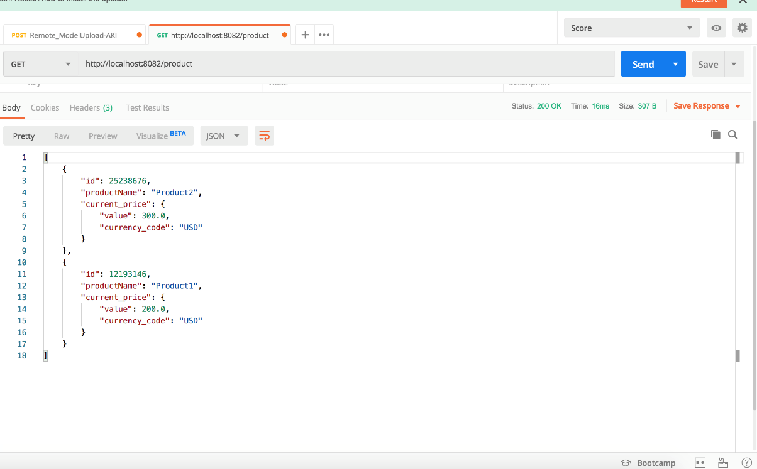

1. **Get api with product id– used to get specific id .**

**url – http://<ip>:8082/product/id**

**http method – GET**

Note – The product name will be same, as the product name is obtained from external api.

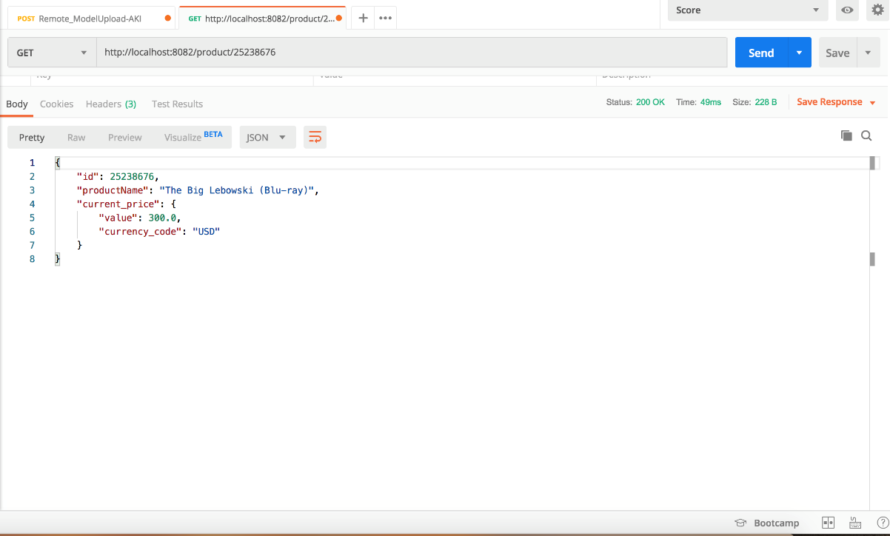

1. **Post api– Used to insert product data.**

**url – http://<ip>:8082/product**

**http method – POST**

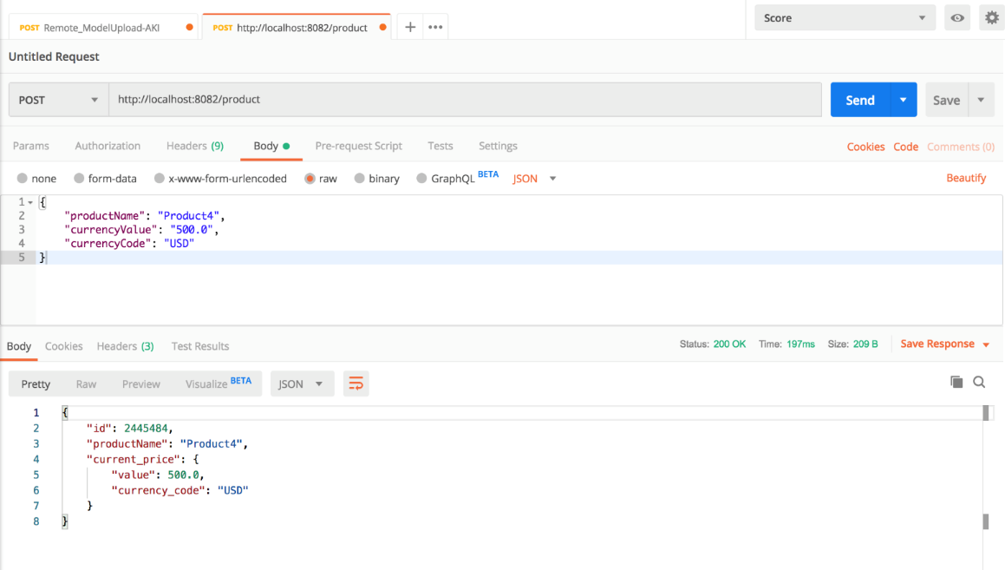

1. **Put api– Used to update product currency data.**

**url – http://<ip>:8082/product**

**http method – PUT**

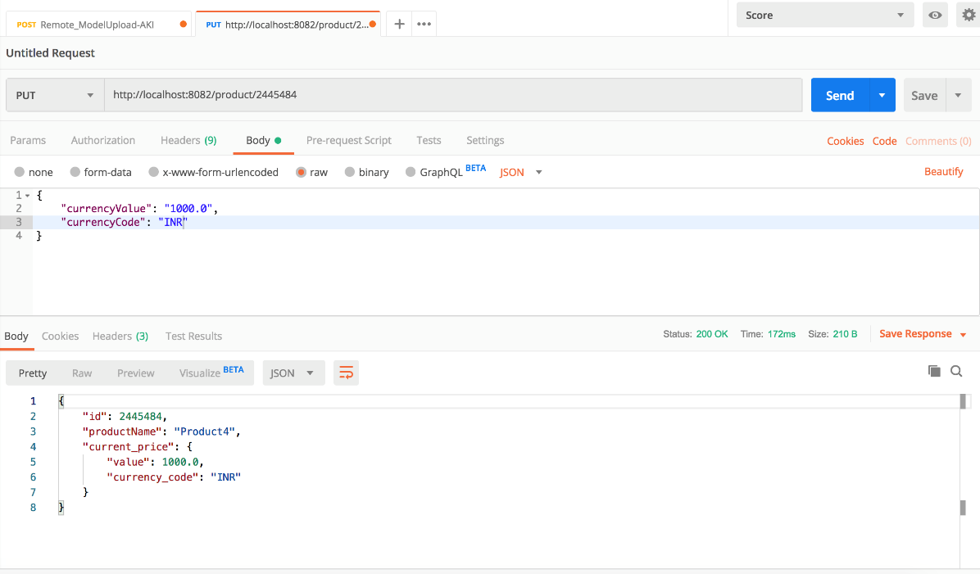

1. **Delete api– Used to delete existing product.**

**url – http://<ip>:8082/product**

**http method – DELETE**

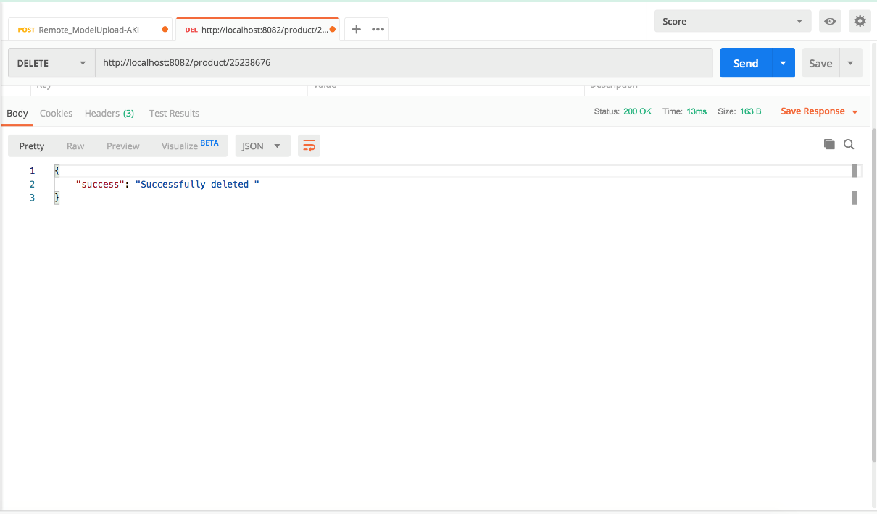

**Table structure.**

CREATE KEYSPACE IF NOT EXISTS retailspace WITH REPLICATION = { 'class' : 'SimpleStrategy', 'replication_factor' : 1 };

USE retailspace;

CREATE TABLE IF NOT EXISTS product ( id INT PRIMARY KEY, productname TEXT , currencyvalue double, currencycode TEXT);

