Operational Genome Architecture (OGA) and Operational Health Index (OHI) Methodology
Foundation for Operational Genomics: A Bio-Inspired Theory of Enterprise Capability Evolution
Document Type: Research methodology and framework design
Reference Domain: Material handling, fleet operations, manufacturing service networks, and warehouse automation
Primary Output: Conceptual architecture, index methodology, mathematical foundation, and software platform logic

1. Purpose of This Design
The purpose of this document is to formalize the two foundational elements of the Operational Genomics theory: the Operational Genome Architecture (OGA) and the Operational Health Index (OHI). The OGA defines how enterprise capability is structured, while the OHI defines how that capability can be measured, diagnosed, and improved. Together, they create a publishable research framework and a practical foundation for a future software platform.

2. Operational Genome Architecture (OGA)
The OGA represents an enterprise as a living operational organism. Its capability is encoded through operational genes, expressed through KPIs, observed through enterprise outcomes, protected through an immune system of risk controls, and coordinated through a digital twin nervous system.
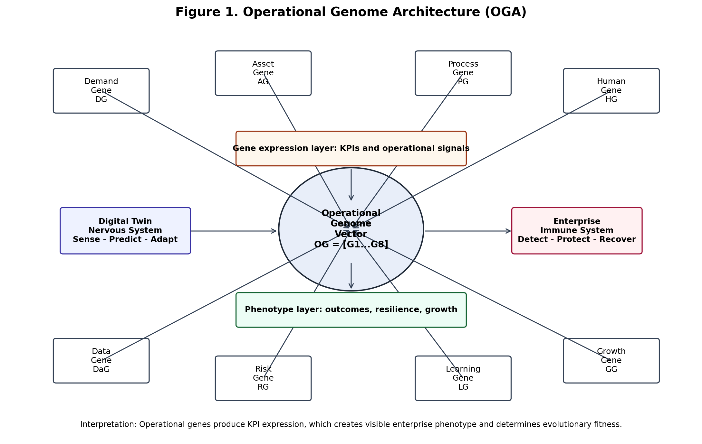
Figure 1. Operational Genome Architecture (OGA).

2.1 OGA Building Blocks
Gene | Symbol | Core capability represented | Typical KPI expression
Demand Gene | DG | Market responsiveness and seasonality sensitivity | Forecast accuracy, order variability, customer churn
Asset Gene | AG | Physical and equipment capability | Fleet utilization, asset availability, MTBF
Process Gene | PG | Operational flow and throughput behavior | Lead time, throughput, cycle time
Human Gene | HG | Workforce capability and service capacity | Technician productivity, skill index, turnover
Data Gene | DaG | Digital intelligence and visibility | Data quality, completeness, latency
Risk Gene | RG | Disruption resistance and immune strength | Incident rate, downtime probability, supplier risk
Learning Gene | LG | Adaptability and improvement velocity | CI rate, knowledge reuse, corrective action closure
Growth Gene | GG | Expansion readiness and evolutionary fitness | Capacity expansion, revenue growth, service coverage
Table 1. Operational genome building blocks and KPI expression.

3. Operational Health Index (OHI) Methodology
The OHI converts raw enterprise data into a structured health score. Instead of treating KPIs as isolated metrics, the OHI interprets them as gene expressions that reveal whether the enterprise is healthy, underdeveloped, mutated, or at risk of operational deformity.
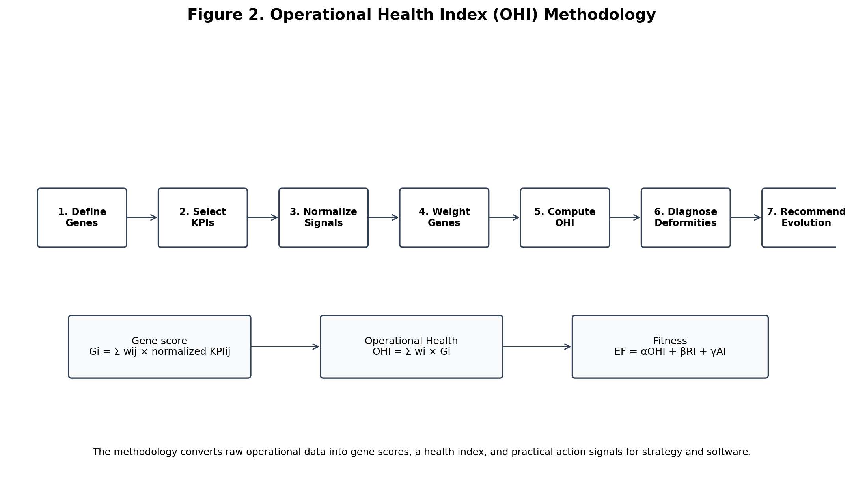
Figure 2. Operational Health Index (OHI) methodology.

3.1 Mathematical Formulation
Operational Genome Vector: OG = [DG, AG, PG, HG, DaG, RG, LG, GG]
Gene Score: Gi = Σ(wij × KPIij_norm)
Operational Health Index: OHI = Σ(wi × Gi)
Operational Immunity Index: OII = f(Risk Detection, Prevention Strength, Recovery Speed)
Enterprise Evolutionary Fitness: EF = αOHI + βRI + γAI
Where Gi is the score of the ith operational gene, wij is the weight of the jth KPI within a gene, wi is the strategic weight assigned to each gene, RI is the resilience index, AI is the adaptability index, and α, β, and γ are calibration coefficients based on strategic priorities.

3.2 Scoring Logic
Score range | Health status | Interpretation | Recommended action
85-100 | Robust | Strong gene expression and high operational fitness | Scale and standardize best practices
70-84 | Stable | Acceptable capability with moderate improvement potential | Improve weaker sub-metrics
55-69 | Fragile | Operational stress or early deformity is visible | Diagnose root cause and prioritize intervention
Below 55 | Critical | Capability failure or high disruption risk | Launch corrective action and redesign process
Table 2. Operational Health Index scoring interpretation.

4. Example Operational Genome Dashboard
A future software platform can visualize gene-level health, identify weak genes, and recommend operational mutations. The example below shows how a dashboard can reveal that the Risk Gene and Human Gene are weaker than other capability areas, suggesting vulnerability in disruption protection and workforce capacity.
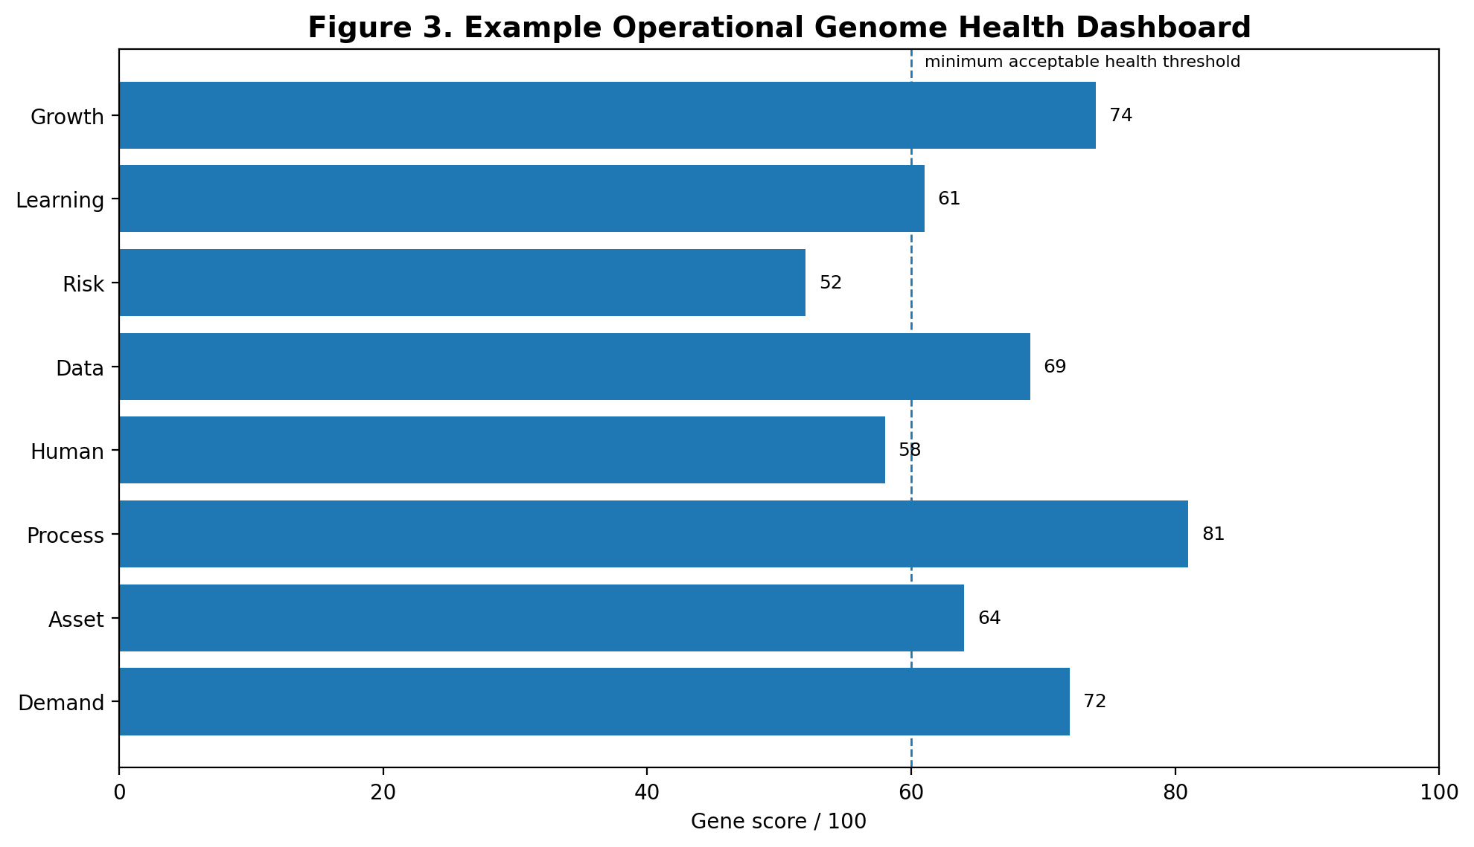
Figure 3. Example operational genome health dashboard.

5. Operational Deformity Detection
Weak or missing gene | Likely deformity | Business symptom | Corrective mutation
Demand Gene | Seasonality imbalance | Stockouts, overcapacity, poor forecasting | Demand sensing and forecasting model
Asset Gene | Equipment weakness | Low utilization, downtime, excessive rental dependency | Fleet optimization and predictive maintenance
Human Gene | Capability fatigue | Technician backlog, quality drift, slow response | Workforce planning and skill matrix
Data Gene | Operational blindness | Late reporting, conflicting numbers, low trust | Data governance and IoT integration
Risk Gene | Weak immune system | Frequent disruptions, safety events, supplier failures | Risk radar and early warning system
Learning Gene | Repeated injury | Same failures recur across periods | Closed-loop CI and knowledge reuse
Growth Gene | Stunted evolution | Business survives but does not scale | Capacity modeling and expansion roadmap
Table 3. Operational deformity detection and corrective mutation logic.

6. Research and Software Platform Roadmap

Phase 1: Genome definition
Define the eight core operational genes and identify measurable KPIs for each gene.

Phase 2: Data architecture
Connect ERP, WMS, CRM, telematics, maintenance, workforce, and financial data sources.

Phase 3: OHI calculation engine
Normalize KPIs, apply weights, compute gene scores, and produce OHI, OII, and EF metrics.

Phase 4: Digital twin nervous system
Use simulation and predictive analytics to sense, predict, coordinate, and adapt operations.

Phase 5: Decision intelligence
Recommend beneficial mutations such as process redesign, staffing changes, asset optimization, or risk controls.

Phase 6: Validation
Validate the framework through case studies in material handling, fleet service, warehouse automation, and manufacturing operations.

