App Dev Project Report

1. Student Details
Name: Shiva Mahika
Roll Number:24f2008316
Email: 24f2008316@ds.study.iitm.ac.in
About Me: I'm a third-year Computer Science Engineering student with a strong interest in software development and problem-solving. I enjoy building practical web applications while continuously learning new technologies and improving my technical and analytical skills.

2. Project Details
Project Title: Trekking Management Application
Problem Statement:
To design and build a web-based application that allows users to adventure organizations to efficiently manage trekking activities involving trek organizers, staff, and participants.
Approach:
The app was built using Flask as the backend framework with a modular structure. It allows users to book treks and staff to manage their assigned trek and participants and admins can assign staff view all booking and stats and create treks and blacklist any user or staff

3. AI/LLM Declaration
I used ChatGPT (GPT-5) to assist in debugging issues a little and for making the search bar and charts
All final implementation logic and integration were done manually.

4. Technologies and Frameworks Used
Technology / Library | Purpose
Flask | Core backend web framework
SQLAlchemy | Object Relational Mapper for SQLite database
Jinja2 | Template engine for rendering dynamic HTML pages
Bootstrap 8 | Frontend styling and responsive design
Flask-Login | User authentication and session management
SQLite | Lightweight local database for storing user data

5.Database Schema / ER Diagram
Relationship | Type | Reason
User → Booking | One-to-Many (1:N) | One user can book many treks, but each booking belongs to only one user.
Trek →Booking | One-to-Many (1:N) | One trek can have many bookings, but each booking is for only one trek.
Staff → Trek | One-to-Many (1:N) | One staff member can manage only one treks
User ↔ Trek | Many-to-Many (M:N) through Booking | A user can book many treks, and a trek can be booked by many users. This relationship is implemented through the Booking table

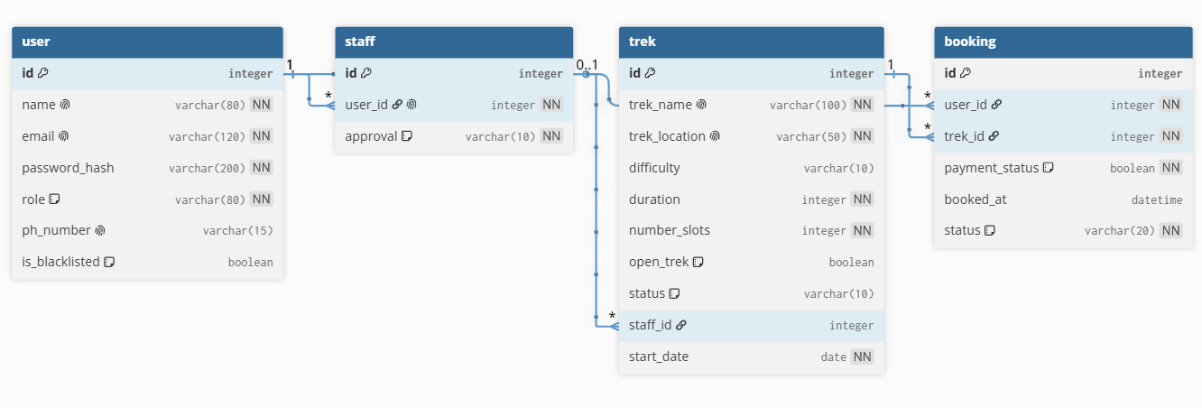
6. Application Routes
Route | Method | Purpose
/login | GET, POST | Authenticate users
/register | GET, POST | Register customer or staff
/customer_dashboard | GET | Display customer dashboard
/book_trek/<trek_id> | POST | Book a selected trek
/admin_dashboard | GET | Display administrator dashboard
/create_trek | GET, POST | Create a new trek
/admin/update_trek/<trek_id> | GET, POST | Update trek information
/delete_trek/<trek_id> | GET, POST | Delete a trek
/staff_dashboard | GET | Display staff dashboard
/logout | GET | Log out the current user

7. Architecture and Features
Architecture Overview:
- app.py – main Flask application entry point, database models using SQLAlchemy,Flask Blueprints for user and activity routes
- /templates – Jinja2 HTML templates
- /static – CSS, JS, and images for background
- /instance=sqlite db
Implemented Features:
- User registration and login
- all treks management by admin
- Managing their assigned trek by staff
- Responsive UI built with Bootstrap
- Secure password hashing and user session handling

8. Video Presentation
Drive Link:
https://drive.google.com/file/d/1PbnvEDrwcGJkOClYa2-bGQhhDILyNckK/view?usp=sharing (Accessible to all with “View” permission.)

