**Illinois Institute of Technology**

**CS 587 – Software Project Management**

**Assignment-2 Report**

**St. Name: Shiva Sankar Modala**

**St. ID: A20517528**

I made changes for the assignment-1 as per the corrections suggested by TA. I made few mistakes in precedence order, resource allocation. Because of these changes, there was slight change in the completion date of assignment-1.

**3. Feed the information provided in this handout in MS Project to create the Project Plan and the Network Diagram**

Ans: **Write plan**

(a). Amount of Work = 123 pages

(b). Effort will be calculated as:

**Work/ Productivity Rate** = 123/ 4 pages/ Hour

=30.75 hrs/ 1 Head Count

=30.75/8 days per 1 Head Count

=3.84375 days/ 1 Head Count

(c). Duration will be calculated as:

**Effort/#HeadCount** = 3.84375 days / 1HC

Duration for write plan =3.84375 days

Similar to above, I calculated the below table.

Note: Head Count column represents the Head Count I took for the assignment-2

|  |  |  |  |  |  |
| --- | --- | --- | --- | --- | --- |
| **Tasks** | **Amount of Work** | **Productivity** | **Effort= Work/Productivity Rate** | **Head**  **Count** | Duration= **Effort/#HeadCount** |
| Write plan | 123 pages | 4 pages/Hour | 123 / 4 = 30.75 hrs  = 3.84 days | 1 | 3.84 / 1 = 3.84 days |
| Preparation for review | 123 pages | 5 pages/Hour | 123 / 5 = 24.6 hrs  = 3.08 days | 5 | 3.08 / 5 = 0.62 days |
| Review Meeting | 123 pages | 8 pages/Hour | 123 / 8 = 15.38 hrs  = 1.92 days | 6 | 1.92 / 6 = 0.32 days |
| Rework | 76 defects | 5 defects/Hour | 76 / 5 = 15.2 hrs  = 1.9 days | 2 | 1.9 / 2 = 0.95 days |
|  |  |  |  |  |  |
| Write requirements | 478 Req | 5 Req/Hour | 478 / 5 = 95.6 hrs  = 11.95 days | 6 | 11.95 / 6 = 1.99 days |
| Preparation for review | 478 Req | 5 Req/Hour | 478 / 5 = 95.6 hrs  = 11.95 days | 4 | 11.95 / 4 = 2.99 days |
| Review Meeting | 478 Req | 8 Req/Hour | 478 / 8 = 59.75 hrs  = 7.47 days | 5 | 7.47 / 5 = 1.49 days |
| Rework | 291 defects | 5 defects/Hour | 291 / 5 = 58.2 hrs  = 7.28 days | 5 | 7.28 / 5 = 1.46 days |
|  |  |  |  |  |  |
| Routers | 7 | 2 Routers/day | 7 /2 = 3.5 days | 4 | 3.5 / 4 = 0.88 days |
| Bridge | 7 | 2 Bridges/day | 7 / 2 = 3.5 days | 4 | 3.5 / 4 = 0.88 days |
| Install Server | 15 servers | 1 server/day | 15 / 1 = 15 days | 6 | 15 / 6 = 2.5 days |
| Install Clients | 37 clients | 10 clients/day | 37 / 10 = 3.7 days | 4 | 3.7 / 4 = 0.93 days |
| Install Development Tools | 16 tools | 5 tools/day | 16 / 5 = 3.2 days | 4 | 3.2 / 4 = 0.8 days |
| Install Testing Tools | 18 tools | 4 tools/day | 18 / 4 = 4.5 days | 5 | 4.5 / 5 = 0.9 days |
|  |  |  |  |  |  |
| Write DD | 324 pages | 4 pages/Hour | 324 / 4 = 81 hrs  = 10.12 days | 6 | 10.12 / 6 = 1.69 days |
| Preparation for DD | 324 pages | 5 pages/Hour | 324 / 5 = 64.8 hrs  = 8.1 days | 4 | 8.1 / 4 = 2.03 days |
| Review Meeting | 324 pages | 10 pages/Hour | 324 / 10 = 32.4 hrs  = 4.05 days | 5 | 4.05 / 5 = 0.81 days |
| Rework | 288 defects | 7 defects/Hour | 288 / 7 = 41.14 hrs  = 5.14 days | 5 | 5.14 / 5 = 1.03 days |
|  |  |  |  |  |  |
| Create Data Model | 91 pages | 1 page/Hour | 91 / 1 = 91 hrs  = 11.38 days | 5 | 11.38 / 5 = 2.28 days |
| Preparation for DM | 91 pages | 5 pages/Hour | 91 / 5 = 18.2 hrs  = 2.28 days | 4 | 2.28 / 4 = 0.57 days |
| Review Meeting | 91 pages | 10 pages/Hour | 91 / 10 = 9.1 hrs  = 1.14 days | 5 | 1.14 / 5 = 0.23 days |
| Rework | 189 defects | 5 defects/Hour | 189 / 5 = 37.8 hrs  = 4.72 days | 5 | 4.72 / 5 = 0.94 days |
|  |  |  |  |  |  |
| Write Code | 6325 SLOC | 5 SLOC/Hour | 6325 / 5 = 1265 hrs  = 158.12 days | 8 | 158.12 / 8 = 19.76 days |
| Prepare/Execute Test Cases | 572 test cases | 5 Test Case/Hour | 572 / 5 = 114.4 hrs  = 14.3 days | 6 | 14.3 / 6 = 2.38 days |
| Fix Found Defects | 512 Defects | 10 Defects/Day | 512 / 10 = 51.2 days | 7 | 51.2 / 7 = 7.31 days |
| Test Fixed Defects | 512 Defects | 12 Defects/Day | 512 / 12 = 42.67 days | 6 | 42.67 / 6 = 7.11 days |
| Preparation for Code Inspection | 6325 SLOC | 145 SLOC/Hour | 6325 / 145 = 43.62 hrs  = 5.45 days | 4 | 5.45 / 4 = 1.36 days |
| Code Inspection Meeting | 6325 SLOC | 180 SLOC/Hour | 6325 / 180 = 35.14 hrs  = 4.39 days | 5 | 4.39 / 5 = 0.88 days |
| Rework | 912 defects | 7 defects/Hour | 912 / 7 = 130.29 hrs  = 16.28 days | 5 | 16.28 / 5 = 3.26 days |
|  |  |  |  |  |  |
| Write test plan (TP) | 256 pages | 5 pages/Day | 256 / 5 = 51.2 days | 6 | 51.2 / 6 = 8.53 days |
| Preparation for TP | 256 pages | 5 pages/Hour | 256 / 5 = 51.2 hrs  = 6.4 days | 4 | 6.4 / 4 = 1.6 days |
| Review TP Meeting | 256 pages | 10 pages/Hour | 256 / 10 = 25.6 hrs  = 3.2 days | 5 | 3.2 / 5 = 0.64 days |
| Rework | 184 defects | 5 defects/Hour | 184 / 5 = 36.8 hrs  = 4.6 days | 4 | 4.6 / 4 = 1.15 days |
| Execute TP (test cases) | 475 test cases | 12 test cases/day | 475 / 12 = 39.58 days | 6 | 39.58 / 6 = 6.6 days |
| Fix Found Defects | 120 defects | 6 defects/day | 120 / 6 = 20 days | 5 | 20 / 5 = 4 days |
|  |  |  |  |  |  |
| User Documentation | 265 pages | 5 page/Hour | 265 / 5 = 53 hrs  = 6.63 days | 5 | 6.63 / 5 = 1.33 days |
| Preparation for UD review meeting | 265 pages | 5 pages/Hour | 265 / 5 = 53 hrs  = 6.63 days | 4 | 6.63 / 4 = 1.66 days |
| Review UD Meeting | 265 pages | 10 pages/Hour | 265 / 10 = 26.5 hrs  = 3.31 days | 5 | 3.31 / 5 = 0.66 days |
| Rework | 189 defects | 5 defects/Hour | 189 / 5 = 37.8 hrs  = 4.73 days | 4 | 4.73 / 4 = 1.18 days |
|  |  |  |  |  |  |
| Training Handouts (TH) | 210 pages | 1 page/Hour | 210 / 1 = 210 hrs  = 26.25 days | 6 | 26.25 / 6 = 4.38 days |
| Preparation for TH review meeting | 210 pages | 8 pages/Hour | 210 / 8 = 26.25 hrs  = 3.28 days | 4 | 3.28 / 4 = 0.82 days |
| Review TH Meeting | 210 pages | 10 pages/Hour | 210 / 10 = 21 hrs  = 2.63 days | 5 | 2.63 / 5 = 0.53 days |
| Rework | 418 defects | 15 defects/Hour | 418 / 15 = 27.87 hrs  = 3.48 days | 4 | 3.48 / 4 = 0.87 days |

**4. Create a WBS with the required phases and activities to complete this project**

Ans: Created WBS with the required phases and activities to complete the project (Assignment#2).

**5. Assign the Resources to the Tasks making any assumptions you consider appropriate (Software Engineering Assumptions).**

Ans: Assigned the resources to the tasks taking into consideration all the software engineering assumptions.

**6. What is the earliest finish date for this project if it is scheduled to start on 9/27/22? (Under this scenario, as soon as engineers complete their tasks on Homework#1 you will assign them to start working on tasks for Homework#2 project)**

Ans: The earliest finish date for this project if it is scheduled to start on 09/27/22 is

02/22/2023 i.e., February 22, 2023

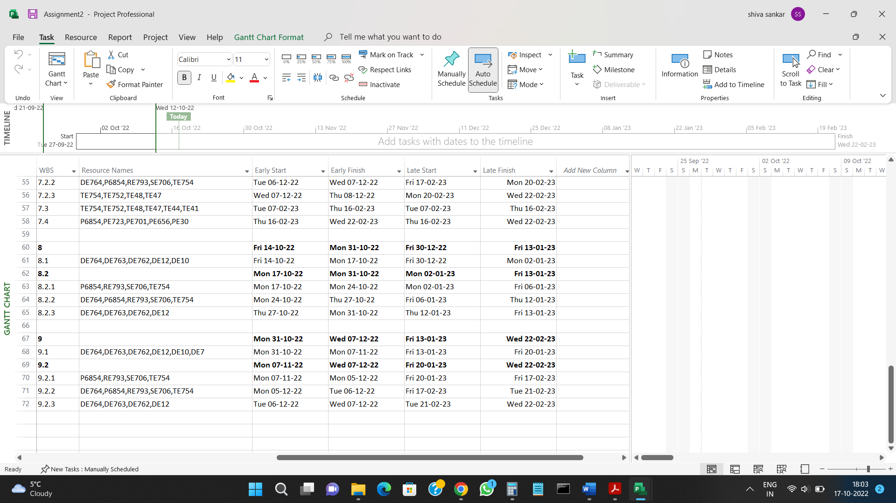

**7. Is it feasible to complete this project (Assignment#2 project) 2 weeks after the completion date you identified for the project in Assignment#1? Explain.**

Ans: Yes, it is feasible to complete this project (Assignment#2 project) 2 weeks after the completion date of Assignment#1 project. If we carefully assign the available resource, we can work on two projects parallelly and complete them with a gap of 2 weeks.

In my case, since new resources were available, I allocated more resources to Assignment#2 project compared to Assignment#1 project. Hence, it completed earlier than Assignment#1 project.

**9. Submit your Comments regarding the start and completion dates and resources assignments for the two projects in a PDF document called Analysis.pdf.**

Ans:

**Assignment#1 Project:**

Start date: 09/12/2022 i.e., September 12, 2022

Completion date: 03/17/2023 i.e., March 17, 2023

**Assignment#2 Project:**

Start date: 09/27/2022 i.e., September 27, 2022

Completion date: 02/22/2023 i.e., February 22, 2023