**Illinois Institute of Technology**

**CS 587 – Software Project Management**

**Assignment-3 Report**

**St. Name: Shiva Sankar Modala**

**St. ID: A20517528**

PART – 1

EXTRAPOLATING VALUES:

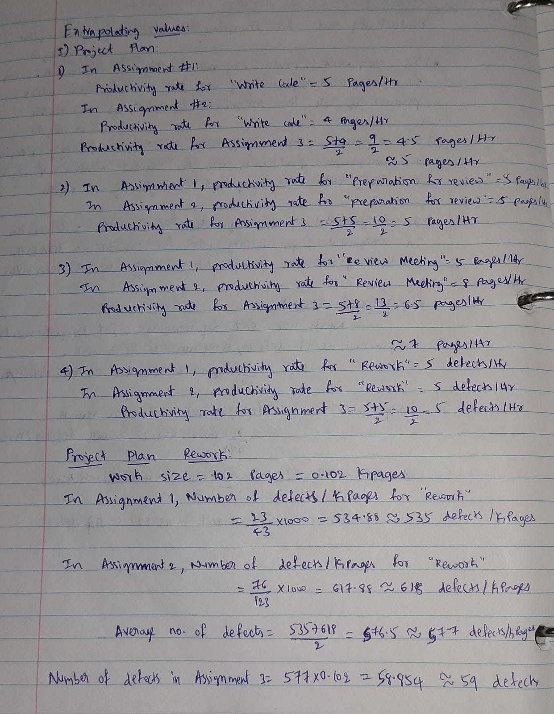

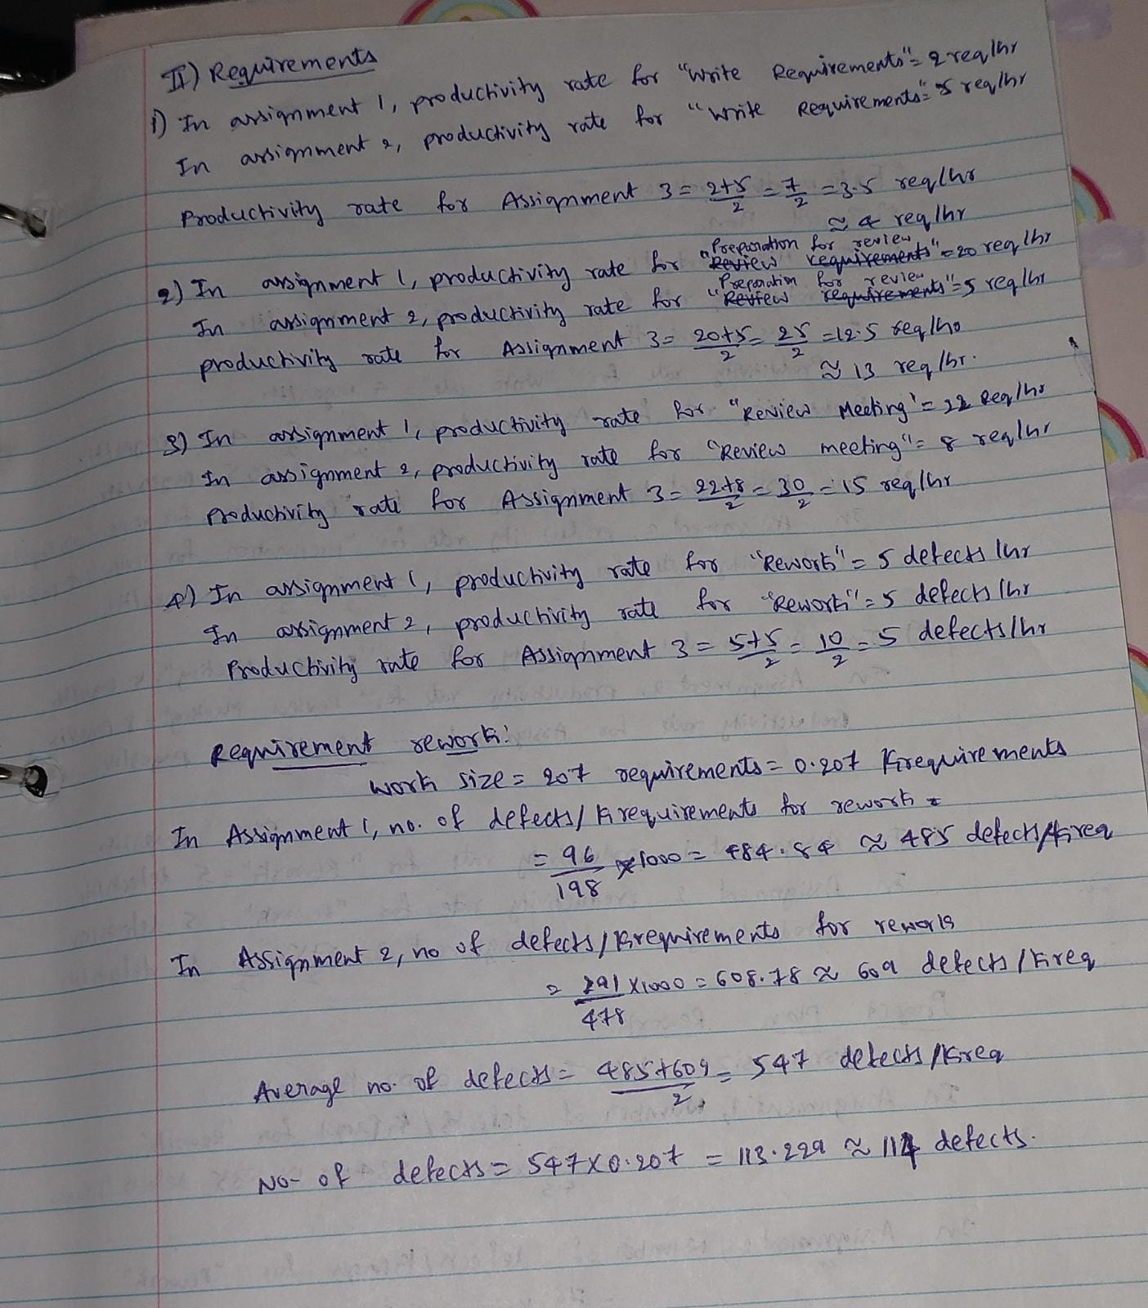

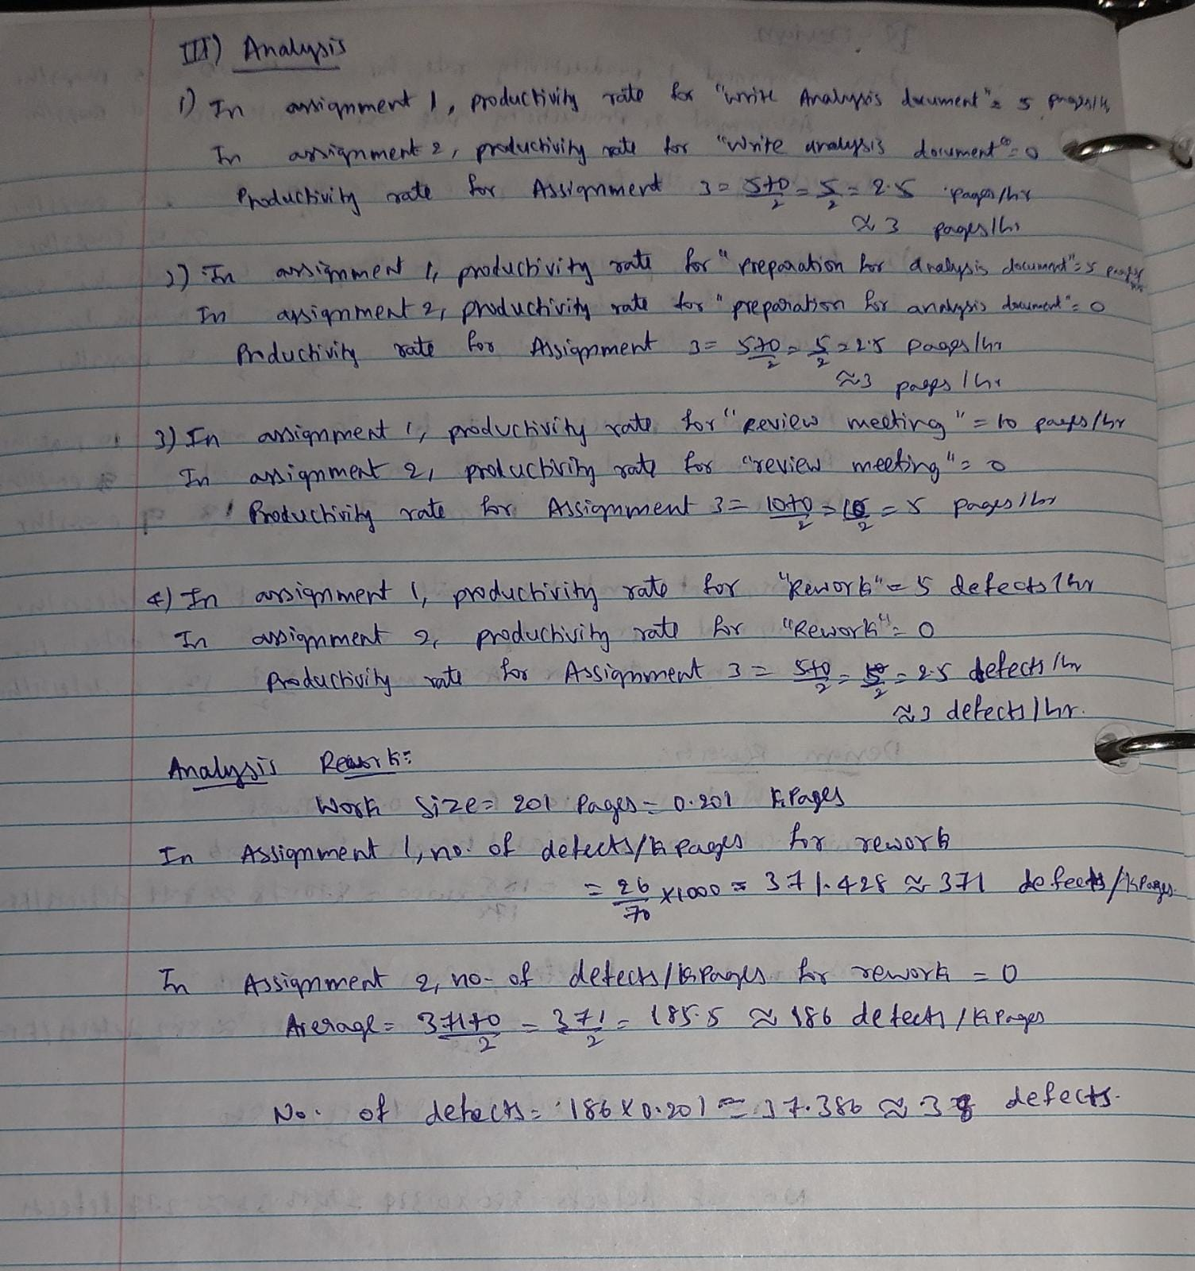

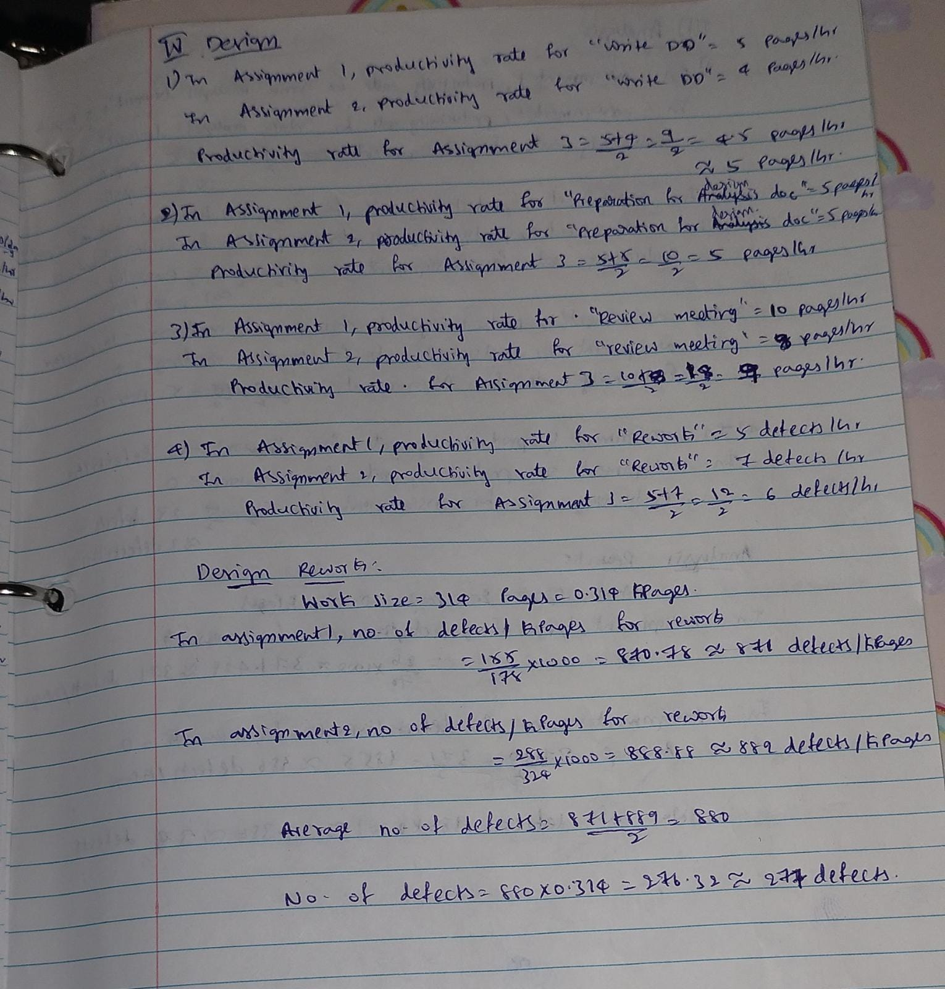

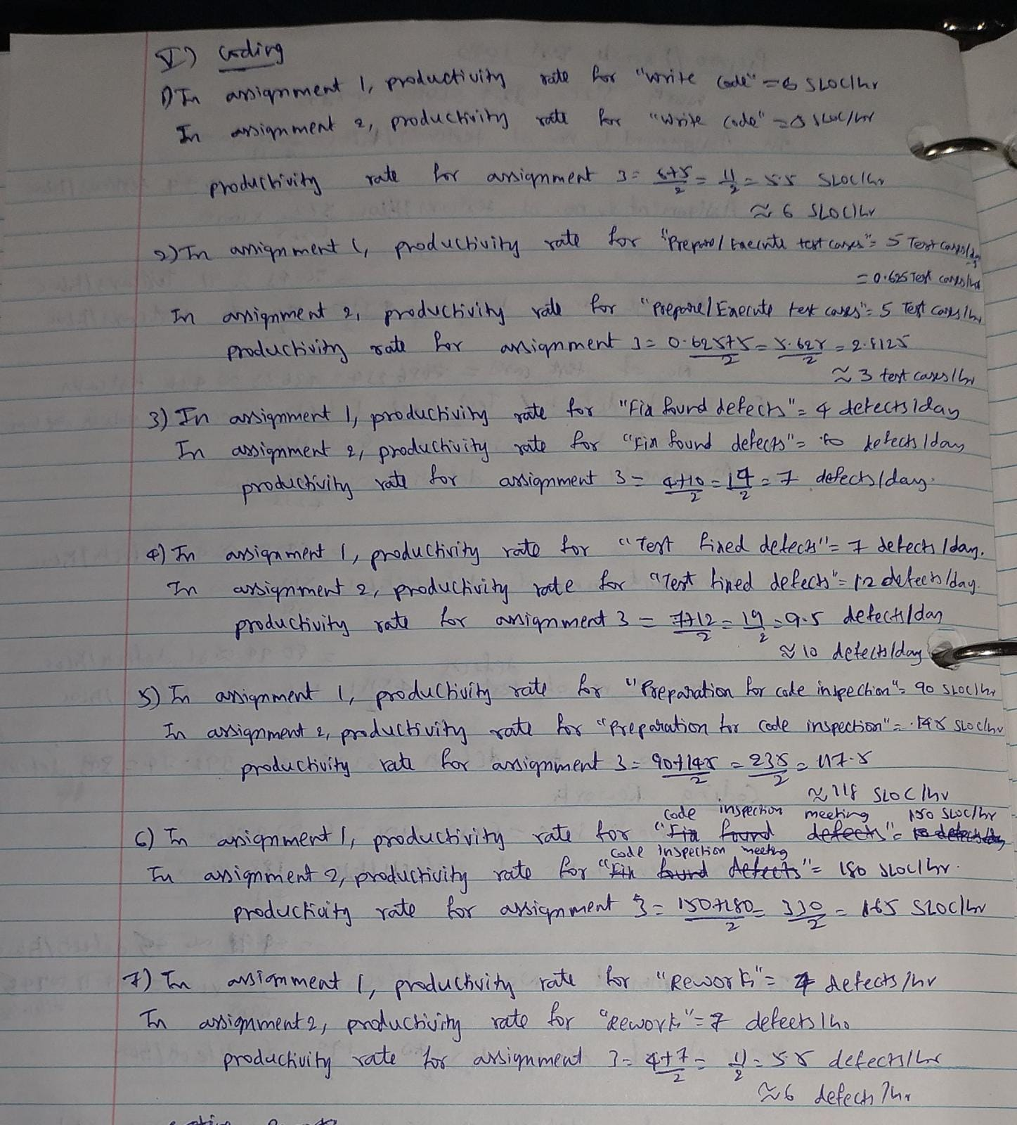

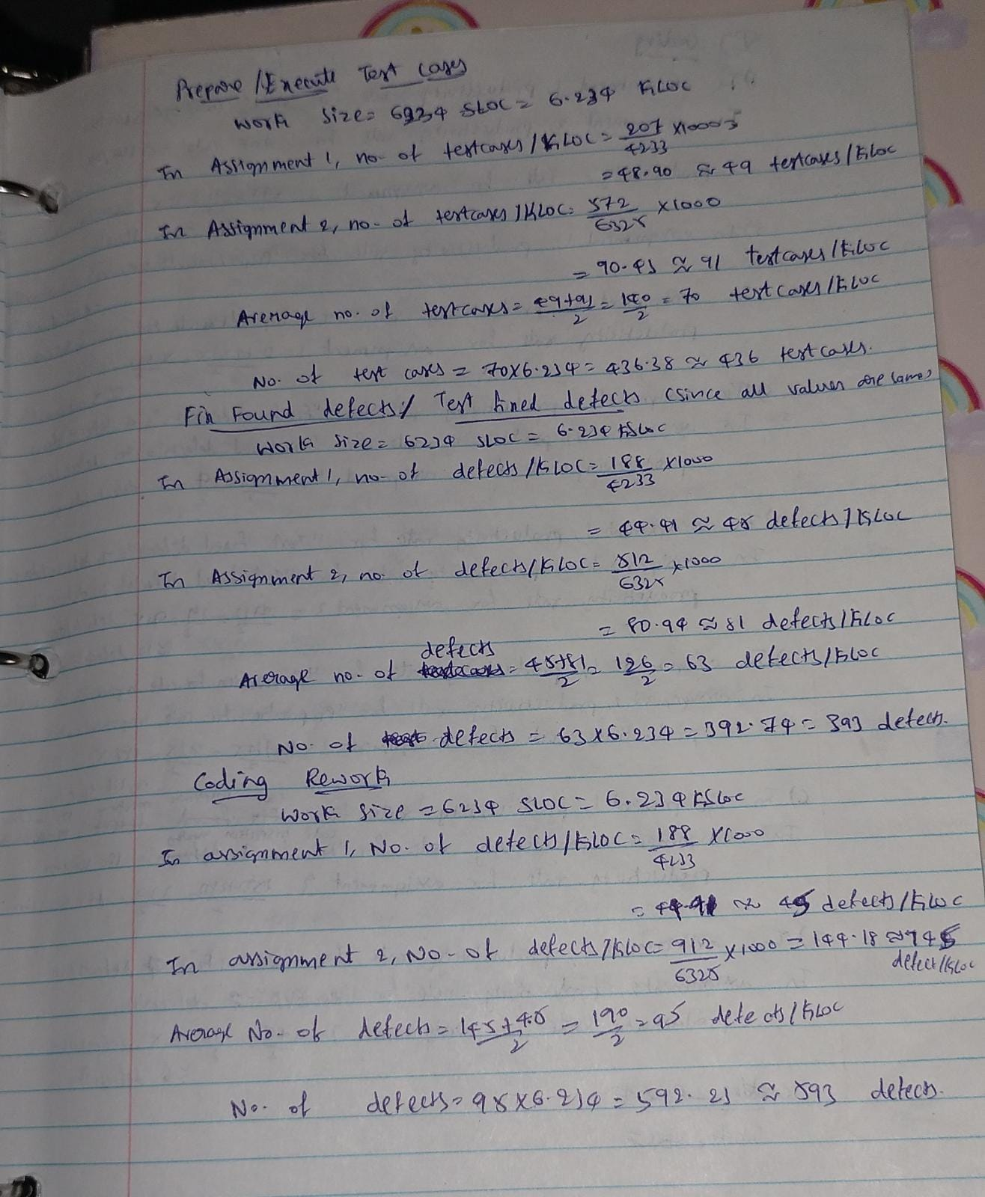

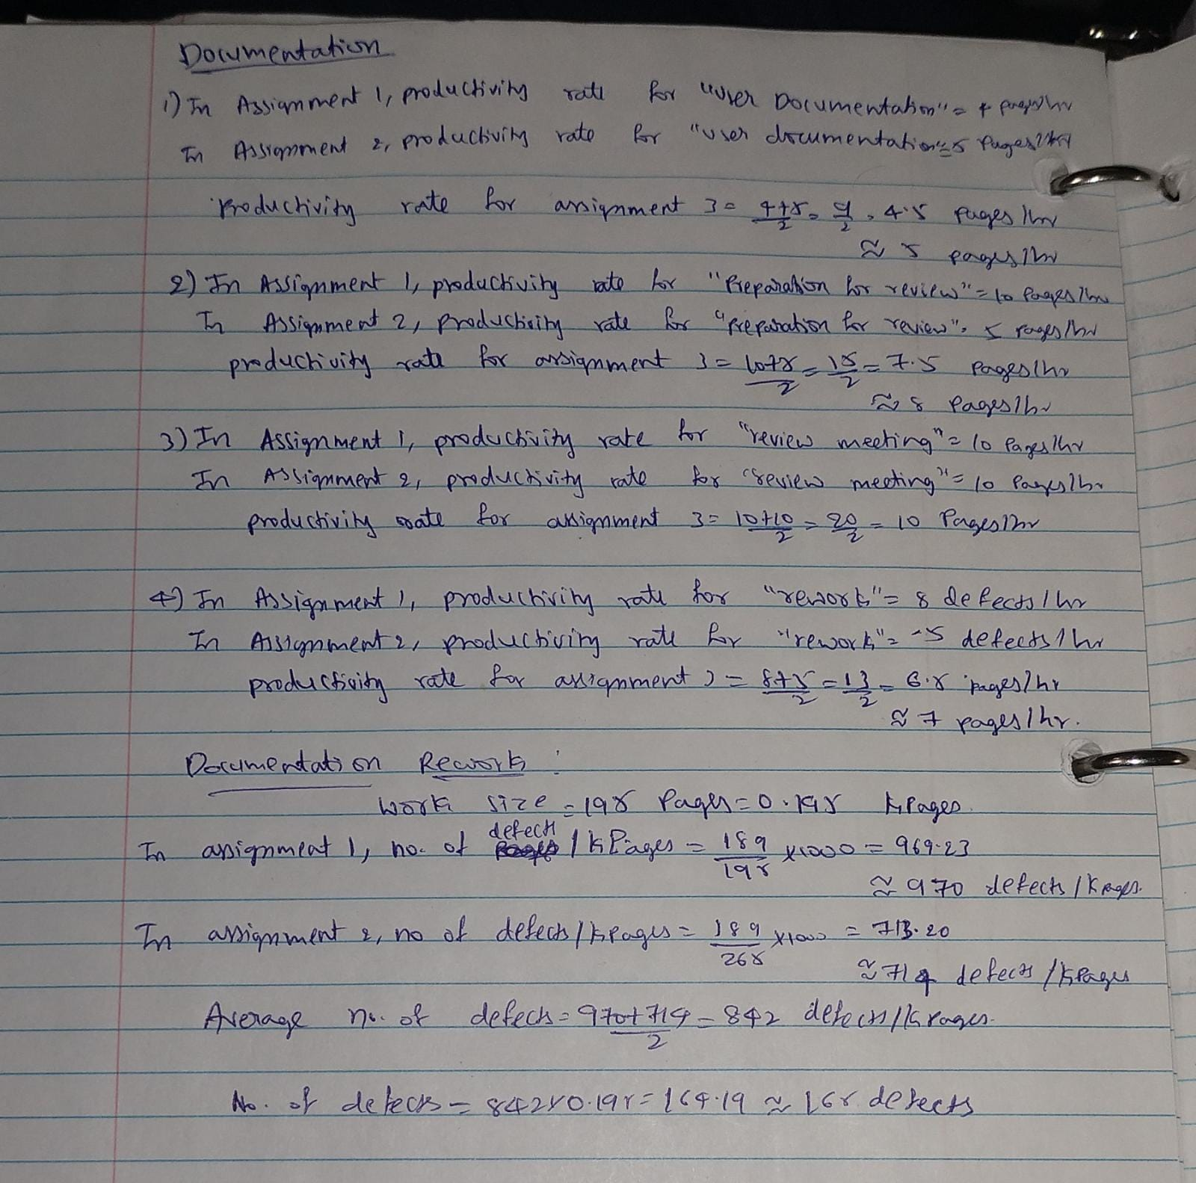

|  |  |  |
| --- | --- | --- |
| **PHASE** | **SIZE** | **Productivity** |
| **Project Plan** | 102 pages |  |
| Write Plan | 102 pages | 5 pages/hour |
| **Review Plan** |  |  |
| Preparation for review | 102 pages | 5 pages/hour |
| Review Meeting | 102 pages | 7 pages/hour |
| Rework | 59 defects | 5 defects/hour |
| **Documented Software Development Process Updates** | 101 changes |  |
| Process Changes | 101 changes | 4 changes/hour |
| **Review Changes** |  |  |
| Preparation for review | 101 changes | 3 changes/hour |
| Review Meeting | 101 changes | 5 changes/hour |
| Rework | 104 defects | 5 defects/hour |
| **Requirement** | 207 requirements |  |
| Write requirements | 207 requirements | 4 requirements/hour |
| **Review Requirements** |  |  |
| Preparation for review | 207 requirements | 13 requirements/hour |
| Review Meeting | 207 requirements | 15 requirements/hour |
| Rework | 114 defects | 5 defects/hour |
| **Build the development and testing lab environment** |  |  |
| **Hardware Environment** |  |  |
| Servers | 25 | 1 server/day |
| Clients | 31 | 5 clients/day |
| **Software Development Tools** |  |  |
| Build/compile tools | 7 | 1 tool/hour |
| **Software Testing Tools** |  |  |
| Test Cases Execution tools | 8 | 3 tool/day |
| Simulation tools | 4 | 2 tool/day |
| **Analysis** | 201 pages |  |
| Write Analysis Document | 201 pages | 3 pages/hour |
| **Review Analysis Document** |  |  |
| Preparation for Analysis Document | 201 pages | 3 pages/hour |
| Review Meeting | 201 pages | 5 pages/hour |
| Rework | 38 defects | 3 defects/hour |
| **Design** | 314 pages |  |
| Write DD | 314 pages | 5 pages/hour |
| **Review DD** |  |  |
| Preparation for DD | 314 pages | 5 pages/hour |
| Review Meeting | 314 pages | 9 pages/hour |
| Rework | 277 defects | 6 defects/hour |
| **Coding** | 6234 SLOC |  |
| Write Code | 6234 SLOC | 6SLOC/hour |
| **Unit Testing** |  |  |
| Prepare/Execute Test Cases | 436 test cases | 3 testcases/hour |
| Fix Found Defects | 393 defects | 7 defects/hour |
| Test Found Defects | 393 defects | 10 defects/hour |
| **Code Inspection** |  |  |
| Preparation for Code Inspection | 6234 SLOC | 118 SLOC/hour |
| Code Inspection Meeting | 6234 SLOC | 165 SLOC/hour |
| Rework | 593 defects | 6 defects/hour |
| **Testing** | 174 pages |  |
| Write test plan (TP) | 174 pages | 10 pages/day |
| **Review TP** |  |  |
| Preparation for TP | 174 pages | 4 pages/hour |
| Review TP Meeting | 174 pages | 10 pages/hour |
| Rework | 134 defects | 5 defects/hour |
| Execute TP (test cases) | 404 test cases | 15 test cases/day |
| Fix Found Defects | 102 defects | 10 defects/day |
| Test Found Defects | 102 defects | 28 defects/day |
| **Documentation** | 232 pages |  |
| User Documentation | 232 pages | 5 pages/hour |
| **Review UD** |  |  |
| Preparation for UD Review | 232 pages | 8 pages/hour |
| Review UD Meeting | 232 pages | 10 pages/hour |
| Rework | 165 defects | 7 pages/hour |

PART 2

7. What is the earliest finish date for this project if it is scheduled to start on 10/24/22?

Ans: The earliest finish date for this project is 06/05/2023 i.e., June 05, 2023 if it is scheduled to start on 10/24/22

8. Can this project be completed 2 months after it starts? Explain why yes or no.

Ans: No, this project cannot be completed in 2 months after it starts.

Because we are sharing the resources of assignment 1 and assignment 2 and few additional resources provided in assignment 3. We cannot use a resource unless it is free from other work. After completely utilizing all the resources, this project completion date is 06/05/2023 i.e., June 05, 2023

10. Submit your Comments regarding the start and completion dates and resources assignments for the three projects in a PDF document called Analysis.pdf.

1. Document and comment on the WBS

WBS gives us a hierarchical structure of the entire project by assigning sequential

numbers to each task. These can also be used as task IDs. Budgets can be calculated or defined based on WBS.

2. Document and comment on the Network Diagram

Network diagram helps us to visualize the orientation of the entire project

We can also see the tasks, their dependencies and have a good overview of the project.

Network diagram also gives us information about the critical path of the project.

3. Document and comment on the resource pool utilization

Assignment 3 has its own resource pool in addition to resources available in Assignment1 and 2 which have a shared resource pool which meant they had to share the resources among two projects

Because of this shared resource pool, assigning resources had to be done carefully and there

are conflicts that come up when we assign resources which had to be resolved.