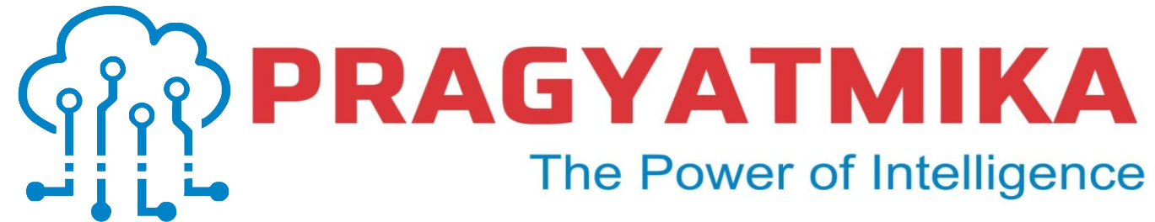
INTERNSHIP REPORT
On AIoT
SMART ATTENDANCE SYSTEM USING FACIAL RECOGNITION
Submitted by
T. Shiva Sharan (160722735077)
P. Abhilash (160722735086)
Class: ECE-B
Department of Electronics and Communication Engineering

In partial fulfillment of the Internship Project
Under the guidance of [Amit Kumar]

Internship Duration: [06-05-2025] to [28-05-2025]
Internship Mode: [ Offline]
Organisation : [Pragyatmika : The Power of Intelligence]

Institution Name :
[Methodist College of Engineering and Technology]
[Hyderabad, Telangana]

Table of Contents
- Acknowledgement
- Company Overview
- Introduction
- Work Responsibilities During the Internship
- Code Overview
- Skills Learned and Experiences Gained
- Conclusion

Acknowledgement
I would like to express my sincere gratitude to Pragyatmika for giving me the opportunity to carry out my internship in the domain of Artificial Intelligence and Internet of Things (AIoT).
I am especially thankful to Amit Kumar, whose guidance, feedback, and encouragement helped me complete the project on “Smart Attendance System using Face Recognition with ESP32-CAM and MQTT” effectively. The exposure to real-time problem-solving and integration of software and hardware enhanced my understanding of embedded systems and IoT protocols.
I would also like to thank the faculty and staff of Methodist College of Engineering and Technology, especially my project coordinator, for their academic support and motivation throughout this internship.

Company Overview
PRAGYATMIKA, established in 2019 and headquartered in Ghaziabad, Uttar Pradesh, is a pioneering Indian company specializing in Electronics Design, Industrial IoT, E-Mobility Solutions, and Technology Training. Operating under the vision of “The Power of Intelligence,” the company delivers end-to-end services in embedded systems, power electronics, battery management systems, fleet management, and EV technologies.
PRAGYATMIKA collaborates with Original Equipment Manufacturers (OEMs) to provide R&D consultancy, product re-engineering, and technology lifecycle support. Their expertise spans across domains such as smart electronics, Li-ion battery systems, drones and UAVs, medical instrumentation, and grid-based pollution control. The company is actively engaged in AIoT (Artificial Intelligence of Things), integrating AI with IoT for innovative solutions.
In addition to its technical services, PRAGYATMIKA offers live and hybrid training programs in areas like Embedded Systems, Industrial IoT Security, E-Automotive, AR/VR, and Green Hydrogen. These programs are designed for students, professionals, and faculty, providing hands-on experience through remotely accessible hardware and development boards. The company has established Centers of Excellence in cities like Hyderabad, Bengaluru, and the NCR region to foster innovation and skill development.
Under the leadership of CEO Mrs. Rupam Jha and supported by mentors from esteemed institutions like BARC, DRDO, and IITs, PRAGYATMIKA has expanded its reach both nationally and internationally. The company is committed to delivering secure and intelligent digital solutions that contribute to a sustainable and connected future.
This experience has strengthened my practical knowledge, improved my confidence in working on AIoT systems, and contributed significantly to my technical growth and career development.

Introduction
This project focuses on the development of a Smart Attendance System using Face Recognition as part of an AIoT (Artificial Intelligence of Things) internship program conducted by PRAGYATMIKA.
The system leverages ESP32-CAM for image capture, OpenCV and face_recognition libraries in Python for face detection and recognition, and the MQTT protocol for real-time data communication. The objective is to automate the attendance process in a contactless, accurate, and efficient manner—eliminating manual intervention and minimizing errors.
Once a face is detected and matched with a registered dataset, the attendance is automatically recorded with a timestamp and stored locally or uploaded to a cloud platform. A buzzer provides audible confirmation of successful recognition. The project showcases the integration of embedded systems, artificial intelligence, and cloud communication—core principles of AIoT.
This solution is ideal for schools, offices, and institutions seeking to streamline attendance monitoring with modern, scalable technology.

Work Responsibilities During the Internship

During my internship at PRAGYATMIKA, under the Centre of Excellence – IIoT, I held the position of an AIoT Intern, where I was actively involved in both training sessions and project development activities related to Artificial Intelligence of Things (AIoT).
🔹 Daily Responsibilities:
- Attended technical lectures and hands-on lab sessions on Python, OpenCV, IoT protocols (like MQTT), and cloud integration (Adafruit IO).
- Participated in coding exercises focusing on image processing, sensor interfacing, and real-time data communication.
- Configured and programmed ESP32-CAM and ESP8266 modules for camera input, Wi-Fi connectivity, and MQTT communication.
🔹 Key Tasks and Assignments:
- Built a Smart Attendance System using Facial Recognition as the primary internship project.
- Used OpenCV with Python to develop and test face detection and recognition scripts.
- Configured ESP32-CAM to capture images and transmit them to a local or cloud-based system.
- Implemented MQTT protocol for publishing recognized attendance events.
- Integrated a buzzer system to provide real-time feedback upon successful face recognition.
🔹 Skills Learned:
- Practical knowledge in embedded systems and AI integration.
- Familiarity with Arduino IDE, Python (NumPy, Pandas, OpenCV), and Adafruit IO cloud dashboard.
- Experience with team-based project planning, debugging hardware/software interfaces, and time-bound task execution.

🔹 Project Work:
- Team Project: Developed the Smart Attendance System as a collaborative effort, working with peers to integrate hardware and software modules.
- Contributed to system design, camera module programming, and cloud dashboard configuration.
- Took initiative to troubleshoot ESP32-CAM connectivity issues and optimize the face recognition model for better performance.
This role helped me grow professionally by strengthening my problem-solving skills, enhancing my understanding of AIoT ecosystems, and preparing me for future roles in smart system development and IoT innovation.

Code Overview
1. Load Known Faces from Folder
for filename in os.listdir(KNOWN_FACES_DIR):
if filename.lower().endswith(('.jpg', '.jpeg', '.png')):
image_path = os.path.join(KNOWN_FACES_DIR, filename)
name = os.path.splitext(filename)[0]
image = face_recognition.load_image_file(image_path)
encodings = face_recognition.face_encodings(image)
if encodings:
known_face_encodings.append(encodings[0])
known_face_names.append(name)
Explanation :
This block loads images from a folder, extracts face encodings, and saves them along with the person’s name. These encodings are used to compare with live face data.

2. Capture Frames from ESP32-CAM Stream
stream = urllib.request.urlopen(ESP32_URL)
bytes_stream = b''
while True:
bytes_stream += stream.read(1024)
a = bytes_stream.find(b'\xff\xd8')
b = bytes_stream.find(b'\xff\xd9')
if a != -1 and b != -1:
jpg = bytes_stream[a:b+2]
bytes_stream = bytes_stream[b+2:]
frame = cv2.imdecode(np.frombuffer(jpg, dtype=np.uint8), cv2.IMREAD_COLOR)
Explanation :
This part connects to the ESP32-CAM's video stream and reads incoming image bytes. It then decodes these bytes into a usable video frame using OpenCV.
3. Detect and Recognize Faces
rgb_frame = frame[:, :, ::-1]
face_locations = face_recognition.face_locations(rgb_frame)
face_encodings = face_recognition.face_encodings(rgb_frame, face_locations)

for (top, right, bottom, left), face_encoding in zip(face_locations, face_encodings):
matches = face_recognition.compare_faces(known_face_encodings, face_encoding)
name = "Unknown"
face_distances = face_recognition.face_distance(known_face_encodings, face_encoding)
best_match_index = face_distances.argmin() if face_distances.size > 0 else None
if best_match_index is not None and matches[best_match_index]:
name = known_face_names[best_match_index]
Explanation :
This code converts the frame to RGB (as required by the face recognition library), detects faces, and generates encodings. It compares these with known encodings to identify the person.
4. Mark Attendance in CSV
if name not in attendance_marked:
now = datetime.now().strftime("%Y-%m-%d %H:%M:%S")
with open(ATTENDANCE_FILE, mode='a', newline='') as file:
writer = csv.writer(file)
writer.writerow([name, now])
print(f"Attendance marked for {name} at {now}")
attendance_marked.add(name)
Explanation :
If a recognized face hasn’t already been marked for attendance, this block logs the person's name and current time into a CSV file and confirms the action via console print.

5. Display Result with OpenCV
cv2.rectangle(frame, (left, top), (right, bottom), (0, 255, 0) if name != "Unknown" else (0, 0, 255), 2)
cv2.putText(frame, name, (left, top - 10), cv2.FONT_HERSHEY_SIMPLEX, 0.8, (255, 255, 255), 2)
cv2.imshow("ESP32-CAM Face Recognition", frame)
if cv2.waitKey(1) & 0xFF == ord('q'):
break
Explanation :
This displays the video frame with rectangles around detected faces. Green for known persons, red for unknown. It also shows the name above the face and listens for a quit command (q key).
Output
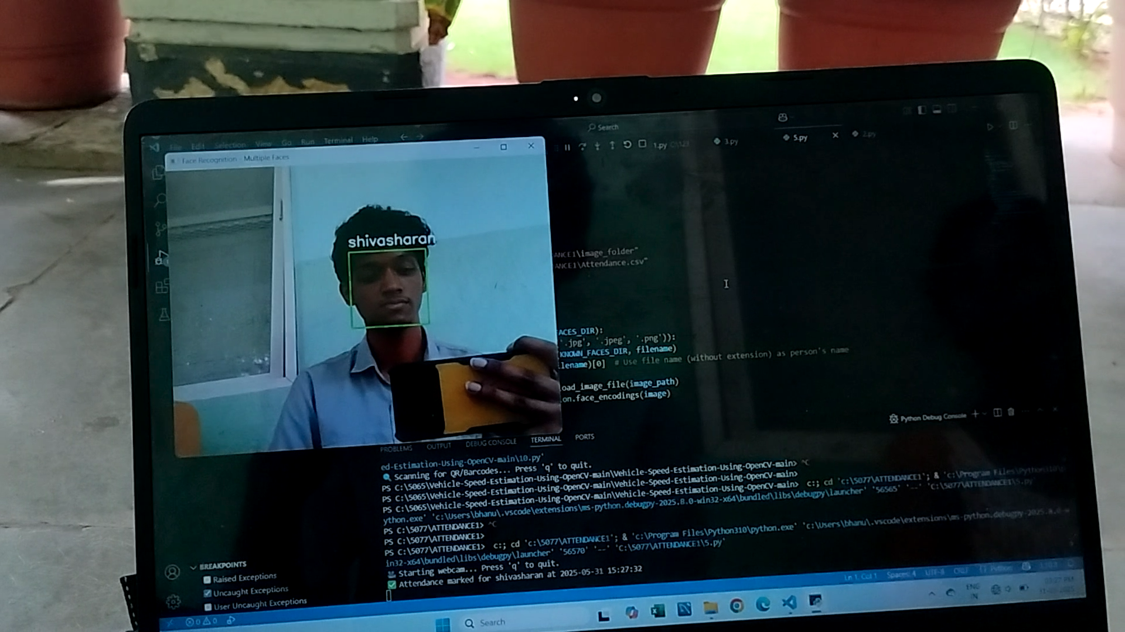
Output in Attendace.csv File :
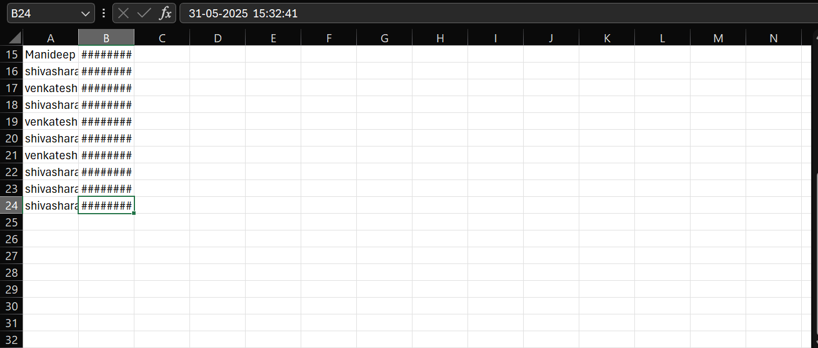

Skills Learned and Experiences Gained
During my internship at PRAGYATMIKA, I acquired a wide range of technical and professional skills that have significantly contributed to my academic and career development.
🔹 Technical Skills Learned:
- Python Programming: Learned core Python concepts including data types, loops, functions, exception handling, and data structures, which strengthened my programming foundation.
- OpenCV for Computer Vision: Gained practical experience in image and video processing, face detection, object recognition, and real-time computer vision applications.
- Embedded Systems: Worked extensively with ESP32-CAM and ESP8266, learning how to flash firmware, program using Arduino IDE, and connect to Wi-Fi networks.
- MQTT Protocol: Understood and implemented publish/subscribe communication for real-time data exchange between devices and cloud servers.
- Cloud Integration: Configured and used Adafruit IO to visualize, control, and monitor data remotely using feeds and dashboards.
🔹 Professional and Soft Skills:
- Project Planning and Execution: Followed a structured workflow from idea to deployment, improving my skills in modular development and system integration.
- Team Collaboration: Coordinated with peers on tasks like testing, hardware debugging, and presentation preparation, enhancing my teamwork and communication.
- Problem Solving: Faced real-time issues like face detection errors, network instability, and hardware connection failures—and learned to troubleshoot them effectively.
🔹 Relation to Academic Background:
These skills closely align with my studies in Electronics and Communication Engineering. The concepts of microcontroller programming, sensor interfacing, and AI-based automation are directly applicable to the subjects in my academic curriculum such as Embedded Systems, IoT, and Signal Processing.

🔹 Impact on Career Goals:
This internship confirmed my interest in working in the field of AIoT and Smart Systems. The exposure to real-world applications, like attendance automation and cloud-based monitoring, has inspired me to pursue further learning and research in this domain. I now feel more confident in contributing to intelligent embedded systems and aspire to work on scalable, real-time AIoT solutions in the future.

Conclusion
My internship at PRAGYATMIKA provided a highly valuable and immersive learning experience in the field of Artificial Intelligence of Things (AIoT). Through active participation in both training and project development, I enhanced my skills in embedded systems, Python programming, computer vision, and real-time IoT communication.
This experience has given me clarity about the career path I wish to pursue—working on intelligent embedded solutions that solve real-world problems in automation, security, and monitoring.
🔹 Ongoing Considerations:
- I aim to deepen my understanding of advanced computer vision techniques, including multi-face detection, facial feature tracking, and gesture recognition.
- I would like to improve my cloud and edge computing skills, especially around security, scalability, and latency optimization in IoT systems.
- I’m interested in exploring TinyML and Edge Impulse further for deploying machine learning models on low-power devices.
- Building mobile integration and app-based interfaces for AIoT systems is another area I intend to develop.
In future internships or projects, I would appreciate opportunities to engage more with industry-standard tools and real-time deployment environments, including working on large datasets, handling sensor noise, and managing multiple IoT nodes.
I am grateful to PRAGYATMIKA for providing an environment that was both technically enriching and professionally inspiring. The mentorship and practical exposure have set a strong foundation for my continued growth in this domain.

