Smart Attendance System using Facial Recognition
Team Members :
T.Shiva Sharan (160722735077)
P.Abhilash (160722735086)
CH.Manideep (160722735094)
Pragyatmika : The Power of Excellence
Mentor : Praveen K

OBJECTIVE OF PROJECT
Smart Attendance Management:
- To design and implement a face recognition-based attendance system using ESP32CAM.
- To automatically capture, detect, and recognize faces in real-time.
- To mark attendance with a timestamp and store the data in a local database or cloud.
IoT Integration:
- To integrate the system with MQTT protocol for communication.
- To store and visualize attendance data on cloud dashboards (Adafruit IO, ThingsBoard, etc.).
- To provide remote monitoring for teachers, administrators, or managers.
System Features:
- Contactless and hygienic attendance process (no touch required).
- Low-cost and scalable solution for classrooms, offices, and industries.
- Real-time notifications and reporting.

GOAL
The goal of this project is to provide a contactless, secure, and automated attendance system that eliminates the drawbacks of manual registers and RFID systems. The key goals are:
- Accuracy: Reduce errors and prevent proxy attendance.
- Efficiency: Automate the attendance process, saving time during roll calls.
- Scalability: Deploy the solution in schools, offices, healthcare, or events.
- Security: Ensure that only registered individuals are recognized.
- Integration: Use IoT and cloud platforms for centralized access and monitoring.

DESCRIPTION OF THE PROJECT
- Attendance is an important daily task in every institution and organization. Manual systems are time-consuming, error-prone, and vulnerable to manipulation. RFID and fingerprint scanners, while faster, require physical contact, making them less suitable in the post-pandemic era where hygiene is crucial.
- This project introduces a Smart Attendance System using Facial Recognition. It uses an ESP32-CAM microcontroller with an inbuilt camera to capture images of individuals. OpenCV and face_recognition libraries process these images to detect and recognize faces. Once a match is found with registered data, the system automatically marks attendance with name, date, and time.
- The system is enhanced with IoT integration. Using the MQTT protocol, attendance logs can be uploaded to cloud platforms like Adafruit IO for remote monitoring. Administrators can access attendance reports through a web or mobile dashboard.
- This approach ensures a fast, contactless, and reliable attendance solution that can be deployed in multiple domains.

APPLICATIONS
- Educational Institutions: Automated student attendance without roll calls.
- Corporate Offices: Employee entry/exit tracking.
- Industries & Factories: Shift management and workforce monitoring.
- Healthcare: Contactless attendance to reduce infection spread.
- Event Management: Participant verification and access control.
- Secure Facilities: Monitoring and restricting entry to authorized personnel.

TECHNOLOGIES
- Hardware Technologies:
  - ESP32-CAM Module (camera + microcontroller with Wi-Fi). o FTDI Programmer (USB-to-serial converter for flashing). o MicroSD Card for local storage. o Buzzer for real-time recognition feedback.
  - 5V Power Supply.
- Software Technologies:
  - Arduino IDE with ESP32 Board Package.
  - Python with OpenCV & face_recognition library. o MQTT Protocol for IoT communication. o Adafruit IO (Cloud Dashboard).

BLOCK DIAGRAM
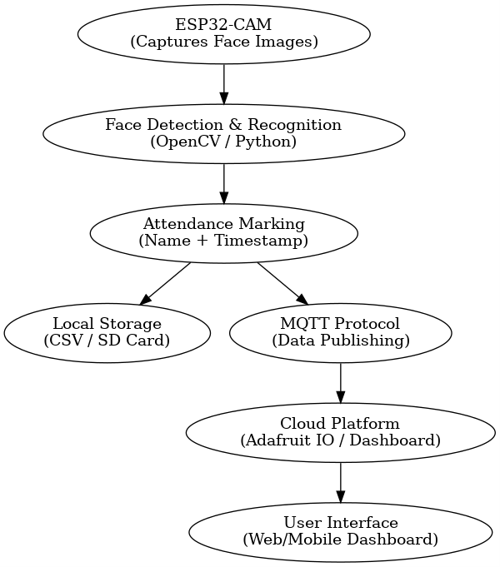

TARGET USERS
- Schools, Colleges, and Universities
- Corporate Offices and IT Companies
- Factories and Industries
- Hospitals and Healthcare Facilities
- Government & Security Agencies

TOOLS & RESOURCES
Hardware Tools:
- ESP32-CAM, FTDI Programmer, Power Supply.
- Jumper Wires, USB Cable, MicroSD Card.
Software Tools:
- Arduino IDE (C/C++ Programming).
- Python (NumPy, Pandas, OpenCV, face_recognition).
- MQTT Broker & Client Libraries.
- Cloud Services (Adafruit IO, ThingsBoard).

PROPOSED TIMELINE
- Week 1 – 3: Project Planning and Literature Review.
- Week 4 – 6: Requirement Analysis and Hardware Setup.
- Week 7 – 9: ESP32-CAM Firmware Programming and Testing.
- Week 10 – 12: Face Detection & Recognition Algorithm Implementation.
- Week 13 – 15: IoT (MQTT & Cloud) Integration.
- Week 16: Final Testing, Validation, Documentation, and Report Submission.

CONCLUSION
- The Smart Attendance System using Facial Recognition provides a modern solution to replace outdated manual and RFID systems. By combining AI-based face recognition with IoT-based cloud monitoring, it offers a fast, contactless, and reliable attendance process.
- This system not only improves efficiency and accuracy but also enhances security and scalability. Its applications span across education, healthcare, industries, and secure facilities. With future developments such as mobile app integration, multiface recognition, and biometric fusion (face + fingerprint), this project can evolve into a comprehensive smart monitoring solution for real-world deployments.

REFERENCES
- IJERT (2020) – Smart Attendance System using OpenCV based on Facial Recognition.
- IJRASET (2023) – Comparative Study of Face Recognition Models for Smart Attendance.
- IJSREM (2024) – Smart Attendance Management System using Face Recognition.
- MDPI Electronics (2022) – IoT-Based Intelligent Attendance System: Framework & Practice.
- IJRASET (2024) – Multi-factor Authentication (Face + OTP).
- arXiv (2018–2024) – AttenFace, CNN-based Face Recognition Systems.
- Scaler & KickerAI Blogs (2024) – Practical Deployments of Face Recognition Attendance Systems.
- AttendX – Humber Polytechnic Capstone Project.

