Impact of SBERT Sentence Embeddings on Software Story Point Estimation
Within-project estimation with chronological (temporal) data splitting on the TAWOS dataset
Project PS-6 | Natural Language Processing

Group members | Gulapala Shiva Kumar (B230957CS)  Poosa Yashwanth (B230691CS)  Shaik Mohammad Arif (B230555CS)  Kathuri Manaswin (B230668CS)  G Sai Sukumar Reddy (B230959CS)
Course / instructor | Natural Language Processing / Dr. Shewta
Date | November 2026
GitHub repository

Abstract
Story points express the relative effort of a software issue. This report studies project PS-6: can SBERT sentence embeddings of an issue's text predict the story points of later issues of the same project? Using the TAWOS dataset, 39,588 issues from 39 projects were available after filtering. For every project the issues were ordered by creation date; the oldest 80% formed the development set (rolling-origin validation with five validation folds) and the newest 20% the held-out test set. Issues were embedded with all-MiniLM-L6-v2 and a three-layer 1-D CNN was trained per project. It was compared, on identical splits, with a median predictor, ridge regression and kNN on the same embeddings, and TF-IDF with ridge regression.
Averaged over projects, the CNN reached a held-out test MAE of 1.857 and MdAE of 1.395, against 1.872 and 1.436 for the median predictor. Its MAE was within 2% of the median predictor's in 30 of 39 projects. The best model was kNN on the SBERT embeddings (MAE 1.817, MdAE 1.244), 2.9% below the median baseline; ridge regression and TF-IDF + ridge were worse than the median baseline. In this setting the SBERT embeddings therefore carry only a small amount of usable signal beyond each project's typical story point value, and the CNN adds no measurable gain over a constant prediction.

1. Introduction and objectives
In agile development, story points are assigned to issues or user stories to express relative effort. The goal is a model that predicts the story point value of an issue from its textual description. Text must first be converted to numbers; sentence embeddings represent a whole passage as one vector intended to capture its meaning. SBERT (Sentence-BERT) produces such vectors.
Project PS-6 fixes the setting: SBERT sentence embeddings, within-project estimation (training and testing issues come from the same project) and temporal ordering (older issues for training, the most recent issues for testing). The objectives are to:
- investigate how well SBERT sentence embeddings predict the story points of later issues of the same project;
- evaluate with Mean Absolute Error (MAE) and Median Absolute Error (MdAE), reporting five-fold validation results separately from the final held-out test results;
- judge the result against simple baselines trained on exactly the same splits, so that any gain is attributable to the representation and model rather than to the data split;
- document the configuration, seeds and procedure so that the experiments are reproducible.
The sibling projects PS-2 (BERT word embeddings) and PS-10 (combined embeddings) use the same setting; a comparison across representations therefore requires their results on the same partitions (Section 6.1).

2. Dataset

2.1 Source, extraction and filtering
The data come from TAWOS (https://doi.org/10.5522/04/21308124), a collection of issues from open-source Jira projects. Issues were extracted from the MySQL release with one query joining the issue, project and repository tables. Only issues carrying a story point were pulled (65,427). The following filters were then applied, in this order; Table 1 shows how many issues each removed.
- a valid creation date;
- a non-empty Resolution value (any value; see the threat to validity in Section 6.3);
- a story point in the range 0 < SP ≤ 100;
- story point, title and description not changed after the estimate was made (three flags provided by TAWOS), so that the text used corresponds to what was estimated;
- a non-empty title or description.

Filter step | Issues remaining | Removed
Story_Point IS NOT NULL (start) | 65,427 | 0
Creation_Date valid | 65,427 | 0
Resolved (Resolution non-empty) | 59,785 | 5,642
0.0 < Story_Point <= 100.0 | 57,429 | 2,356
Story_Point not changed after estimation | 50,200 | 7,229
Title not changed after estimation | 41,307 | 8,893
Description not changed after estimation | 41,307 | 0
Non-empty text (title or description) | 41,307 | 0

Table 1. Extraction filter funnel.
Preprocessing then built the model input as title + blank line + description text, removed HTML and Jira markup, dropped story points below 1, texts shorter than five characters and duplicate issue keys, and wrote one file per project. This left 39,588 issues (1,719 fewer than after extraction) in 39 projects. No project was excluded for size (min_issues = 0).

2.2 Project coverage and size
The guidelines name 39 projects. 36 of them were found in the extracted data under matching names. Three were not found by name: Evergreen, C++ driver (Appcelerator), C++ driver (MongoDB). 3 projects present in the data are not in the guideline list (aptana_studio, the_mongo_c_driver, the_mongodb_engineering); So we took the 3 projects present in TAWOS as a replacement for the ones given in guidelines
Statistic | Issues per project | Development | Test (newest 20%)
Minimum | 20 | 16 | 4
25th percentile | 222 | 178 | 44
Median | 354 | 283 | 71
75th percentile | 846 | 677 | 170
Maximum | 11,448 | 9,158 | 2,290
Total | 39,588 | 31,669 | 7,919

Table 2. Project sizes after filtering and splitting.
Projects are very unequal: the smallest, apache_mxnet, has only 20 issues (4 test issues), the largest, lsstcorp_data_management, has 11,448. 4 projects have fewer than 30 test issues (apache_mxnet, atlassian_crowd, atlassian_fisheye, the_mongo_c_driver); they are kept in the all-project averages but also reported with a 'reliable' subset (35 projects with at least 30 test issues).

3. Methodology

3.1 Text representation
Each issue text is encoded once with the pretrained SBERT model sentence-transformers/all-MiniLM-L6-v2 (384 dimensions, vectors L2-normalised). The model is frozen: it is never trained or fine-tuned, so embedding all issues before splitting leaks no label information. The encoder truncates input at 256 word pieces, so the tail of long descriptions is not seen (a limitation, Section 6.3).

3.2 Within-project temporal splitting
Every project is handled separately. Its issues are sorted by creation date (stable sort, ties keep export order). The oldest 80% is the development set and the newest 20% the held-out test set; the test set is used exactly once, after all choices are made. Whether all test issues are newer than all development issues is checked in code.

3.3 Rolling five-fold validation on the development set
The guidelines ask for five folds on the development set. A random or 'leave-one-block-out' scheme would train on later issues to predict earlier ones, violating the chronological requirement. We therefore use forward-chaining (rolling-origin) validation: the development set is cut into six contiguous chronological blocks; block 0 is only ever training data, and each of blocks 1 to 5 is validated once, using all earlier blocks for training. This gives exactly five validation folds, each validated strictly on data newer than its training data.
Fold | Training blocks | Validation block
1 | 0 | 1
2 | 0 to 1 | 2
3 | 0 to 2 | 3
4 | 0 to 3 | 4
5 | 0 to 4 | 5

Table 3. Rolling validation layout (each block is about one sixth of the development set). Early folds train on little data.

3.4 CNN regressor
The prediction model is a three-layer 1-D convolutional network (about 12,300 trainable parameters). The 384-dimensional vector is treated as a one-channel sequence and passed through three blocks of Conv1D (16, 32, 64 filters; kernel size 3) with batch normalisation, ReLU and dropout (0.3), then global average pooling and a head of Linear(64, 64), ReLU, dropout and Linear(64, 1). One regression output is produced, clipped to at least 1 story point.

3.5 Training, model selection and final model
Training uses the L1 loss (which targets the MAE), Adam, weight decay 1e-4 and a batch size capped so that small training sets still receive about four updates per epoch. Targets are centred on the median story point of the training rows, so the untrained network already predicts the training median. The learning rate is chosen per project from {1e-3, 3e-4} by the mean MAE over the five validation folds (development data only). When a training block has enough rows (at least 30 for both parts), the last 15% (chronologically) is held out for early stopping (patience 20, at least 30 epochs); otherwise the network trains for a fixed 30 epochs. Across the 195 fold runs, 73 used early stopping and 122 the fixed budget. The validation fold is scored once after training and never influences epoch choice. The final model is retrained on all development rows for the median best epoch of the selected learning rate (or the fixed budget) and scores the test set once. Random seed: 42 (single run).

3.6 Baselines (same splits, same protocol)
- Median: constant prediction equal to the median story point of the training rows.
- Ridge (SBERT): ridge regression on the SBERT vectors, α chosen per project from {0.01, 0.1, 1, 10, 100}.
- kNN (SBERT): median story point of the k most cosine-similar training issues, k chosen per project from {5, 10, 20, 50}.
- TF-IDF + Ridge: a non-SBERT reference: TF-IDF (1-2 grams, at most 20,000 features, minimum document frequency 2, English stop words), the vocabulary and weights fitted on the training rows of each fold only; α as for ridge.
Hyper-parameters are chosen by mean validation MAE; the chosen setting is refit on all development rows and scores the test set once. Predictions are clipped at 1 as for the CNN.

3.7 Metrics and aggregation
MAE and MdAE are computed per project, per fold and on the test set. Results over projects are summarised by the macro average (each project counts equally), the pooled value over all test issues (large projects dominate) and a macro average over reliable projects (at least 30 test issues). CNN and baselines are compared per project with a paired Wilcoxon signed-rank test on test MAE differences; because projects are heterogeneous and not independent samples, the p-values are descriptive. Validation results are reported as the mean and standard deviation over the five folds.

4. Experimental configuration
Item | Value
Random seed | 42 (single run per model)
Text model | sentence-transformers/all-MiniLM-L6-v2 (384-d, normalised)
Split | 80% development / 20% test by creation date, within each project
Validation | rolling-origin, 6 blocks, 5 validation folds
CNN | Conv1D 16-32-64, kernel 3, BatchNorm, ReLU, dropout 0.3, global average pooling, FC 64
Optimisation | L1 loss, Adam, weight decay 1e-4, lr grid {1e-3, 3e-4}, max 200 epochs, patience 20, min 30 epochs
Early stopping | last 15% of training rows if both parts have 30+ rows; else fixed 30 epochs
Story-point range | 1 to 100; predictions clipped at 1
Reliable-project threshold | at least 30 test issues

Table 4. Main configuration (the full YAML file is in the repository).

5. Results

5.1 Five-fold validation results (development data)
Model | Val MAE (mean) | Mean fold SD of MAE | Val MdAE (mean)
kNN (SBERT) | 1.873 | 0.631 | 1.331
CNN (SBERT) | 1.966 | 0.665 | 1.437
Median (constant) | 1.947 | 0.665 | 1.433
TF-IDF + Ridge | 2.127 | 0.570 | 1.649
Ridge (SBERT) | 2.100 | 0.573 | 1.617

Table 5. Chronological five-fold validation, macro-averaged over 39 projects (mean over folds per project, then over projects). Selected hyper-parameters per project. Rows are ordered by test MAE.
On validation data the ranking by MAE is kNN (SBERT), Median (constant), CNN (SBERT), Ridge (SBERT), TF-IDF + Ridge. The CNN's validation MAE (1.966) is slightly above that of the median predictor (1.947). The fold-to-fold standard deviation (about 0.57 to 0.67 story points on average) is large relative to the differences between models. The CNN selected a learning rate of 1e-3 in 32 of 39 projects and 3e-4 in 7. Per-project validation means and standard deviations are in Appendix A.

5.2 Held-out test results
# | Model | Test MAE | Test MdAE | Pooled MAE | Pooled MdAE | Reliable MAE | Wins* | Mean rank | vs median
1 | kNN (SBERT) | 1.817 | 1.244 | 2.274 | 1.000 | 1.918 | 21 | 2.21 | +2.9%
2 | CNN (SBERT) | 1.857 | 1.395 | 2.467 | 1.496 | 1.963 | 1 | 3.08 | +0.8%
3 | Median (constant) | 1.872 | 1.436 | 2.439 | 1.000 | 1.982 | 14 | 2.38 | -
4 | TF-IDF + Ridge | 2.041 | 1.399 | 2.752 | 1.367 | 2.162 | 3 | 3.78 | -9.0%
5 | Ridge (SBERT) | 2.100 | 1.510 | 2.769 | 1.371 | 2.228 | 8 | 3.55 | -12.2%

Table 6. Held-out test results (newest 20% of each project), 39 common projects. Test MAE/MdAE are macro averages over projects; pooled values use all 7,919 test issues; 'reliable' averages the 35 projects with at least 30 test issues. *Wins = number of projects where the model has the lowest MAE (ties counted for every tied model). 'vs median' = MAE reduction relative to the median predictor (positive = better).
The guideline-format table for the assigned model (SBERT + CNN) is:
Representation | Model configuration | MAE | MdAE
SBERT sentence embeddings (PS-6) | 3-layer CNN, filters [16, 32, 64], lr per project from [0.001, 0.0003], L1 loss, seed 42; within-project, temporal 80/20, 5-fold rolling CV; MAE/MdAE = test, macro-average over 39 projects | 1.8571 | 1.3953

Table 7. SBERT + CNN, test results (macro average over projects). Validation results are in Table 5 and Appendix A.
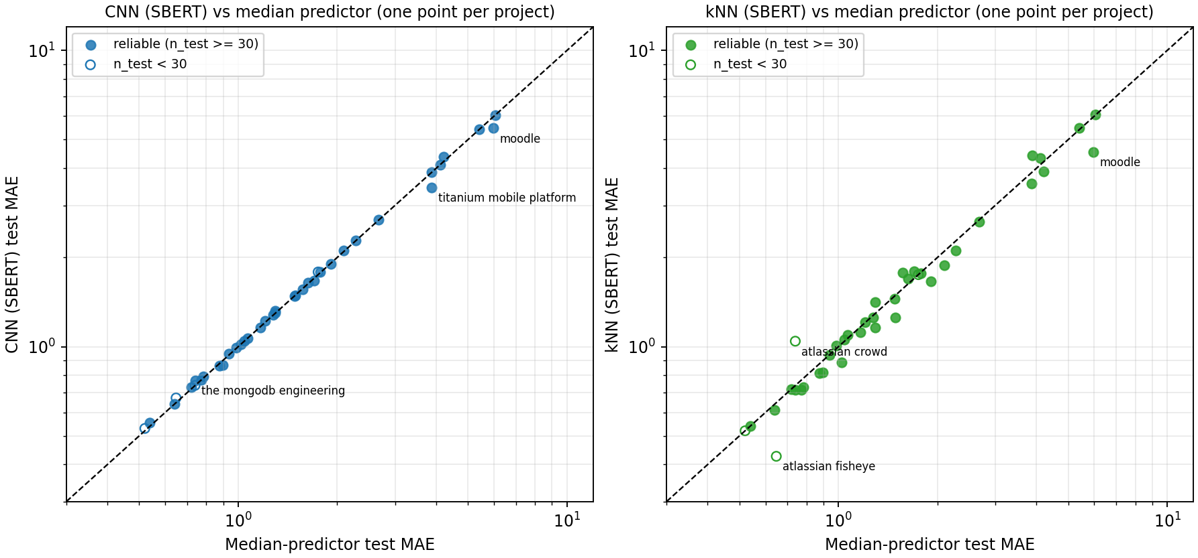
Figure 1. Test MAE of the CNN (left) and of kNN (right) against the median predictor, one point per project (log axes). Points on the dashed line are no better than the median predictor; the CNN lies almost exactly on it.
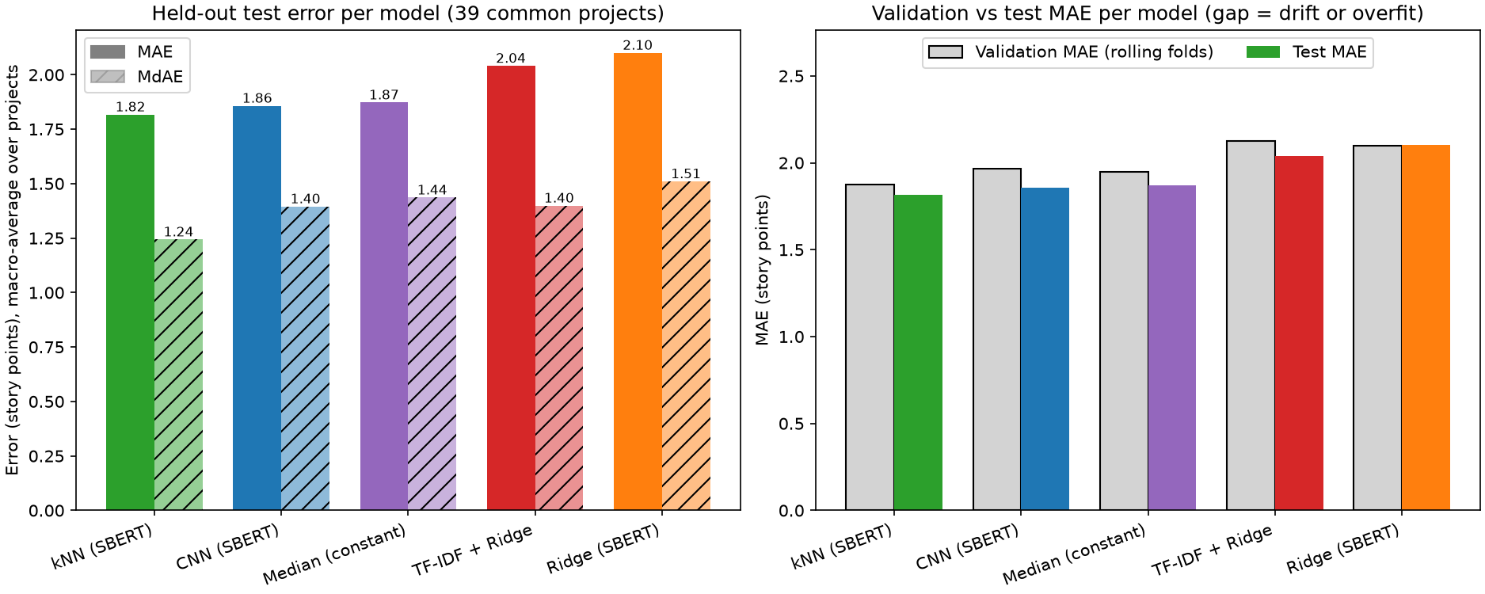
Figure 2. Left: macro-averaged test MAE and MdAE per model. Right: validation versus test MAE per model.

5.3 CNN versus the baselines
Baseline | Scope | Projects | CNN better | Baseline better | Median diff | Wilcoxon p
Ridge (SBERT) | all | 39 | 25 | 14 | +0.081 | 0.015
Ridge (SBERT) | reliable | 35 | 23 | 12 | +0.090 | 0.023
kNN (SBERT) | all | 39 | 13 | 26 | -0.027 | 0.117
kNN (SBERT) | reliable | 35 | 12 | 23 | -0.027 | 0.119
TF-IDF + Ridge | all | 39 | 27 | 12 | +0.054 | 0.022
TF-IDF + Ridge | reliable | 35 | 24 | 11 | +0.054 | 0.039
Median (constant) | all | 39 | 10 | 29 | -0.003 | 0.039
Median (constant) | reliable | 35 | 10 | 25 | -0.001 | 0.123

Table 8. Paired per-project comparison on test MAE. 'Median diff' = median over projects of (baseline MAE minus CNN MAE): positive favours the CNN, negative the baseline.
Against the median predictor, the CNN had a lower test MAE in only 10 of 39 projects and the median predictor in 29; the typical difference is a few thousandths of a story point (median difference -0.0027), while the mean difference is slightly positive because of a few projects where the CNN gains (Figure 1). The paired test for this comparison is borderline (Wilcoxon p = 0.039 over all projects, 0.123 over reliable projects): the median predictor wins in most projects by tiny margins, the CNN in fewer projects by larger ones. The CNN's MAE is within 2% of the median predictor's in 30 projects, clearly lower in 3 (hyperledger_fabric, moodle, titanium_mobile_platform) and clearly higher in 6 (alloy_framework, apache_mxnet, atlassian_fisheye, lsstcorp_data_management, the_mongo_java_driver, the_mongodb_engineering). Against ridge and TF-IDF + ridge the CNN was better in 25 and 27 projects (Wilcoxon p = 0.015 and 0.022); both are worse than the median predictor, so this reflects their weakness more than the CNN's strength. kNN beat the CNN in 26 of 39 projects, but the difference was not significant (p = 0.117; 0.119 for reliable projects).
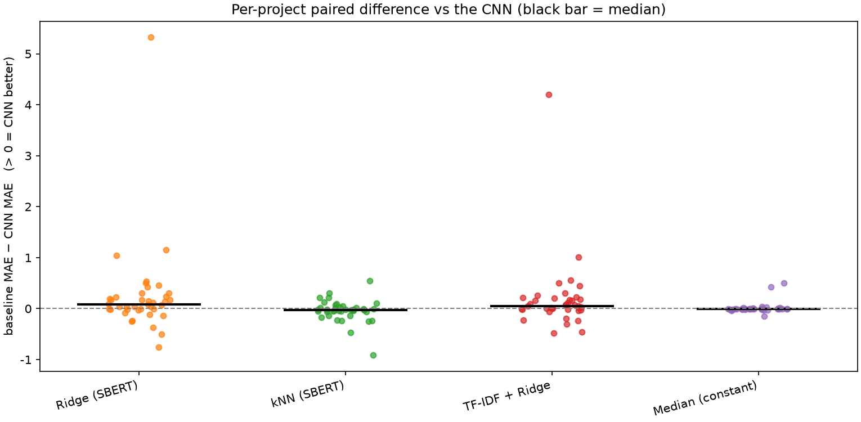
Figure 3. Per-project paired difference between each baseline's test MAE and the CNN's (positive = CNN better; black bar = median).

5.4 Behaviour of the predictions
The pooled actual-versus-predicted plots (Appendix B, Figure B1) show that all models predict in a narrow low range while actual story points reach 100: large values are systematically under-predicted. The CNN's predictions occupy an even narrower band than those of the other models, close to the median predictor's horizontal line. The pooled MdAE of the median predictor and of kNN is 1.00, but 1.50 for the CNN; this is probably because constant or neighbour-median predictions coincide exactly with commonly used discrete story point values, whereas continuous CNN outputs rarely do (an interpretation we did not test). On projects with the largest errors (atlassian_jira_server, moodle, appcelerator_daemon, lsstcorp_data_management, atlassian_clover) all models perform alike or poorly: these projects contain a few very large story points that no model predicts. For ridge and TF-IDF the squared-error objective is a likely contributor to their poor results on such heavy-tailed targets (for example moodle: ridge 10.8, TF-IDF + ridge 9.7, median predictor 6.0). The selected kNN neighbourhood was k = 50, the largest value in the grid, for 22 of 39 projects, i.e. the kNN works best when it averages heavily towards a local median.
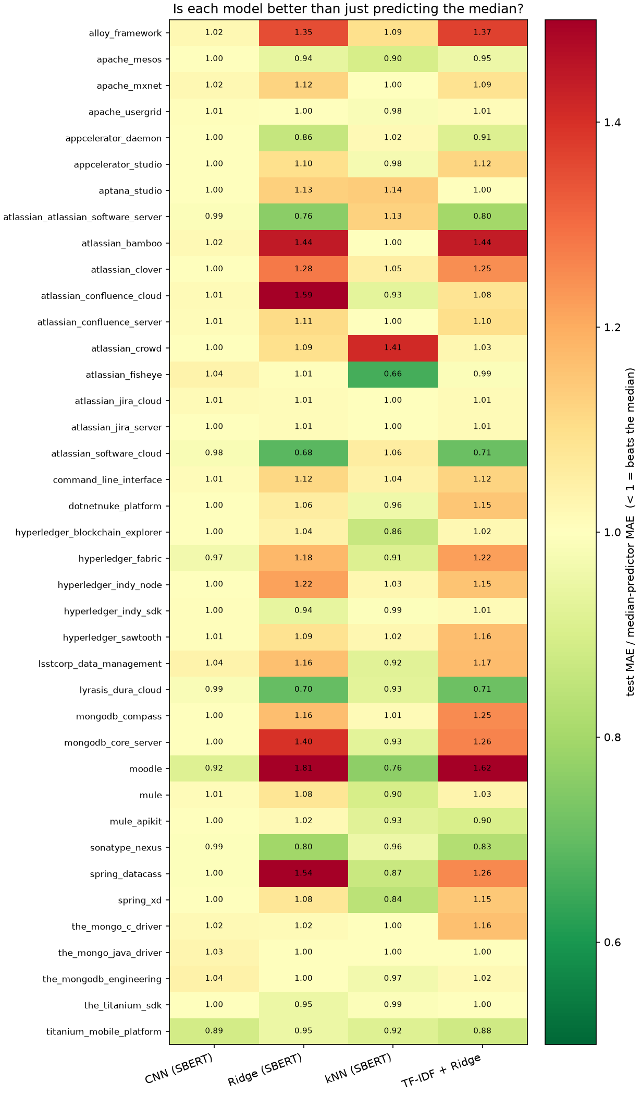
Figure 4. Test MAE of each model divided by the median predictor's test MAE, per project (green, below 1: better than predicting the median).

6. Discussion

6.1 Which representation and model achieve the lowest MAE and MdAE?
Among the models studied here, kNN on SBERT embeddings has the lowest macro test MAE (1.817) and MdAE (1.244), the best mean rank and the most project wins; it is also best on validation data. Its advantage over the median predictor is small (about 2.9% in MAE) and, relative to the CNN, not statistically significant. The assigned CNN (SBERT) ranks second on test MAE but is third on validation MAE, behind the median predictor, so its position relative to a constant prediction is within noise.
Representation | Model configuration | MAE | MdAE
SBERT sentence embeddings | 3-layer CNN (assigned model), temporal within-project, macro test | 1.857 | 1.395
SBERT sentence embeddings | kNN on SBERT vectors (additional baseline) | 1.817 | 1.244

Table 9. Comparison across representations

6.2 Possible explanations
The following are hypotheses consistent with the results; none was tested in this study.
- Weak textual signal. Story points are subjective, team-specific and noisy. If similar texts are not reliably assigned similar values, no text model can beat the median by much. The small gain of a heavily smoothed kNN (k = 50) is consistent with this.
- Small data per project. Median project size is about 350 issues (about 280 for development); many validation folds contain only a few dozen issues.
- CNN suitability and training budget. The embedding dimensions have no natural order, so convolution followed by global average pooling is a weak fit and may discard dimension-specific information; and most fold runs (122 of 195) used a short fixed budget. An MLP on the same vectors (supported by the code, not run) and a longer training budget would be natural ablations. Note that on the three projects with the largest test sets (lsstcorp_data_management, the_mongodb_engineering, mule), whose final epoch count came from early-stopped folds, the CNN was still no better than the median predictor, while kNN was.
- Heavy-tailed targets and temporal drift. A few very large story points dominate MAE in several projects, and the newest 20% of a project may differ from its history. Test MAE was lower than validation MAE for most models (for the CNN 1.966 to 1.857), i.e. the held-out windows were not systematically harder than the validation folds.

6.3 Limitations and threats to validity
- Single seed and no confidence intervals. Every number comes from one run (seed 42). Differences of a few hundredths of a story point, including CNN versus median, are within plausible run-to-run and sampling variation.
- Small test sets. The median project has 71 test issues; 4 projects have fewer than 30 (apache_mxnet only 4). Macro averages treat all projects equally, while pooled values are dominated by lsstcorp_data_management (2,290 test issues).
- Filtering choices. Any non-empty Resolution was accepted, which includes values such as Won't Fix, Duplicate, Invalid and Cannot Reproduce (5,059 of the 59,785 issues with a non-empty Resolution, counted before the later filters). Such issues may carry estimates that were never validated by completed work, and duplicates may have near-identical text. The filter on changed descriptions removed no additional issues after the title filter; we did not verify whether that flag is populated in the extracted data. Story points below 1 were dropped. These choices bias the sample towards well-documented, stable issues.
- No duplicate or near-duplicate check between development and test texts was performed; cloned issues could inflate scores (for all models alike).
- Rolling validation adapts the guidelines. The first folds train on only about one sixth of the development data; fold scores are noisy and not directly comparable across folds.
- Training protocol. 122 of 195 fold runs used a fixed epoch budget instead of early stopping; the learning-rate grid has two values; the kNN grid is bounded at k = 50 (selected in 22 projects), so its best value may lie outside the grid.
- Representation limits. all-MiniLM-L6-v2 truncates input at 256 word pieces; only title and description were used (no issue type, priority, components or author information).
- Generalisation. Results concern TAWOS, within-project estimation only, and are not evidence about cross-project settings or other datasets.

7. Conclusions
Within-project, chronologically split story point estimation from SBERT sentence embeddings is hard. The assigned SBERT + CNN model reached a macro test MAE of 1.857 and MdAE of 1.395 over 39 projects, which is only 0.8% below a constant median predictor in MAE; the median predictor had the lower MAE in 29 of 39 projects and the two are practically indistinguishable (within 2% in 30 projects). A simple kNN on the same embeddings was the most accurate model (MAE 1.817, MdAE 1.244), but its gain over the median predictor is also modest. Ridge regression on SBERT vectors and TF-IDF + ridge were worse than the median predictor. We therefore claim only that SBERT sentence embeddings carry a small amount of usable signal for story points in TAWOS, and we do not claim that the CNN improves on a constant prediction.
Future work that would test the explanations in Section 6.2: an MLP ablation and a longer training budget; several seeds with bootstrap confidence intervals; restricting Resolution to completed issues and checking duplicates; adding issue metadata (type, priority, components); and the comparison with BERT word and combined embeddings on the same partitions.

8. Reproducibility
The repository contains the extraction script, the configuration file (model names, hyper-parameters, seed, split settings), the code for preprocessing, embedding extraction, split creation, validation, test evaluation, baselines, aggregation and plotting, and all result tables and plots. A single command, python run_all.py, runs every stage in order; python -m src.predict --project <slug> --title ... --description ... predicts the story points of a new issue with a saved project model. The random seed is 42; split manifests are stored for reuse by the PS-2 and PS-10 groups.

Appendix A. Per-project results
Project | n dev | n test | Val MAE (mean ± SD) | Val MdAE (mean ± SD) | Test MAE | Test MdAE | Median MAE | kNN MAE | lr | Epochs
alloy_framework | 164 | 41 | 1.30 ± 0.41 | 1.60 ± 0.50 | 1.32 | 1.95 | 1.29 | 1.41 | 0.0003 | 30
apache_mesos | 1,606 | 402 | 1.30 ± 0.12 | 0.88 ± 0.07 | 1.30 | 1.01 | 1.30 | 1.16 | 0.0003 | 17
apache_mxnet * | 16 | 4 | 2.43 ± 1.70 | 2.60 ± 1.68 | 1.79 | 1.07 | 1.75 | 1.75 | 0.0003 | 30
apache_usergrid | 203 | 51 | 0.87 ± 0.07 | 0.71 ± 0.45 | 1.28 | 1.02 | 1.27 | 1.25 | 0.001 | 30
appcelerator_daemon | 138 | 35 | 5.10 ± 2.82 | 2.65 ± 0.64 | 5.41 | 3.01 | 5.40 | 5.49 | 0.001 | 30
appcelerator_studio | 1,798 | 449 | 2.15 ± 1.30 | 2.56 ± 1.25 | 1.48 | 2.00 | 1.48 | 1.45 | 0.001 | 63
aptana_studio | 361 | 90 | 5.18 ± 0.80 | 3.92 ± 1.57 | 3.88 | 2.95 | 3.88 | 4.42 | 0.001 | 12
atlassian_atlassian_software_server | 169 | 42 | 1.98 ± 0.80 | 1.41 ± 0.50 | 1.56 | 0.97 | 1.57 | 1.77 | 0.0003 | 30
atlassian_bamboo | 283 | 71 | 1.18 ± 0.52 | 1.19 ± 0.41 | 0.73 | 0.99 | 0.72 | 0.72 | 0.001 | 45
atlassian_clover | 215 | 54 | 4.28 ± 3.62 | 2.00 ± 2.21 | 4.12 | 1.05 | 4.11 | 4.33 | 0.001 | 30
atlassian_confluence_cloud | 186 | 46 | 1.42 ± 0.47 | 1.20 ± 0.38 | 0.79 | 0.86 | 0.78 | 0.73 | 0.001 | 30
atlassian_confluence_server | 259 | 65 | 1.04 ± 0.23 | 1.01 ± 0.04 | 0.95 | 1.01 | 0.94 | 0.94 | 0.001 | 64
atlassian_crowd * | 91 | 23 | 0.80 ± 0.17 | 0.89 ± 0.22 | 0.74 | 0.99 | 0.74 | 1.04 | 0.0003 | 30
atlassian_fisheye * | 66 | 17 | 0.83 ± 0.17 | 0.92 ± 0.19 | 0.67 | 0.97 | 0.65 | 0.43 | 0.001 | 30
atlassian_jira_cloud | 251 | 63 | 1.17 ± 0.12 | 0.62 ± 0.89 | 1.22 | 0.03 | 1.21 | 1.21 | 0.001 | 32
atlassian_jira_server | 218 | 55 | 1.27 ± 0.25 | 0.43 ± 0.89 | 6.06 | 0.03 | 6.05 | 6.07 | 0.001 | 30
atlassian_software_cloud | 150 | 37 | 1.77 ± 0.59 | 1.41 ± 0.50 | 1.67 | 0.95 | 1.70 | 1.80 | 0.001 | 30
command_line_interface | 205 | 51 | 1.63 ± 0.25 | 1.76 ± 0.34 | 1.65 | 1.96 | 1.63 | 1.70 | 0.0003 | 30
dotnetnuke_platform | 1,477 | 369 | 1.08 ± 0.46 | 0.46 ± 0.46 | 0.64 | 1.00 | 0.64 | 0.61 | 0.001 | 59
hyperledger_blockchain_explorer | 186 | 47 | 1.25 ± 0.33 | 0.62 ± 0.52 | 1.02 | 0.99 | 1.02 | 0.88 | 0.001 | 30
hyperledger_fabric | 352 | 88 | 1.28 ± 0.31 | 0.92 ± 0.17 | 0.87 | 0.75 | 0.90 | 0.82 | 0.001 | 53
hyperledger_indy_node | 295 | 74 | 1.16 ± 0.21 | 1.01 ± 0.69 | 1.07 | 0.99 | 1.07 | 1.09 | 0.001 | 37
hyperledger_indy_sdk | 323 | 81 | 1.22 ± 0.45 | 1.19 ± 0.45 | 1.79 | 1.96 | 1.78 | 1.77 | 0.001 | 20
hyperledger_sawtooth | 513 | 128 | 0.96 ± 0.26 | 0.98 ± 0.05 | 0.99 | 1.02 | 0.98 | 1.01 | 0.001 | 7
lsstcorp_data_management | 9,158 | 2,290 | 5.03 ± 0.63 | 1.93 ± 0.26 | 4.36 | 2.23 | 4.21 | 3.90 | 0.001 | 32
lyrasis_dura_cloud | 386 | 97 | 0.73 ± 0.26 | 0.17 ± 0.28 | 0.86 | 0.95 | 0.88 | 0.81 | 0.0003 | 94
mongodb_compass | 291 | 73 | 1.20 ± 0.30 | 1.21 ± 0.81 | 1.04 | 0.99 | 1.04 | 1.05 | 0.001 | 35
mongodb_core_server | 422 | 105 | 1.38 ± 0.46 | 1.02 ± 0.04 | 0.77 | 1.00 | 0.77 | 0.71 | 0.001 | 72
moodle | 643 | 161 | 7.96 ± 1.55 | 5.20 ± 0.45 | 5.46 | 6.40 | 5.96 | 4.55 | 0.001 | 25
mule | 2,032 | 508 | 2.74 ± 0.16 | 2.98 ± 0.02 | 2.11 | 2.03 | 2.09 | 1.88 | 0.001 | 17
mule_apikit | 260 | 65 | 1.77 ± 0.61 | 1.98 ± 0.68 | 2.28 | 1.95 | 2.28 | 2.11 | 0.001 | 11
sonatype_nexus | 711 | 178 | 0.77 ± 0.23 | 0.21 ± 0.44 | 1.16 | 0.97 | 1.17 | 1.12 | 0.001 | 7
spring_datacass | 134 | 34 | 3.89 ± 2.52 | 2.61 ± 1.31 | 1.90 | 1.97 | 1.91 | 1.66 | 0.001 | 30
spring_xd | 1,684 | 421 | 2.03 ± 0.81 | 1.29 ± 0.42 | 1.49 | 1.99 | 1.49 | 1.26 | 0.001 | 12
the_mongo_c_driver * | 102 | 25 | 0.33 ± 0.37 | 0.04 ± 0.01 | 0.53 | 0.04 | 0.52 | 0.52 | 0.001 | 30
the_mongo_java_driver | 155 | 39 | 0.03 ± 0.01 | 0.03 ± 0.01 | 0.55 | 0.02 | 0.54 | 0.54 | 0.001 | 30
the_mongodb_engineering | 3,362 | 840 | 0.75 ± 0.10 | 0.62 ± 0.19 | 0.77 | 0.66 | 0.74 | 0.72 | 0.001 | 60
the_titanium_sdk | 1,998 | 499 | 2.58 ± 0.86 | 1.98 ± 0.04 | 2.68 | 2.00 | 2.68 | 2.65 | 0.001 | 7
titanium_mobile_platform | 806 | 201 | 2.85 ± 0.65 | 1.85 ± 0.30 | 3.45 | 1.68 | 3.88 | 3.55 | 0.001 | 72

Table A1. CNN validation (mean ± SD over the five folds, selected learning rate) and test results per project, with the median predictor and kNN test MAE for reference. * = fewer than 30 test issues. 'Epochs' = epochs used for the final retraining.

Appendix B. Additional figures
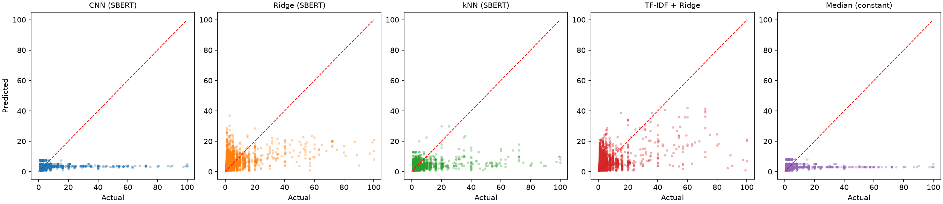
Figure B1. Actual versus predicted story points on the held-out test sets, all projects pooled, per model (dashed red line = perfect prediction).
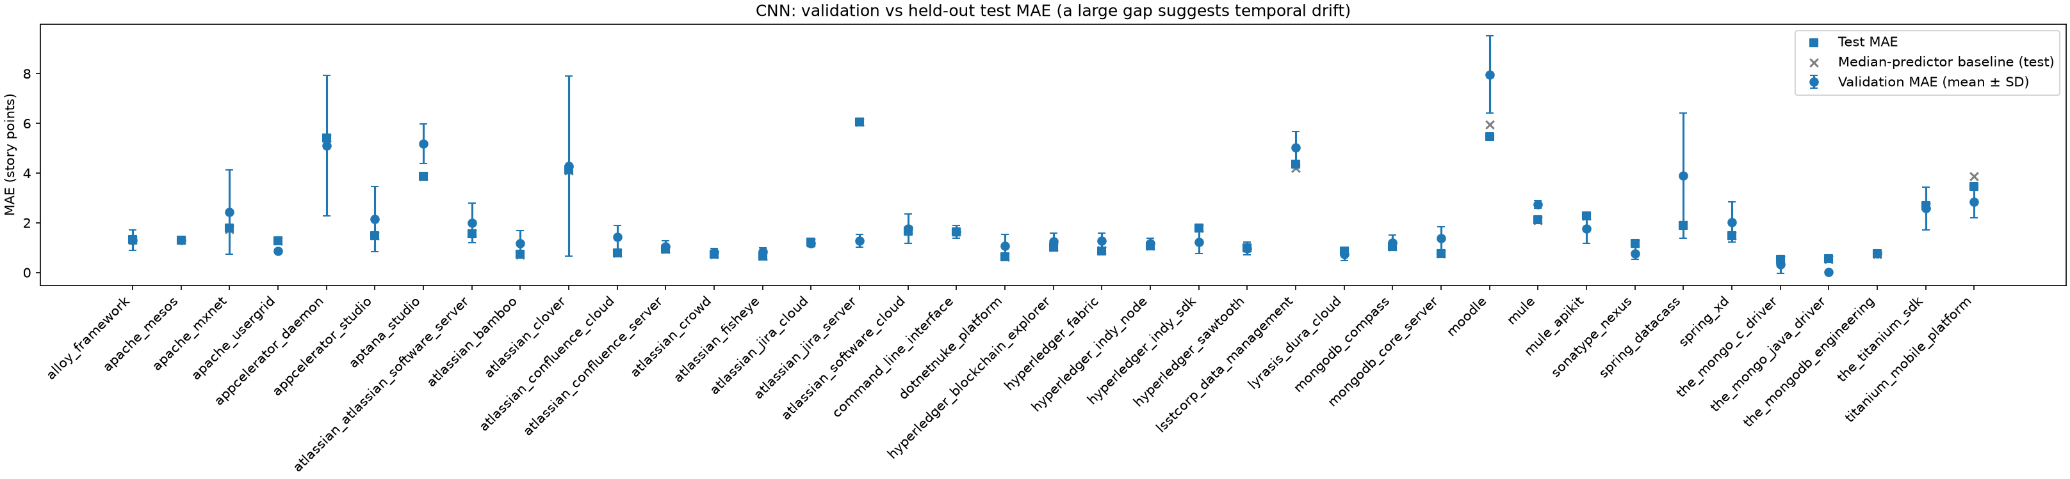
Figure B2. CNN validation MAE (mean ± SD over folds) versus held-out test MAE per project, with the median predictor's test MAE.

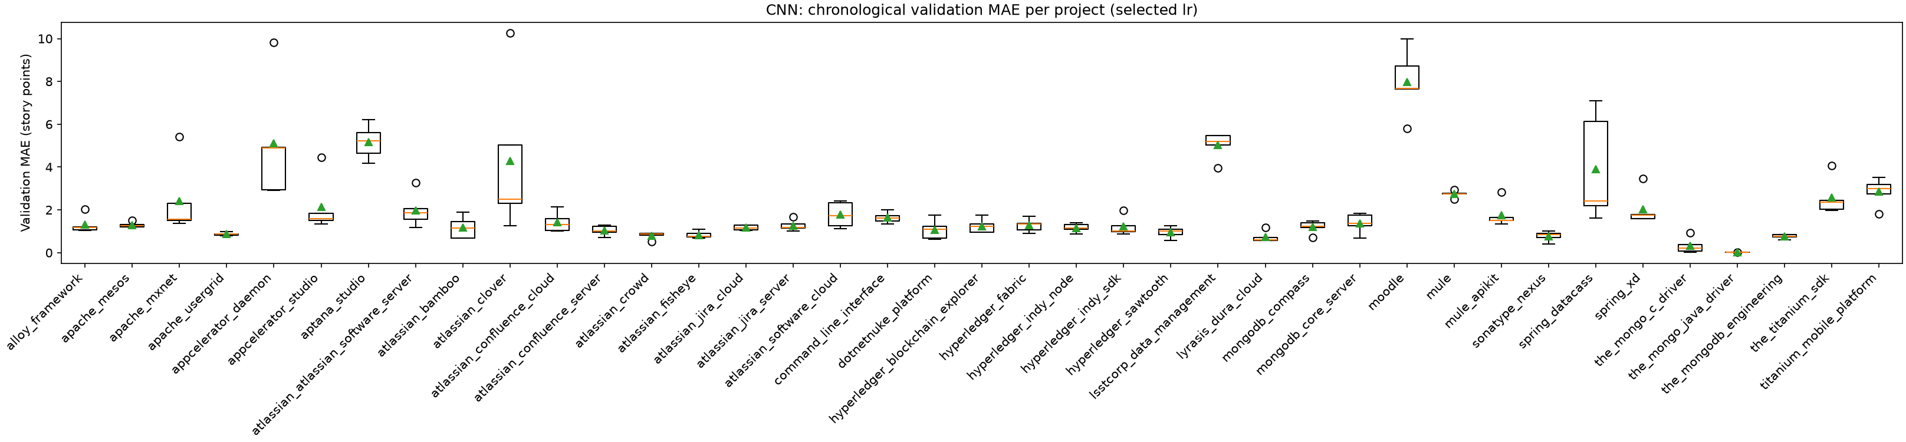
Figure B3. Distribution of CNN validation MAE over the five folds, per project (triangle = mean).
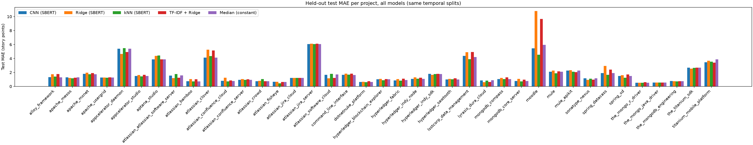
Figure B4. Held-out test MAE of every model per project.

