PS-6 Evaluation Report
SBERT + CNN for software-project story-point estimation
Held-out temporal evaluation across 39 projects
Prepared from generated PS-6 results | 03 November 2026
Evaluation scope | Verified value
Projects evaluated | 39
Pooled held-out test issues | 7,919
Validation design | 5 chronological rolling folds; project-specific learning-rate selection
Primary metric | MAE in story points; MdAE as robust companion
Embedding model | sentence-transformers/all-MiniLM-L6-v2
CNN configuration | 3-layer CNN; filters [16, 32, 64]; L1 loss; seed 42

1. Executive summary
PS-6 evaluates whether SBERT sentence embeddings combined with a convolutional neural network (CNN) can estimate software issue story points under a chronological, within-project split. Training uses earlier issues and testing uses later issues, reducing the risk of optimistic random-split estimates.
- CNN held-out macro-MAE: 1.86 story points; macro MdAE: 1.40.
- kNN (SBERT) was best overall at 1.82 macro-MAE; CNN ranked second and was slightly better than the median baseline (1.87).
- CNN beat the median baseline on 10 of 39 projects; kNN beat it on 21.
- Pooled CNN MAE was 2.47, higher than the macro-average, showing that project size and error distribution affect the aggregate.
- Error is heterogeneous: some projects are stable and accurate, while a few show large errors and temporal drift.

Overall conclusion
SBERT representations are useful, but the CNN does not decisively outperform simpler alternatives. kNN using the same SBERT representation is the strongest aggregate performer; the CNN remains competitive with the median baseline. Any deployment should be project-aware, monitored over time, and benchmarked against both baselines.

2. Evaluation design
The pipeline preprocesses project issue data, creates chronological rolling splits, encodes issue text with SBERT, trains/evaluates the CNN, and compares it with baseline models. The experiment log records seed 42, CPU execution, five rolling folds, and the environment versions used.
Component | Implementation
Data unit | Software-project issue/development rows with story-point targets
Temporal protocol | Within-project chronological rolling validation and later held-out test period
Validation | 5 folds per project; 195 total fold-level evaluations
Model selection | Project-specific CNN learning rate from [0.001, 0.0003]
CNN input | Normalized SBERT embeddings from all-MiniLM-L6-v2
Baselines | Median, Ridge (SBERT), kNN (SBERT), TF-IDF + Ridge
Metrics | MAE, MdAE, macro-average by project, pooled test error

3. Aggregate model comparison
Model | Macro MAE | Macro MdAE | Pooled MAE | Project wins | Better than median
kNN (SBERT) | 1.82 | 1.24 | 2.27 | 21 | 21
CNN (SBERT) | 1.86 | 1.40 | 2.47 | 1 | 10
Median (constant) | 1.87 | 1.44 | 2.44 | 14 | ?
TF-IDF + Ridge | 2.04 | 1.40 | 2.75 | 3 | 9
Ridge (SBERT) | 2.10 | 1.51 | 2.77 | 8 | 10
Macro metrics weight projects equally; pooled metrics weight individual test issues equally.
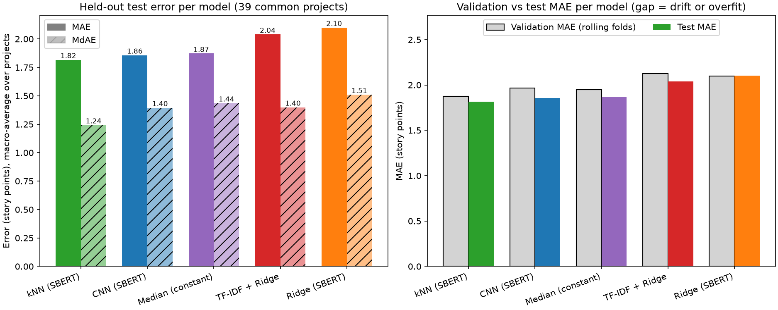
Figure 1. Held-out macro error and validation-to-test comparison for all models.

4. CNN project-level findings
CNN validation averaged 1.97 MAE across projects versus 1.86 on the held-out period. The test macro-MAE standard deviation across projects was 1.47, confirming substantial project-to-project variation.
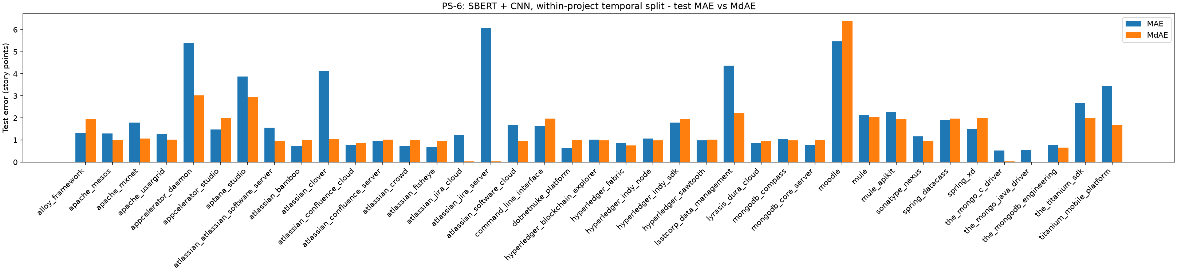
Figure 2. CNN test MAE and MdAE by project.
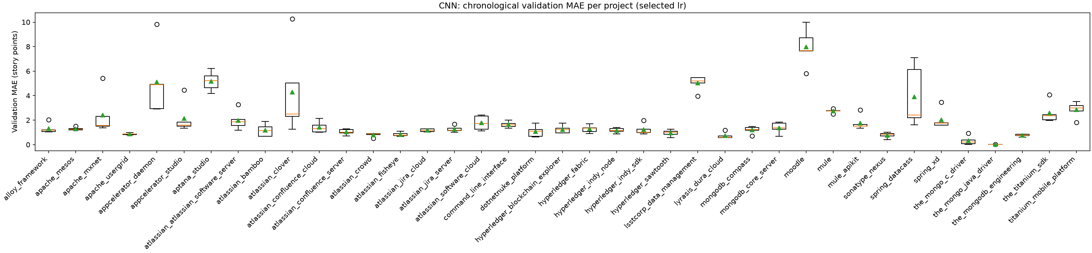
Figure 3. CNN chronological validation MAE distributions.
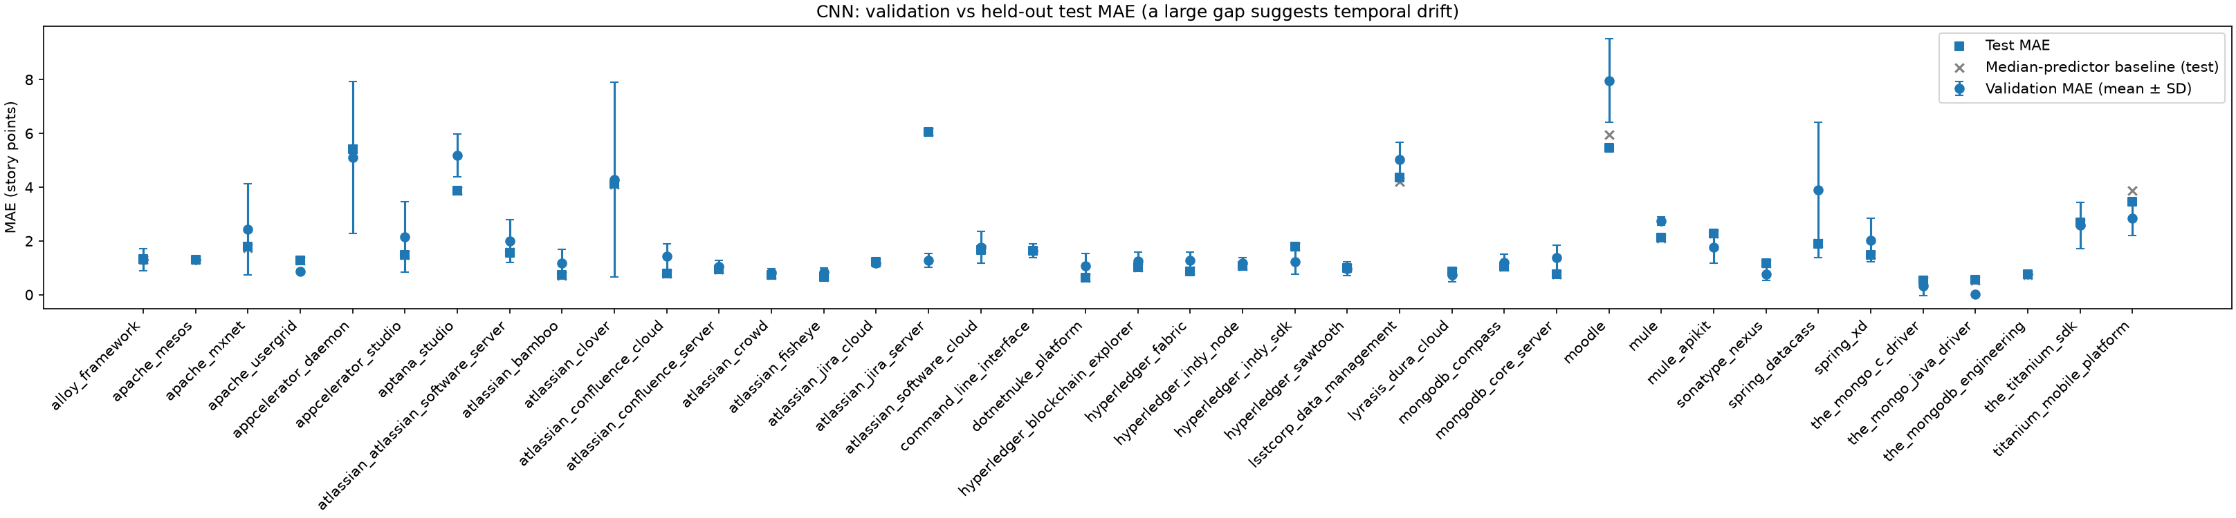
Figure 4. CNN validation versus held-out test MAE; gaps suggest drift or overfit.

5. Error diagnostics and interpretation
- Pooled predictions cluster in a narrow low-to-mid story-point range and track high actual values weakly, indicating regression-to-the-mean and limited calibration for large stories.
- Paired differences are mixed: no alternative dominates the CNN on every project.
- The relative-to-median heatmap shows model choice is project-dependent.
- Projects with wide fold distributions or large validation/test separation deserve data-quality and temporal-drift review.
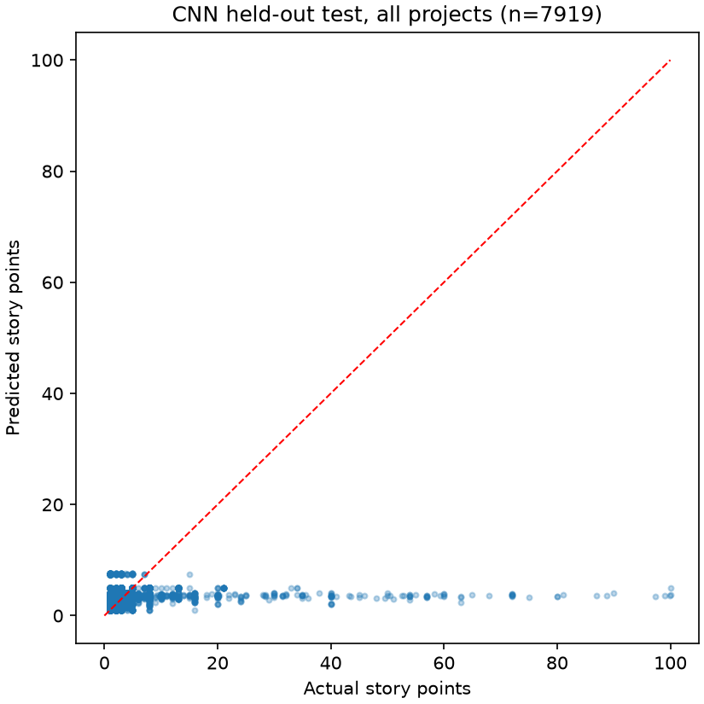
Figure 5. CNN pooled held-out predictions versus actual story points (n=7,919).
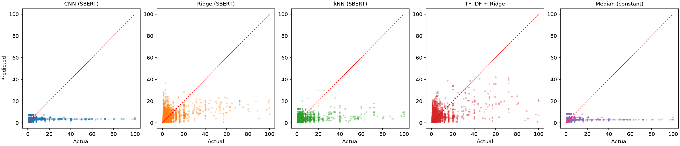
Figure 6. Pooled actual-versus-predicted scatter by model.
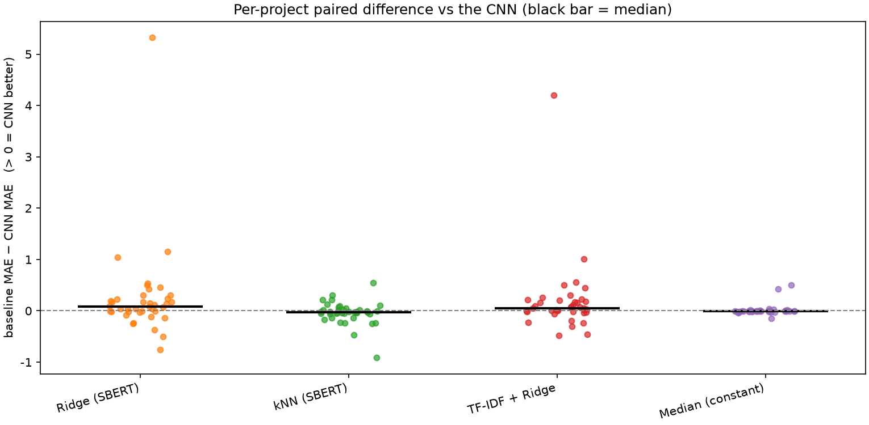
Figure 7. Per-project paired error differences relative to CNN.
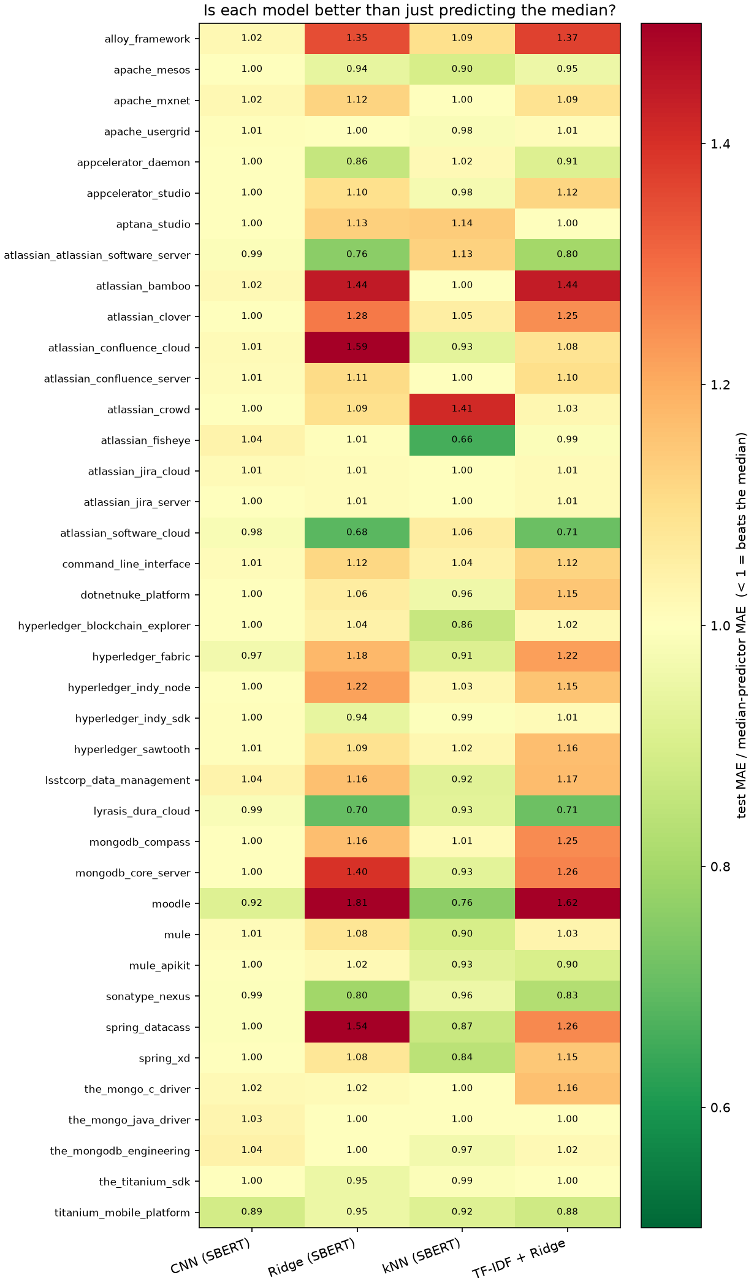
Figure 8. Test MAE relative to the project median baseline; values below 1 indicate improvement.

6. Reliability, limitations, and recommendations
For projects with at least 30 test issues, 35 projects met the reliability threshold. CNN macro-MAE was 1.96; kNN was 1.92; median was 1.98.
- This run uses one seed and one SBERT checkpoint; robustness across seeds and embedding models is not established.
- Temporal performance may change as project processes, teams, or story-point conventions change.
- MAE and MdAE should be monitored together.
- Before deployment, add repeated-seed confidence intervals, drift monitoring, calibration by story-point range, and explicit handling of project-specific label conventions.
- Use the median baseline as mandatory and select a learned model only when improvement is stable across temporal folds.

7. Reproducibility and source artifacts
This report was generated from the project workspace and verified summary artifacts:
- results/summary/aggregate_results.csv ? aggregate metrics
- results/summary/comparative_table.csv ? model ranking and metrics
- results/summary/test_results.csv ? project-level CNN test results
- results/summary/five_fold_summary.csv ? chronological fold summaries
- results/summary/model_comparison_by_project.csv ? project-by-model comparison
- results/experiment_log.csv ? pipeline stages and environment versions
- results/plots/ ? included generated figures
Interpretation note: lower is better for MAE and MdAE. Macro-average values weight projects equally; pooled values weight individual test issues equally.

