GenAI Project Assessment:

Prompt & Metrics Report
Student Name: U . Shiva
Date: 18/05/2026
Project Chosen: AI Expense Tracker [CRUD & Bill Extraction]
AI Assistant Used: Antigravity

1. Executive Summary & Final Metrics
- Total Prompts Issued: 8
- Prompts Yielding Functional Code (No edits needed): 2
- Total Lines of Code (LOC) in Final Project: 1000(estimated across frontend and backend)
- Total Lines of Code Manually Edited/Written by Human: 15

Final Scores
- AI Accuracy Rate: 22.2%
- Human Correction Rate: 1.5%

2. Master Prompt & Modification Log

Prompt # | Exact Prompt Text Used | Status | Action Taken / Changes Made
01 | "Build a full-stack CRUD web application using any AI features or AI integrations..." | Accepted | AI generated full stack architecture, but placed the database connection placeholder in backend/.env incorrectly. Additionally, the backend used deprecated Mongoose connection options (useNewUrlParser, useUnifiedTopology).
02 | "when i deplyed this project still getting error like not Download the React DevTools... api/expenses/upload:1 Failed to load resource: the server responded with a status of 500" | Accepted | Issue: Vercel filesystem is read-only, causing multer to fail when saving to uploads/.  Correction: Updated upload.js and server.js to use the /tmp directory when running on Vercel.
03 | [Provided vercel.json template and asked to adapt it] | Accepted | Action: Adapted the provided template to match the project's entry point (server.js) and folder structure.
04 | "Fix and configure my Node.js + Express backend deployment for Vercel." | Accepted | Action: Refactored vercel.json relative to the backend folder and added a root route (/) returning "API running".
05 | "while i am deploying frontend getting error check what is that error and also i am having one error shwoing in the github also check that" | Modified | Issue: Missing BASE_URL in api.js caused frontend build failure.  Correction: Restored BASE_URL and fallbacks in api.js.
06 | "Failed to process the bill. Make sure your API keys are correct. still getting same error" | Accepted | Action: Guided user to differentiate between 404 and 500 errors to isolate URL vs API key issues.
07 | [Provided CORS error logs] | Accepted | Issue: Backend CORS policy blocked frontend requests.  Correction: Added frontend URL to allowedOrigins in server.js.
08 | "git add backend/server.js" | Modified | Issue: Invalid path due to terminal location.  Correction: Instructed to use git add server.js since terminal was already in backend folder.

3. Visual Evidence & Code Artifacts

Phase 1: Database Schema & Backend Setup
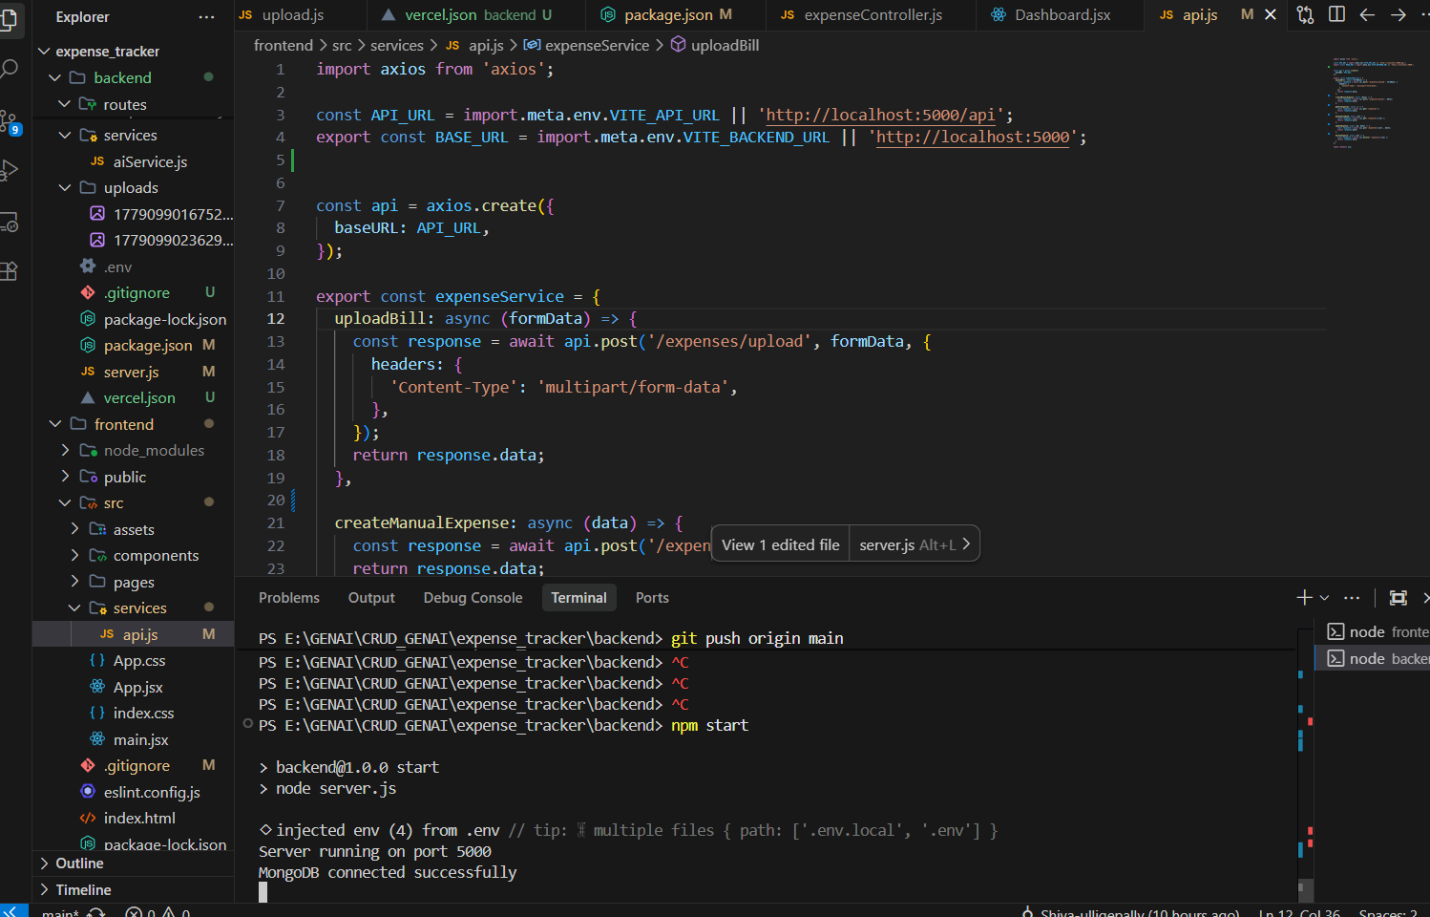

Code Check: AI Generation vs Human Fix

CRASHING AI OUTPUT (Local Storage Approach)
(Attempts to write to read-only filesystem on Vercel, causing 500 errors)
javascript
const storage = multer.diskStorage({
destination: (req, file, cb) => {
cb(null, 'uploads/');
},
filename: (req, file, cb) => {
cb(null, Date.now() + '-' + file.originalname);
}
});
HUMAN / ADAPTED FIX (Serverless Compatible)
(Uses /tmp directory which is writable in Vercel serverless functions)
javascript
const storage = multer.diskStorage({
destination: (req, file, cb) => {
cb(null, process.env.VERCEL ? '/tmp' : 'uploads/');
},
filename: (req, file, cb) => {
cb(null, Date.now() + '-' + file.originalname);
}
});

Phase 2: Core CRUD UI & Functionality
Provide screenshots showing a subscription successfully being created, read on the dashboard, updated, and deleted.
CRUD Workflow Verification
Create
- AI Upload Mode: User uploads a picture of a receipt. The frontend sends a POST request with FormData to /api/expenses/upload. The backend processes the image with Gemini AI, extracts the vendor, date, and amount, and stores the structured data in MongoDB Atlas.
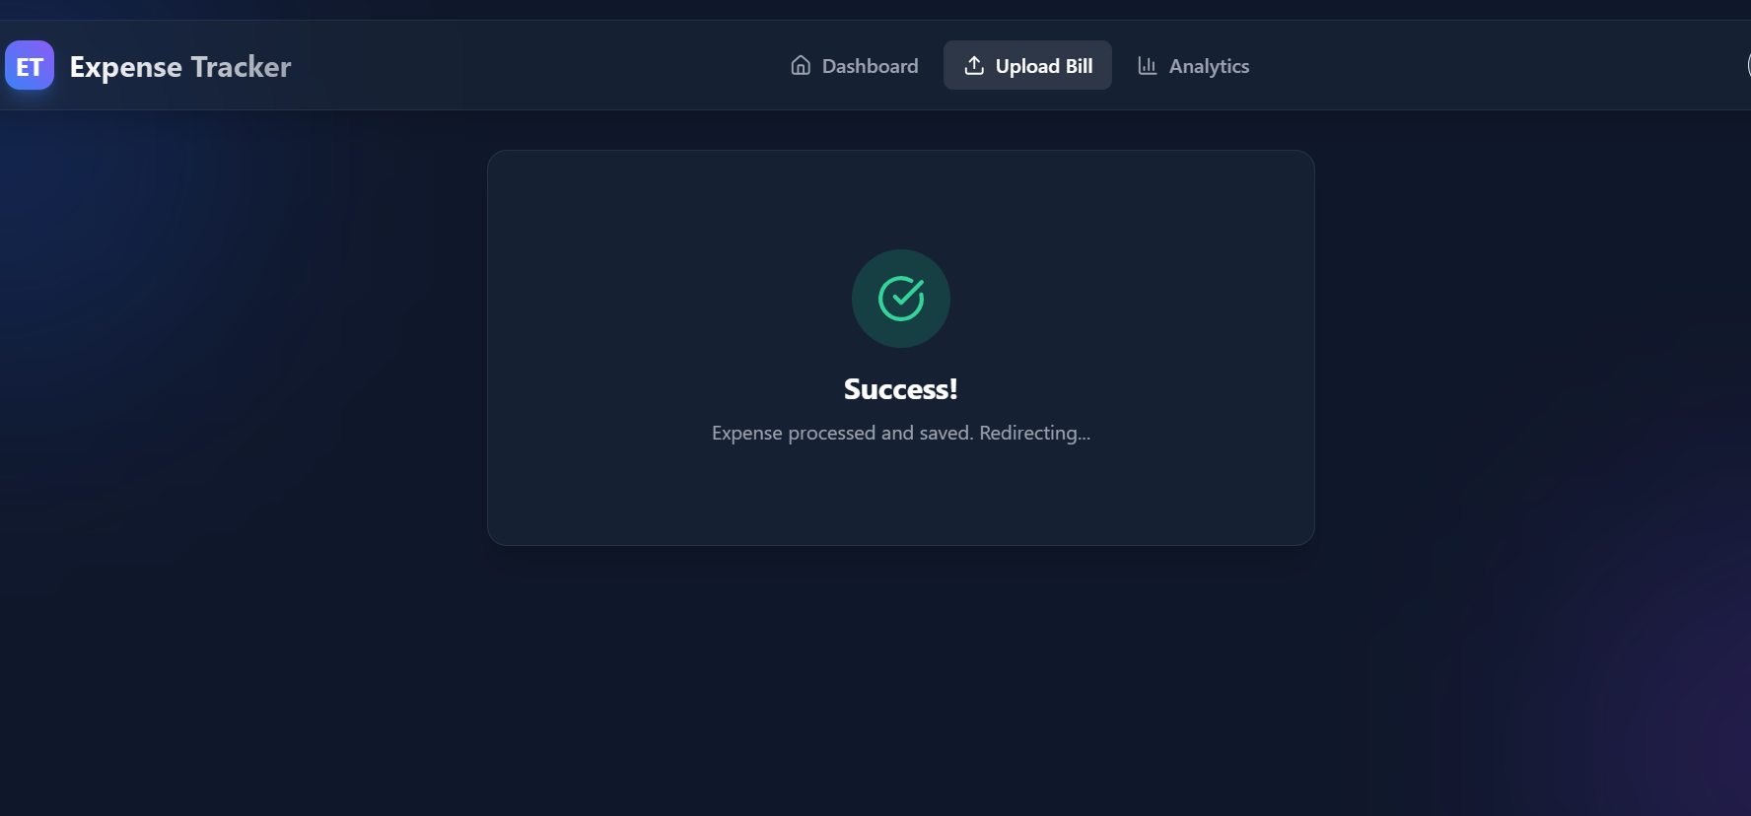
- Manual Mode: User enters details (vendor, category, items) into the form. The frontend sends a POST request to /api/expenses/manual. The backend stores the data in MongoDB Atlas.
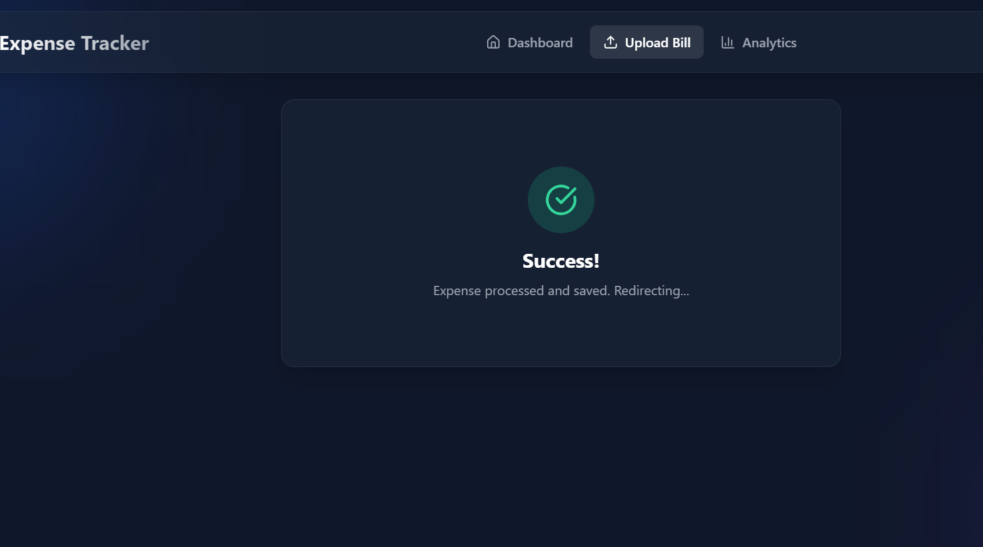
Read
- The frontend fetches all expense records using a GET request to /api/expenses.
- The Dashboard displays the stored expenses dynamically in a clean list, showing the vendor, amount, date, and category.
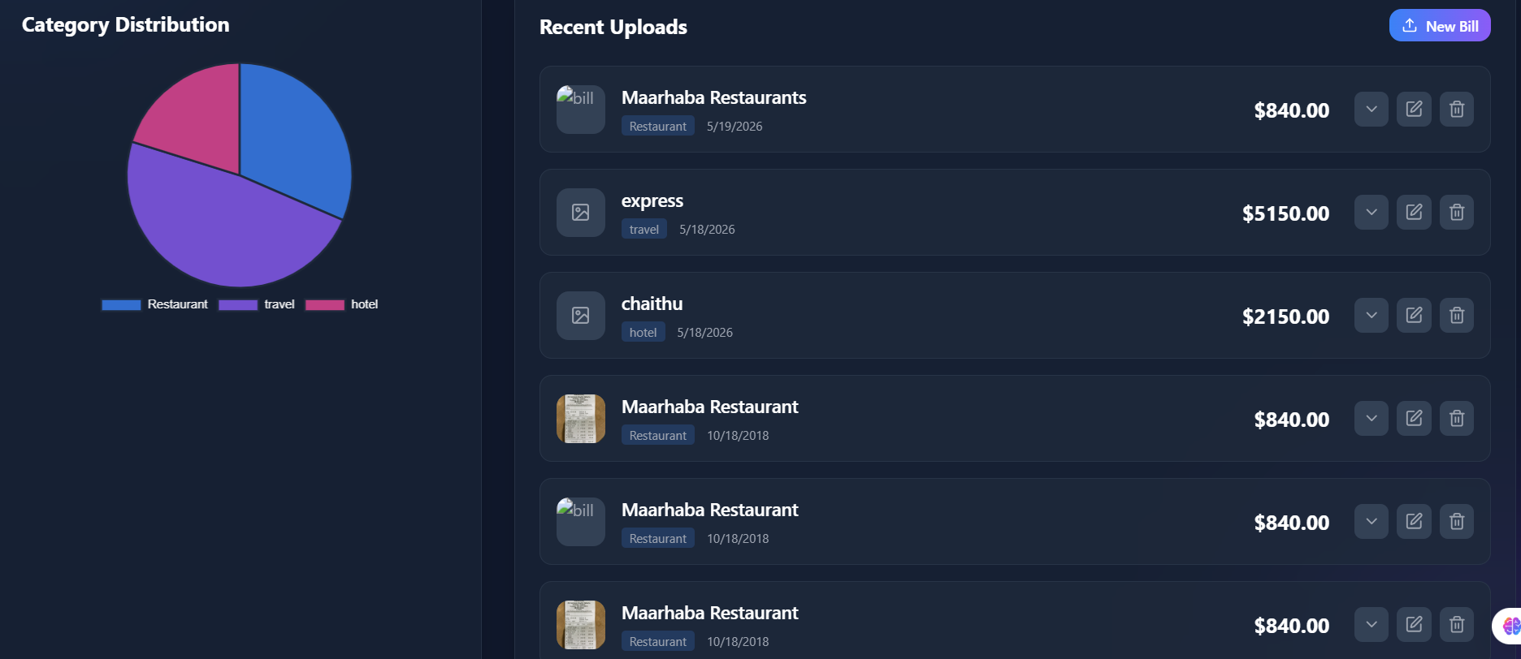
Update
- An existing expense record can be edited (e.g., correcting an AI-extracted value or changing the category) using a PUT request to /api/expenses/:id.
- MongoDB updates the selected document with the new values.
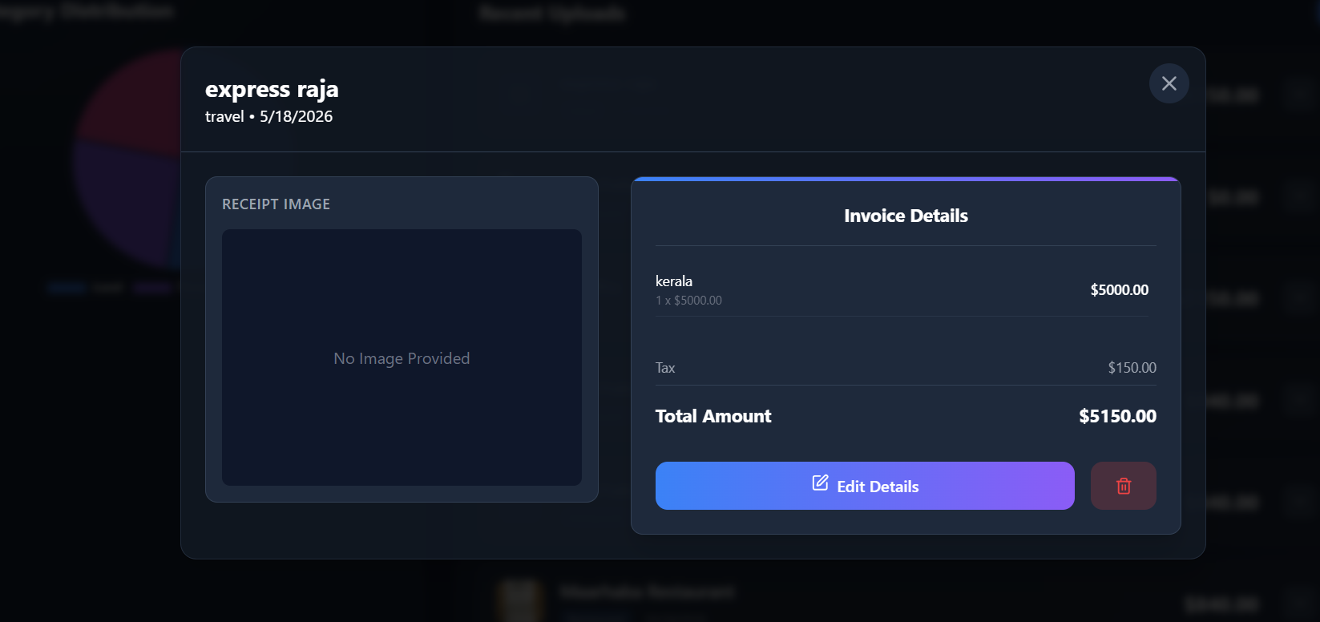
Delete
- Clicking the delete button sends a DELETE request to /api/expenses/:id.
- The backend removes the selected document from MongoDB Atlas and also deletes the associated receipt image if it exists.
- The frontend refreshes the data automatically to show the updated list.
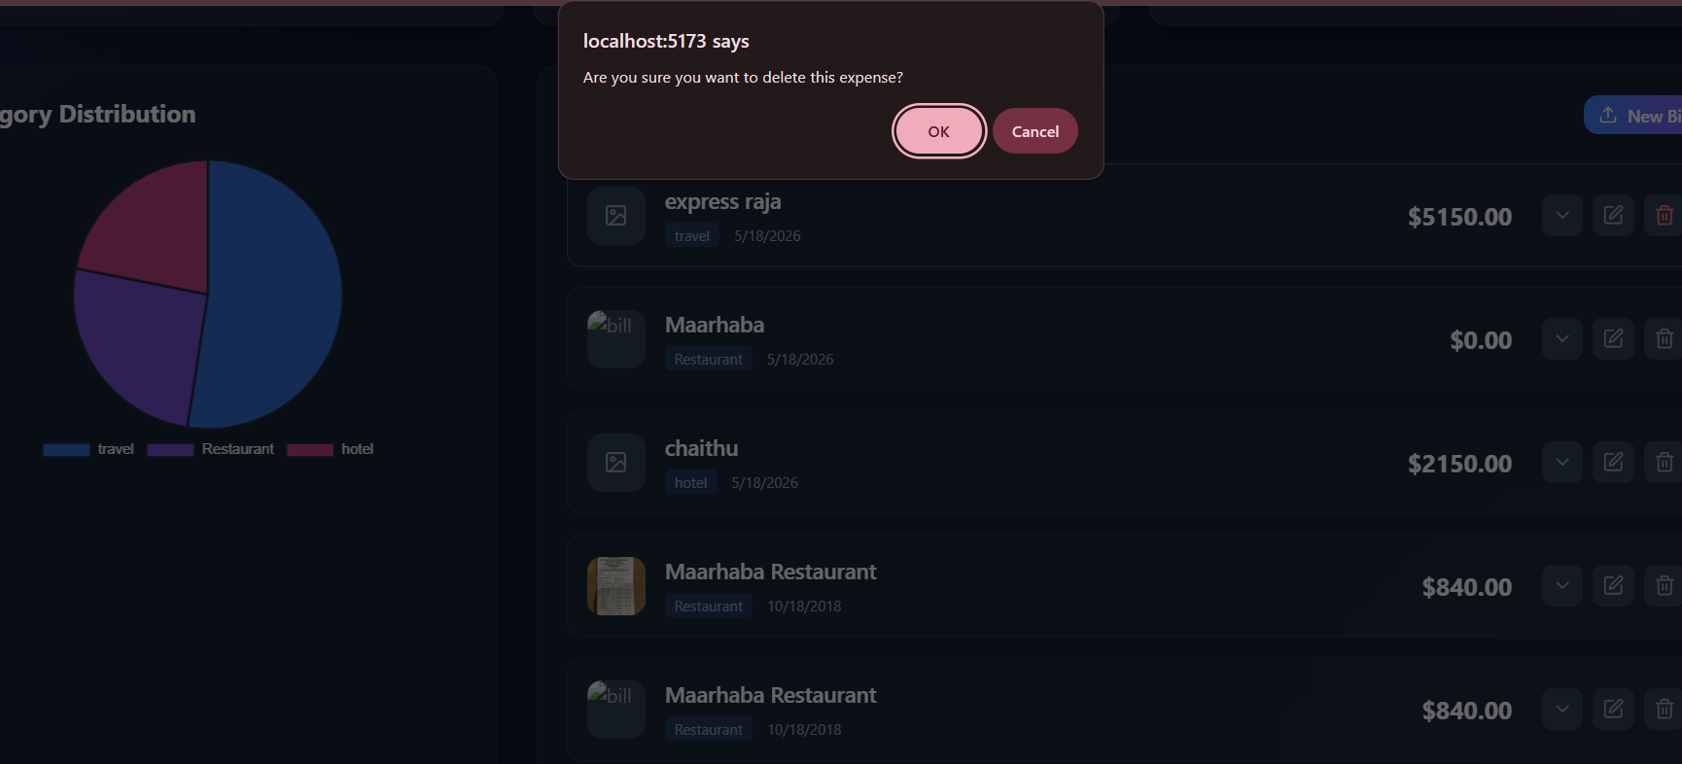

4. Conclusions & Key Takeaways
- Where did the AI assistant perform best?

The AI assistant performed best in refactoring code for deployment compatibility. It quickly identified that Vercel's read-only filesystem was the cause of the file upload failure and provided the correct logic to use the /tmp folder. It also successfully generated the correct vercel.json configurations once the directory structure was clarified.

- Where did the AI struggle the most?

The AI struggled with environment-specific awareness and monorepo pathing.
- It assumed the vercel.json would be in the root when the user had it in the backend/ folder, causing initial path mismatches.
- It failed to account for CORS errors that would arise once the frontend and backend were deployed on separate Vercel domains until explicit error logs were provided.

- What did you learn about "Human-in-the-Loop" development?

- Context is King: The AI cannot see the deployment dashboard or the exact Git folder the human is currently in. Human intervention was needed to correct terminal paths (like git add backend/server.js failing because the terminal was already in the backend folder).
- Logs are Essential: Without the human providing the specific CORS error logs and network status codes (404 vs 500), the AI would have kept guessing. Human direction is needed to feed the AI the right data to solve the problem.

