# INTRODUCTION

Many web platforms and applications perform A/B testing to run experiments to find the best design, layout, or themes for their platform. Instead of relying on assumptions or hunches, applications and websites can test different design variations on real-time users to measure their impact on user behaviour and metrics. By collecting and analyzing the data, they can identify which design elements resonate most with users and optimize their offerings accordingly. So, performing A/B testing to find the best theme on a website using Python.

## **Overview:**

A/B testing is a powerful and widely used [Data Science](https://thecleverprogrammer.com/2022/03/12/data-science-roadmap/) technique to compare and evaluate marketing strategies, designs, layouts, or themes. The primary purpose of A/B testing is to make data-driven decisions that lead to improved user experiences, enhanced performance metrics, and ultimately better business outcomes. Let’s say we have two themes, dark mode and light mode. A company wants to understand which theme looks the best on its website. To understand which theme is better, the company can set a light theme as the default theme of the website for a certain period and collect data on how users interact with the website. Likewise, they can set a dark theme as the default theme for the same period and compare the user interaction data of both themes to find which theme resulted in better user interaction, purchases, signups, longer session duration, and more.

So for the task of A/B testing of themes, we need to have a dataset of user interaction data on two themes or design templates.

## **A/B Testing of Themes using Python:**

Let’s get started with the task of A/B testing of themes by importing the necessary Python libraries and the [dataset](https://statso.io/light-theme-and-dark-theme-case-study/)**.**

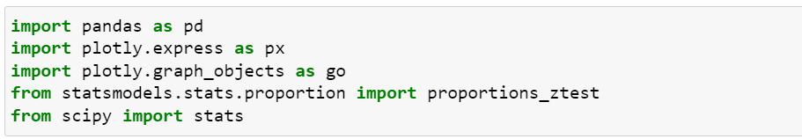

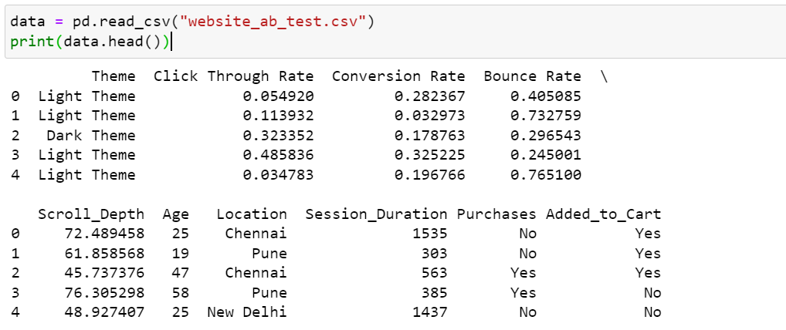

Check the data has null values or not

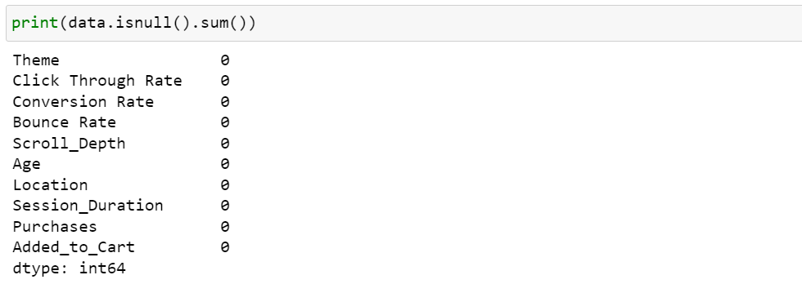

The data doesn’t have null values. Now checking the column insights before moving forward.

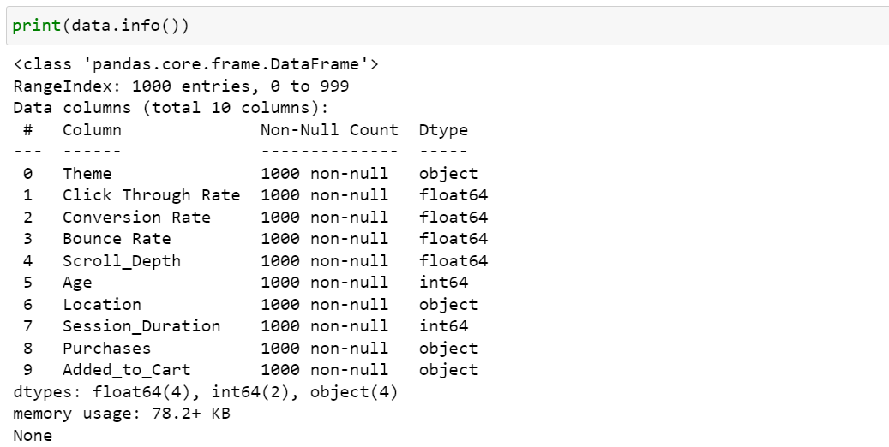

Now let’s have a look at the descriptive statistics of the data

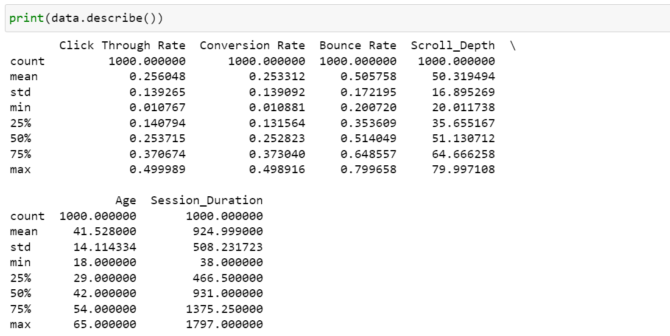

Now before moving forward, here’s the detail of all the columns you should know:

* Theme: dark or light
* Click Through Rate: The proportion of the users who click on links or buttons on the website.
* Conversion Rate: The percentage of users who signed up on the platform after visiting for the first time.
* Bounce Rate: The percentage of users who leave the website without further interaction after visiting a single page.
* Scroll Depth: The depth to which users scroll through the website pages.
* Age: The age of the user.
* Location: The location of the user.
* Session Duration: The duration of the user’s session on the website.
* Purchases: Whether the user purchased the book (Yes/No).
* Added_to_Cart: Whether the user added books to the cart (Yes/No).

So conversion rate in this data means the daily percentage of users who signed up on the website. Let’s have a look at the relationship between CTR and conversion rate of both themes.

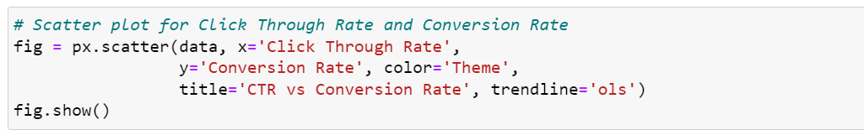



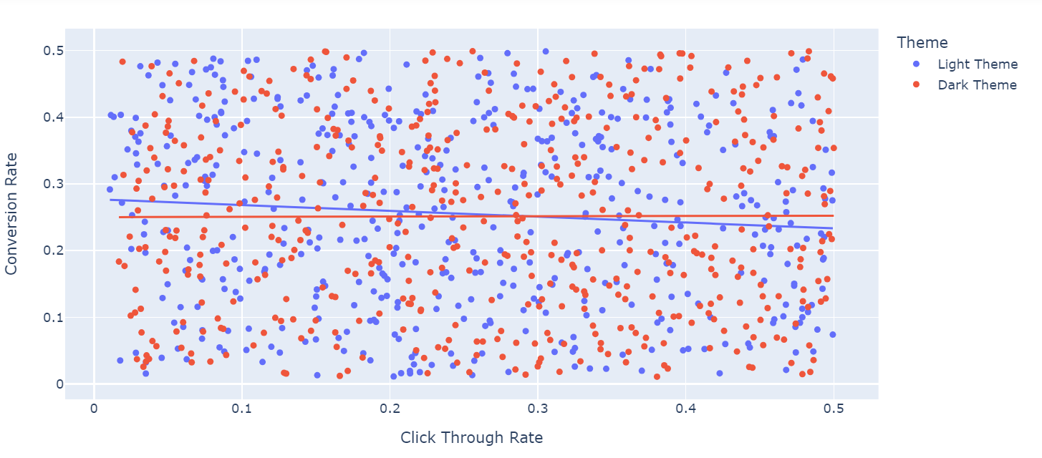

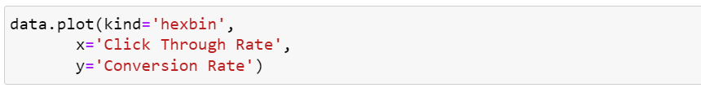

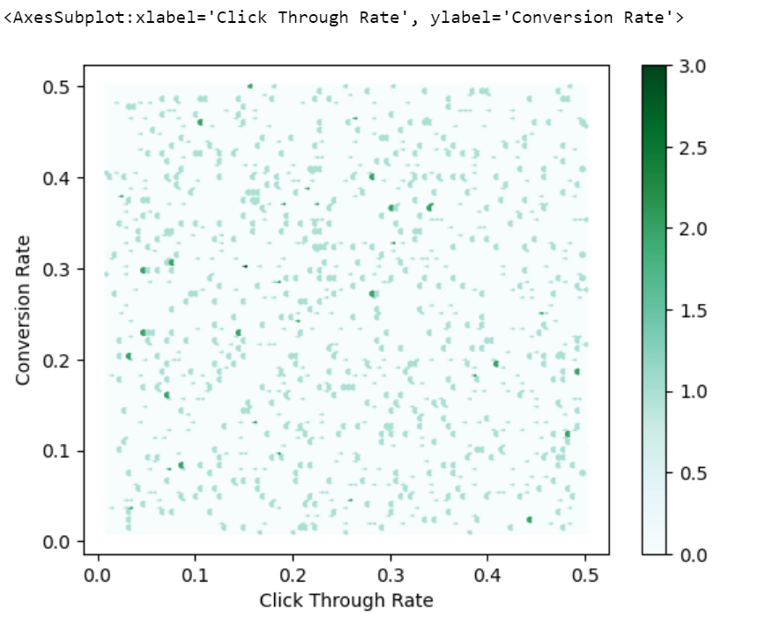

The relationship between the Click Through Rate (CTR) and Conversion Rate is consistent and nearly unchanged, as shown by the scatter plot. It means that as more users click on links or buttons (CTR increases), a similar proportion of them also end up signing up daily (Conversion Rate remains stable). In other words, the percentage of users who take the desired action of signing up remains roughly the same regardless of how many users initially clicked on links or buttons to explore the website.

Now, let’s have a look at the histogram of the CTR of both themes

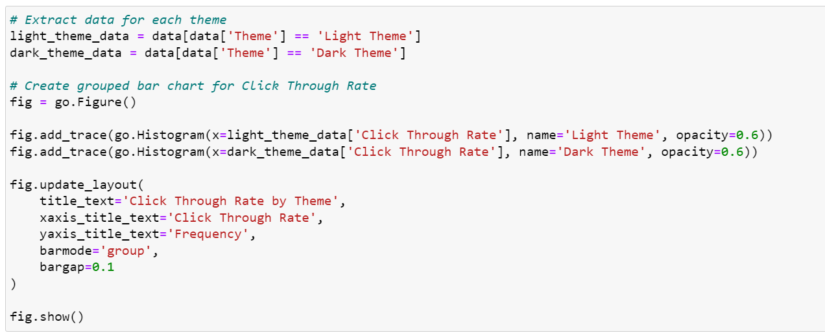



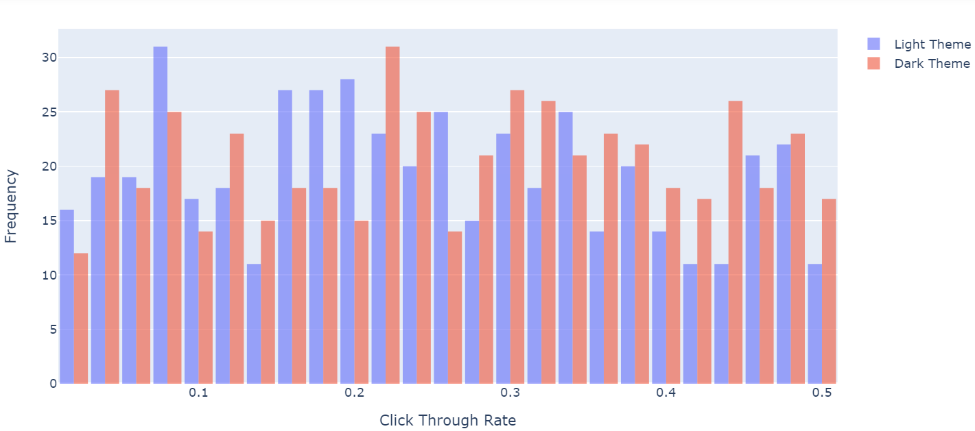

We can see in the above histogram that there’s not much difference between the performance of both themes. Now let’s have a look at the histogram of the conversion rates of both themes.

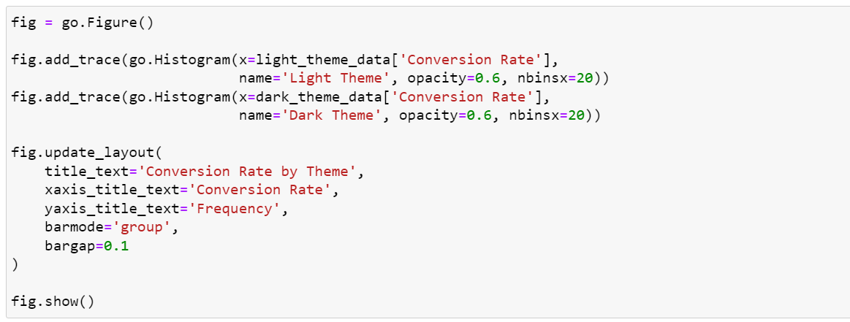



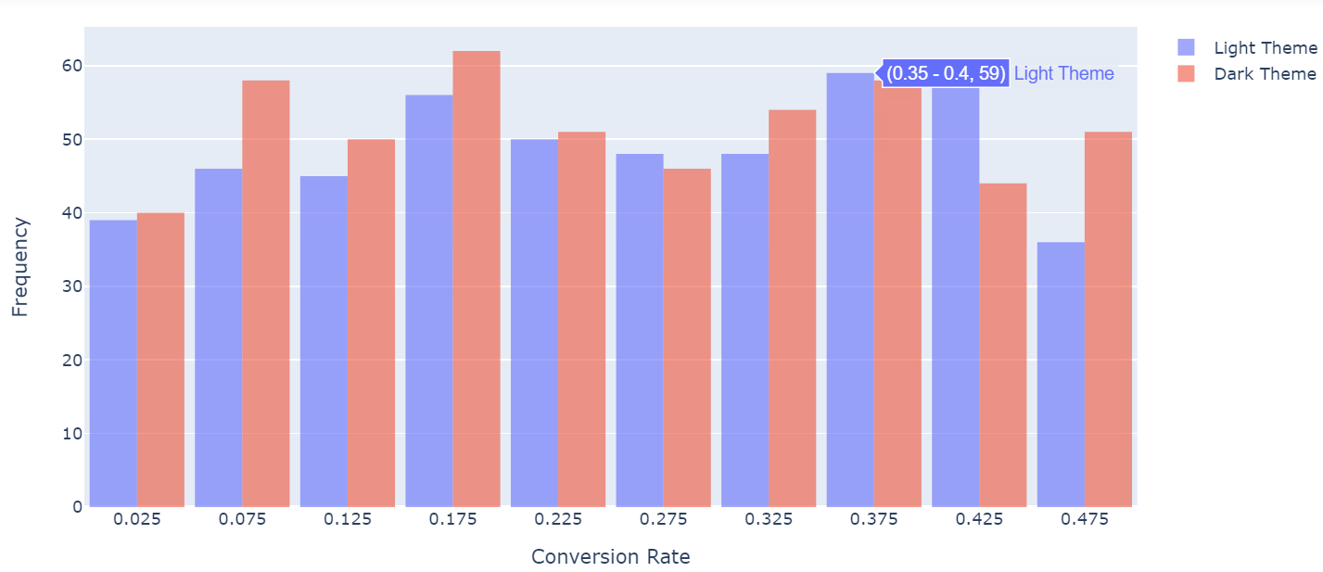

Although there’s not much difference, the conversion rate of the dark theme is slightly better than the light theme. Now let’s have a look at the distribution of the bounce rates of both themes**.**

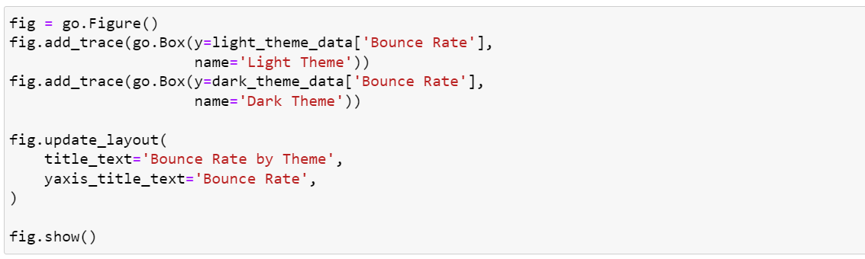

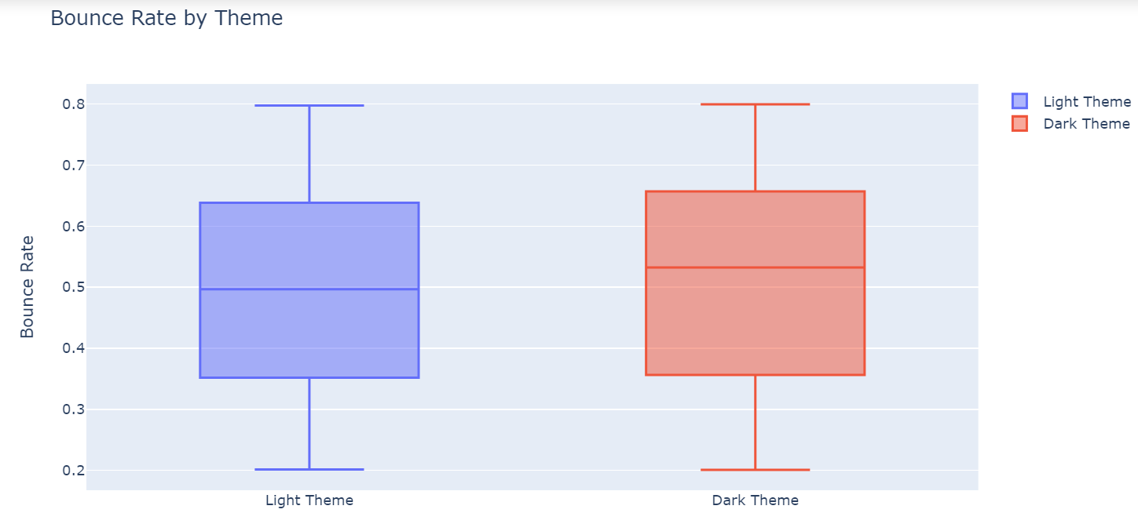

There’s not much difference between the bounce rates of both themes still, the bounce rate of the light theme is slightly lower (which means it’s slightly better). Now let’s have a look at the scroll depth of both themes

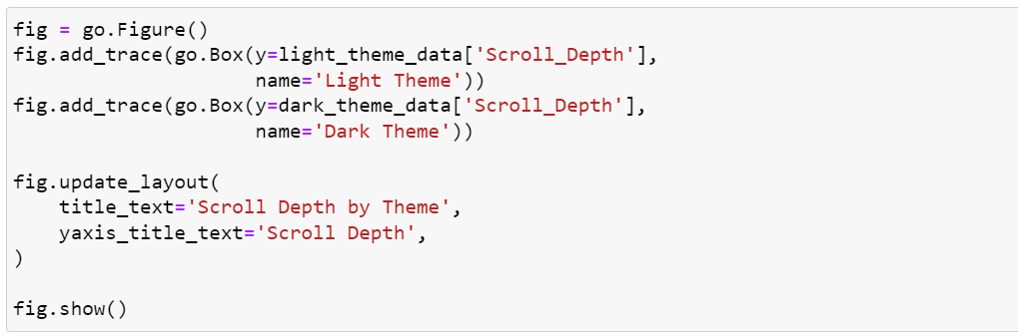

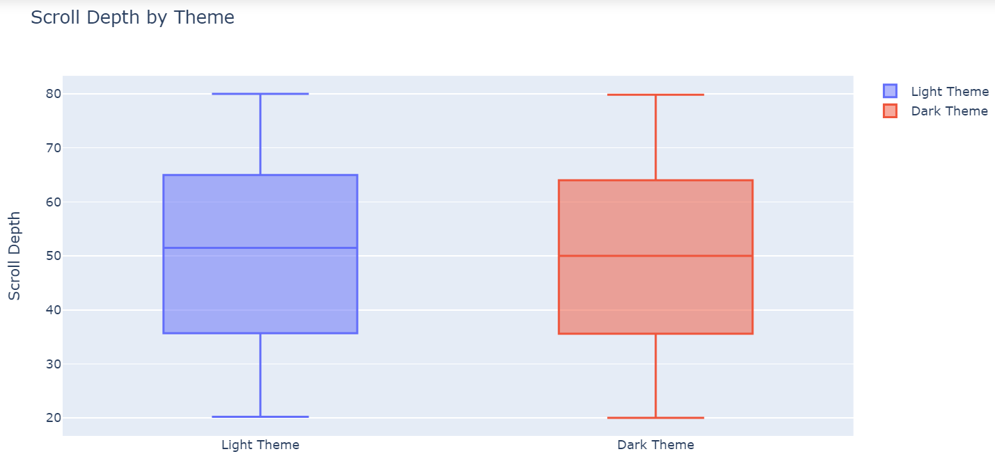

There’s not much difference, but the scroll depth of the light theme is slightly better.

#### **Comparison of Both Themes based on Purchases:**

Now perform a two-sample performance test to compare the purchases from both themes

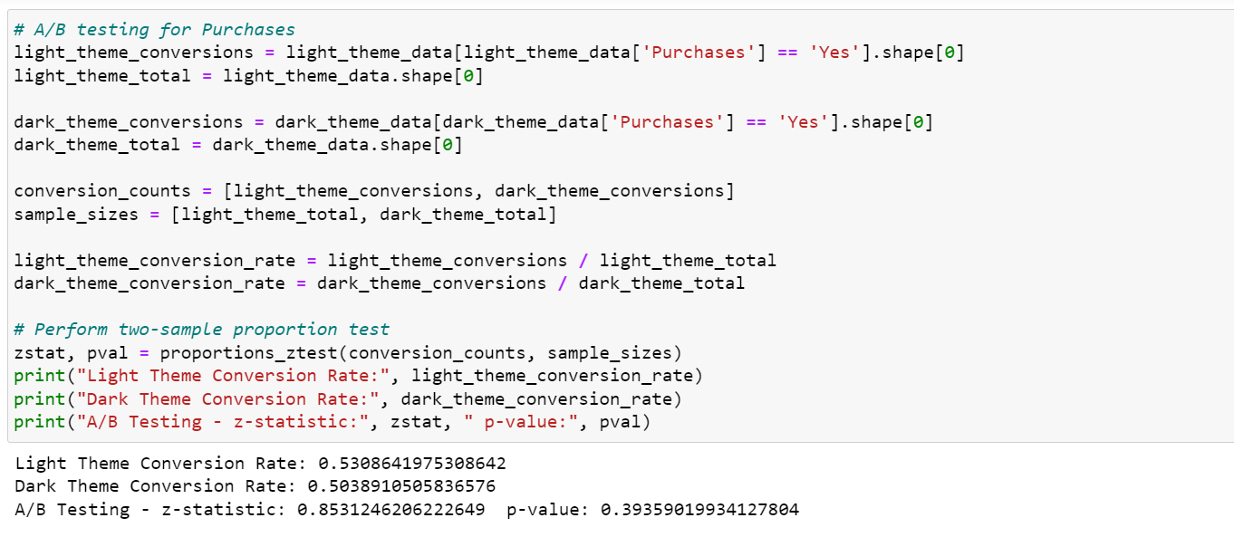

In the comparison of conversion rates based on purchases from both themes, we conducted an A/B test to determine if there is a statistically significant difference in the conversion rates between the two themes. The results of the A/B test are as follows:

* z-statistic: 0.8531
* p-value: 0.3936

The z-statistic measures the difference between the conversion rates of the two themes in terms of standard deviations. In this case, the z-statistic is approximately 0.8531. The positive z-statistic value indicates that the conversion rate of the Light Theme is slightly higher than the conversion rate of the Dark Theme.

The p-value represents the probability of observing the observed difference in conversion rates or a more extreme difference if the null hypothesis is true. The null hypothesis assumes that there is no statistically significant difference in conversion rates between the two themes. In this case, the p-value is approximately 0.3936.

Since the p-value is greater than the typical significance level of 0.05 (commonly used in A/B testing), we do not have enough evidence to reject the null hypothesis. It means that the observed difference in conversion rates between the two themes is not statistically significant. The results suggest that any observed difference in the number of purchases could be due to random variation rather than a true difference caused by the themes. In simpler terms, based on the current data and statistical analysis, we cannot confidently say that one theme performs significantly better than the other in terms of purchases.

#### **Comparison of Both Themes based on Session Duration:**

The session duration is also an important metric to determine how much users like to stay on your website. Now I’ll perform a two-sample t-test to compare the session duration from both themes

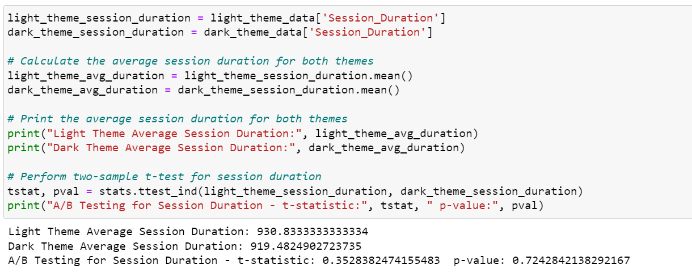

In the comparison of session duration from both themes, we performed an A/B test to determine if there is a statistically significant difference in the average session duration between the two themes. The results of the A/B test are as follows:

* t-statistic: 0.3528
* p-value: 0.7243

The t-statistic measures the difference in the average session duration between the two themes, considering the variability within the datasets. In this case, the t-statistic is approximately 0.3528. A positive t-statistic value indicates that the average session duration of the Light Theme is slightly higher than the average session duration of the Dark Theme.

The p-value represents the probability of observing the observed difference in average session duration or a more extreme difference if the null hypothesis is true. The null hypothesis assumes there is no statistically significant difference in average session duration between the two themes. In this case, the p-value is approximately 0.7243.

Since the p-value is much greater than the typical significance level of 0.05, we do not have enough evidence to reject the null hypothesis. It means that the observed difference in average session duration between the two themes is not statistically significant. The results suggest that any observed difference in session duration could be due to random variation rather than a true difference caused by the themes. In simpler terms, results indicate that the average session duration for both themes is similar, and any differences observed may be due to chance.

### **Summary**

Perform A/B testing of themes or designs using Python these are the outcomes.

* The relationship between the Click Through Rate (CTR) and Conversion Rate is consistent and there’s not much difference between the performance of both themes in click through rates.
* Although there’s not much difference, the conversion rate of the dark theme is slightly better than the light theme.
* The positive z-statistic value indicates that the conversion rate of the Light Theme is slightly higher than the conversion rate of the Dark Theme but we cannot confidently say that one theme performs significantly better than the other in terms of purchases.
* A positive t-statistic value indicates that the average session duration of the Light Theme is slightly higher than the average session duration of the Dark Theme and results indicate that the average session duration for both themes is similar, and any differences observed may be due to chance.

A/B testing is a powerful and widely used technique to compare and evaluate marketing strategies, designs, layouts, or themes. The primary purpose of A/B testing is to make data-driven decisions that lead to improved user experiences, enhanced performance metrics, and ultimately better business outcomes.