SKILL-9B
Code:
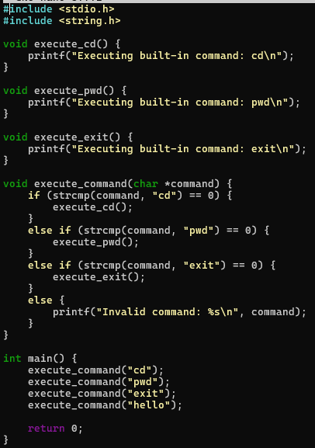
Output:
