PRACTICAL -11A

Code(11A):
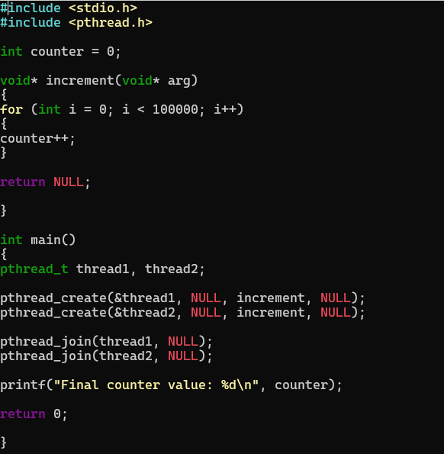

OUTPUT:

