SKILL -7B
Code:
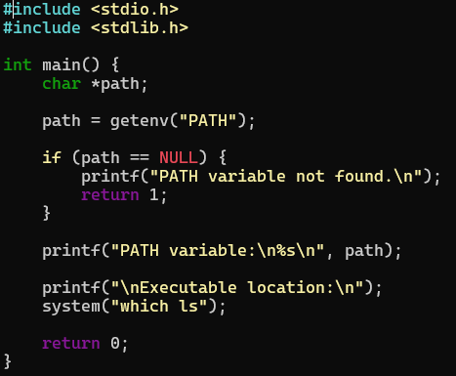

OUTPUT:
