OS -Lab

Program 1: One Process (Before fork()):
Output:

Program 2: fork() Creates a Child:
Output:
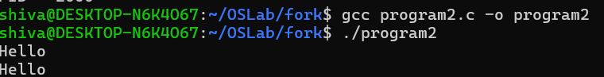

Program 3: Parent vs Child:
Output:
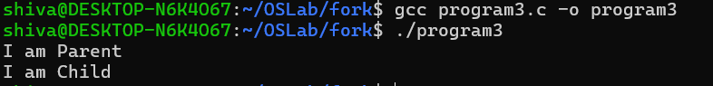

Program 4: Display Both PIDs:
Output:
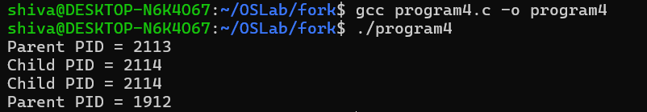

Program 5: Parent Waits for Child:
Output:
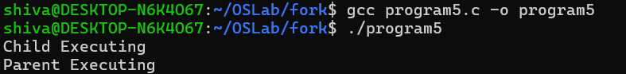

Program 6: Multiple fork() Calls:
Output:
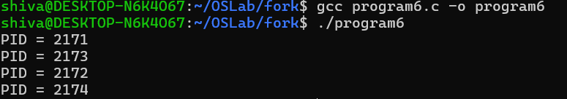

Program 7: Child Executes Another Program (exec()):
Output:
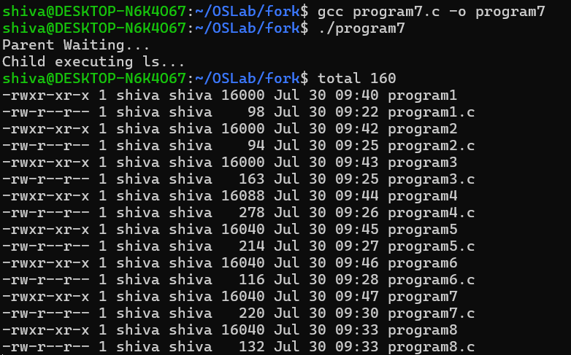

Program 8: fork() Inside a Loop (Fun):
Output:
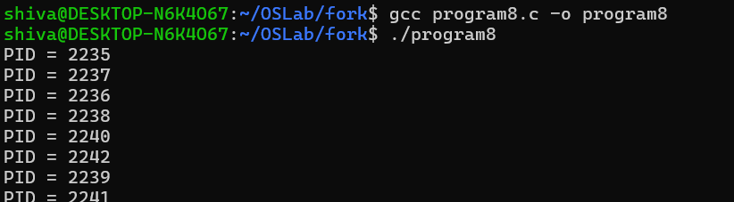

Program 9:
Output:
