6.Create a client-server application using Named Pipes (FIFOs). The client sends messages and the server processes and responds to them. Analyze FIFO behavior when multiple clients communicate simultaneously.

Create a POSIX signal handling program that captures SIGINT, SIGTERM, and SIGUSR1. Demonstrate asynchronous event handling and explain the role of signal handlers.

Code(6A):
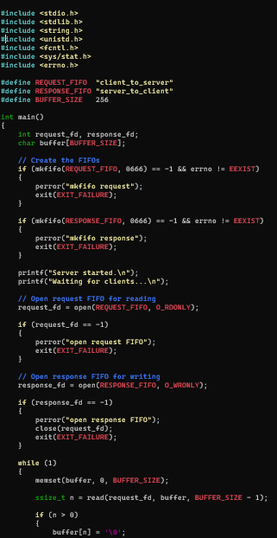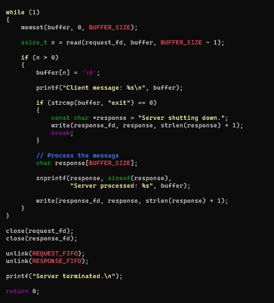
Output(6A):

Code (6b)
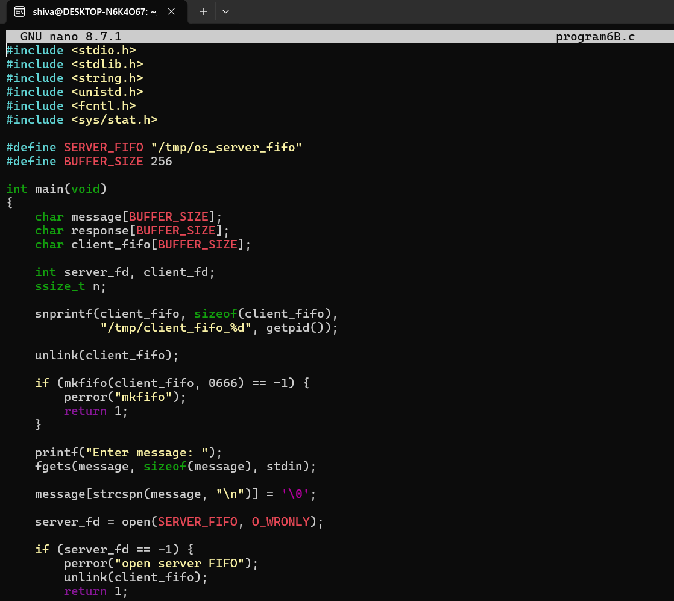
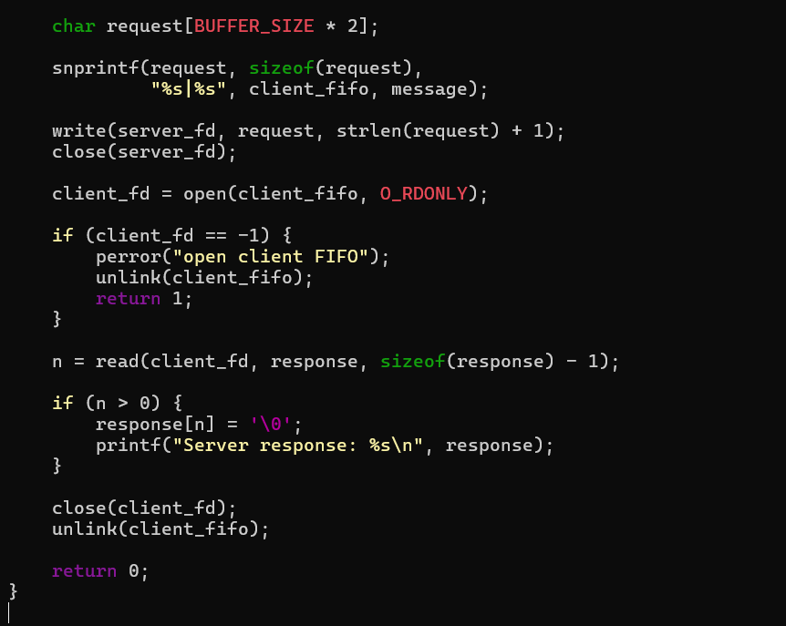

Output 6b

Client server output
