PRACTICAL-9B

Code:
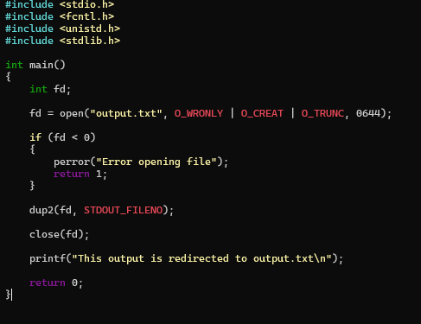

OUTPUT:
