SKILL-9A
Code:
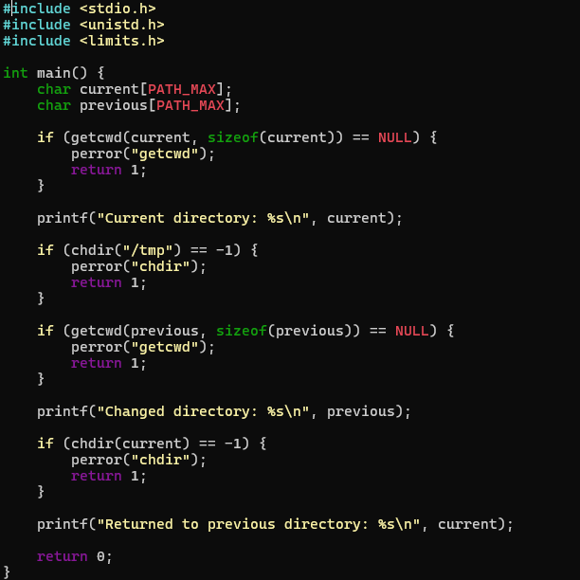

OUTPUT:
