SKILL-6A
Code:
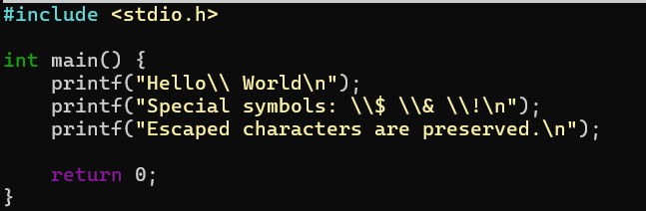

OUTPUT:
