SKILL -8B
Code:
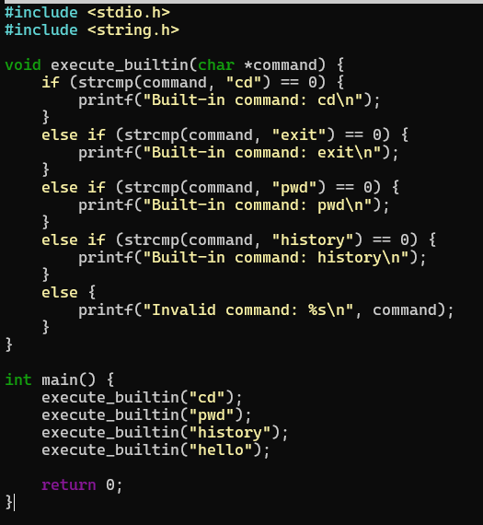
OUTPUT:
